# Running Snake Drift

1. 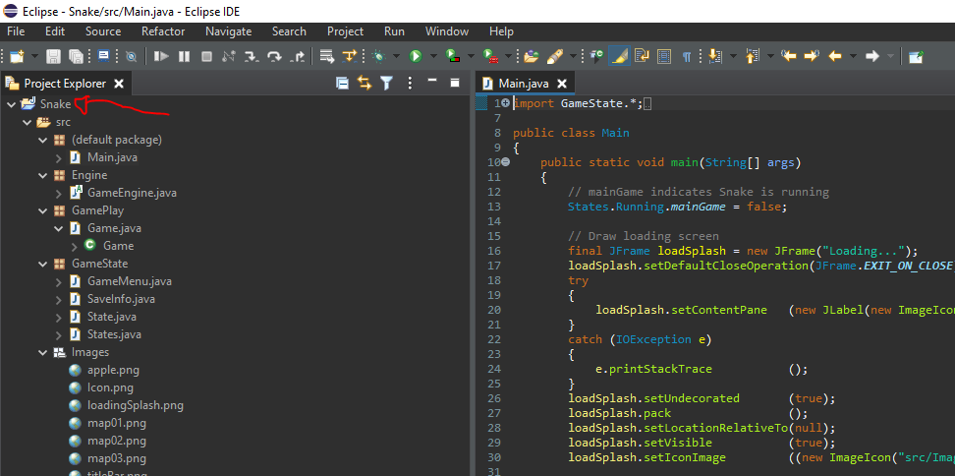Import the project into Eclipse ID
2. Ignore the code
3. Press “Run Main” button

**Note:** *On first run the volume will not be set. Subsequently the loading music will play at 100%. Please do not have your headphones in until you have adjusted your music level in game, or lowered your PC’s music output level responsibly.*

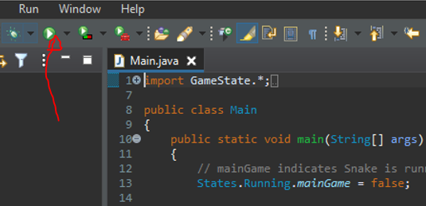

1. 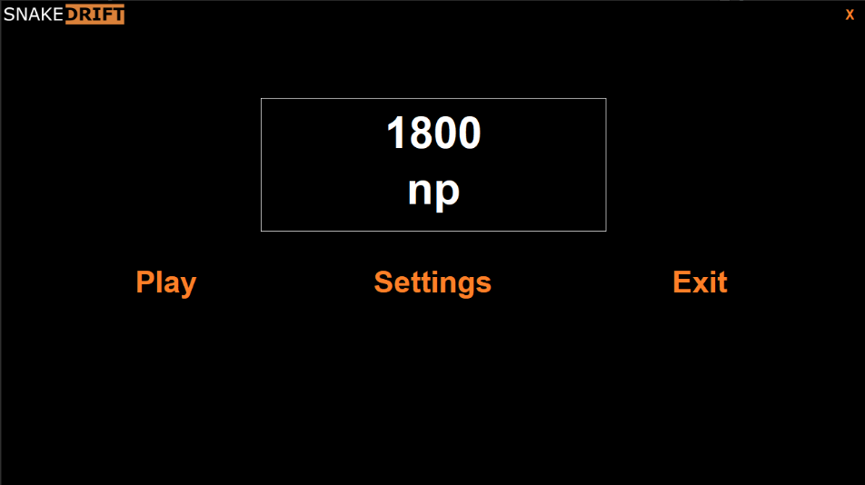The game is now loaded, feel free to play

# Controls

**While in Menu mode**

Mouse button to make selections

**While in game**

W - Turn upwards

A - Turn right

S - Turn downwards

D - Turn left

# Additional Features

## Drift Patterns

As the level increases so too does your speed and, subsequently, your drift patterns. They are drawn below:

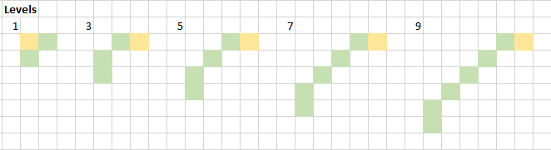

**Note:** *Snake is moving right to left, yellow indicates place where the “D” keypress is received. Green indicates the snakes drift path.*

## Maps Objects, Volume Controls and Starting Difficulty

You can toggle each of these from the settings menu. Clicking “Save” or “Play” will save the settings to disk in your use profile.

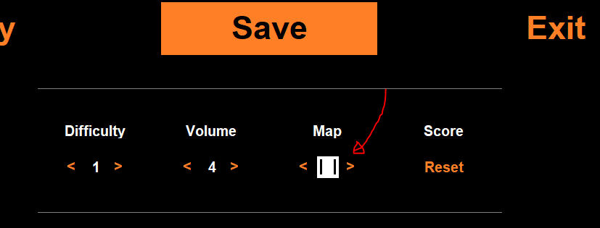

These settings are reloaded from your use profile each time you start the executable.

# Notes

1. *The apple is denoted as a green space*
2. *Colliding with the grey map objects, snake or white border will cause you to loose a life and reset your snake.*