Министерство науки и высшего образования Российской Федерации

Федеральное государственное автономное учреждение высшего образования

МОСКОВСКИЙ ПОЛИТЕХНИЧЕСКИЙ УНИВЕРСИТЕТ (МОСКОВСКИЙ ПОЛИТЕХ)

Факультет информационных технологий

Кафедра «Прикладная информатика»

Форма обучения: очная

Лабораторная работа №2

Реализация структуры Data Vault

по дисциплине

«Хранилища данных»

|  |  |  |
| --- | --- | --- |
| Студент |  | Я.А.Елизарова |

Москва 2025

## Структура базы данных в соответствии с моделью 3NF

Вариант 9 Система должна описывать работу одного из участков автосалона.

Создадим таблицы машины, клиенты, менеджеры по продажам и сделки (продажи) в соответствии с моделью 3NF (ПРИЛОЖЕНИЕ А):

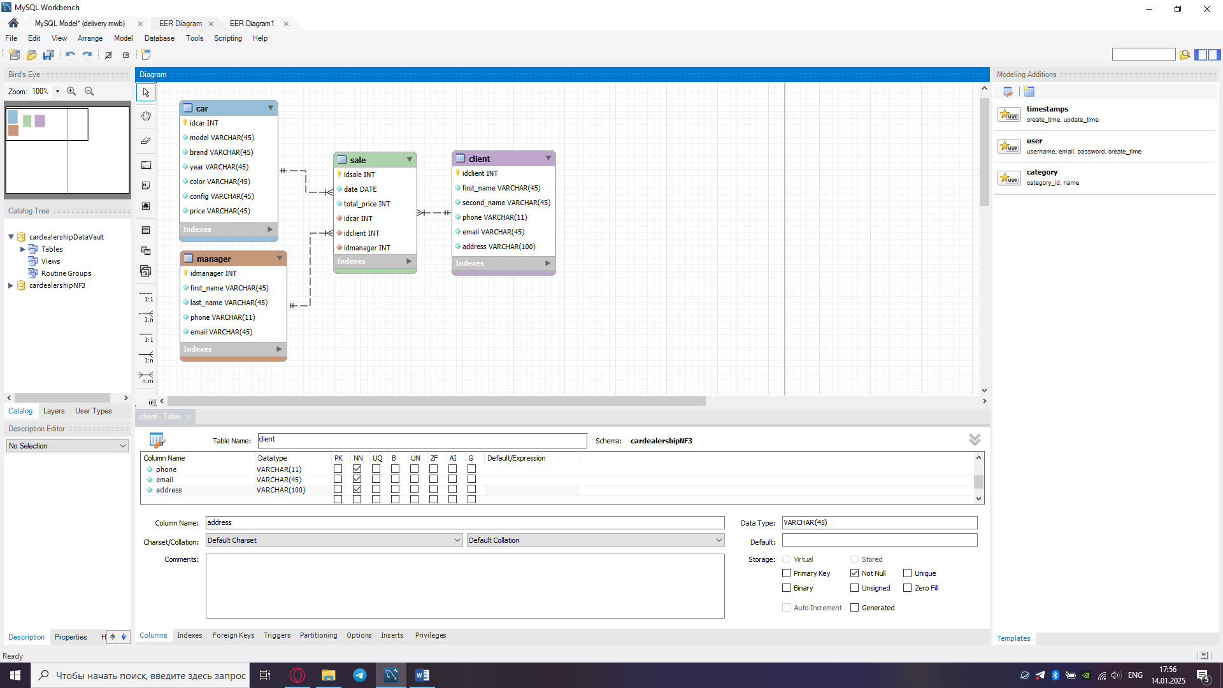

Рисунок 1 - База данных, модель 3NF

## Структура базы данных в соответствии с моделью DataVault

Создадим таблицы машины, клиенты, менеджеры по продажам и сделки (продажи) в соответствии с моделью Data Vault (ПРИЛОЖЕНИЕ Б):

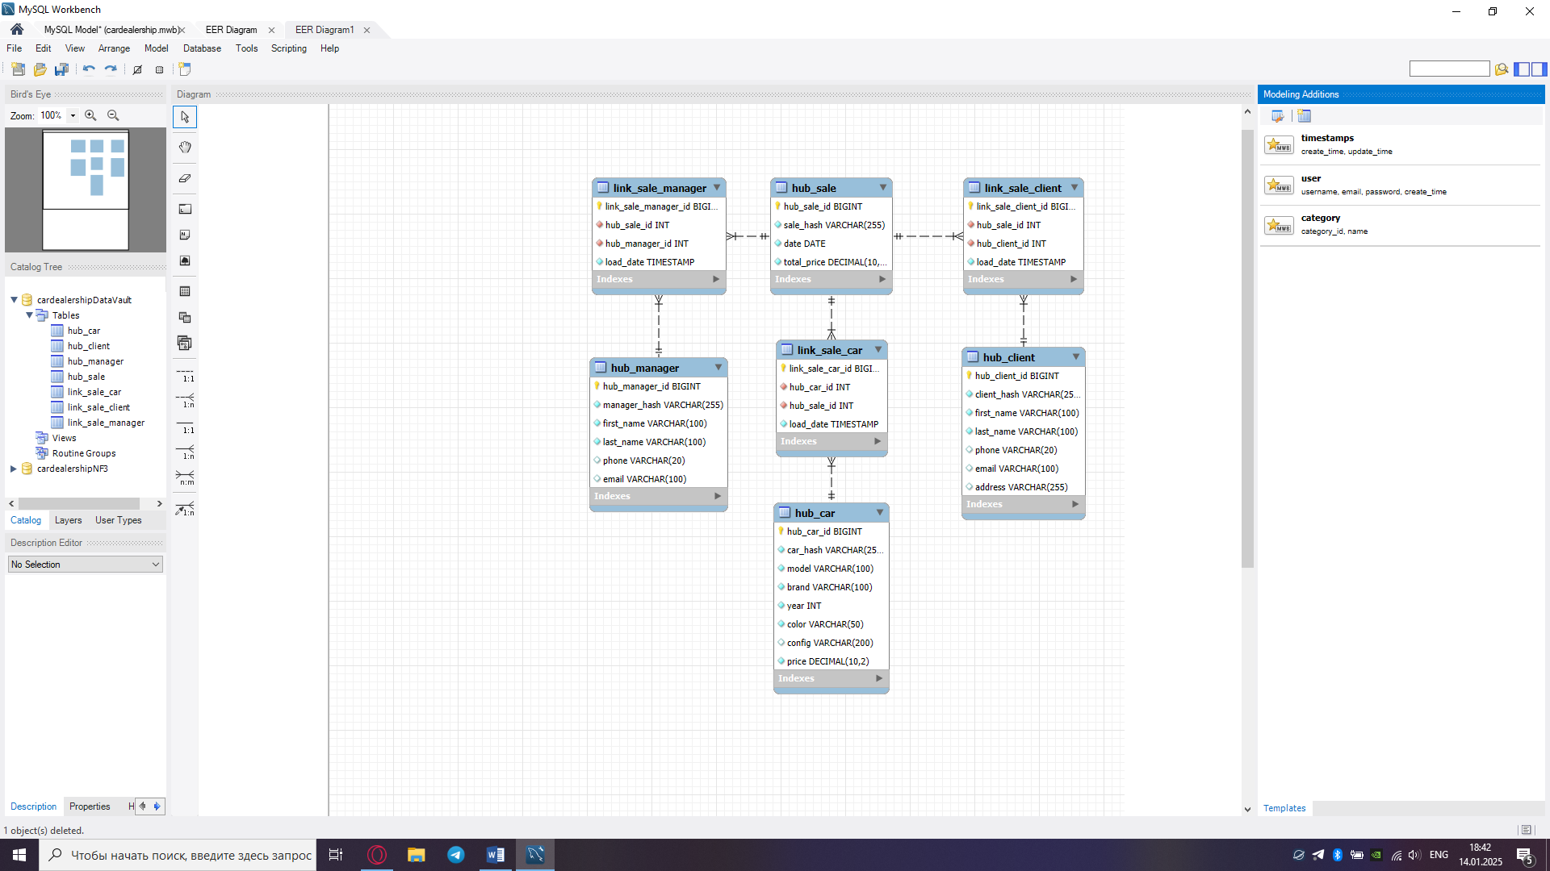

Рисунок 2 - База данных, модель Data Vault

# ПРИЛОЖЕНИЕ А

-- MySQL Script generated by MySQL Workbench

-- Tue Jan 14 22:52:00 2025

-- Model: New Model Version: 1.0

-- MySQL Workbench Forward Engineering

SET @OLD_UNIQUE_CHECKS=@@UNIQUE_CHECKS, UNIQUE_CHECKS=0;

SET @OLD_FOREIGN_KEY_CHECKS=@@FOREIGN_KEY_CHECKS, FOREIGN_KEY_CHECKS=0;

SET @OLD_SQL_MODE=@@SQL_MODE, SQL_MODE='ONLY_FULL_GROUP_BY,STRICT_TRANS_TABLES,NO_ZERO_IN_DATE,NO_ZERO_DATE,ERROR_FOR_DIVISION_BY_ZERO,NO_ENGINE_SUBSTITUTION';

-- -----------------------------------------------------

-- Schema cardealershipNF3

-- -----------------------------------------------------

-- -----------------------------------------------------

-- Schema cardealershipNF3

-- -----------------------------------------------------

CREATE SCHEMA IF NOT EXISTS `cardealershipNF3` DEFAULT CHARACTER SET utf8 ;

USE `cardealershipNF3` ;

-- -----------------------------------------------------

-- Table `cardealershipNF3`.`manager`

-- -----------------------------------------------------

CREATE TABLE IF NOT EXISTS `cardealershipNF3`.`manager` (

`idmanager` INT NOT NULL AUTO_INCREMENT,

`first_name` VARCHAR(45) NOT NULL,

`last_name` VARCHAR(45) NOT NULL,

`phone` VARCHAR(11) NOT NULL,

`email` VARCHAR(45) NOT NULL,

PRIMARY KEY (`idmanager`),

UNIQUE INDEX `idproduct_UNIQUE` (`idmanager` ASC) VISIBLE)

ENGINE = InnoDB

DEFAULT CHARACTER SET = utf8

COLLATE = utf8_bin

COMMENT = 'Товары';

-- -----------------------------------------------------

-- Table `cardealershipNF3`.`car`

-- -----------------------------------------------------

CREATE TABLE IF NOT EXISTS `cardealershipNF3`.`car` (

`idcar` INT NOT NULL AUTO_INCREMENT,

`model` VARCHAR(45) NOT NULL,

`brand` VARCHAR(45) NOT NULL,

`year` VARCHAR(45) NOT NULL,

`color` VARCHAR(45) NOT NULL,

`config` VARCHAR(45) NOT NULL,

`price` VARCHAR(45) NOT NULL,

PRIMARY KEY (`idcar`),

UNIQUE INDEX `idshop_UNIQUE` (`idcar` ASC) VISIBLE)

ENGINE = InnoDB

DEFAULT CHARACTER SET = utf8

COLLATE = utf8_bin

COMMENT = 'Киоски';

-- -----------------------------------------------------

-- Table `cardealershipNF3`.`client`

-- -----------------------------------------------------

CREATE TABLE IF NOT EXISTS `cardealershipNF3`.`client` (

`idclient` INT NOT NULL AUTO_INCREMENT,

`first_name` VARCHAR(45) NOT NULL,

`second_name` VARCHAR(45) NOT NULL,

`phone` VARCHAR(11) NOT NULL,

`email` VARCHAR(45) NOT NULL,

`address` VARCHAR(100) NOT NULL,

PRIMARY KEY (`idclient`),

UNIQUE INDEX `idsupplier_UNIQUE` (`idclient` ASC) VISIBLE)

ENGINE = InnoDB

COMMENT = 'Поставщики';

-- -----------------------------------------------------

-- Table `cardealershipNF3`.`sale`

-- -----------------------------------------------------

CREATE TABLE IF NOT EXISTS `cardealershipNF3`.`sale` (

`idsale` INT NOT NULL AUTO_INCREMENT,

`date` DATE NOT NULL,

`total_price` INT NOT NULL,

`idcar` INT NOT NULL,

`idclient` INT NOT NULL,

`idmanager` INT NOT NULL,

PRIMARY KEY (`idsale`),

INDEX `idshop_idx` (`idcar` ASC) VISIBLE,

INDEX `idsuppliers_idx` (`idclient` ASC) VISIBLE,

INDEX `idproduct_idx` (`idmanager` ASC) VISIBLE,

UNIQUE INDEX `iddelivery_UNIQUE` (`idsale` ASC) VISIBLE,

CONSTRAINT `idshop`

FOREIGN KEY (`idcar`)

REFERENCES `cardealershipNF3`.`car` (`idcar`)

ON DELETE CASCADE

ON UPDATE CASCADE,

CONSTRAINT `idsuppliers`

FOREIGN KEY (`idclient`)

REFERENCES `cardealershipNF3`.`client` (`idclient`)

ON DELETE CASCADE

ON UPDATE CASCADE,

CONSTRAINT `idproduct`

FOREIGN KEY (`idmanager`)

REFERENCES `cardealershipNF3`.`manager` (`idmanager`)

ON DELETE CASCADE

ON UPDATE CASCADE)

ENGINE = InnoDB

DEFAULT CHARACTER SET = utf8

COLLATE = utf8_bin

SET SQL_MODE=@OLD_SQL_MODE;

SET FOREIGN_KEY_CHECKS=@OLD_FOREIGN_KEY_CHECKS;

SET UNIQUE_CHECKS=@OLD_UNIQUE_CHECKS;

# ПРИЛОЖЕНИЕ Б

-- MySQL Script generated by MySQL Workbench

-- Tue Jan 14 22:52:00 2025

-- Model: New Model Version: 1.0

-- MySQL Workbench Forward Engineering

SET @OLD_UNIQUE_CHECKS=@@UNIQUE_CHECKS, UNIQUE_CHECKS=0;

SET @OLD_FOREIGN_KEY_CHECKS=@@FOREIGN_KEY_CHECKS, FOREIGN_KEY_CHECKS=0;

SET @OLD_SQL_MODE=@@SQL_MODE, SQL_MODE='ONLY_FULL_GROUP_BY,STRICT_TRANS_TABLES,NO_ZERO_IN_DATE,NO_ZERO_DATE,ERROR_FOR_DIVISION_BY_ZERO,NO_ENGINE_SUBSTITUTION';

-- -----------------------------------------------------

-- Schema cardealershipDataVault

-- -----------------------------------------------------

-- -----------------------------------------------------

-- Schema cardealershipDataVault

-- -----------------------------------------------------

CREATE SCHEMA IF NOT EXISTS `cardealershipDataVault` DEFAULT CHARACTER SET utf8 ;

-- -----------------------------------------------------

-- Table `cardealershipDataVault`.`hub_car`

-- -----------------------------------------------------

CREATE TABLE IF NOT EXISTS `cardealershipDataVault`.`hub_car` (

`hub_car_id` BIGINT NULL DEFAULT NULL,

`car_hash` VARCHAR(255) NOT NULL,

`model` VARCHAR(100) NOT NULL,

`brand` VARCHAR(100) NOT NULL,

`year` INT NOT NULL,

`color` VARCHAR(50) NOT NULL,

`config` VARCHAR(200) NULL DEFAULT NULL,

`price` DECIMAL(10,2) NOT NULL,

PRIMARY KEY (`hub_car_id`),

UNIQUE INDEX (`car_hash` ASC) VISIBLE);

-- -----------------------------------------------------

-- Table `cardealershipDataVault`.`hub_client`

-- -----------------------------------------------------

CREATE TABLE IF NOT EXISTS `cardealershipDataVault`.`hub_client` (

`hub_client_id` BIGINT NULL DEFAULT NULL,

`client_hash` VARCHAR(255) NOT NULL,

`first_name` VARCHAR(100) NOT NULL,

`last_name` VARCHAR(100) NOT NULL,

`phone` VARCHAR(20) NULL DEFAULT NULL,

`email` VARCHAR(100) NULL DEFAULT NULL,

`address` VARCHAR(255) NULL DEFAULT NULL,

PRIMARY KEY (`hub_client_id`),

UNIQUE INDEX (`client_hash` ASC) VISIBLE);

-- -----------------------------------------------------

-- Table `cardealershipDataVault`.`hub_manager`

-- -----------------------------------------------------

CREATE TABLE IF NOT EXISTS `cardealershipDataVault`.`hub_manager` (

`hub_manager_id` BIGINT NULL DEFAULT NULL,

`manager_hash` VARCHAR(255) NOT NULL,

`first_name` VARCHAR(100) NOT NULL,

`last_name` VARCHAR(100) NOT NULL,

`phone` VARCHAR(20) NULL DEFAULT NULL,

`email` VARCHAR(100) NULL DEFAULT NULL,

PRIMARY KEY (`hub_manager_id`),

UNIQUE INDEX (`manager_hash` ASC) VISIBLE);

-- -----------------------------------------------------

-- Table `cardealershipDataVault`.`hub_sale`

-- -----------------------------------------------------

CREATE TABLE IF NOT EXISTS `cardealershipDataVault`.`hub_sale` (

`hub_sale_id` BIGINT NULL DEFAULT NULL,

`sale_hash` VARCHAR(255) NOT NULL,

`date` DATE NOT NULL,

`total_price` DECIMAL(10,2) NOT NULL,

PRIMARY KEY (`hub_sale_id`),

UNIQUE INDEX (`sale_hash` ASC) VISIBLE);

-- -----------------------------------------------------

-- Table `cardealershipDataVault`.`link_sale_car`

-- -----------------------------------------------------

CREATE TABLE IF NOT EXISTS `cardealershipDataVault`.`link_sale_car` (

`link_sale_car_id` BIGINT NULL DEFAULT NULL,

`hub_car_id` INT NOT NULL,

`hub_sale_id` INT NOT NULL,

`load_date` TIMESTAMP NOT NULL DEFAULT CURRENT_TIMESTAMP(),

PRIMARY KEY (`link_sale_car_id`),

INDEX (`hub_car_id` ASC) VISIBLE,

INDEX (`hub_sale_id` ASC) VISIBLE,

CONSTRAINT ``

FOREIGN KEY (`hub_car_id`)

REFERENCES `cardealershipDataVault`.`hub_car` (`hub_car_id`),

CONSTRAINT ``

FOREIGN KEY (`hub_sale_id`)

REFERENCES `cardealershipDataVault`.`hub_sale` (`hub_sale_id`));

-- -----------------------------------------------------

-- Table `cardealershipDataVault`.`link_sale_client`

-- -----------------------------------------------------

CREATE TABLE IF NOT EXISTS `cardealershipDataVault`.`link_sale_client` (

`link_sale_client_id` BIGINT NULL DEFAULT NULL,

`hub_sale_id` INT NOT NULL,

`hub_client_id` INT NOT NULL,

`load_date` TIMESTAMP NOT NULL DEFAULT CURRENT_TIMESTAMP(),

PRIMARY KEY (`link_sale_client_id`),

INDEX (`hub_sale_id` ASC) VISIBLE,

INDEX (`hub_client_id` ASC) VISIBLE,

CONSTRAINT ``

FOREIGN KEY (`hub_sale_id`)

REFERENCES `cardealershipDataVault`.`hub_sale` (`hub_sale_id`),

CONSTRAINT ``

FOREIGN KEY (`hub_client_id`)

REFERENCES `cardealershipDataVault`.`hub_client` (`hub_client_id`));

-- -----------------------------------------------------

-- Table `cardealershipDataVault`.`link_sale_manager`

-- -----------------------------------------------------

CREATE TABLE IF NOT EXISTS `cardealershipDataVault`.`link_sale_manager` (

`link_sale_manager_id` BIGINT NULL DEFAULT NULL,

`hub_sale_id` INT NOT NULL,

`hub_manager_id` INT NOT NULL,

`load_date` TIMESTAMP NOT NULL DEFAULT CURRENT_TIMESTAMP(),

PRIMARY KEY (`link_sale_manager_id`),

INDEX (`hub_sale_id` ASC) VISIBLE,

INDEX (`hub_manager_id` ASC) VISIBLE,

CONSTRAINT ``

FOREIGN KEY (`hub_sale_id`)

REFERENCES `cardealershipDataVault`.`hub_sale` (`hub_sale_id`),

CONSTRAINT ``

FOREIGN KEY (`hub_manager_id`)

REFERENCES `cardealershipDataVault`.`hub_manager` (`hub_manager_id`));

ENGINE = InnoDB

SET SQL_MODE=@OLD_SQL_MODE;

SET FOREIGN_KEY_CHECKS=@OLD_FOREIGN_KEY_CHECKS;

SET UNIQUE_CHECKS=@OLD_UNIQUE_CHECKS;