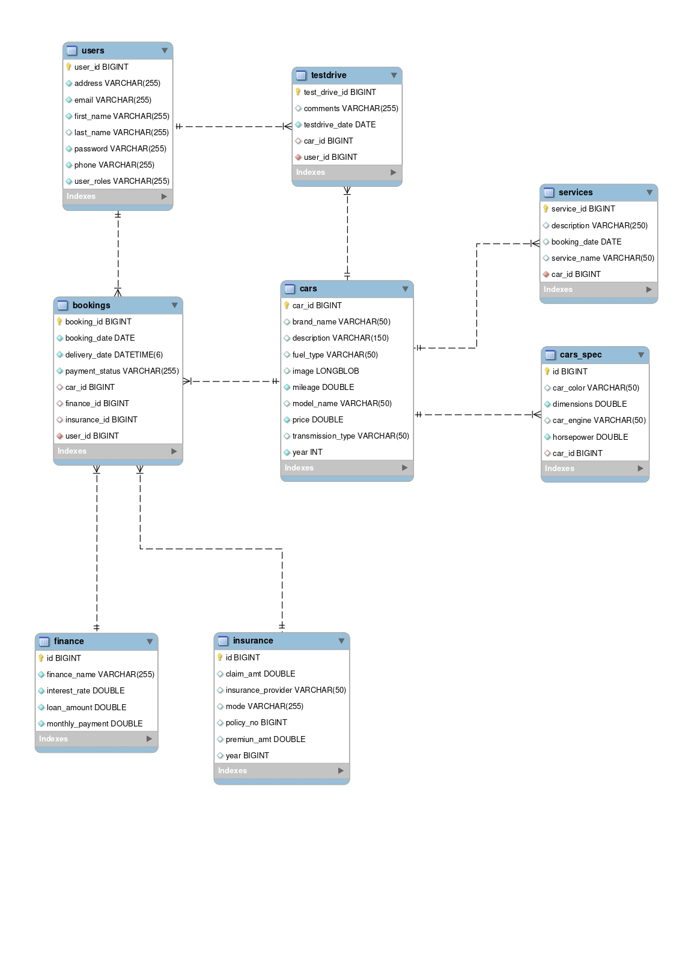

Fig 1.1 : ER Diagram

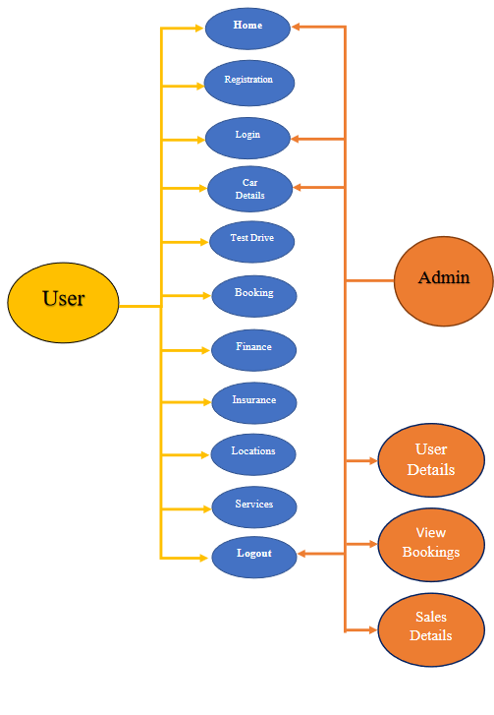

Fig 1.2 : User Flow Diagram

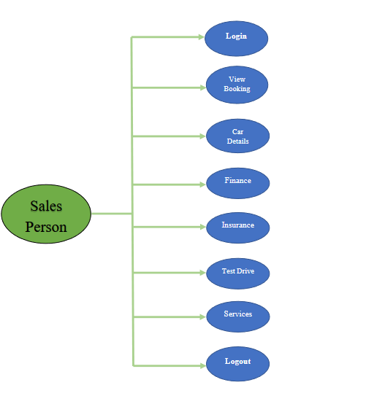

Fig 1.2 : User Flow Diagram