MONGODB ASSIGNMENT
Roll no-84016

Q6.View list of available databases
Ans.
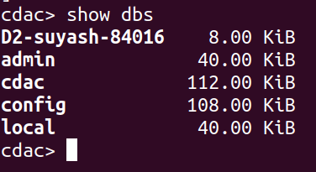

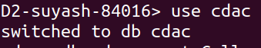
Q7.Create a new database named CDAC and connect to it.
Ans.

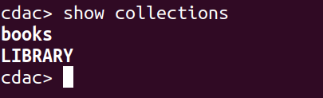
Q8.View list of available collections in CDAC database.
Ans.

Q9.Create a new collection by the name of LIBRARY.
Ans.
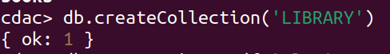

Q10. Insert the following document in the LIBRARY collection:- title:'MongoDB programming', author:'Sameer', likes:100.
Ans.
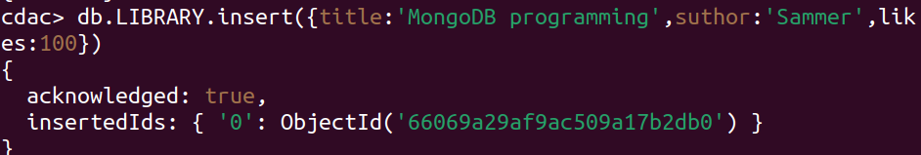
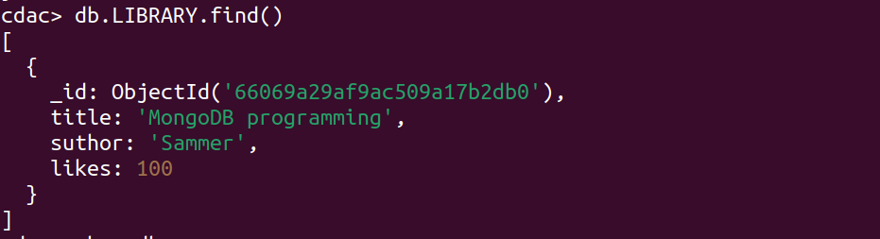
Q11.View the recently inserted document and note the _id field.
Ans.

Q12.Insert another document in the LIBRARY collection as follows:-title:'MySQL programming',authors:['Jack','Jill'], likes:200.
Ans.
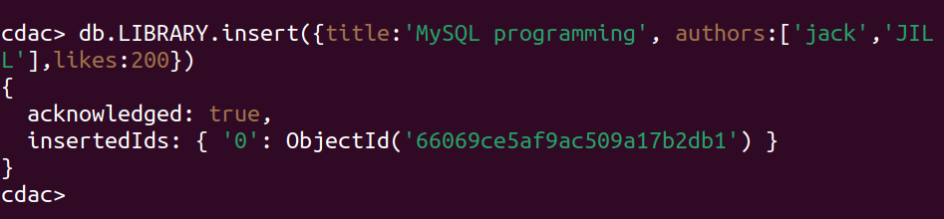

Q13.likes:200View the inserted documents

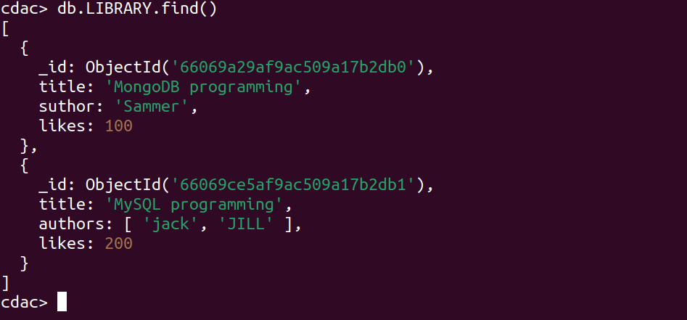

Q14.View only the first inserted document
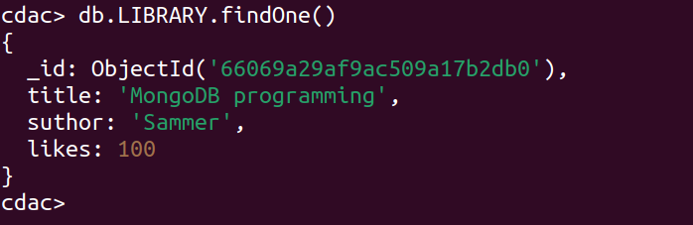

Q15.View the documents using the pretty() method
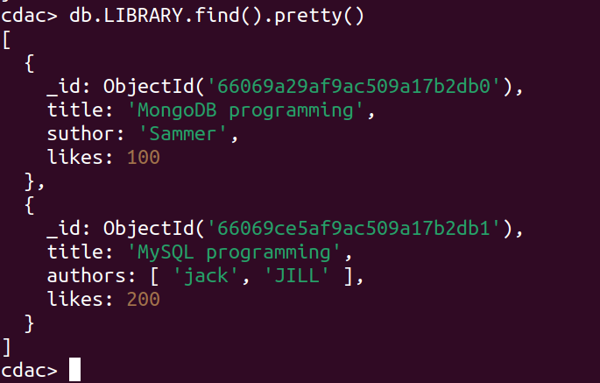
Q16.Update the document where author name Sameer and change it to Sameer Dehadrai

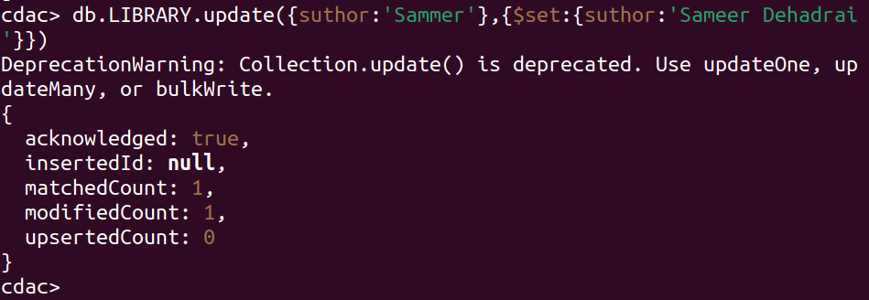

Q17.Delete all documents that have 100 likes.

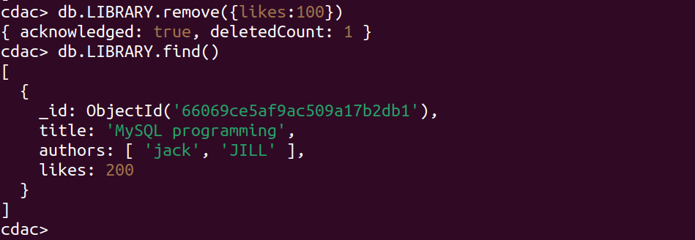
Q18. Drop the LIBRARY collection
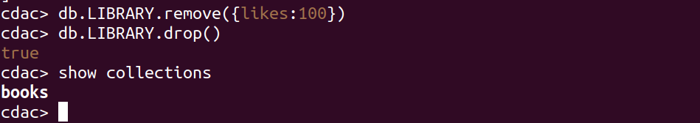
Q19 Drop the CDAC database
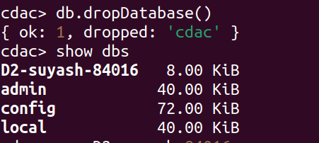
Q20 Exit from MongoDB shell
