**Practical-1**

**AIM:** Study of basic network command and Network configuration commands.

1. **Ping**

Ping is a [computer network](https://en.wikipedia.org/wiki/Computer_network) administration [software utility](https://en.wikipedia.org/wiki/Utility_software) used to test the reachability of a [host](https://en.wikipedia.org/wiki/Host_(network)) on an [Internet Protocol](https://en.wikipedia.org/wiki/Internet_Protocol)  network. It is available for virtually all operating systems that have networking capability, including most embedded network administration software.

Ping measures the [round-trip time](https://en.wikipedia.org/wiki/Round-trip_time) for messages sent from the originating host to a destination computer that are echoed back to the source. The name comes from [active sonar](https://en.wikipedia.org/wiki/Active_sonar) terminology that sends a [pulse](https://en.wikipedia.org/wiki/Pulse_(signal_processing)) of sound and listens for the [echo](https://en.wikipedia.org/wiki/Echo) to detect objects under water.

The [command-line options](https://en.wikipedia.org/wiki/Command-line_option) of the ping utility and its output vary between the numerous implementations. Options may include the size of the payload, count of tests, limits for the number of network hops ([TTL](https://en.wikipedia.org/wiki/Time_to_live#IP_packets)) that probes traverse, interval between the requests and time to wait for a response.

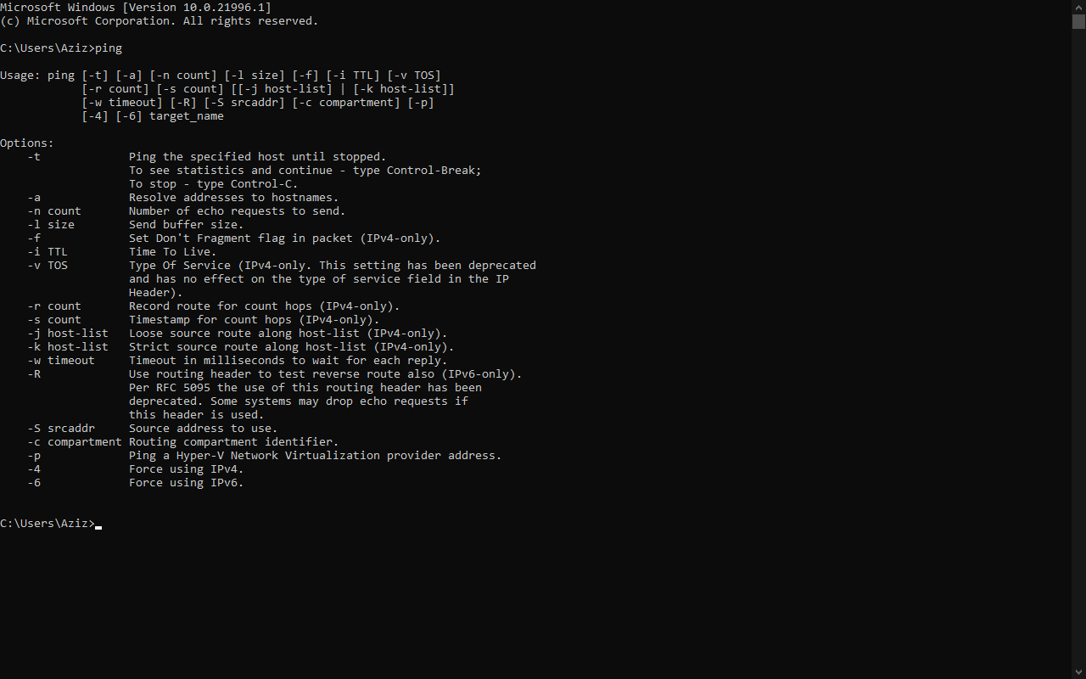The program reports errors, [packet loss](https://en.wikipedia.org/wiki/Packet_loss), and a statistical summary of the results, typically including the minimum, maximum, the [mean](https://en.wikipedia.org/wiki/Mean_(average)) round-trip times, and [standard deviation](https://en.wikipedia.org/wiki/Standard_deviation) of the mean.

1. **Traceroute:**

Traceroute are [computer network](https://en.wikipedia.org/wiki/Computer_network) diagnostic [commands](https://en.wikipedia.org/wiki/Command_(computing)) for displaying possible routes and measuring transit delays of [packets](https://en.wikipedia.org/wiki/Network_packet) across an [Internet Protocol](https://en.wikipedia.org/wiki/Internet_Protocol) (IP) network. The history of the route is recorded as the round-trip times of the packets received from each successive host in the route, the sum of the mean times in each [hop](https://en.wikipedia.org/wiki/Hop_(networking)) is a measure of the total time spent to establish the connection. Traceroute proceeds unless all sent packets are lost more than twice, then the connection is lost and the route cannot be evaluated. [Ping](https://en.wikipedia.org/wiki/Ping_(networking_utility)), on the other hand, only computes the final round-trip times from the destination point.

The [command](https://en.wikipedia.org/wiki/Command_(computing)) tracer route is available on many modern [operating systems](https://en.wikipedia.org/wiki/Operating_system). On [Unix-like](https://en.wikipedia.org/wiki/Unix-like) systems such as MacOS and [Linux](https://en.wikipedia.org/wiki/Linux) it is available as a command line tool. Traceroute is also graphically accessible in MacOS within the Network Utilities suite.

[Microsoft Windows](https://en.wikipedia.org/wiki/Microsoft_Windows) and react OS provide a program named tracer that performs the same route-tracing function. [Windows NT](https://en.wikipedia.org/wiki/Windows_NT)-based operating systems also provide ping pong, with similar functionality.

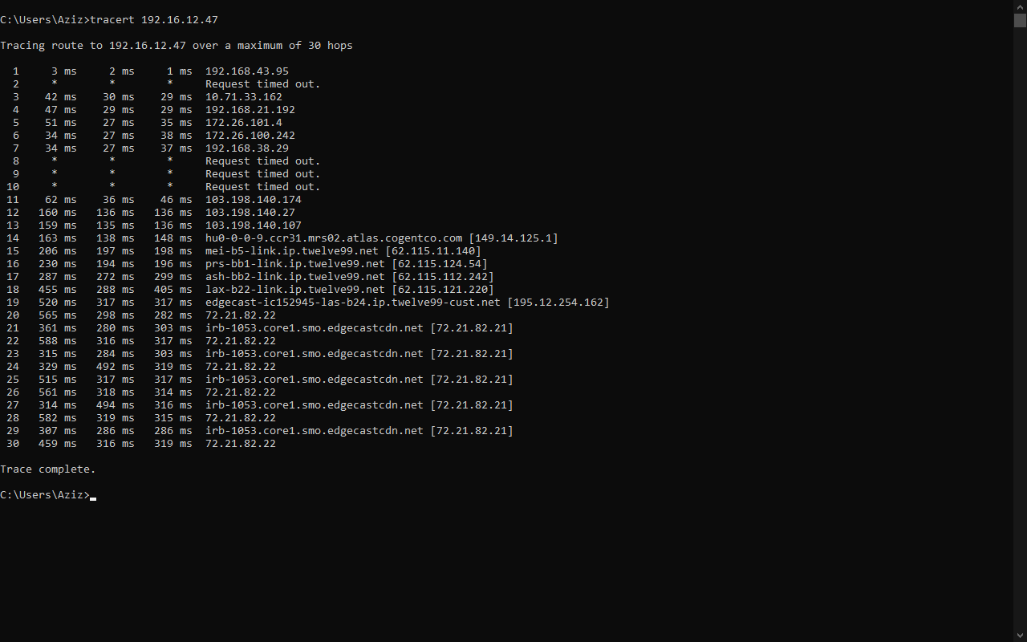On Windows, tracer sends ICMP Echo Request packets, rather than the UDP packets traceroute sends by default.

1. **Ipconfig:**

Display all current TCP/IP network configuration values and refreshes Dynamic Host configuration protocol (DHCP) and Domain name system (DNS) settings. Used without parameters, ipconfig displays Internet protocol version 4 (IPV4) and IPv6 addresses, subnets mask, and default gateways for all adapters.

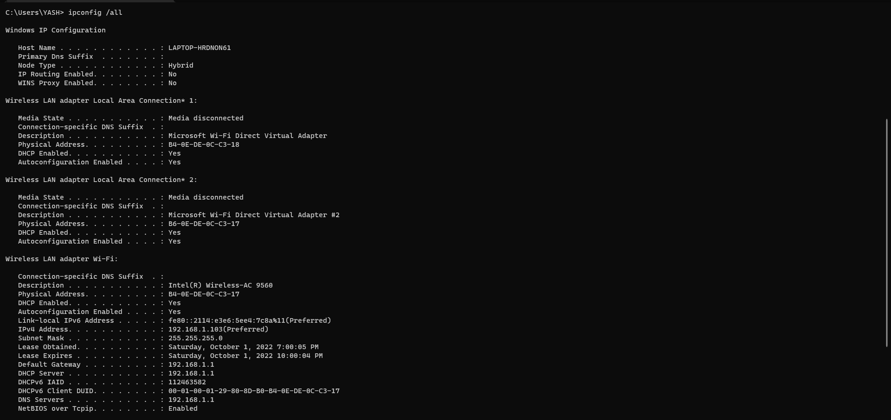

1. **NSLOOKUP:**

NSLOOKUP is a [network administration](https://en.wikipedia.org/wiki/Network_administration) [command-line](https://en.wikipedia.org/wiki/Command-line) tool for querying the [Domain Name System](https://en.wikipedia.org/wiki/Domain_Name_System) (DNS) to obtain the mapping between [domain name](https://en.wikipedia.org/wiki/Domain_name) and [IP address](https://en.wikipedia.org/wiki/IP_address), or other [DNS records](https://en.wikipedia.org/wiki/DNS_record).

NSLOOKUP was a member of the [BIND](https://en.wikipedia.org/wiki/BIND) name server software. Early[ in the development of BIND 9, the [Internet Systems Consortium](https://en.wikipedia.org/wiki/Internet_Systems_Consortium) planned to deprecate NSLOOKUP in favor of [host](https://en.wikipedia.org/wiki/Host_(Unix)) and [dig](https://en.wikipedia.org/wiki/Dig_(command)). This decision was reversed in 2004 with the release of BIND and NSLOOKUP has been fully supported since then.

Unlike [dig](https://en.wikipedia.org/wiki/Dig_(command)), NSLOOKUP does not use the operating system's local Domain Name System resolver library to perform its queries, and thus may behave differently. Additionally, vendor-provided versions may include output of other sources of name information, such as [host files](https://en.wikipedia.org/wiki/Hosts_(file)), and [Network Information Service](https://en.wikipedia.org/wiki/Network_Information_Service).



1. **Pathping:**

Provides information about network latency and network loss intermediate hops between a source and destination. This command send multiple echo request message to each router between a source and destination, over a period of time, and then computers results based on the packets returned from each router or link, you can determine which router or subnets might be having network problems.

Options:

-g host-list loose source router along host-list.

-maximum hops maximum number of hops to search for target.

-I address Use the specified source address.

-n do not resolve addresses to hostnames.

-p period wait period milliseconds between pings.

-w timeout Wait timeout millisecond for each reply.

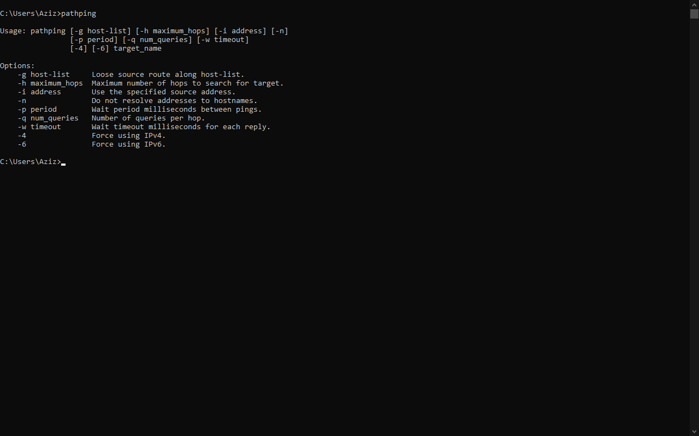

1. **Netstat:**

The netstat command means networks statistics, is a command prompt command used to display very detailed information about how your computer is communicating with other computers or networks connections, overall and protocol, local address, foreign address and the state.

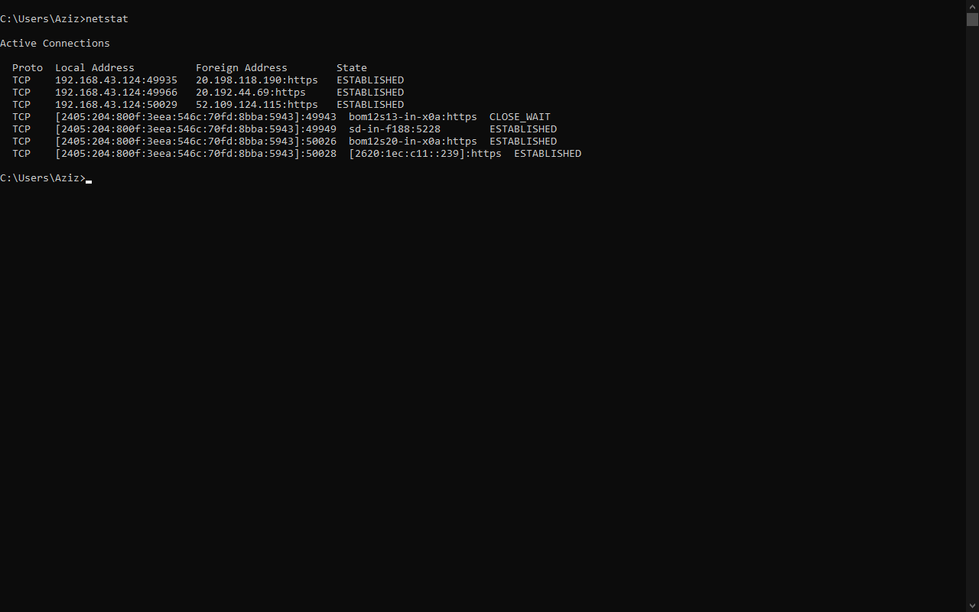

1. **ARP:**

Address Resolution protocol is a protocol or procedure that connects an ever-changing Internet Protocol address to a fixed physical machine address, also know as a media access control (MAC) address, in a local area network (LAN).

The Address Resolution Protocol is a [request-response](https://en.wikipedia.org/wiki/Request-response) protocol. Its messages are directly encapsulated by a link layer protocol. It is communicated within the boundaries of a single network, never routed across internetworking nodes.

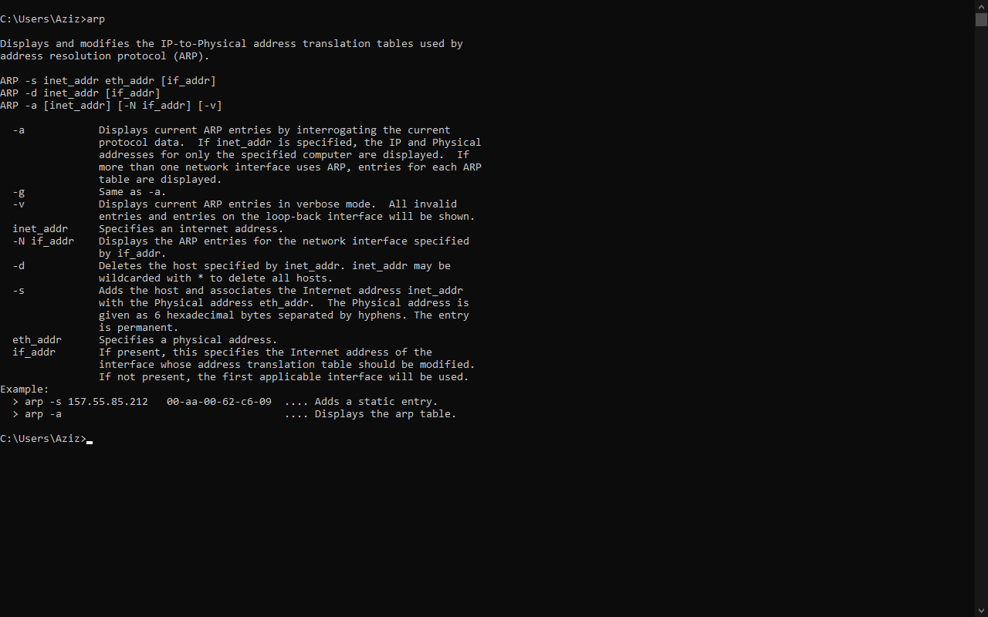

1. **Hostname:**

The hostname command displays the name of the current host system. Only users with root user authority can set the host name. To see the hostname type ‘hostname’ command in command prompt.

