# Practical: 3

## AIM:

Practice GIT by creating a repository and demonstrating key commands.

## THEORY:

## OUTPUT:

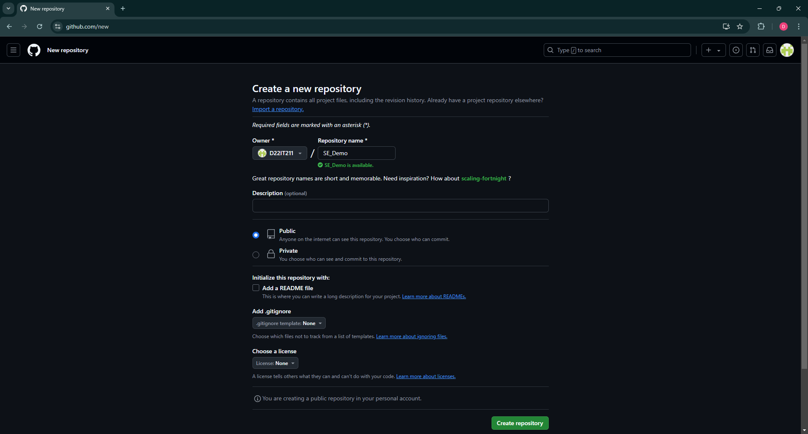

Figure 1.1 Creating a GitHub repo.

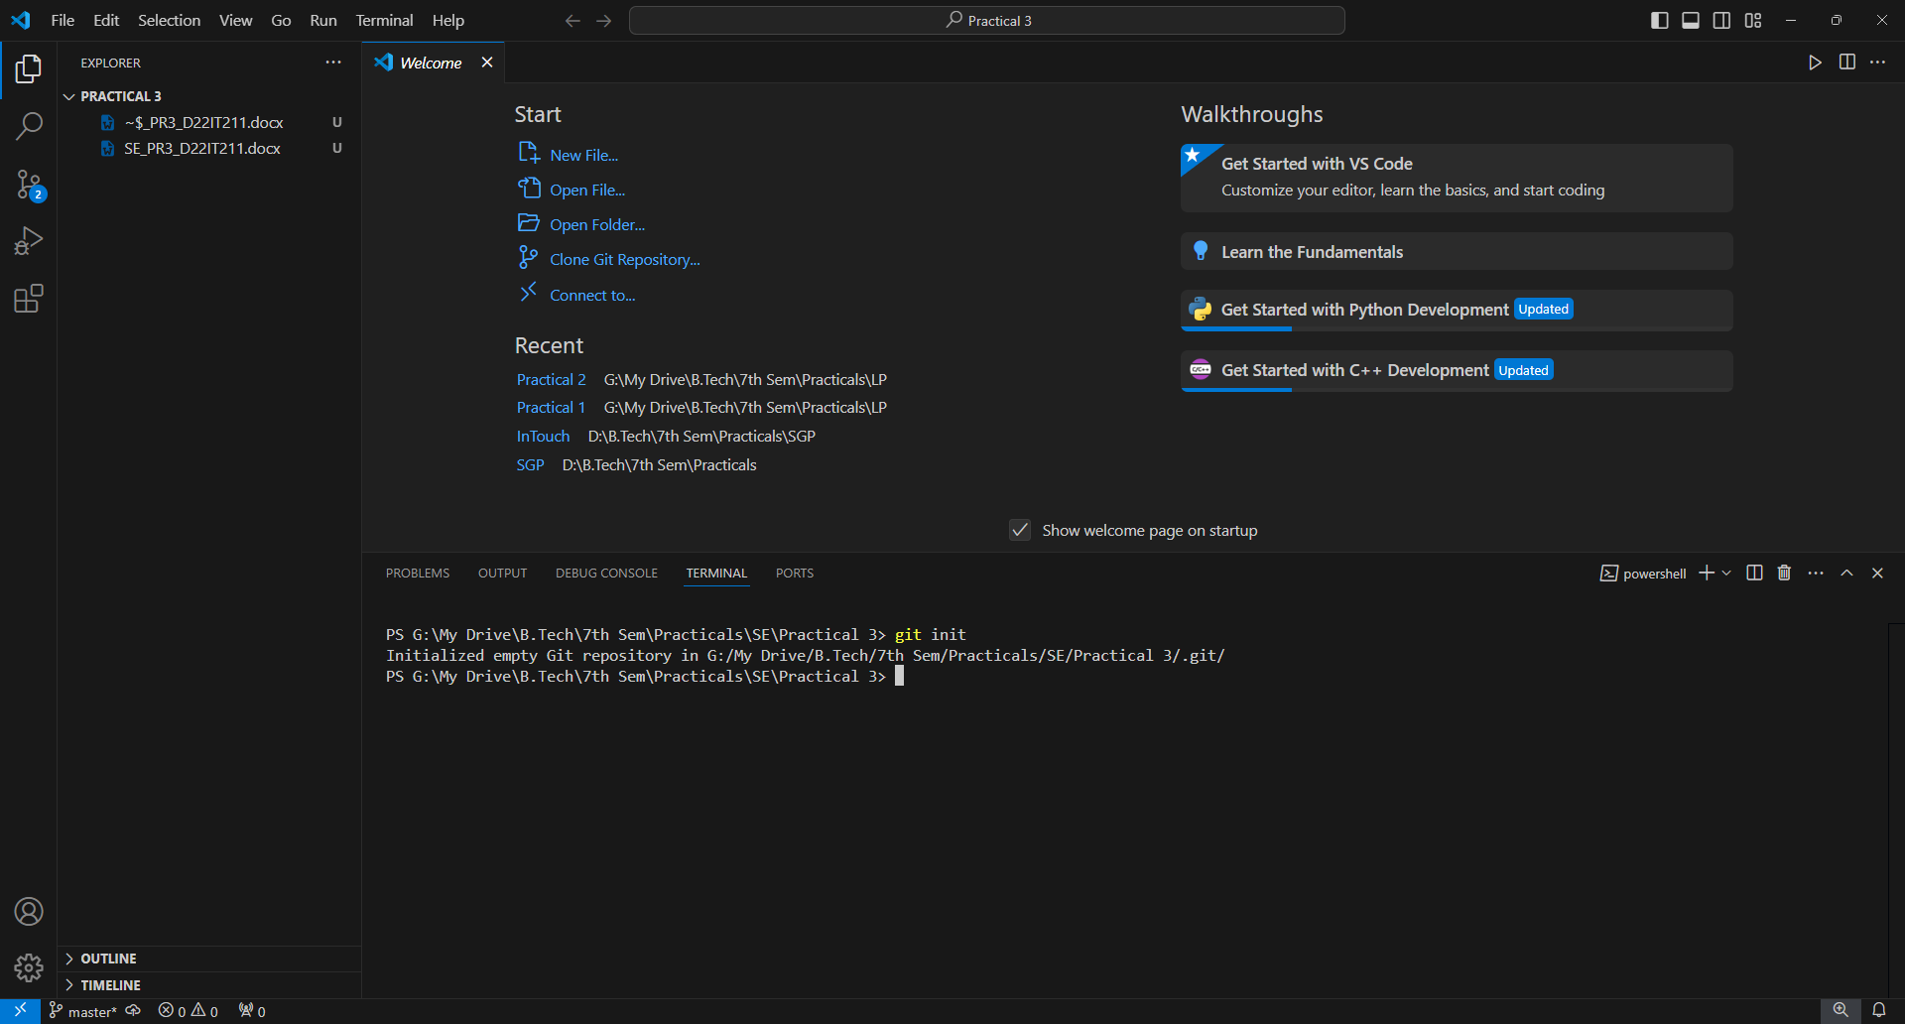

Figure 1.2 Initializing the repo.

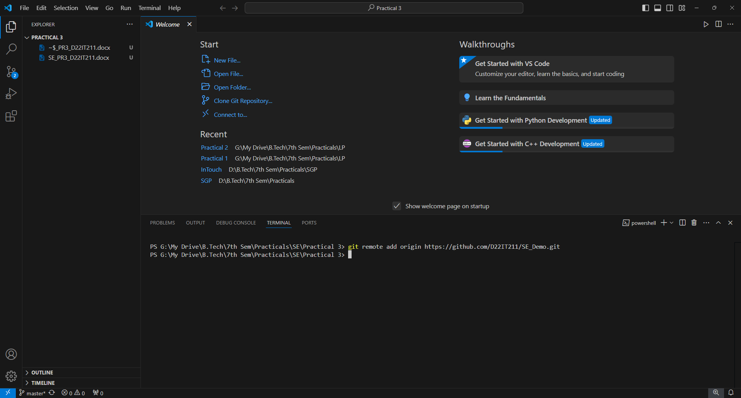

Figure 1.3 Adding remote origin at local.

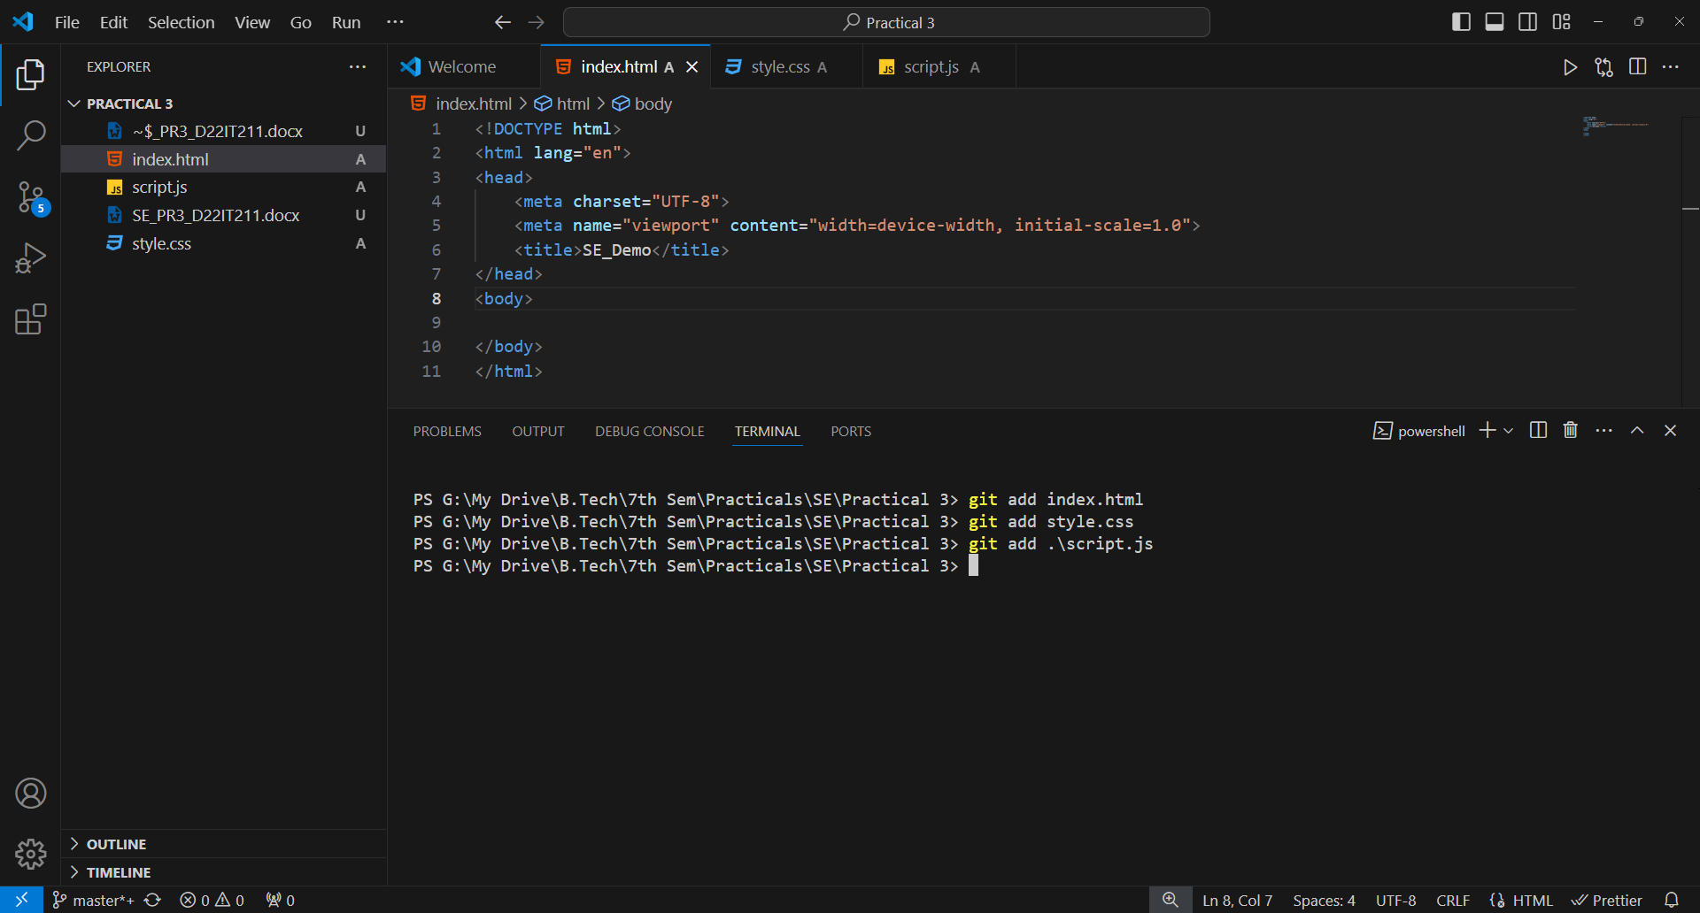

Figure 1.4 Adding files using git add <filename> command.

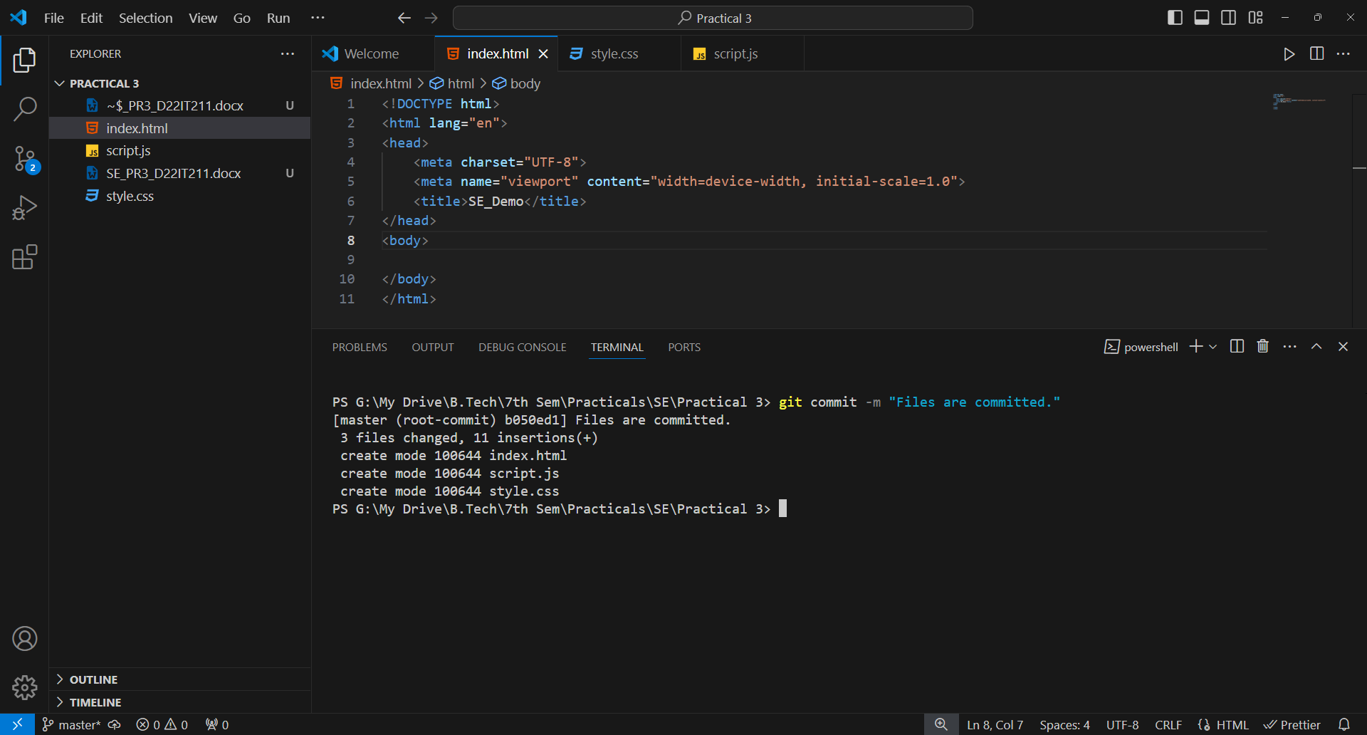

Figure 1.5 Commit the files.

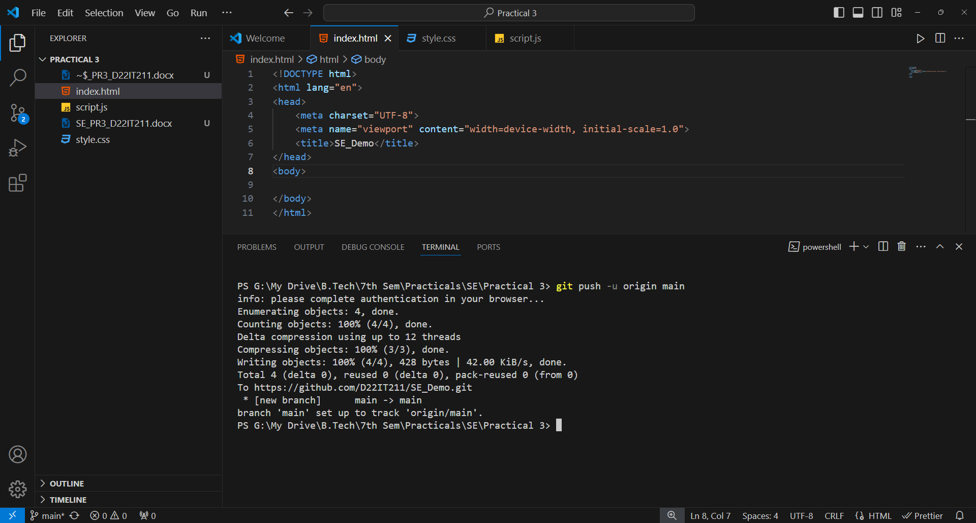

Figure 1.6 Pushing the files to GitHub repo.

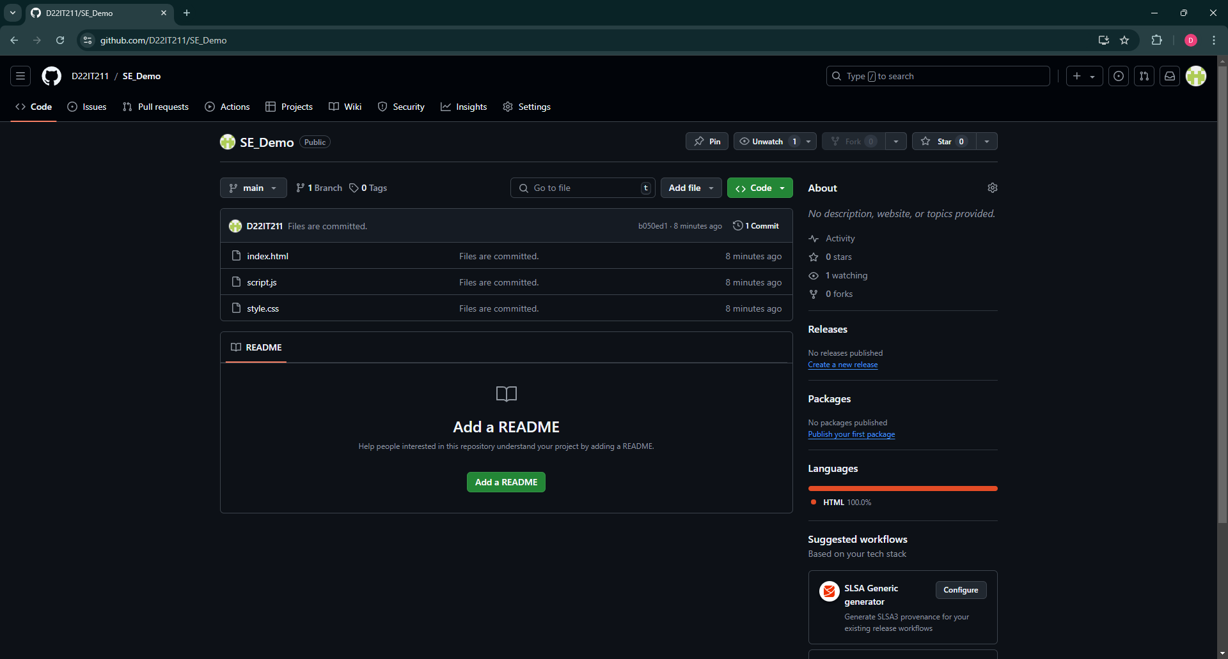

Figure 1.7 Files are successfully saved to GitHub repo.

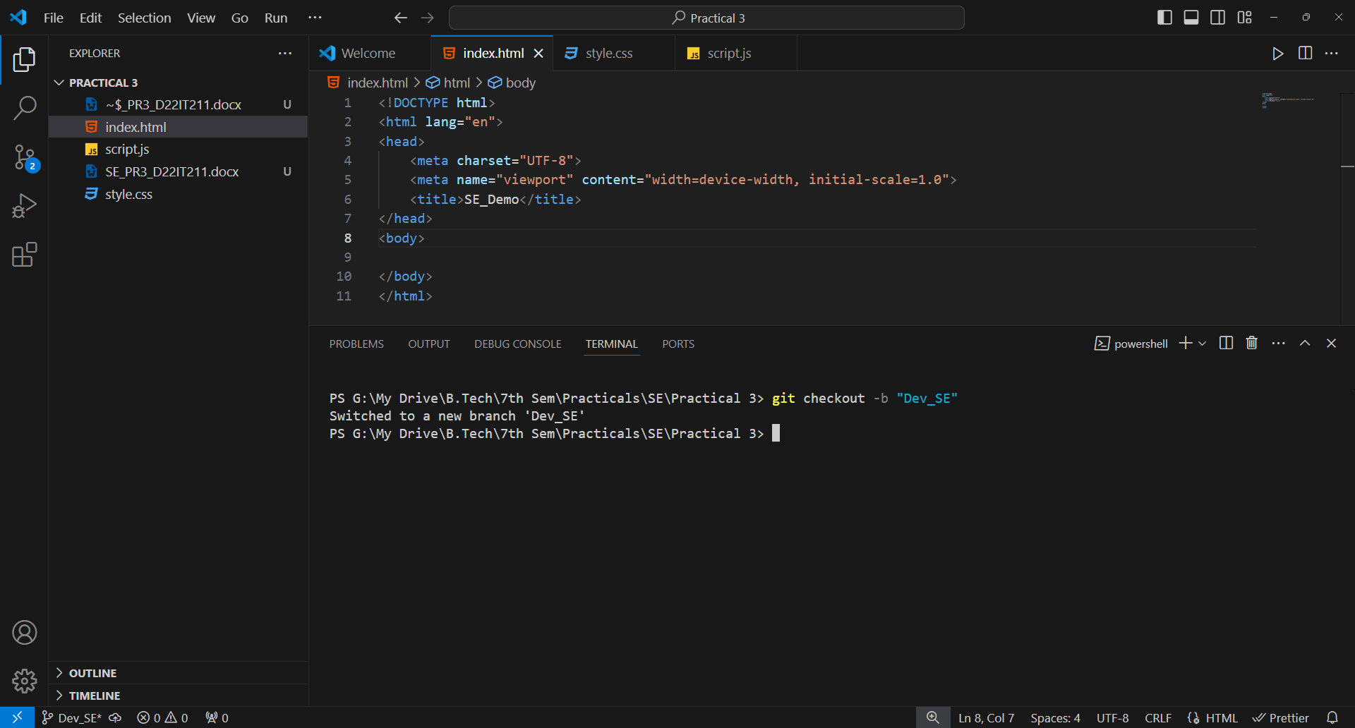

Figure 1.8 Creating a new branch named Dev_SE.

## LEARNING OUTCOME: