**Exp no: 2** Implement programs for visualizing time series data.

**Date: 24/1/25**

**Aim:**

To implement program for visualizing time series data

### ****Steps for Time Series Sales Data Preprocessing****:

### ****1. Reading the Dataset****

This step involves reading the CSV file containing stock data and parsing the 'Date' column as a datetime index.

**python**

**Copy**

**# Reading the dataset using read_csv**

**df = pd.read_csv("stock_data.csv",**

**parse_dates=True,**

**index_col="Date")**

**# Displaying the first five rows of dataset**

**df.head()**

print**(df.columns)**

### ****2. Plotting the High Price Over Time****.

**sns.set(style="whitegrid") # Setting the style to whitegrid for a clean background**

**plt.figure(figsize=(12, 6)) # Setting the figure size**

**sns.lineplot(data=df, x='Date', y='High', label='High Price', color='blue')**

**plt.xlabel('Date')**

**plt.ylabel('High')**

**plt.title('Share Highest Price Over Time')**

**plt.show()**

**Output:**

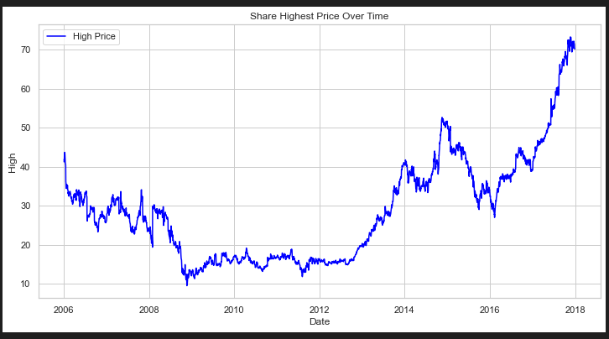

### ****3. Autocorrelation Function (ACF) Plot****

In this step, we plot the autocorrelation function (ACF) for the 'Volume' column to identify any correlations in the data at different lags.

**plt.figure(figsize=(12, 6))**

**plot_acf(df['Volume'], lags=40) # You can adjust the number of lags as needed**

**plt.xlabel('Lag')**

**plt.ylabel('Autocorrelation')**

**plt.title('Autocorrelation Function (ACF) Plot')**

**plt.show()**

**Output:**

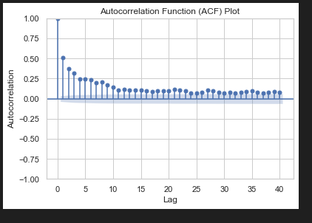

### ****4. Differencing****

we apply differencing on the 'High' column and plot the original and differenced series for comparison.

**df['high_diff'] = df['High'].diff()**

**plt.figure(figsize=(12, 6))**

**plt.plot(df['High'], label='Original High', color='blue')**

**plt.plot(df['high_diff'], label='Differenced High', linestyle='--', color='green')**

**plt.title('Original vs Differenced High')**

**plt.show()**

**Output:**

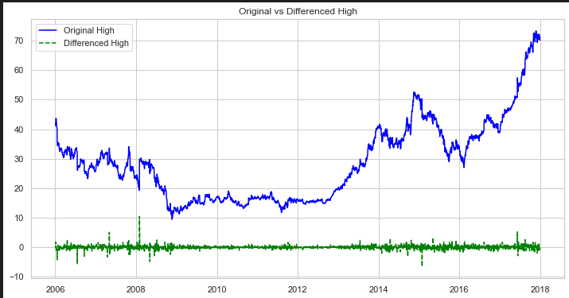

### ****5. Moving Average****

We apply a moving average with a window size of 120 to smooth the 'High' price data and plot the results to visualize trends.

**python**

**Copy**

**# Moving Average**

**window_size = 120**

**df['high_smoothed'] = df['High'].rolling(window=window_size).mean()**

**# Plotting**

**plt.figure(figsize=(12, 6))**

**plt.plot(df['High'], label='Original High', color='blue')**

**plt.plot(df['high_smoothed'], label=f'Moving Average (Window={window_size})', linestyle='--', color='orange')**

**plt.xlabel('Date')**

**plt.ylabel('High')**

**plt.title('Original vs Moving Average')**

**plt.legend()**

**plt.show()**

**Output:**

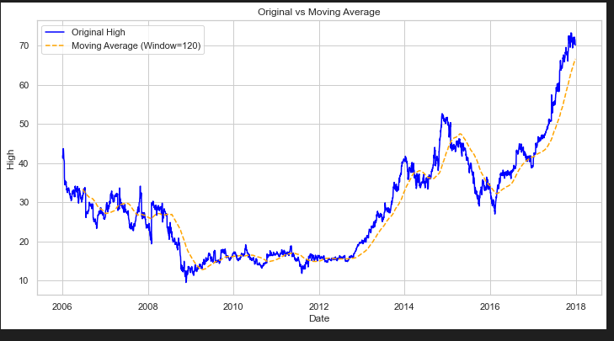

### ****6. Monthly Resampling****

**df_resampled = df.resample('M').mean() # Resampling to monthly frequency, using mean as an aggregation function**

**sns.set(style="whitegrid") # Setting the style to whitegrid for a clean background**

**plt.figure(figsize=(12, 6)) # Setting the figure size**

**sns.lineplot(data=df_resampled, x=df_resampled.index, y='High', label='Month Wise Average High Price', color='blue')**

**plt.xlabel('Date (Monthly)')**

**plt.ylabel('High')**

**plt.title('Monthly Resampling Highest Price Over Time')**

**output :**

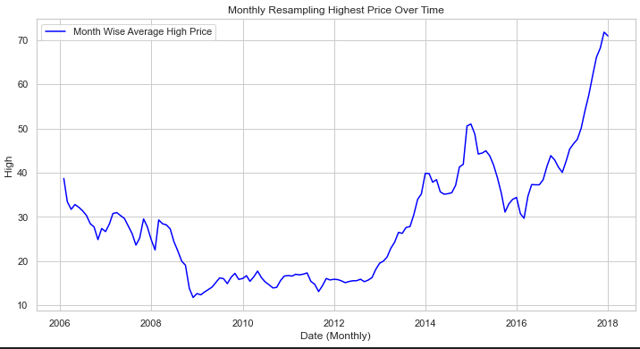

Result:

Thus the program is implemented and Output got output successfully

221501024