**How to Mod D2R:  
  
First we must understand how modding differs from D2L.  
You have 2 different CLA's you can use in D2R:**

**-direct -txt: The ones everyone familiar with, but the requirements have changed.   
You are now required to have all data files(~30-40GB) extracted to your D2R folder for this CLA to work. This is not meant for sharing mods, as every individual file would need to be shared also, or the edits required being github'ed for the user to copy. You can however make changes and do tests much faster than re-packing a MPQ everytime.  
-mod modname: The new one that is similar to the former -direct -txt in legacy. Only the modded files are needed in the D2R folder; the rest will be used from the packed data. This is meant for sharing mods; only a single MPQ must be shared with all mod assets located inside. It is not great for development/testing however as you need to constantly re-pack the MPQ with the new edits.  
  
With that out of the way, I will continue with the actual steps to use these functions:  
  
  
For -direct -txt editing:**  
**Step 1 (Extracting Game files)**Download CASC Viewer  
<https://www.hiveworkshop.com/threads/ladiks-casc-viewer.331540/>  
  
**Select the Open Storage option and select your D2R install folder** **Select the data folder shown below and click the Extract button** **Again, choose your D2R Install folder as the location**  
This will take several minutes to extract all the data (~30GB). Once complete, you should now see a new "data" folder inside your D2R install data folder.

__________________________________________________________________________________

**Step 2 (Move files to proper location)**There are 3-4 folders we need to move to the proper spot:   
(Locales can be deleted/skipped if you don't need additional language options)  
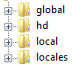  
**These files should be placed in: D2R Install/Data. There should be 3 folders here already:**  
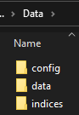  
**Your D2R Install/Data should now look like this:**  
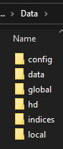

__________________________________________________________________________________

**Step 3 (Enable new game data folders)  
Your D2R file preparation is complete, now it's time to enable the new folders.  
Open up the Bnet Launcher for D2R and select the game settings option: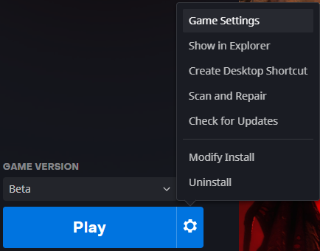 Check the box to enter in command line arguments and enter the following:**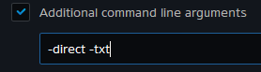  
**Click Done and launch the game...it is now being launched from the unpacked game files instead of the packed data folder. Any changes you make to .json, .txt, etc should now be applicable in-game...enjoy!**  
  
**If your game crashes on startup, then you do not have all necessary game files in the proper location. Please double-check it using the screenshots above.**

**For -mod modname editing:  
Create a folder named "mods" inside your base D2R folder.  
Inside this mods folder, create a folder with your modname...we will use a name of mymod for this example.**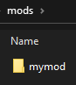

**Download Ladik's MPQ Editor**[**http://www.zezula.net/en/mpq/download.html**](http://www.zezula.net/en/mpq/download.html) **Go to File and select NEW MPQ  
Leave the bottom box blank, but enter in a name/save location for your new MPQ...for our example we will just use mymod.mpq. We will save this MPQ file in our newly created mymod folder.**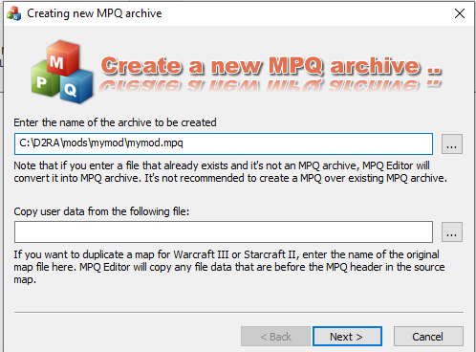

**After clicking Next, you can now decide if you want to create the MPQ as an empty one(drag your files in as you complete them), or as a directory or such that already has modded files ready. For our example, we will just create an empty MPQ.**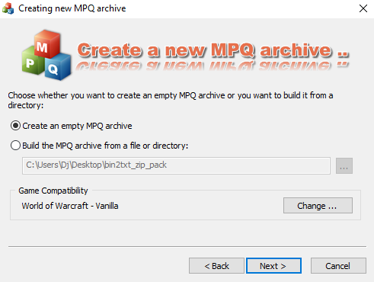

**Set the max files to something you think is a safe limit...mine defaulted to 4000 files; which seems like more than i'll ever need.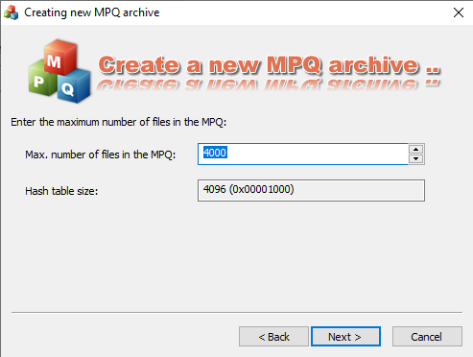 You can ignore the "game compatibility" section, but your screen confirmation should look something like this now:**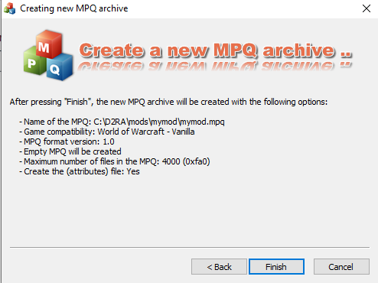

**Click Finish and now we can see our blank MPQ with listfile automatically created.**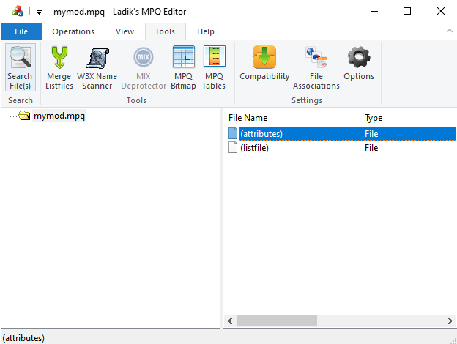

**Simply drag in w/e files you wish to have an edited version of for your mod into the right-pane of the window to add them into your MPQ. In our example; all we will be doing is make a barbarian turn around in the character select screen. The normal path structure for this file must be maintained!  
(So we will create data/global/ui/layouts folder that are needed)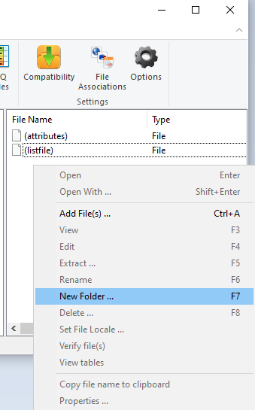 Now we can drag our modded charactercreatehd.json file (with the turned around barbarian)  
into the correct folder.**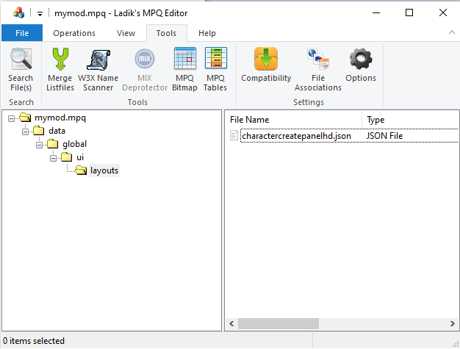

**Now create a new file called modinfo.json...this can be done in notepad. Use the following text:  
  
{**

**"name": "mymod",  
 "savepath": "mymod/"**

**}**

**The name tells it what your mod name is(and therefore what folder to look for)...while the savepath determines where the players' save files are located. In this example, they would be saved to:  
C:/Users/Username/Saved Games/D2R/mods/mymod/  
  
As with the json file before, drag your modinfo.json file to the root of your MPQ. (Not in any folders)**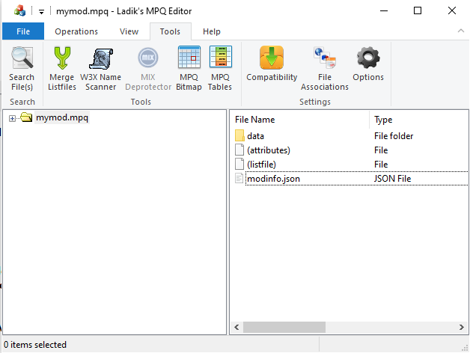

**We are now done with the MPQ...there is no save option, so just select File > Close MPQ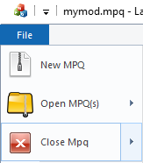 Now open up your D2R CLA either by creating a shortcut to exe or by editing it from Bnet launcher(as shown above) and use the argument: -mod mymod**

**With this done, you can now launch the game and enjoy your modded content. If done correctly, you will be presented with the "first-time user" screens such as choose gamma calibration, color blind mode, etc.**