VeriQuery SQL Writer Evaluation
Harsh Saand | AI6130 Group Project
Fine-tuning Qwen2.5-Coder-7B-Instruct increased execution accuracy from 36.36% to 40.40% on a matched BIRD evaluation. The improvement was modest, with 13 fixes and 9 regressions.

Model and fine tuning
I trained a QLoRA adapter on 5,500 BIRD question–SQL examples, with 562 validation examples from separate databases. Training used 4-bit NF4 loading, LoRA rank 16, scaling 32, a learning rate of 0.0001 and a 4,096-token sequence limit. The run completed 343 optimizer steps, approximately one epoch, on an NTU NVIDIA A40 in about three hours.

Evaluation
The original and fine-tuned 7B models answered the same 100 unique MiniDev questions with identical prompts, greedy decoding and up to two execution-error repairs. One reference answer exceeded the 10,000-row limit, leaving 99 scorable questions. Accuracy compares sets of returned rows.
Measure | Original 7B | Fine tuned 7B
Correct answers | 36 of 99 | 40 of 99
Execution accuracy | 36.36% | 40.40%
Execution errors | 19 | 10
Executable wrong answers | 44 | 49
Mean writer time per question | 6.25 s | 7.91 s
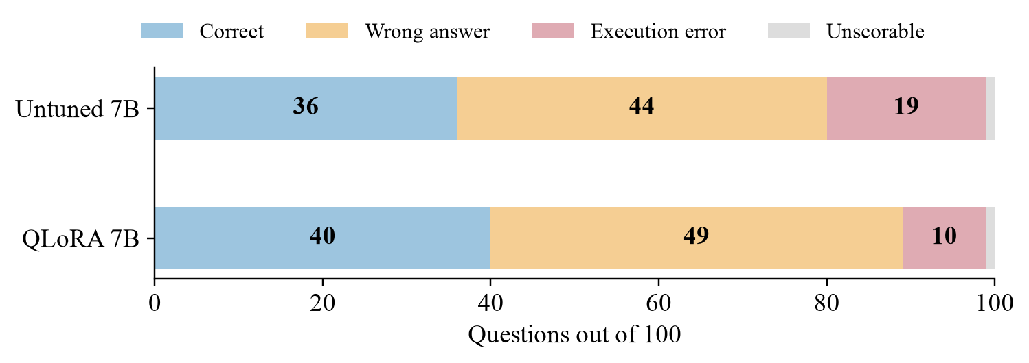
Outcomes across all 100 questions, including one unscorable reference.

Conclusion
The gain was 4.04 percentage points. Fine-tuning reduced execution errors, but some incorrect queries still ran successfully. The paired exact test gave p = 0.523, so this sample does not establish a reliable improvement. These results cover the 7B SQL writer; they do not measure the 32B model or high-confidence accuracy.

