Querying Multiple Tables at Once.

Q1. Write a query that lists each order number followed by the name of the customer who made the order.

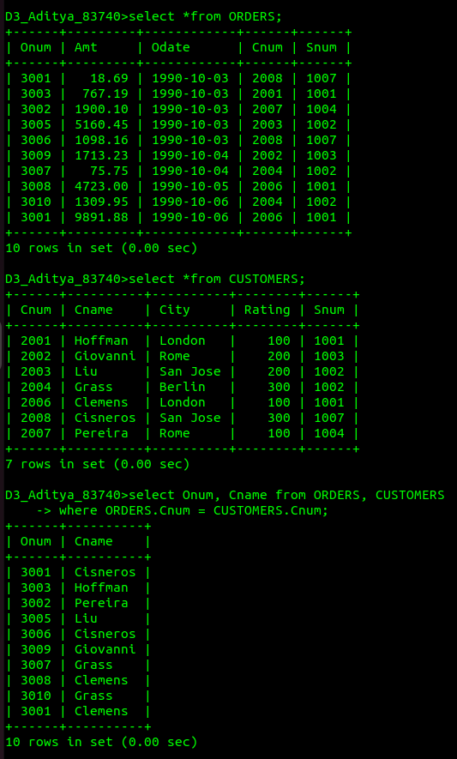

Q2. Write a query that gives the names of both the salesperson and the customer for each order along with the order number.

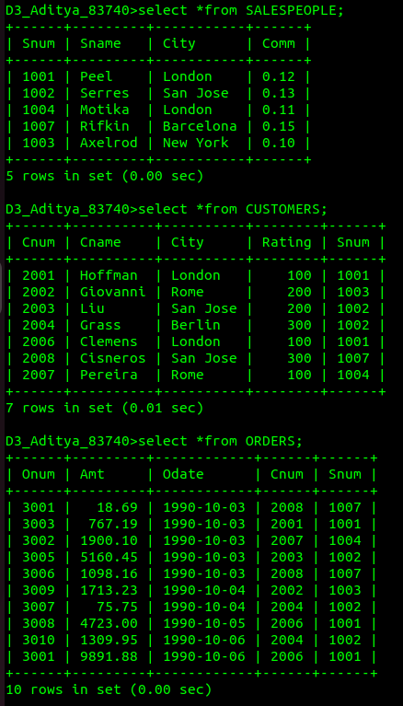

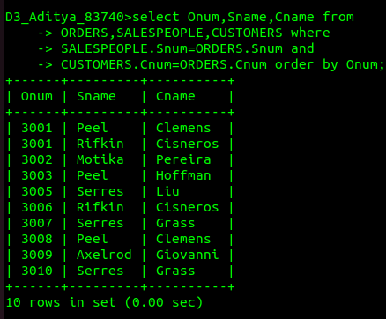

Q3. Write a query that produces all customers serviced by salespeople with a commission above 12%. Output the customer’s name, the salesperson’s
name, and the salesperson’s rate of commission.

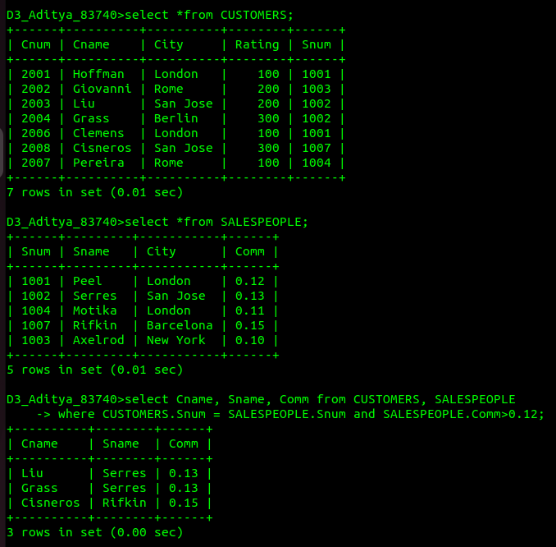

Q4. Write a query that calculates the amount of the salesperson’s commission on each order by a customer with a rating above 100.

