Q1. Write a query that counts all orders from October 3.

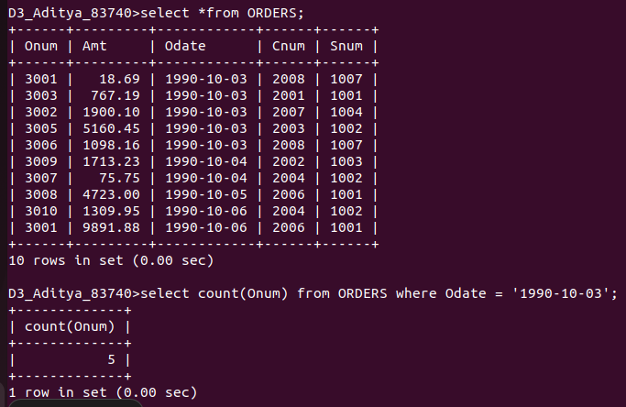

Q2. Write a query that counts the number of different non-NULL city values in the Customers table.
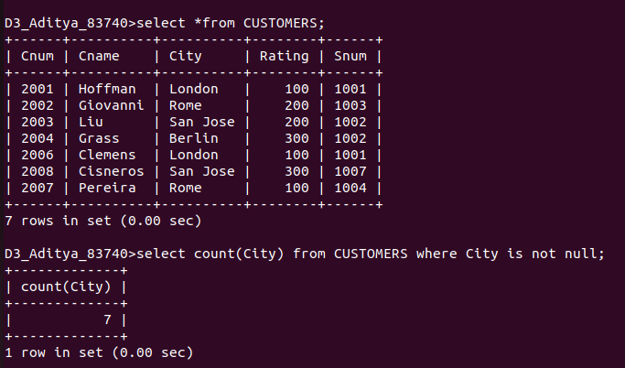
Q3. Write a query that selects each customer’s smallest order.

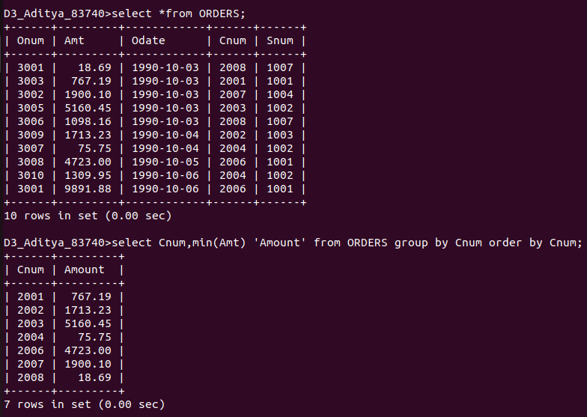

Q4. Write a query that selects the first customer, in alphabetical order,
whose name begins with G.

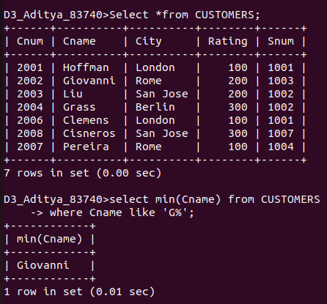

Q5. Write a query that selects the highest rating in each city.

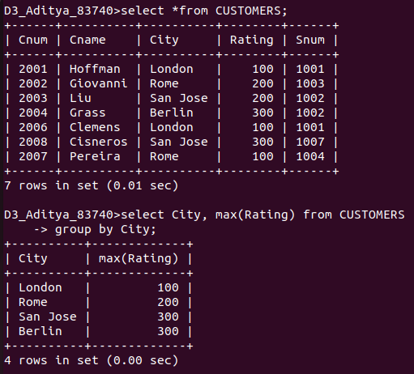

Q6. Write a query that counts the number ofsalespeople registering orders for each day. (If a salesperson has more than one order on a givenday, he or she should be counted only once.).

