Q1. Assume each salesperson has a 12% commission. Write a query on the orders table that will produce the order number, the salesperson number, and the amount of the salesperson’s commission for that order.

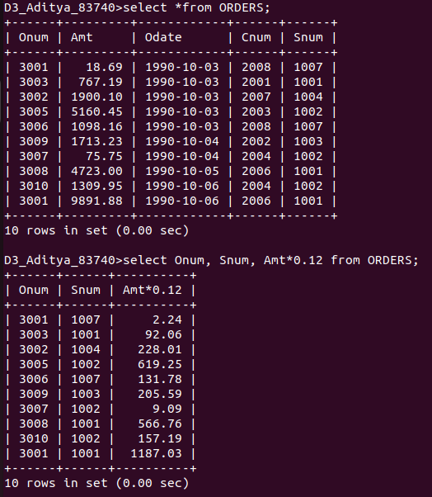

Q2. Write a query on the Customers table that will find the highest rating in each city. Put the output in this form: For the city (city), the highest rating is : (rating).

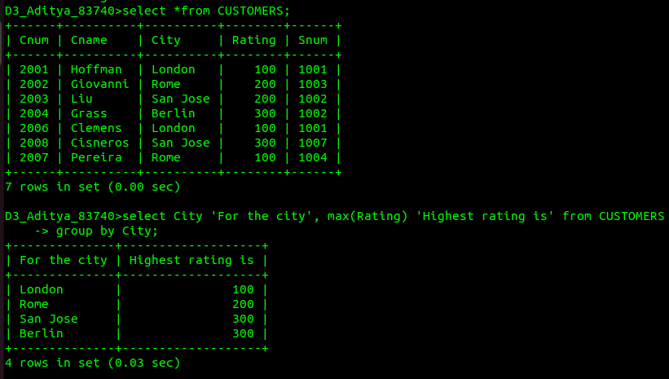

Q3. Write a query that lists customers in descending order of rating. Output the rating field first, followed by the customer’s name and number.

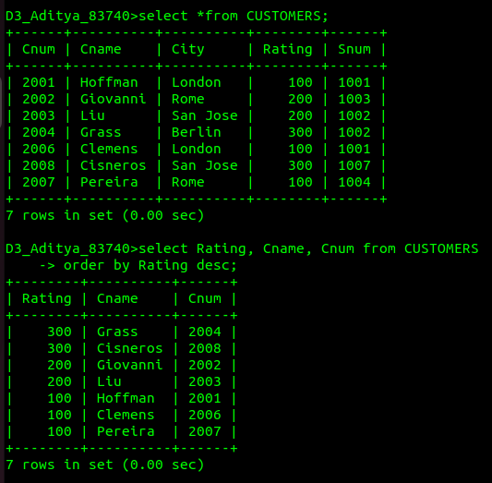

Q4. Write a query that totals the orders for each day and places the results in descending order.

