Assignment 2

Q.1 List the directory contents date wise sorted. ( man ls)

Ans :
admin1@admin1-HP-Pavilion-Gaming-Laptop-15-ec1xxx:~/OScmd$ ls -l -t
total 12



Q.2 List the directory contents size wise sorted.(man ls)

Ans :
admin1@admin1-HP-Pavilion-Gaming-Laptop-15-ec1xxx:~/OScmd$ ls -l -s -h
total 12K



Q.3 List directory contents along with their inode no. (man
ls)

Ans :
admin1@admin1-HP-Pavilion-Gaming-Laptop-15-ec1xxx:~/OScmd$ ls -l -i
total 12


Q.4 List the contents of the subdirectory.

Ans :
admin1@admin1-HP-Pavilion-Gaming-Laptop-15-ec1xxx:~/OScmd$ ls -R
.:


Q.5 Create a file, write your surname and name in it and
save.
i. now open the same file and add your address in it and
save.
ii. reopen the same file and check your name and address in
it.

Ans :

admin1@admin1-HP-Pavilion-Gaming-Laptop-15-ec1xxx:~/OScmd$ cat > xyz/OS_Assign2.txt
Sneha Maskar

admin1@admin1-HP-Pavilion-Gaming-Laptop-15-ec1xxx:~/OScmd$ cat >> xyz/OS_Assign2.txt
Warkatne, Karmala

admin1@admin1-HP-Pavilion-Gaming-Laptop-15-ec1xxx:~/OScmd$ cat xyz/OS_Assign2.txt
Sneha Maskar
Warkatne, Karmala

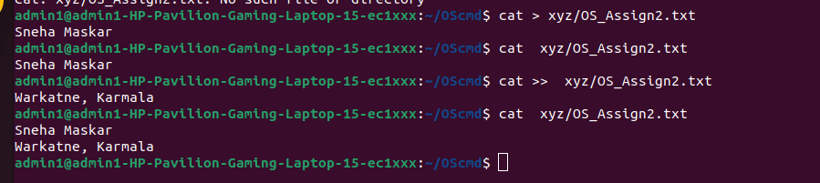

Q.6 how to change the time stamp of file (man touch)

Ans :

admin1@admin1-HP-Pavilion-Gaming-Laptop-15-ec1xxx:~/OScmd$ touch neha.txt
admin1@admin1-HP-Pavilion-Gaming-Laptop-15-ec1xxx:~/OScmd$ ls -l neha.txt
-rw-rw-r-- 1 admin1 admin1 120 Jun 1 18:10 neha.txt



Q .7 Create directory structure : Give following commands ,
-> mkdir one
-> cd one
-> touch 1.txt 11.txt 111.txt
-> mkdir two
-> cd two
-> touch 2.txt 22.txt 222.txt
-> mkdir three
-> cd three
-> touch 3.txt 33.txt 333.txt
-> mkdir four
-> cd four
-> touch 4.txt 44.txt 444.txt
-> mkdir five
-> cd five
-> touch 5.txt 55.txt 555.txt
-> cd ~ (i.e. go to your home directory)

Ans :

admin1@admin1-HP-Pavilion-Gaming-Laptop-15-ec1xxx:~/OScmd$ mkdir one
admin1@admin1-HP-Pavilion-Gaming-Laptop-15-ec1xxx:~/OScmd$ cd one
admin1@admin1-HP-Pavilion-Gaming-Laptop-15-ec1xxx:~/OScmd/one$ touch 1.txt 11.txt 111.txt
admin1@admin1-HP-Pavilion-Gaming-Laptop-15-ec1xxx:~/OScmd/one$ cd ..
admin1@admin1-HP-Pavilion-Gaming-Laptop-15-ec1xxx:~/OScmd$ mkdir three
admin1@admin1-HP-Pavilion-Gaming-Laptop-15-ec1xxx:~/OScmd$ cd three
admin1@admin1-HP-Pavilion-Gaming-Laptop-15-ec1xxx:~/OScmd/three$ touch 3.txt 33.txt 333.txt
admin1@admin1-HP-Pavilion-Gaming-Laptop-15-ec1xxx:~/OScmd/three$ cd ..
admin1@admin1-HP-Pavilion-Gaming-Laptop-15-ec1xxx:~/OScmd$ mkdir two
admin1@admin1-HP-Pavilion-Gaming-Laptop-15-ec1xxx:~/OScmd$ touch 2.txt 22.txt 222.txt
admin1@admin1-HP-Pavilion-Gaming-Laptop-15-ec1xxx:~/OScmd$ mkdir four
admin1@admin1-HP-Pavilion-Gaming-Laptop-15-ec1xxx:~/OScmd$ touch 4.txt 44.txt 444.txt
admin1@admin1-HP-Pavilion-Gaming-Laptop-15-ec1xxx:~/OScmd$ cd four
admin1@admin1-HP-Pavilion-Gaming-Laptop-15-ec1xxx:~/OScmd/four$ cd ..
admin1@admin1-HP-Pavilion-Gaming-Laptop-15-ec1xxx:~/OScmd$ mkdir five
admin1@admin1-HP-Pavilion-Gaming-Laptop-15-ec1xxx:~/OScmd$ cd five
admin1@admin1-HP-Pavilion-Gaming-Laptop-15-ec1xxx:~/OScmd/five$ touch 5.txt 55.txt 555.txt

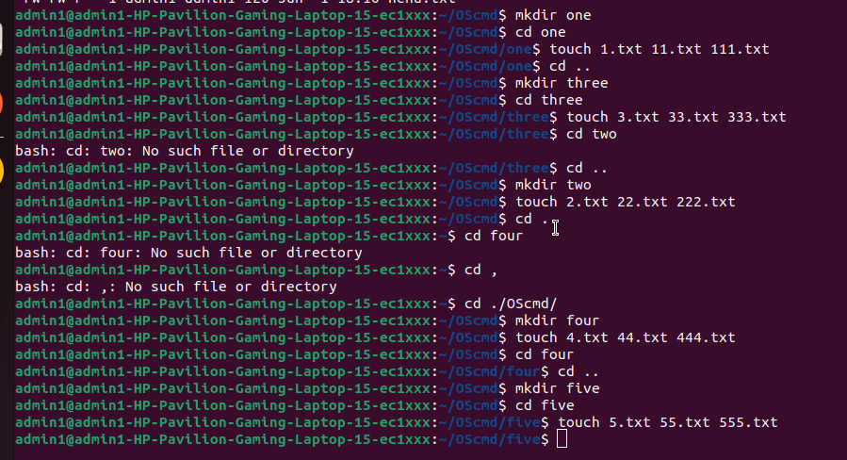

Q.8 Considering above directory structure , Do following
operations :

i. list the directory contents of directory named
"five" from current directory (i.e. home directory).
Ans :

tree

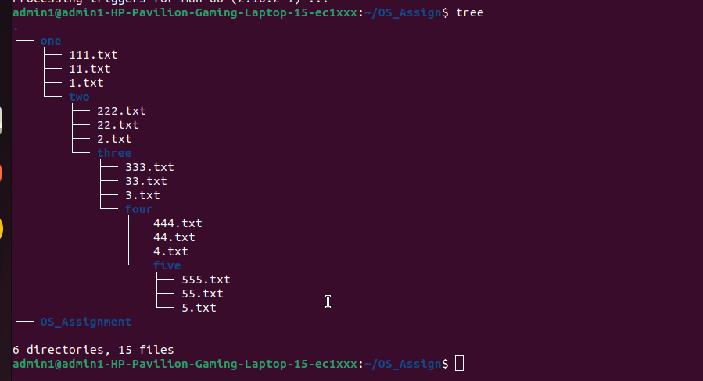

ii. write your name in a file named "44.txt" of
directory "four" from current directory

Ans:
admin1@admin1-HP-Pavilion-Gaming-Laptop-15-ec1xxx:~/OScmd$ cat >> /home/admin1/OScmd/one/two/three/four/44.txt
Sneha Maskar

iii. remove the file named "555.txt" from directory
"five" from current directory.

Ans :

admin1@admin1-HP-Pavilion-Gaming-Laptop-15-ec1xxx:~/OScmd$ rm /home/admin1/OScmd/one/two/three/four/five/555.txt

iv. change directory to five

Ans :

admin1@admin1-HP-Pavilion-Gaming-Laptop-15-ec1xxx:~/OScmd$ cd /home/admin1/OScmd/one/two/three/four/five/

v v. write your course name in file named "3.txt" which
resides in directory "three" from current directory (i.e.
five).also read the same file.

Ans

admin1@admin1-HP-Pavilion-Gaming-Laptop-15-ec1xxx:~/OScmd/one/two/three/four/five$ five>> /home/admin1/OScmd/one/two/three/3.txt

PG-DAC Sunbeam
admin1@admin1-HP-Pavilion-Gaming-Laptop-15-ec1xxx:~/OScmd/one/two/three/four/five$ cat /home/admin1/OScmd/one/two/three/3.txt
PG-DAC
PG-DAC Sunbeam
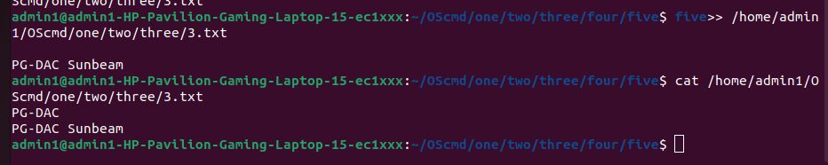

vi. list the contents of directory "two" from current
directory (i.e. five).

Ans :

admin1@admin1-HP-Pavilion-Gaming-Laptop-15-ec1xxx:~/OScmd/one/two/three/four/five$ ls /home/admin1/OScmd/one/
111.txt 11.txt 1.txt two

vii. remove file named "222.txt" which belongs to
directory "two" from current directory (i.e. five)

Ans :

admin1@admin1-HP-Pavilion-Gaming-Laptop-15-ec1xxx:~/OScmd/one/two/three/four/five$ rm /home/admin1/OScmd/one/two/222.txt

viii. now change the directory to "one"
Ans :

ix. remove all files only from directory named "five"
from current directory (i.e. one)

Ans :

admin1@admin1-HP-Pavilion-Gaming-Laptop-15-ec1xxx:~/OScmd$ rm /home/admin1/OScmd/one/two/three/four/five/*

x. remove directory named "five" from current directory
(i.e. one)

Ans :

admin1@admin1-HP-Pavilion-Gaming-Laptop-15-ec1xxx:~/OScmd$ rm -R /home/admin1/OScmd/one/two/three/four/five/

xi. remove whole directory named "four" from current
directory (i.e. one)

Ans :

admin1@admin1-HP-Pavilion-Gaming-Laptop-15-ec1xxx:~/OScmd/one$ rm -R /home/admin1/OScmd/one/two/three/four/

xii. change to your home directory.

Ans

admin1@admin1-HP-Pavilion-Gaming-Laptop-15-ec1xxx:~/OS_Assign$ cd ~

9. change the time stamp of file named "3.txt" which resides
in directory named "three".(man touch)

Ans :

admin1@admin1-HP-Pavilion-Gaming-Laptop-15-ec1xxx:~$ touch /home/admin1/OScmd/one/two/three/3.txt
admin1@admin1-HP-Pavilion-Gaming-Laptop-15-ec1xxx:~$ ls -l /home/admin1/OScmd/one/two/three/3.txt
-rw-rw-r-- 1 admin1 admin1 22 Jun 2 11:43 /home/admin1/OScmd/one/two/three/3.txt

