Assignment 9_Q1

Q.1. man - Command to get help about commands

Ans :
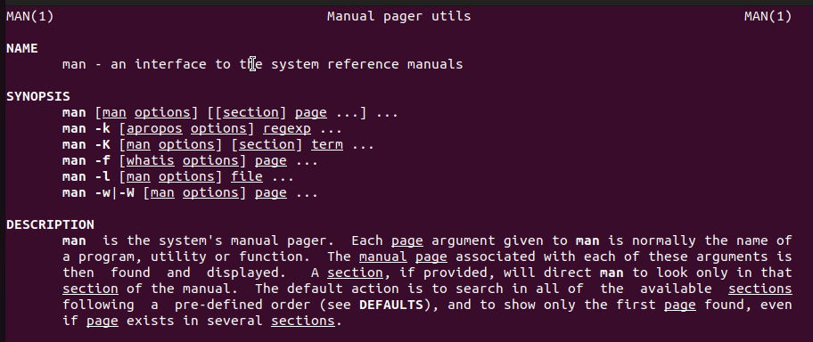

Q.2. uname - Print System information
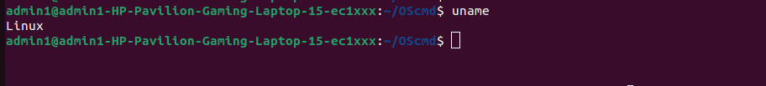

Q.3 pwd - Print current directory

Q.4 hostname - Print IP address and hostname of the machine

Ans :

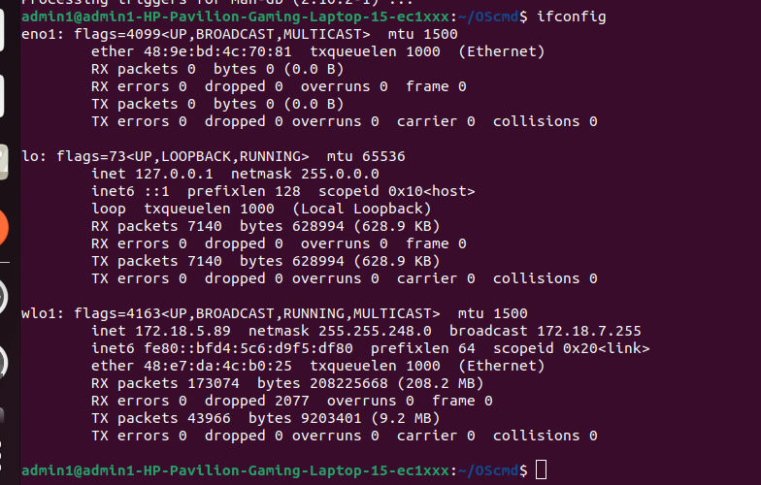

Q.5 date- Find today’s date

Ans :

Q .6 cal - Print calendar for current year

Ans -

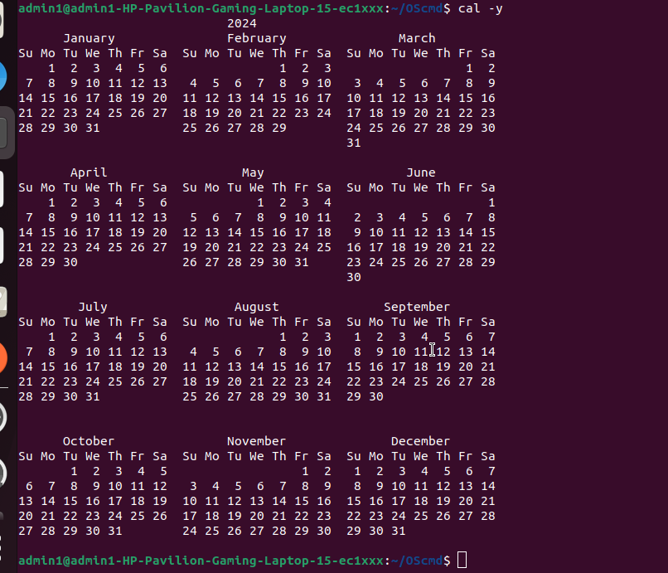

Q.7 ls, dir - See directory structure

Ans :

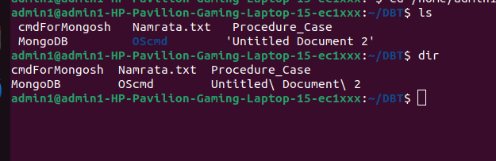

Q 8 cat - Create file

Ans :

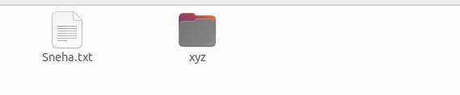

Q 9 cat >> Append some text into existing file

Ans :

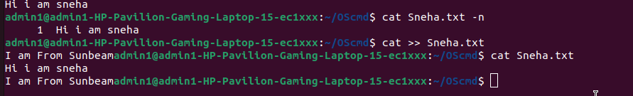

Q. 10 cp - Copy a file, Copy a directory

Ans : cp Sneha.txt /home/admin1/Desktop/

Q 11 . mv Move the files

Ams : mv /home/admin1/Desktop/neha.txt /home/admin1/

Q. 12. mv - Rename a file

Ans : mv Sneha.txt neha.txt

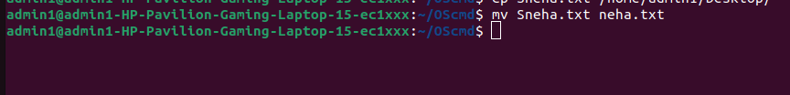

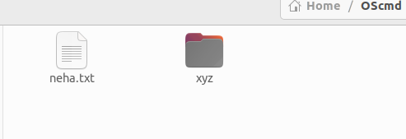

Q.13 tac, rev - Print the file in reverse order, Reverse each line in the file

Ans :

tac neha.txt
rev neha.txt

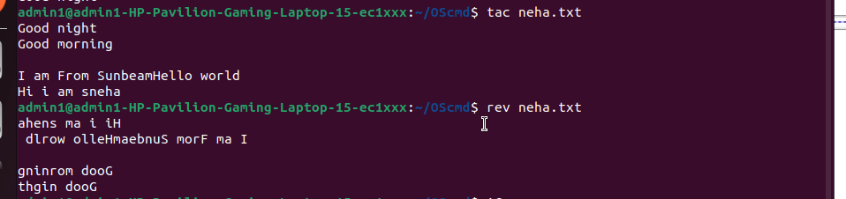

Q 14 wc - Count the words, characters and lines in a file

Ans :

wc < neha.txt

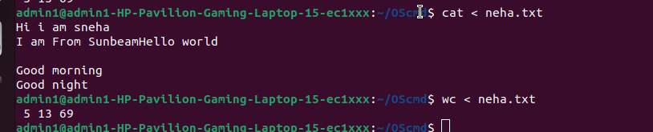

Q 15 mkdir - Create directory

Ans :

mkdir /home/admin1/Oscmd/Sunbeam/

Q 16 cd - Change current directory

Ans :

cd /home/admin1/DBT

Q 17 rm - Remove a file, remove a directory ( with -R )

Ans :

rm -R /home/admin1/Oscmd/Sunbeam/

Q 18 rmdir remove empty directory

Ans :

rm -R /home/admin1/OScmd/Sunbeam/
rm -R /home/admin1/OScmd/Sunbeam/

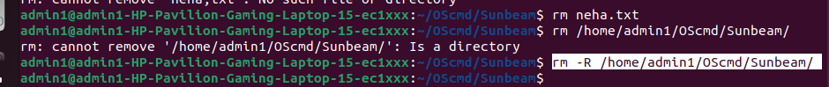

Q 19 touch - change the modification time , Create Multiple empty files at once

Ans :

touch neha.txt
ls -l neha.txt

Q. 20 sort - Sort file.

Ans :
sort neha.txt
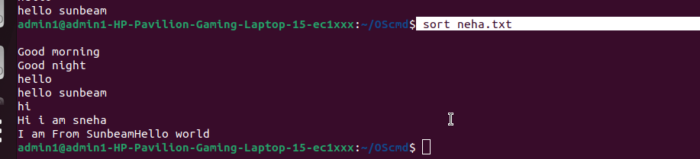

Q.21 unique – avoid repetition in file

Ans :

admin1@admin1-HP-Pavilion-Gaming-Laptop-15-ec1xxx:~/OScmd$ sort neha.txt | uniq

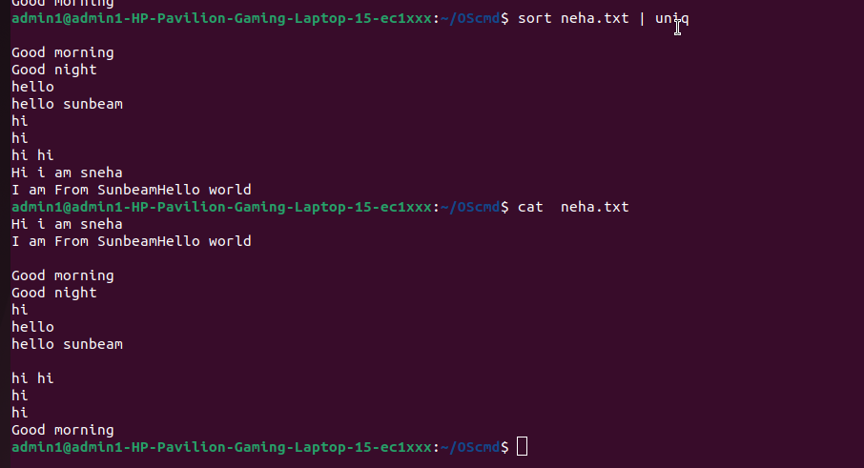
Q 22 head - Print the specified number of lines from top in the file.

Ans :

admin1@admin1-HP-Pavilion-Gaming-Laptop-15-ec1xxx:~/OScmd$ head -2 neha.txt

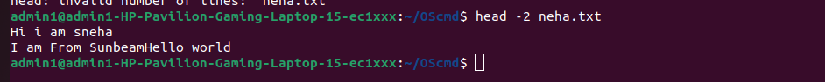

Q 23 tail - Print the specified number of lines from bottom in the file.

Ans :

tail -2 neha.txt

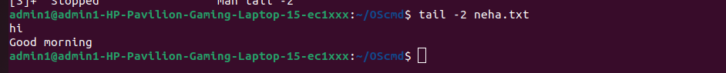

Q 24 factor - Find the factors of a number

Ans :

admin1@admin1-HP-Pavilion-Gaming-Laptop-15-ec1xxx:~/OScmd$ factor 24

Q 25 alias - Create command shortcut

Ans :
admin1@admin1-HP-Pavilion-Gaming-Laptop-15-ec1xxx:~/OScmd$ alias dora=cd ..

Q26 unalias - remove the command shortcut

Ans :

admin1@admin1-HP-Pavilion-Gaming-Laptop-15-ec1xxx:~$ unalias dora

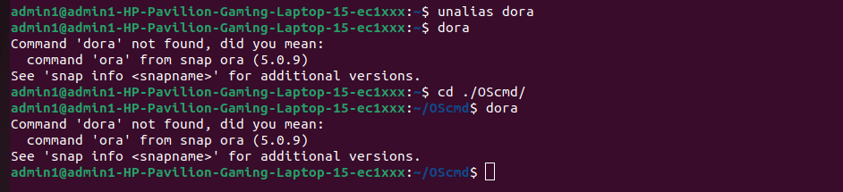

Q 27 echo Print environment variables individually

