SQL ASSIGNMENT 12

1: Write a query that selects al customers whose ratings are equal to or greater than ANY of Serres’.

ayushi>Select * from CUSTOMERS
where RATING >= any
(Select RATING from CUSTOMERS where SNUM =
(Select SNUM from SALESPERSON where SNAME= 'SERRES') );

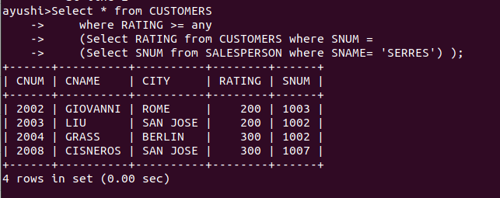

2: Write a query using ANY or ALL that will find all salespeople who have no customers located in their city.

ayushi>select SNAME,SALESPERSON.CITY
->from SALESPERSON,CUSTOMERS
-> where SALESPERSON.SNUM=CUSTOMERS.SNUM
-> and SALESPERSON.CITY != all
-> (select CITY from CUSTOMERS where SNUM = SALESPERSON.SNUM);

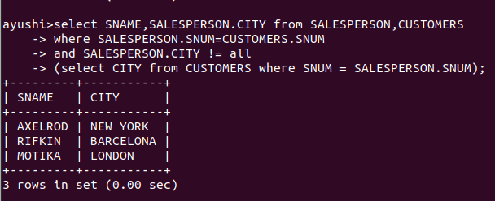

3: Write a query that selects all orders for amounts greater than any for the customers in LONDON.

select * from ORDERS
where AMT >= any
(select ORDERS.AMT
from CUSTOMERS,ORDERS
where CUSTOMERS.CNUM=ORDERS.CNUM
and CUSTOMERS.CITY='LONDON');

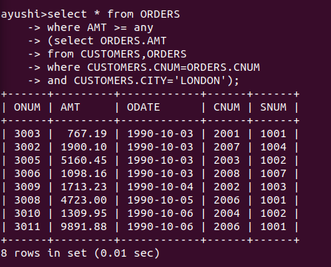

4:
select * from ORDERS
where AMT >=
(select max(amount.AMT) from
(select ORDERS.AMT
from CUSTOMERS,ORDERS
where CUSTOMERS.CNUM=ORDERS.CNUM
and CUSTOMERS.CITY='LONDON') amount);

