SQL ASSIGNMENT 13

1: Create a union of two queries that shows the names, cities, and ratings of all customers. Those with rating of 200 or greater will also have the words “HIGH RATING”, while the others will have the words “LOW RATING”.

select CNAME,CITY, 'HIGH RATING' from CUSTOMERS
where RATING>=200
union
select CNAME,CITY, 'LOW RATING' from CUSTOMERS
where RATING<200;

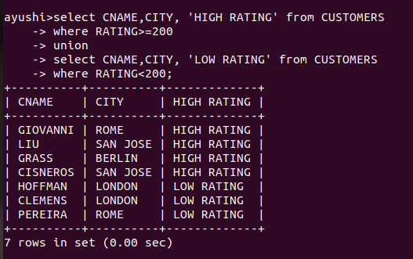

2:
select SALESPERSON.SNAME as NAME,count(ONUM)
from ORDERS,SALESPERSON
where SALESPERSON.SNUM=ORDERS.SNUM
group by SALESPERSON.SNAME
having count(ONUM)>1
union
select CUSTOMERS.CNAME,count(ONUM)
from ORDERS,CUSTOMERS
where CUSTOMERS.CNUM=ORDERS.CNUM
group by CUSTOMERS.CNAME
having count(ONUM)>1;

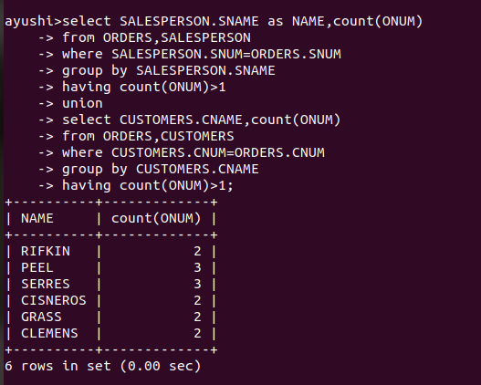

3:
select distinct SNUM as NUM from SALESPERSON
where CITY='SAN JOSE'
union
select distinct CNUM from CUSTOMERS
where CITY='SAN JOSE'
union
select distinct ONUM from ORDERS
where ODATE= '1990-10-03';

