SQL ASSIGNMENT 14

1:
insert into SALESPERSON(CITY,SNAME,COMM,CNUM)
value (‘SAN JOSE’,BLANCO,NULL,1100);

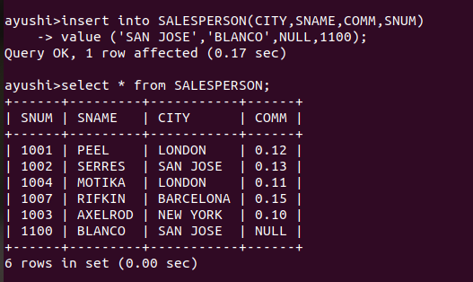

2:
delete from ORDERS
where CNUM =
(select CNUM from CUSTOMERS where CNAME= ‘CLEMENS’);
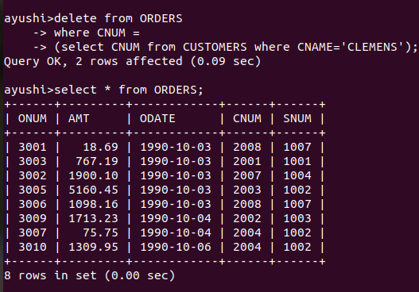

3:
update CUSTOMERS
set RATING=100
where CITY=’ROME’;



4:
update CUSTOMERS
set SNUM =
(select SNUM from SALESPERSON
where SNAME= 'MOTIKA')
where SNUM =
(select SNUM from SALESPERSON
where SNAME = 'SERRES');

