SQL ASSIGNMENT 15

1:
ayushi>create table MULTICUST
-> as
-> select * from SALESPERSON
-> where SNUM = any
-> (select SNUM from CUSTOMERS group by SNUM having count(CNUM)>1);
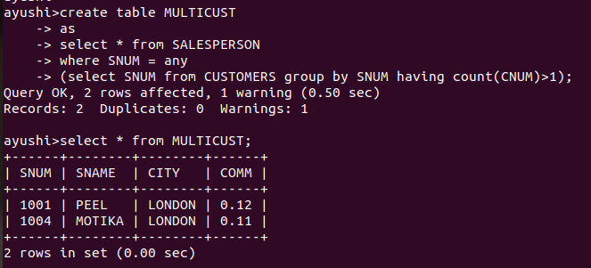

2:
delete from CUSTOMERS
where not exists
(select CNUM from ORDERS group by CNUM);

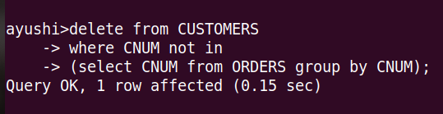

3:
ayushi>update SALESPERSON
set COMM = COMM*0.2
where SNUM in
(select SNUM from ORDERS
group by SNUM
having sum(AMT)>3000);

