SQL ASSIGNMENT 4

1: Write a select command that produces the order number, amount, and date for all rows in the Orders table.

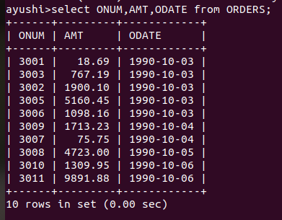

2: Write a query that produces all rows from the CUSTOMERS table for which the SALESPERSON’s number is 1001.

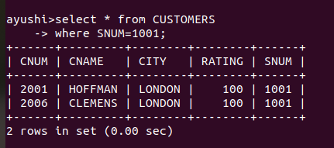

3: Write a query that displays the Salespeople table with the columns in the following order: city, sname, snum, comm.

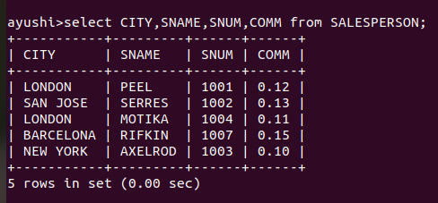

4: Write a select command that produces the rating followed by name of each customer in San Jose.
