SQL ASSIGNMENT 6

1: Write two queries that would produce all orders taken on Oct 3rd and 4th ,1990.

- ayushi>select * from ORDERS
-> where ODATE in('1990-10-03','1990-10-04');

2. ayushi>select * from ORDERS
-> where ODATE='1990-10-03' or ODATE='1990-10-04';

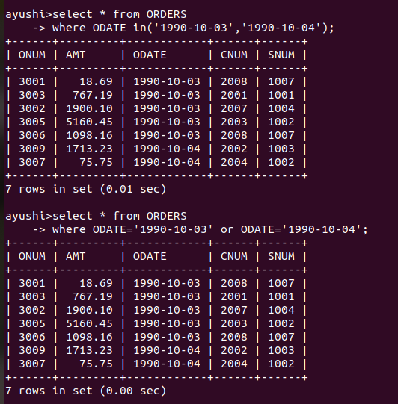

2: Write a query that selects all of the customers serviced by Peel or Motika.

ayushi>select * from CUSTOMERS
-> where SNUM in(1001,1004);

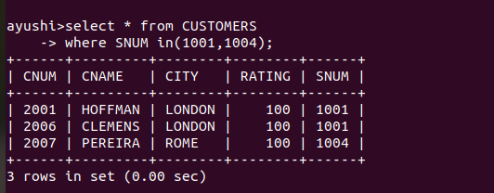
3: Write query that will produce all the customers whose names begin with a letter from ‘A’ to ‘G’.

ayushi>select * from CUSTOMERS
-> where CNAME between 'A' and 'G';

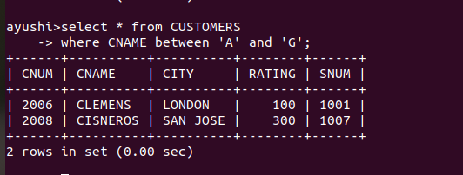

4: Write a query that selects all customers whose name starts with ‘C’.

ayushi>select * from CUSTOMERS
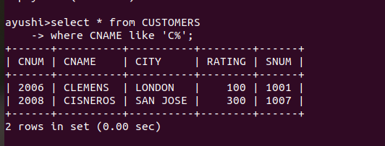
-> where CNAME like 'C%';

5: Write a query that selects all orders except those with zero or nulls in the amt field.
ayushi>select * from ORDERS
->where AMT not in(‘NULL’,0);

