SQL ASSIGNMENT 9

1:Write a query that lists each order number followed by the name of the cuatomer who made the order.

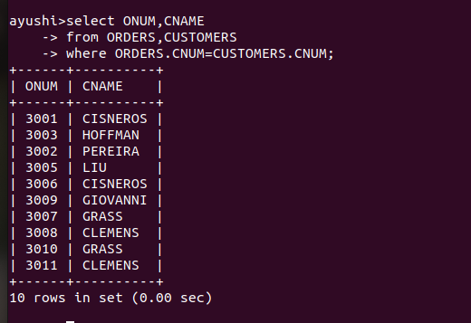
2: Write a query that gives the names of both the salesperson and the customer for each order along with the order number.

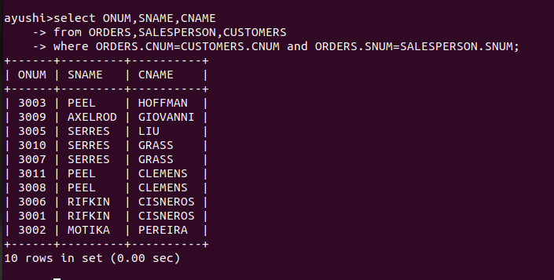

3: Write a query that produces all customers serviced by salespeople with a commission above 12%. Output customers name, the salesperson’s name, and the salesperson’s rate of commission.

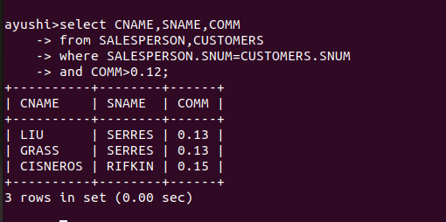

4:Write a query that calculates the amount of the salesperson’s commission on each order by a customer with a rating above 100.

