SQL ASSIGNMENT 11

1: Write a query that uses a subquery to obtain all orders for the customer named Cisneros. Assume you do not know his customer number (cnum).

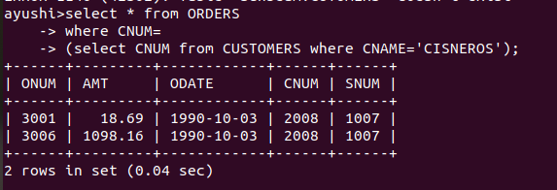

2: Write a query that produces the names and ratings of all customers who have above- average orders.

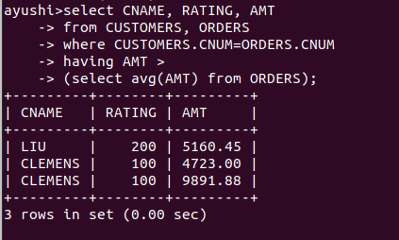

3: Write a query that selects the total amount of orders for each salespeson for whom this total is greater then the amount of largesr order in the table.

