SQL ASSIGNMENT 10

1:Write a query that produces all pairs of salespersons who are living in the same city.

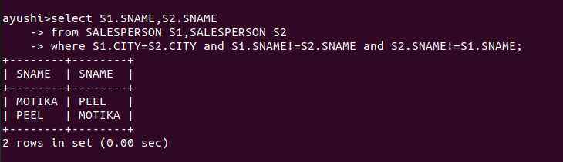

2:Write a query that produces the names and cities of all customers with the same rating as Hoffman.

