SQL ASSIGNMENT 7

1: Write a query that counts all orders for Oct 3.

ayushi>select count(ONUM) from ORDERS where ODATE='1990-10-03';

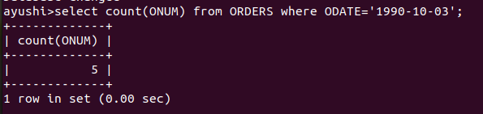
2: Write a queery that counts the number of different non-NULL city values in the Customer table.
ayushi>select count(CITY) from CUSTOMERS;
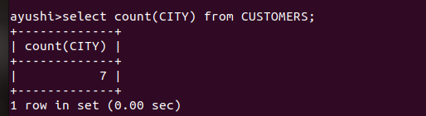
3: Write a query that selects each customer’s smallest order.

ayushi>select CNAME,min(AMT) from CUSTOMERS,ORDERS
-> where CUSTOMERS.CNUM=ORDERS.CNUM
-> group by CNAME;

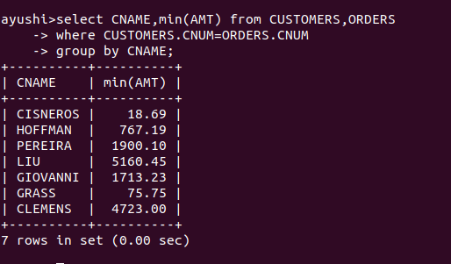

4: Write a query thst selects the first customer, in alphabetical order, whose name begins with G.

ayushi>select * from CUSTOMERS
-> where CNAME LIKE 'G%';

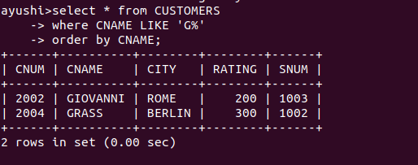

5: Write a query that slects the highest rating in each city.
ayushi>select CITY,max(RATING) from CUSTOMERS
-> group by CITY;

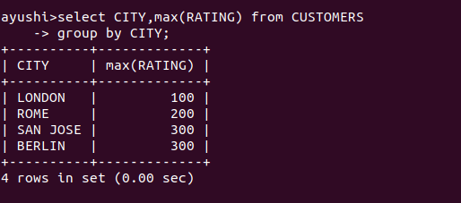

6: Write a query that counts the number of salesperson registering orders for ach day.
ayushi>select ODATE,count(SNUM)
-> from ORDERS group by ODATE;
