Assignment 4

1: count the no. of words ,characters and lines from above 2 file.(man wc)
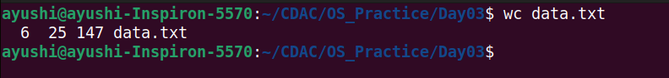
2: list the lines having word "files" (man grep)
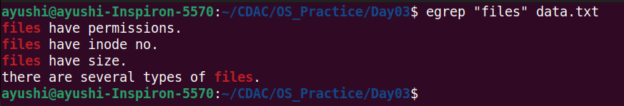
3:list the lines having word "file" (man grep)
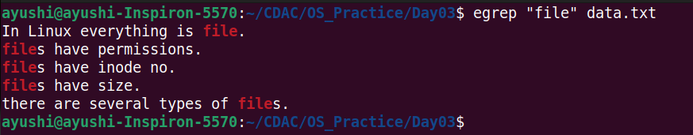
4: list the lines which don't have word "files" (man grep)
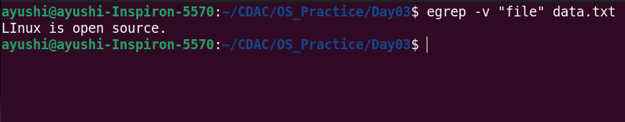
5: list the lines having word "have" . (man grep)
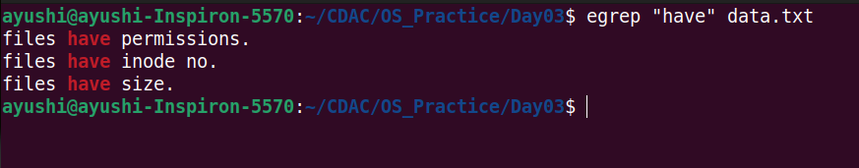
6: list the lines starts with letter "f" (man grep)

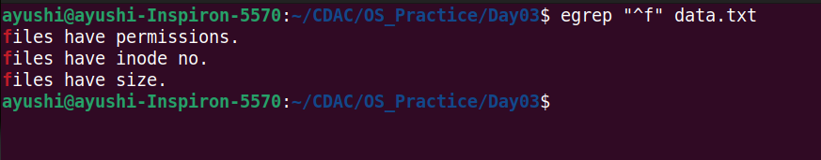
7: list the lines ends with "." (man grep)
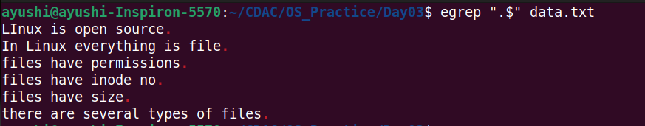
8: list only first two lines.(man head)
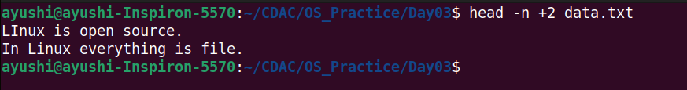
9: list only last three lines.(man tail)
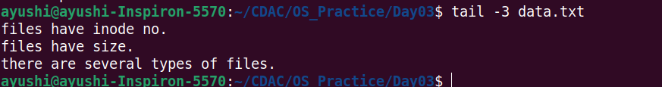

10: list line no.3,4 and 5 . (man head and tail)
