Assignment 3

1: ls
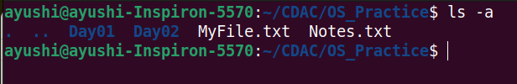
2: rename

3: ln -s

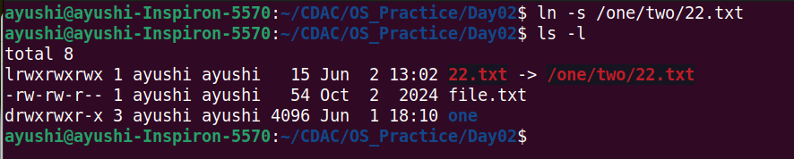
4: ln
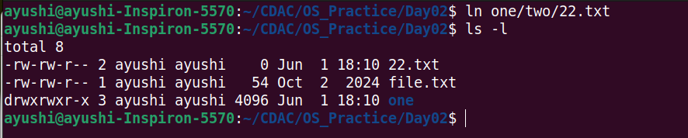
5: stat
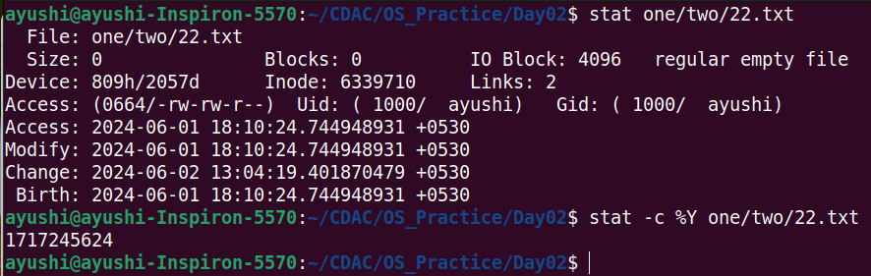

6: touch
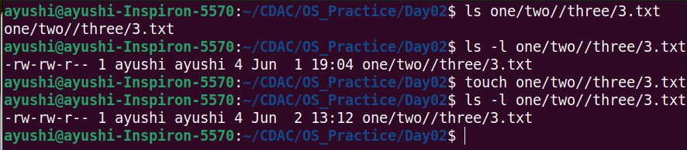
7: touch
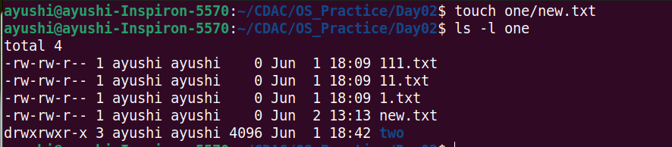
8: tail
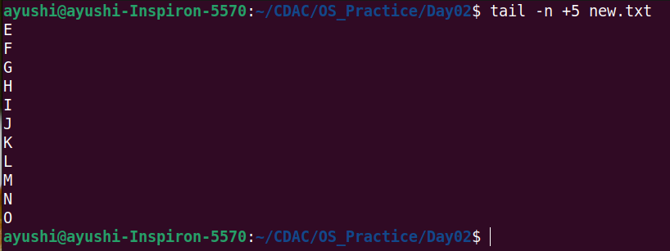
9: init 0 – poweroff
10: init 6 – reboot

12: whoami
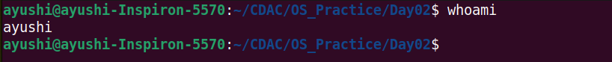
13: tty
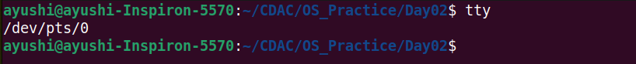
14: who am i

15: users

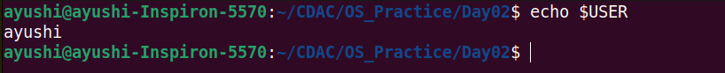
16: who
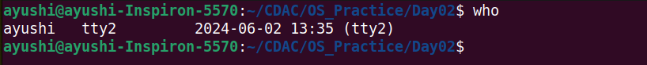
17: grep, egrep, fgrep
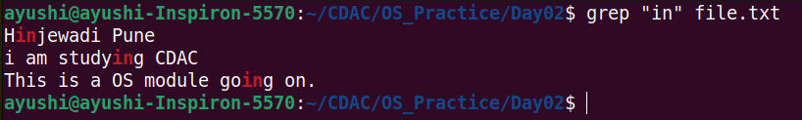

18: chmod
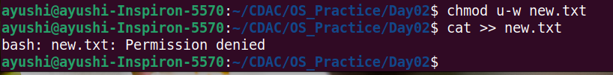
19: chmod
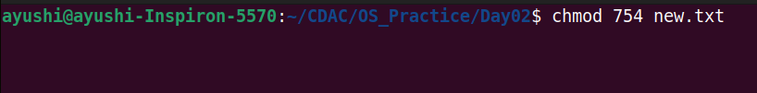
20: wc (using redirection)
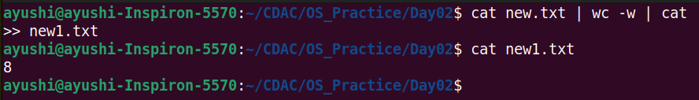
21: who | wc (using pipe)
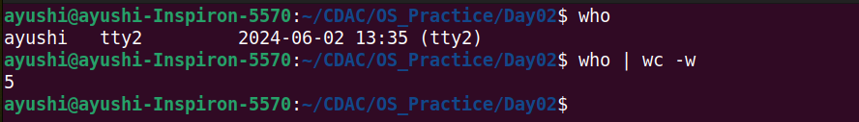

22: head, tail (using pipe)
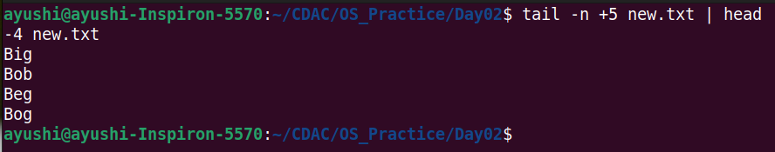
23: sort, uniq (using pipe)
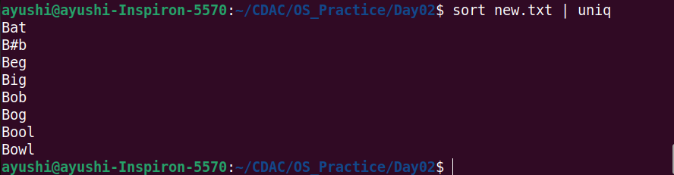
24: who, grep (using pipe)

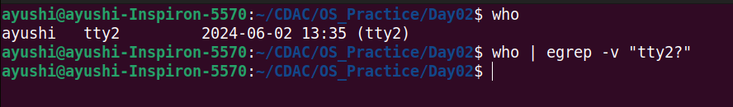
25: ls
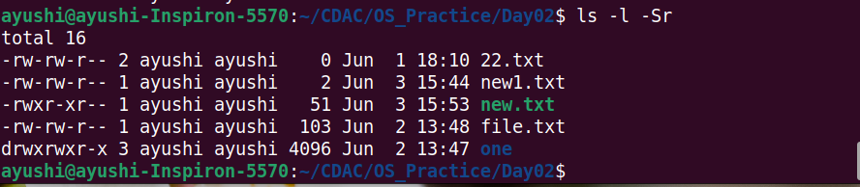
26: ls, grep (using pipe)
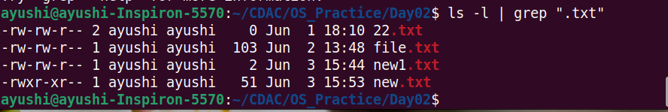
27: ls, grep
28: tr
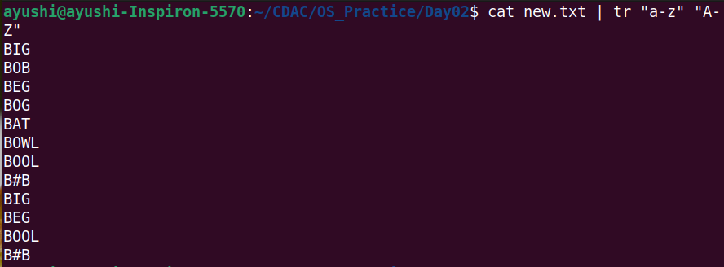
29: cut
