Display hidden files
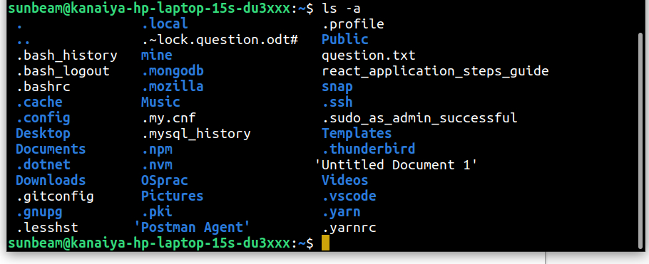
Rename all *.txt files to *.htm
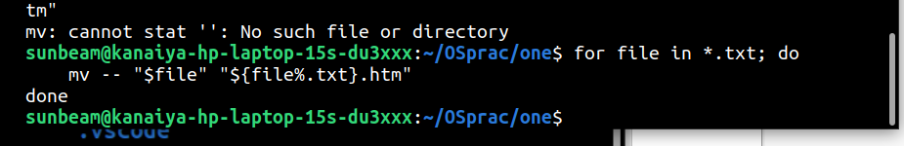
Create symbolic link (shortcut) for a file
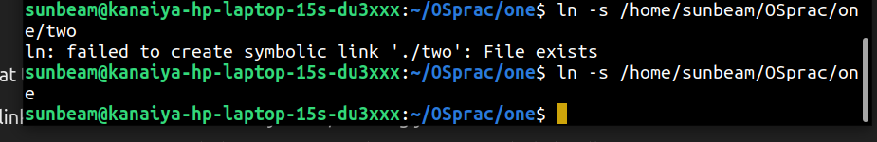
Create hard link for a file
Display time stamp of the file
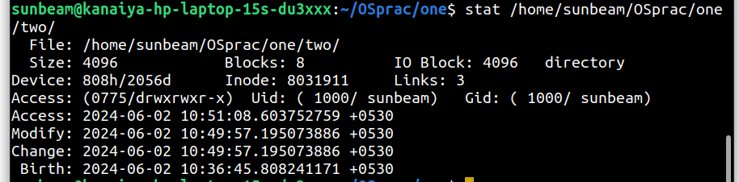
Change the time stamp of the file
Print all lines in a file from fifth line onwards

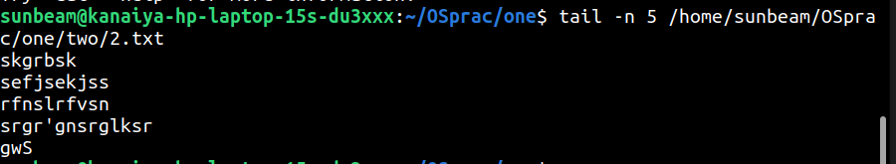
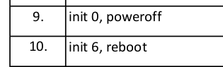
/

Find current user
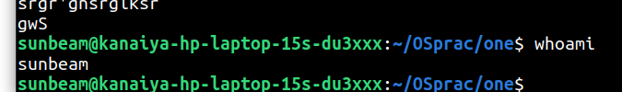

l

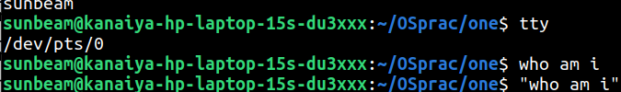
who cmd

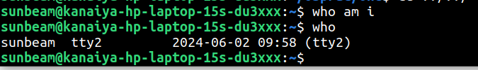
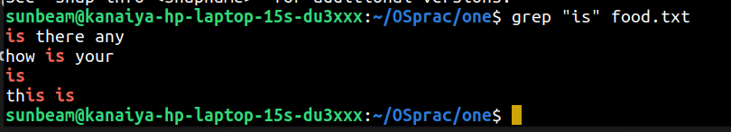
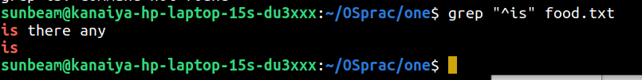
k
