ASSIGNMENT 6
1) Write two different queries that would produce all orders taken on October 3rd or 4th, 1990.
a.
select *from ORDERS
where Odate='1990-10-03' or Odate='1990-10-04';
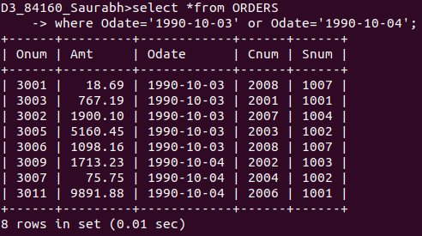

b.
select *from ORDERS
-> where Odate in('1990-10-03','1990-10-04');
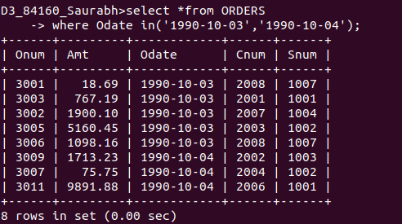

2) Write a query that selects all of the customers serviced by Peel or Motika. (Hint: the snum field relates the two tables to one another).

select *from CUSTOMERS where Snum in(1004,1001);

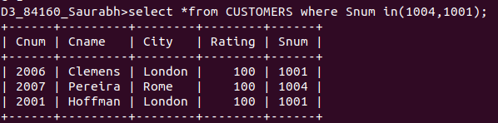

3) Write a query that will produce all the customers whose names begin with a letter from ‘A’ to ‘G’.

select *from CUSTOMERS where Cname<='G%';
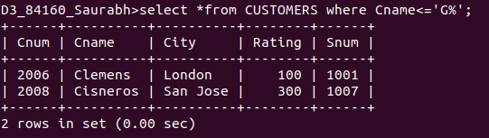

4) Write a query that selects all customers whose names begin with the letter ‘C’.

select * from CUSTOMERS where Cname like 'C%';

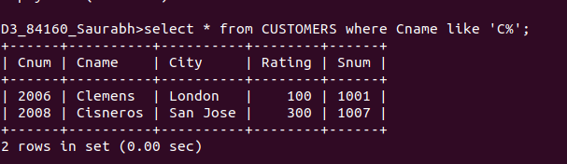

5) Write a query that selects all orders except those with zeroes or NULLs in the amt field.

select * from ORDERS where Amt is not null and Amt!=0;

