ASSIGNMENT NO :- 07

1) Write a query that counts all orders for October 3.

select count(*) from ORDERS where Odate='1990-10-03';
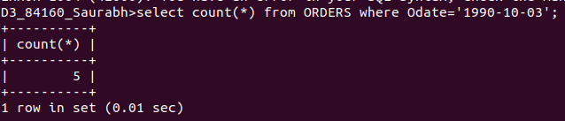
2) Write a query that counts the number of different non-NULL city values in the Customers table.

select count(*) from CUSTOMERS where City is not null;
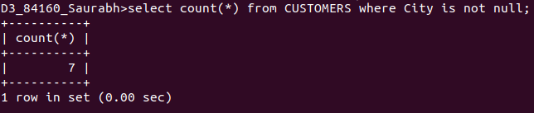

3) Write a query that selects each customer’s smallest order.

select Cnum, min(Amt) from ORDERS group by Cnum order by 1;
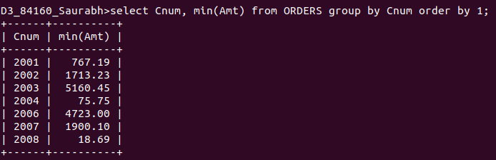

4) Write a query that selects the first customer, in alphabetical order, whose name begins with G.

select * from CUSTOMERS where Cname like 'G%'limit 1;
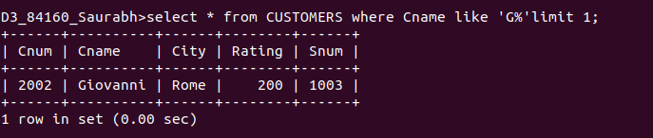

5) Write a query that selects the highest rating in each city.

select City, max(Rating) from CUSTOMERS group by City;
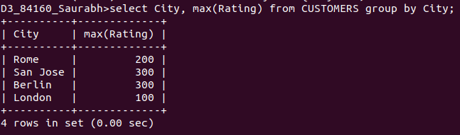

6) Write a query that counts the number of salespeople registering orders for each day. (Ifa salesperson has more than one order on a givenday, he or she should be counted only once.)

