ASSIGNMENT 8
1) Assume each salesperson has a 12% commission. Write a query on the orders table that will produce the order number, the salesperson number, and the amount of the salesperson’s commission for that order.

select Onum"OREDER NUM",Snum"SALEPNO",Amt*0.12"COMMISIION" from ORDERS ORDER BY 2;
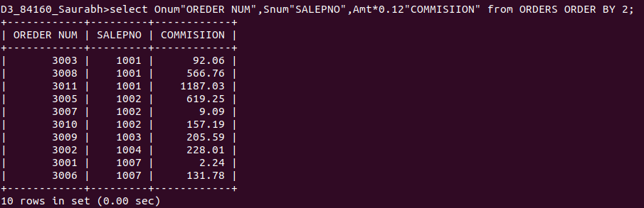
2) Write a query on the Customers table that will find the highest rating in each city. Put the
output in this form: For the city (city), the highest rating is :(rating).

select city"CITY",max(Rating)"RATING" from CUSTOMERS group by City;
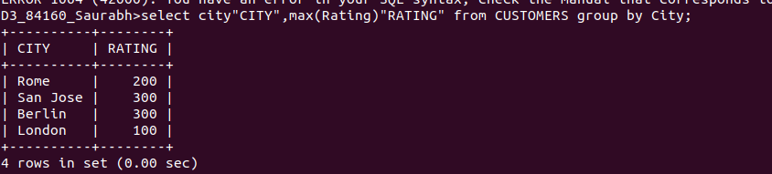
3) Write a query that lists customers in descending order of rating. Output the rating field first, followed by the customer’s name and number.

select Rating, Cname, Cnum from CUSTOMERS order by 1 desc;

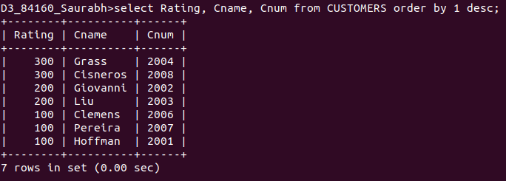
4) Write a query that totals the orders for each day and places the results in descending order.

select Odate, sum(Amt) from ORDERS group by Odate order by sum(Amt) desc;

