1) Write a query that produces all pairs of salespeople who are living in the same city. Exclude
combinations of salespeople with themselves as well as duplicate rows with the order reversed.

select x.Sname, y.Sname from SALESPEOPLE x,SALESPEOPLE y where x.City = y.City and x.Sname < y.Sname ;
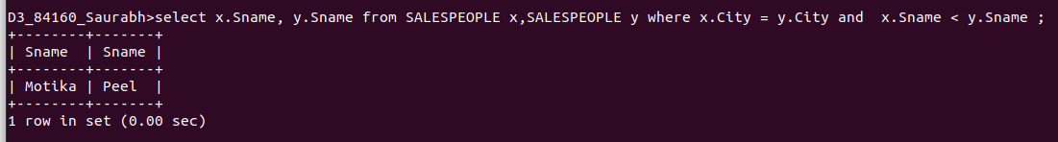

2) Write a query that produces the names and cities of all customers with the same rating as
Hoffman.

select x.Cname ,x.City from CUSTOMERS x, CUSTOMERS y where x.Rating = y.Rating AND y.Cname = 'Hoffman';

