ASSIGNMENT : 11

1) Write a query that uses a subquery to obtain all orders for the customer named Cisneros. Assume
you do not know his customer number (cnum).

select * from ORDERS where Cnum =(select Cnum from CUSTOMERS where Cname='Cisneros');
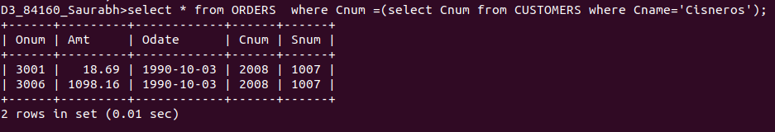

2) Write a query that produces the names and ratings of all customers who have above-average
orders.

select distinct Cname, Rating from CUSTOMERS, ORDERS where Amt > (select Avg(Amt) from ORDERS) and ORDERS.Cnum = CUSTOMERS.Cnum;
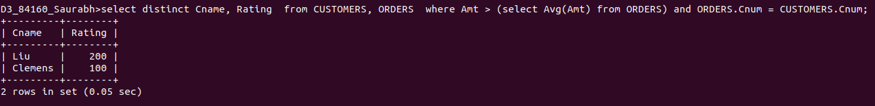

3) Write a query that selects the total amount in orders for each salesperson for whom this total
is greater than the amount of the largest order in the table.

select sum(amt) from ORDERS group by Snum having sum(Amt)>(select max(Amt) from ORDERS );
