ASSIGNMENT 9
1) Write a query that lists each order number followed by the name of the customer who made the
order.

select Onum,Cname from CUSTOMERS,ORDERS
-> where CUSTOMERS.Snum=ORDERS.Snum;
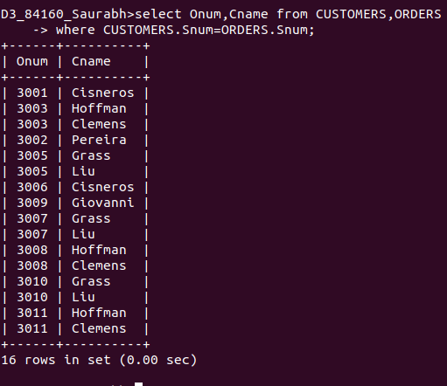

2) Write a query that gives the names of both the salesperson and the customer for each order along
with the order number.

select Sname, Cname, Onum from SALESPEOPLE,CUSTOMERS,ORDERS where ORDERS.Snum=SALESPEOPLE.Snum and ORDERS.Snum= CUSTOMERS.Snum;
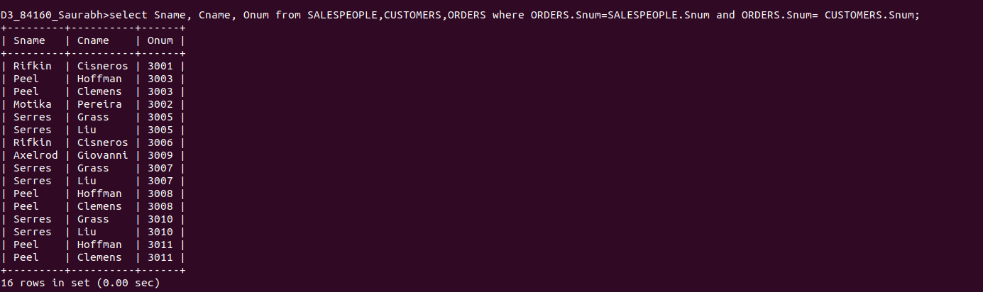

3) Write a query that lists customers in descending order of rating. Output the rating field first, followed by the customer’s name and number.

select Cname,Sname,Comm from CUSTOMERS,SALESPEOPLE where CUSTOMERS.Snum=SALESPEOPLE.Snum AND Comm>0.12;
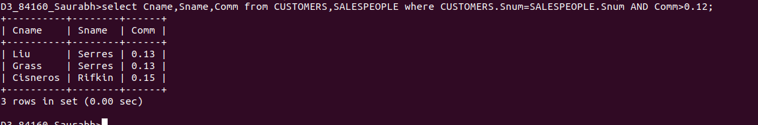

4) Write a query that totals the orders for each day and places the results in descending order.

select Onum, Rating, Comm*Amt from ORDERS, CUSTOMERS, SALESPEOPLE where ORDERS.Cnum = CUSTOMERS.Cnum AND ORDERS.Snum= SALESPEOPLE.Snum AND Rating>100 order by 1;

