Creating All three tables Salespeople, Customers,Orders.

Inserting the The data Into Salespeople Table.

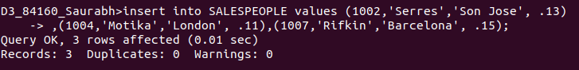

Inserted Data into Salespeople Table

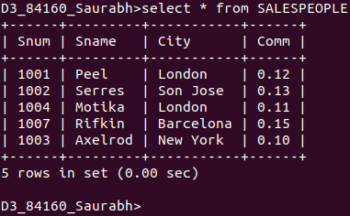

Inserting the The data Into Customers Table.

Inserted Data into Customers Table
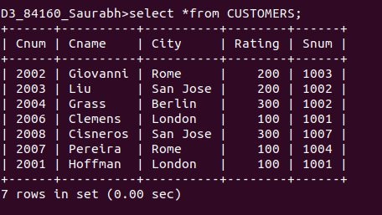

Inserting the The data Into Orders Table.

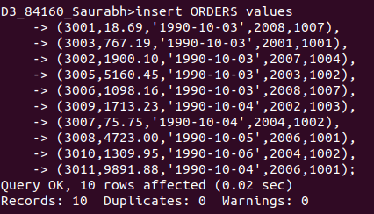

Inserted Data into Orders Table

