1) Write a select command that produces the order number, amount, and date for all rows in the Orders table.

select Onum, Amt, Odate from ORDERS;
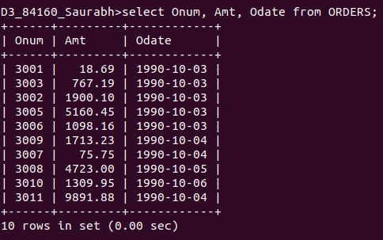

2) Write a query that produces all rows from the Customers table for which the salesperson’s number is 1001.

select* from CUSTOMERS where Snum=1001;

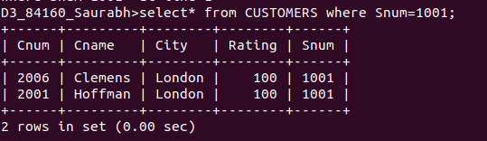
3) Write a query that displays the Salespeople table with the columns in the following order: city, sname, snum, comm.

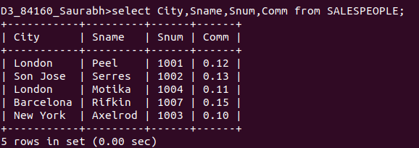
select City,Sname,Snum,Comm from SALESPEOPLE;

4) Write a select command that produces the rating followed by the name of each customer in San Jose.

