ASSIGNMENT 5

1) Write a query that will give you all orders for more than Rs. 1,000.

select *from ORDERS
where Amt>1000;
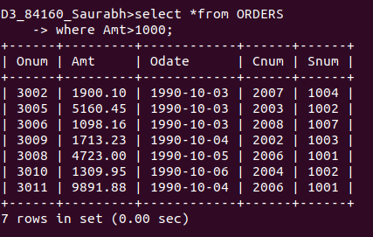

2) Write a query that will give you the names and cities of all salespeople in London with a commission above .10.

select Sname,City from SALESPEOPLE
where Comm>0.10 and City ='London';

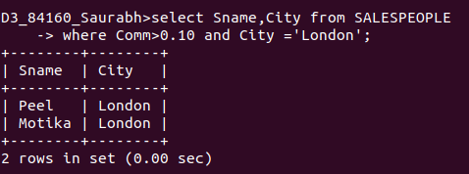

3) Write a query on the Customers table whose output will exclude all customers with a rating <= 100, unless they are located in Rome.

select *from CUSTOMERS where Rating>100 OR City='Rome';

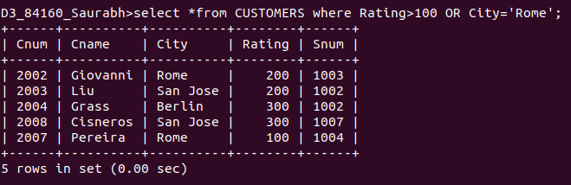

4)
What will be the output from the following query?
Select * from Orders
where (amt < 1000 OR
NOT (odate = ‘1990-10-03’
AND cnum > 2003));
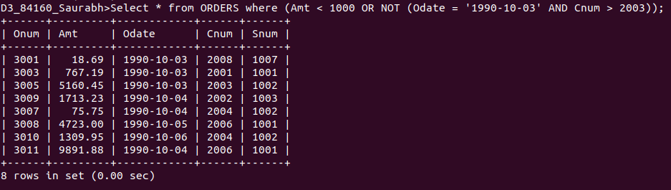
5)
What will be the output of the following query?

Select * from Orders where NOT ((odate = ‘1990-10-03’ OR snum>1006) AND amt >= 1500);
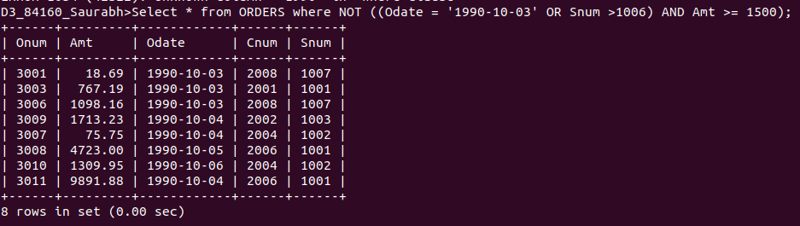
6)
What is a simpler way to write this query?
Select snum, sname, city, comm From Salespeople
where (comm > .12 OR comm <.14);

Select * From SALESPEOPLE where Comm not between 0.12 and 0.14;

