Assignment 3

1. ls Display hidden files
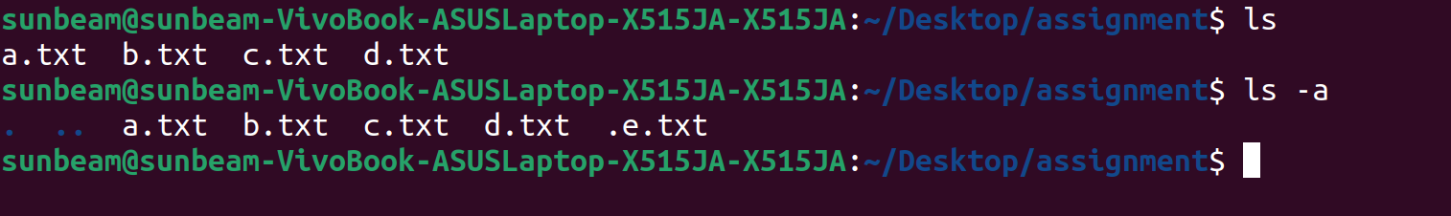

2. rename Rename all *.txt files to *.htm

for file in *.txt; do mv "$file" "${file%.txt}.htm"; done
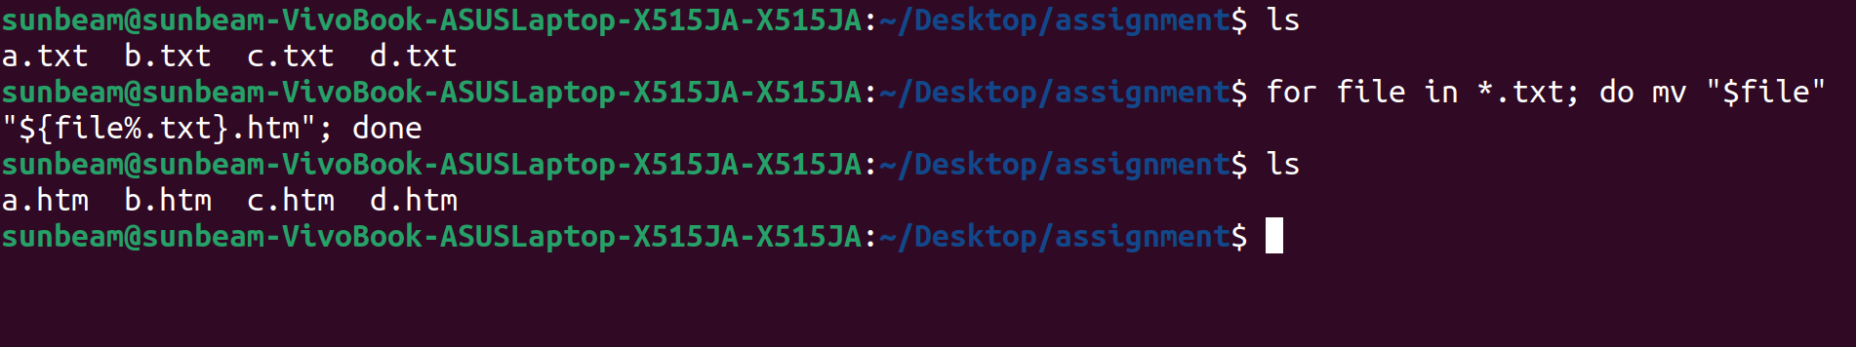

3. ln -s Create symbolic link (shortcut) for a file

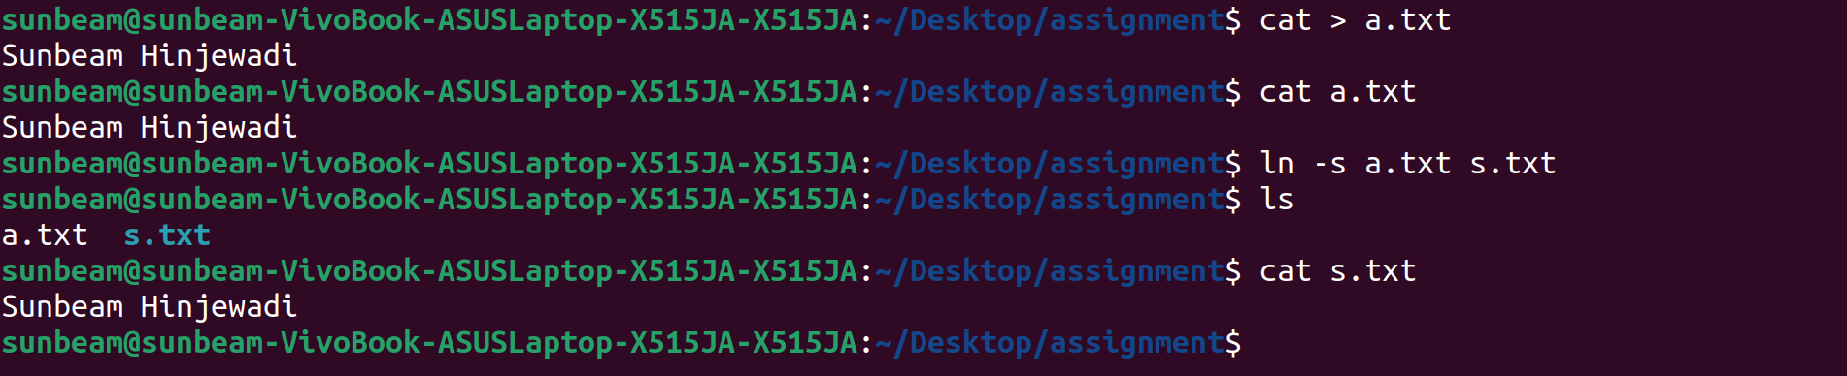
4. ln Create hard link for a file

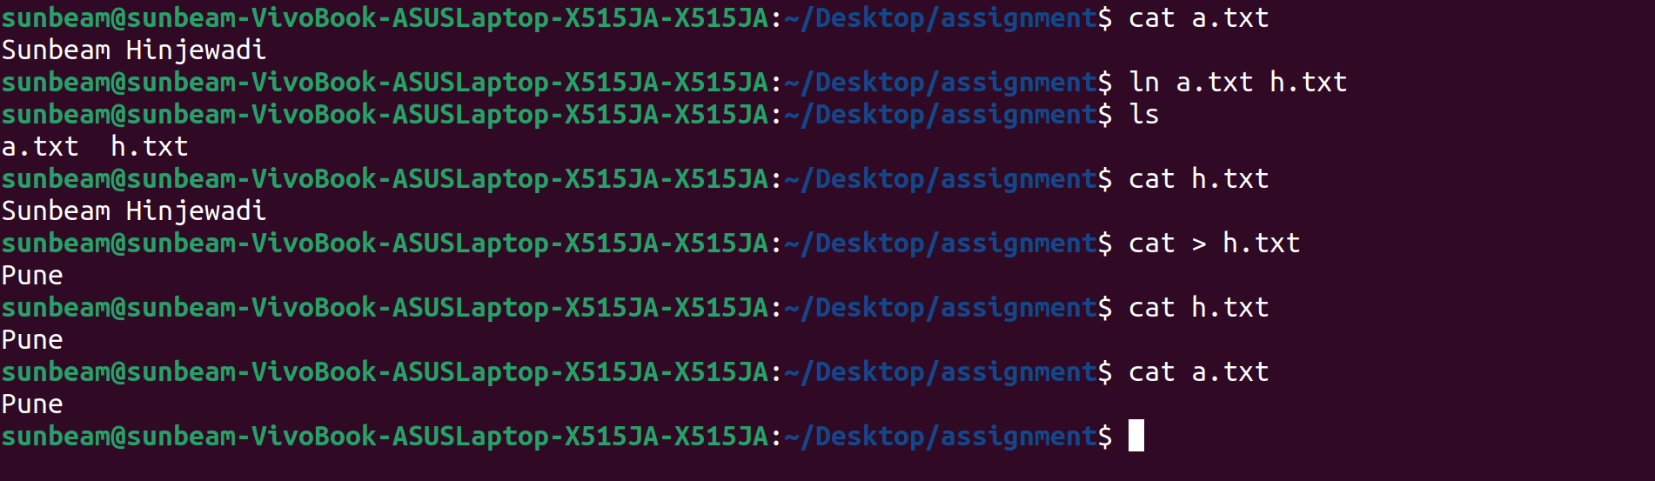

5. stat Display time stamp of the file

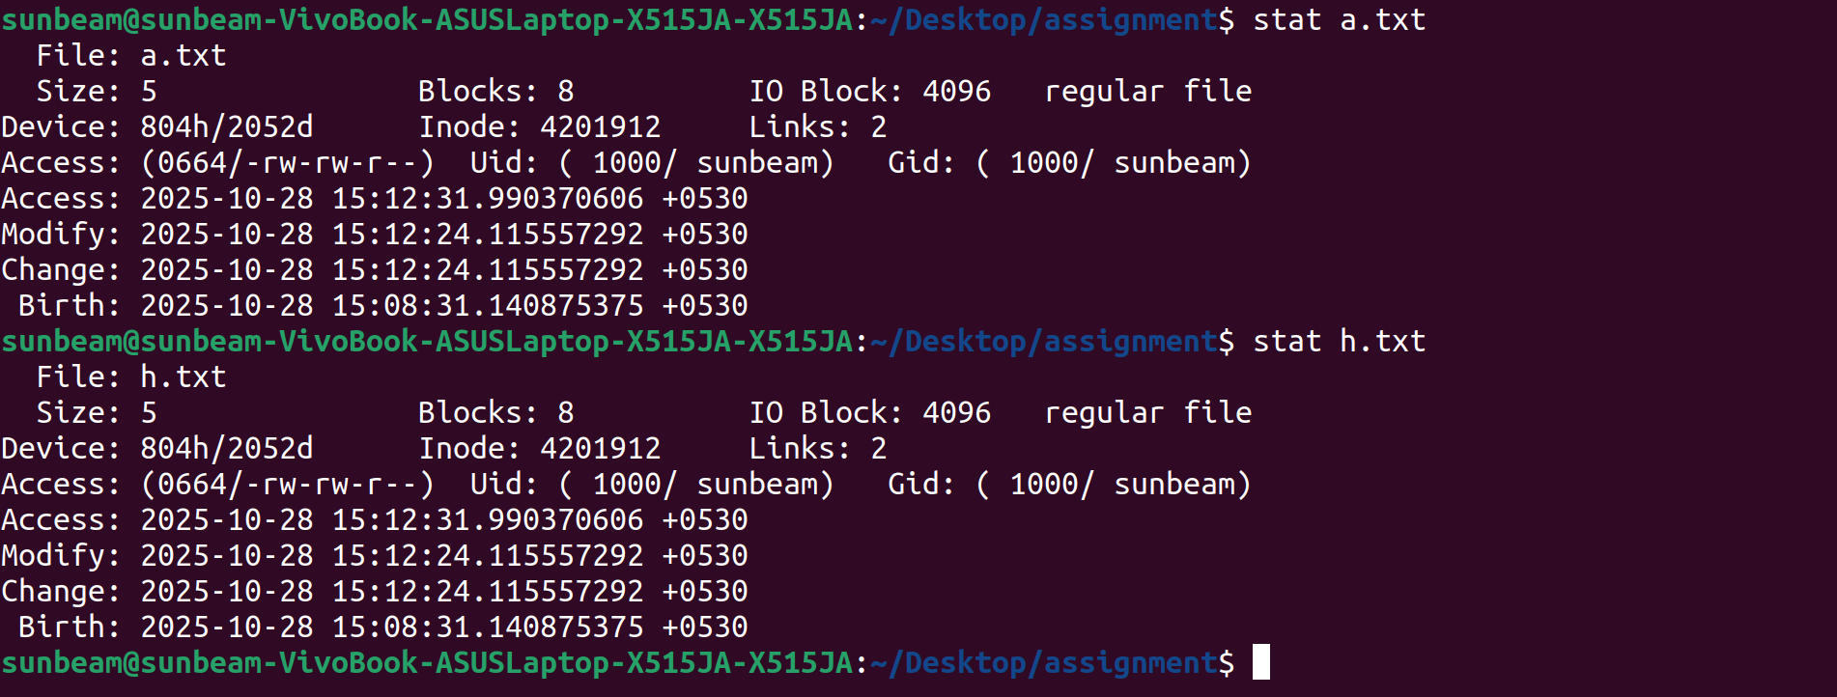
6. touch Change the time stamp of the file

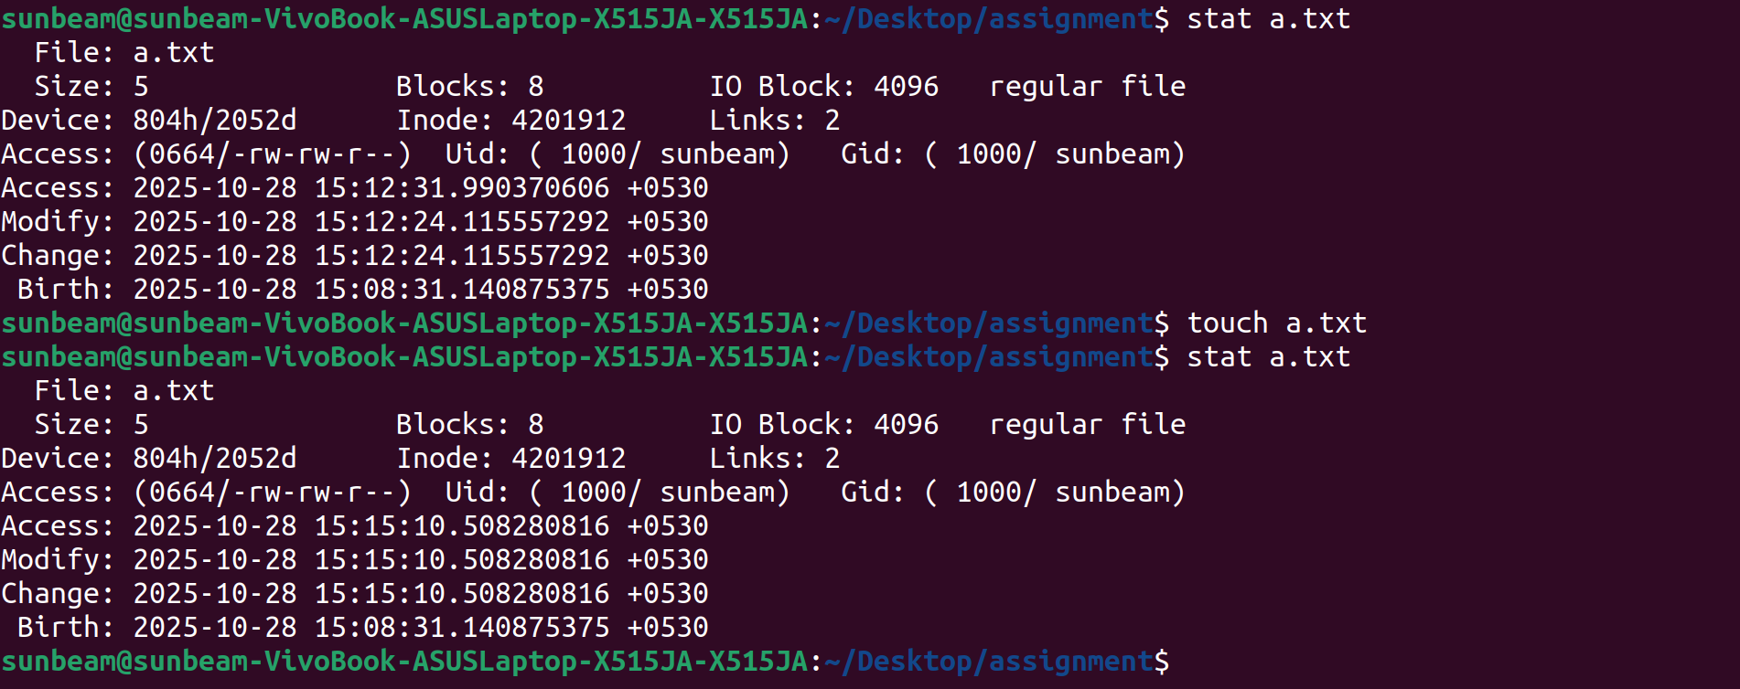
7. touch Create empty file



8. tail Print all lines in a file from fifth line onwards

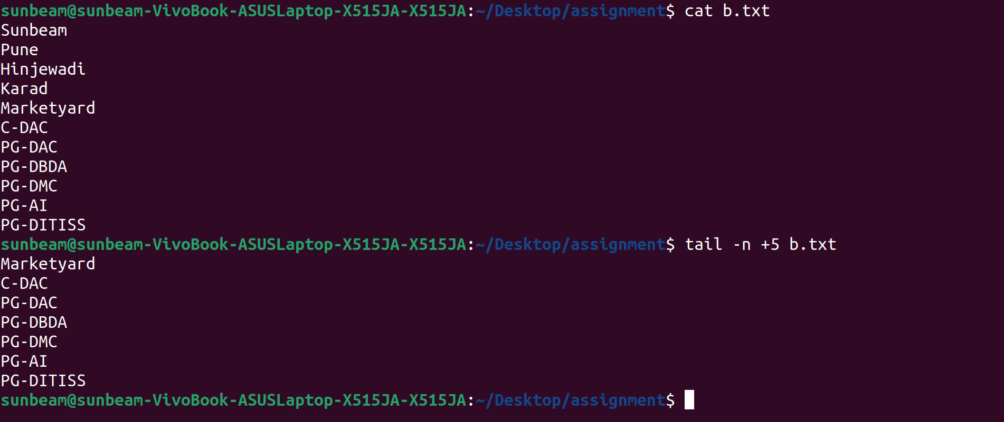
9. init 0, poweroffShutdown (Only for super-user)
10. init 6, rebootReboot (Only for super-user)

12. whoami Find current user


13. tty Find current terminal



14. who am i Find current user and terminal

15. users Find all users logged into the system



16. who Find all users logged in and terminals in use


17. grep, egrep, fgrep Find a given word/pattern from the file



18. chmod Make a file as read-only


19. chmod Make a file as write, read and execute

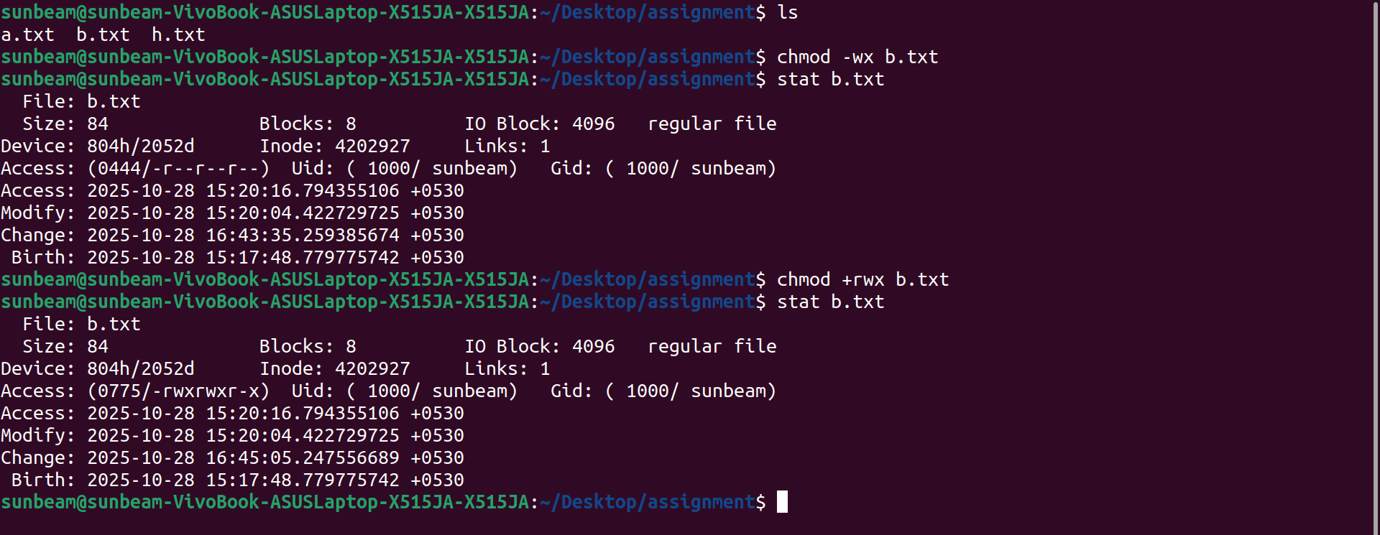


20. wc (using redirection) Take input from the file, count words and store output to other file


21. who | wc (using pipe) Count words in output of “who” command



22. head, tail (using pipe) Print lines 5 to 10 from the given file
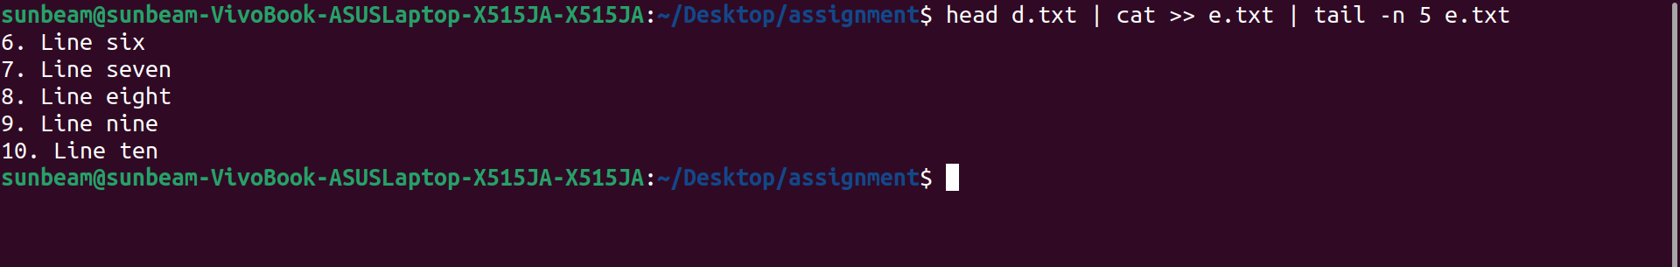

23. sort , uniq (using pipe) Print the uniq values from the unsorted file

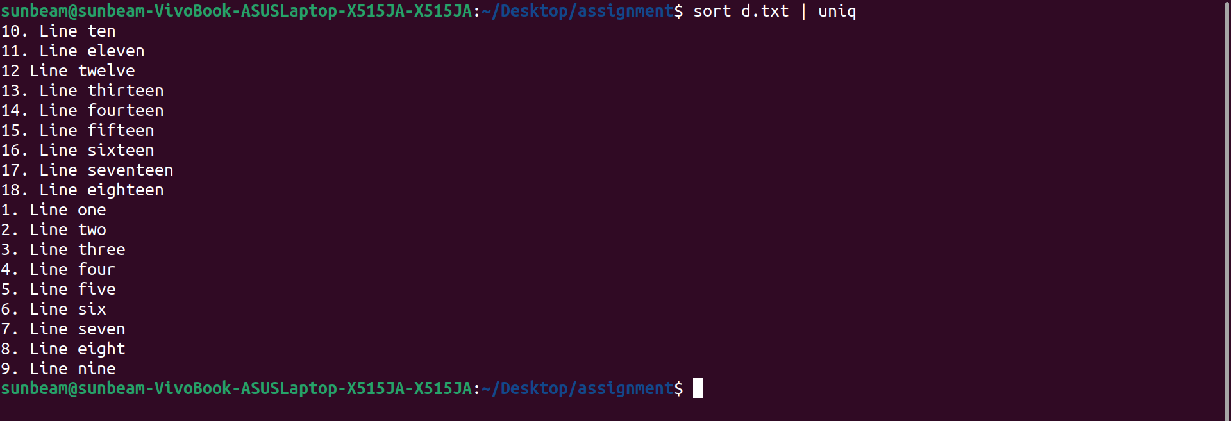

24. who, grep (using pipe) Display all users not using tty2, tty3, tty4

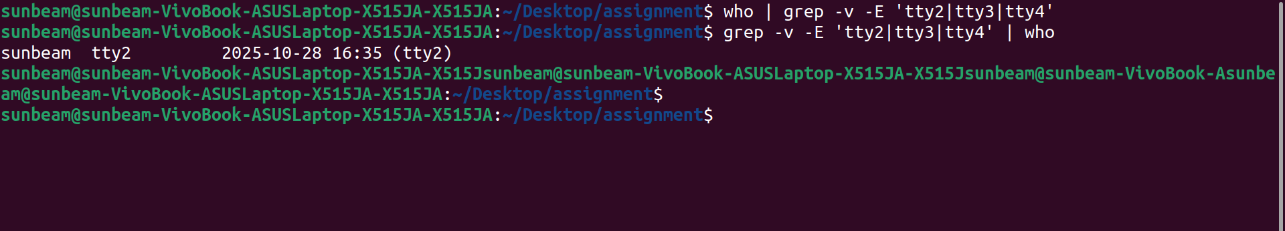

25. ls Display all files in ascending order of their file size

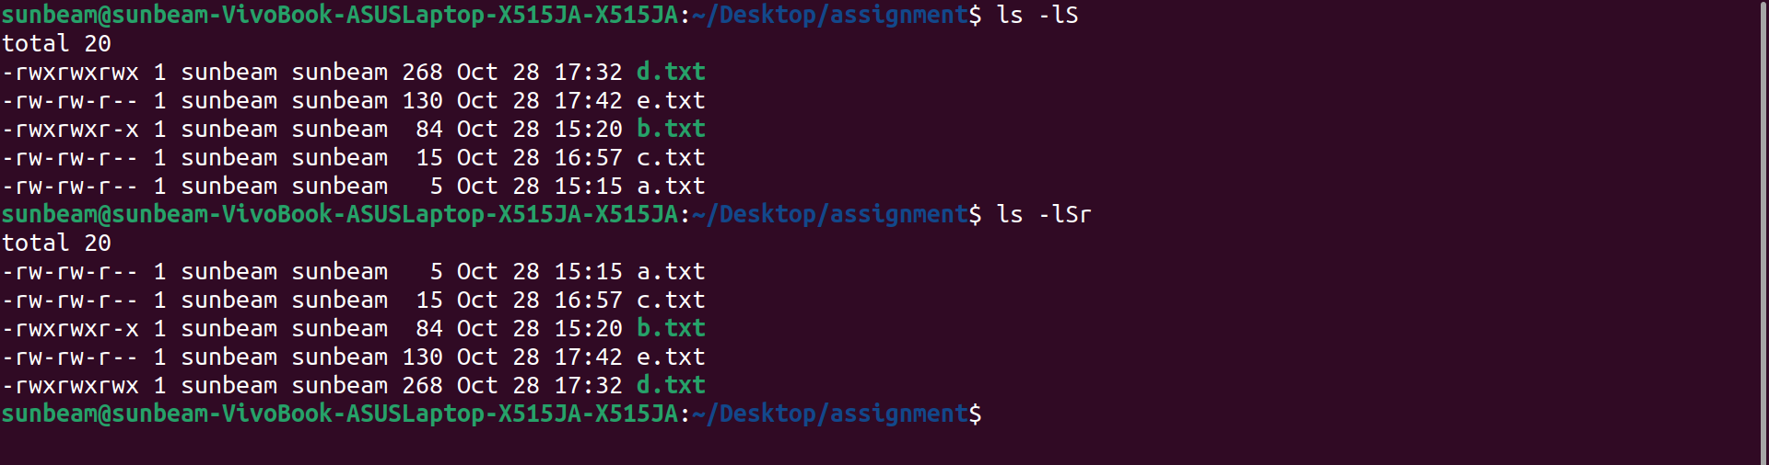

26. ls, grep (using pipe) Count number of files and directories from current directory



27. ls, grep (using pipe) Display only hidden files in a directory

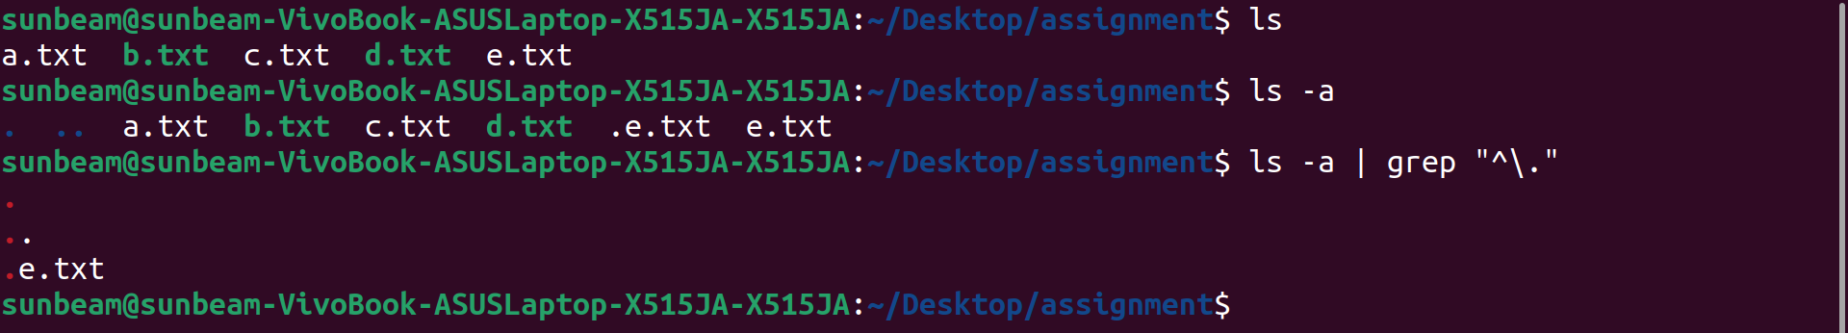

28. tr Convert file contents into uppercase , also learn "-s" option of this command

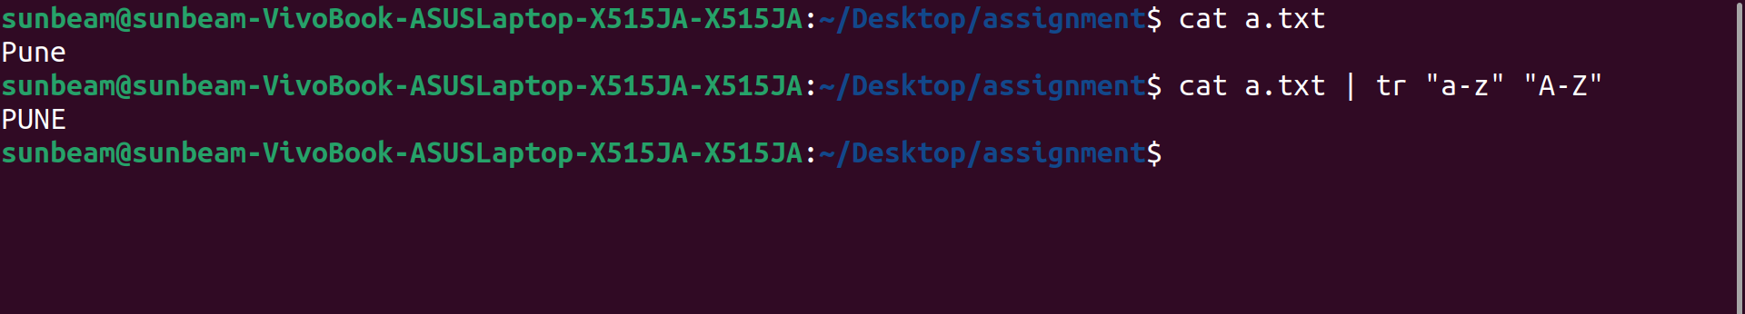

29. cut Split the file contents using delimiter and print required fields

