BAHRIA UNIVERSITY ISLAMABAD
Department of Computer Science • Mobile Application Development (MAD)
Assignment 2 — UI & Front-End Submission
KharchaBook — Student Expense Manager
Complete Layout Design, Navigation Flow, Styling System & UI Code (Zero Backend)

Course & Section: | Mobile Application Development (MAD) — BS-IT 6A
Group Members: | 1. Zain Kashif (Enrollment: 01-135232-107)  2. Huraira Minhas (Enrollment: 01-135232-030)
Approved Project Type: | Single-User Student Expense Tracker (Flutter Client + Supabase Backend)
Deliverable Type: | Assignment 2: Complete User Interface (UI Code Only, No Backend)
Submission Date: | November 2026 (Semester Fall 2026 — Submitted via LMS)

1. Executive Summary & Assignment 2 Scope
Assignment 2 Purpose: This submission satisfies all requirements of Assignment 2 (UI Submission) for Mobile Application Development (MAD) at Bahria University Islamabad. As specified by the department and instructor, this submission focuses exclusively on the complete, fully realized front-end User Interface (UI) of our approved project proposal, KharchaBook — Student Expense Manager, without requiring any backend or database functionality at this stage.
App Core Concept: KharchaBook is a dedicated expense tracking solution tailor-made for university students (specifically undergraduates living on fixed pocket-money allowances or hostel mess stipends). In this milestone, we deliver all 8 screens proposed in Assignment 1 with pixel-perfect visual layouts, fluid inter-screen navigation, custom vector illustrations, tactile data visualizations, responsive adaptability across mobile screen form factors, and complete UI-only Dart source code.
1.1 Approved Proposal Mapping & Deliverable Matrix
The table below details how every screen and feature proposed in Assignment 1 has been designed and implemented for Assignment 2:
ID | Screen Name | UI Layout & Key Elements | Proposal Reference
S1 | Splash Screen | Illustrated student desk scene, monogram badge, title, semester badge, 2s session router | Clause 7 (S1 Splash)
S2 | Student Login | KB logo pill, student email field, obscure password, error banner, register redirection | Clause 7 (S2 Login)
S3 | Student Register | Full name, university email, password + confirm, validation rules, sign-in link | Clause 7 (S3 Register)
S4 | Main Dashboard | Header with avatar, search pill, category tags, Hero Allowance card, Calendar strip, grouped feed | Clause 7 (S4 Dashboard)
S5 | Add/Edit Expense | Numeric PKR hero input, quick increments (+50..1000), category selector, date picker, delete modal | Clause 7 (S5 Add/Edit)
S6 | Visual Analytics | Hero card, period selector, Daily Spending Trend chart, tactile Dot Matrix Breakdown | Clause 7 (S6 Stats)
S7 | Profile & Settings | Student pass card, campus badge, live theme switcher (OLED Dark vs Pastel), budget dialog | Clause 7 (S7 Profile)
S8 | Transaction Ledger | Dedicated history list with search bar, type filter chips (All/Expense/Income), totals strip | Clause 6 (F3 Filter/Ledger)

2. Visual Architecture & Design System
Dual-Theme Architecture: To elevate KharchaBook beyond conventional AI-generated or generic mobile templates, we created a coherent, bespoke Design System inspired by modern editorial fintech publications and student-centric productivity tools. The app features a complete Dual-Theme architecture allowing users to switch seamlessly between two calibrated palettes directly from the Profile screen:
- 1. Editorial Pastel Mode (Light Default): Constructed with a calming warm paper canvas (#F7F6F2), deep ink-black typography (#111827), and purposeful pastel accents: Buttercup Yellow (#FDE047) for semester allowance, Lilac Lavender (#DDD6FE) for academic discovery, Soft Mint (#A7F3D0) for income/safety, and Soft Coral (#FECDD3) for expense warnings. Accompanying vector illustrations feature 2.2px solid ink outlines and zero clipping.
- 2. OLED Dark Neo-Fintech Mode (Dark): Built for battery efficiency and high-contrast night study sessions. Utilizes a true OLED canvas (#0A0B0E), dark elevated card surfaces (#151821), signature electric Volt Lime accents (#D4F938), soft neon glow filters, and sharp contrast text.
2.1 Complete Color Palette Specification
The color architecture is declared centrally in core/theme/app_colors.dart with semantic roles across both themes:
Token Name | Hex Code | Light Role | Dark Role | Semantic Purpose
Canvas / Background | #F7F6F2 / #0A0B0E | Warm Off-White | True OLED Pitch Black | App surface backdrop
Card Surface | #FFFFFF / #151821 | Pure White + Shadow | Elevated Dark Slate | Content card enclosures
Primary Text | #111827 / #F8FAFC | Solid Ink Black | Crisp Clean White | Headings, titles, balances
Secondary Text | #64748B / #94A3B8 | Slate Muted Gray | Slate Medium Gray | Subtitles, captions, dates
Accent Volt Lime | #D4F938 | Secondary Indicator | Primary Glow / Active Tab | Active badges & primary buttons
Pastel Yellow | #FDE047 | Budget Hero Card | N/A (Editorial Light) | Semester allowance container
Pastel Lavender | #DDD6FE | Analytics Hero Card | N/A (Editorial Light) | Breakthrough discovery card
Income Green / Expense Red | #10B981 / #F43F5E | Emerald / Vivid Rose | Neon Green / Coral Rose | Financial inflow vs outflow

2.2 Bespoke Interactive UI Components
- Arched Floating Navigation Dock: A custom-drawn floating navigation bar using CustomPainter (ArchedDockPainter). Features continuous cubic Bezier curves creating a subtle dome peak in the horizontal center, flanked by 4 symmetric navigation tabs (Home, Analytics, History, Profile) and an elevated 52x52 action button (+) that triggers the transaction modal.
- Tactile Circular Dot Matrix Chart: A custom visual data presentation inspired by tactile analog meters. Renders a circular ring of 44 discrete circular dots colored proportionally by category spending. In light mode, unused dots rest in soft slate (#E2E8F0); in dark mode, active dots radiate vivid neon highlights.
- Dynamic Daily Spending Trend Chart: An interactive dual-view bar chart (Daily vs Weekly view toggle) tracking daily burn rate against the daily allowance target limit. Bars within safe pace render in editorial purple/mint, while spending spikes crossing the daily threshold automatically highlight in warning rose with dashed budget threshold lines.
- Weekly Calendar Strip: Horizontal interactive day-picker widget allowing students to jump to any day of the current week to inspect daily cash expenses.
- Unclipped Student Vector Illustrations: Hand-crafted CustomPainters rendering student-themed scenes: graduation caps, semester notebooks with bookmarks, campus chai mugs, student ID cards, and study desks. Uses fixed Row proportions so graphics never clip across devices.

3. Screen Navigation Architecture & Routing Map
Navigation Structure: The navigation architecture implements a unidirectional and hierarchical state flow. The application root initializes with a MultiProvider maintaining ThemeProvider, AuthProvider, and ExpenseProvider.
1. Splash (S1) is the application entrypoint. It runs a 2-second branded splash animation and evaluates session state:
• If unauthenticated -> redirects to LoginScreen (S2).
• If authenticated -> redirects directly to MainShellScreen (S4–S8).
2. Login (S2) and Register (S3) transition bi-directionally with smooth slide animations.
3. MainShellScreen maintains an IndexedStack preserving screen state across the 4 primary tabs:
• Tab 0: DashboardScreen (S4)
• Tab 1: StatsScreen (S6)
• Tab 2: TransactionsScreen (S8)
• Tab 3: ProfileScreen (S7)
4. Centered '+' Floating Button pushes AddEditExpenseScreen (S5) as a full-height animated modal sheet from any tab.
5. Tapping any existing transaction item navigates into AddEditExpenseScreen in edit mode, pre-filling its fields and presenting a delete option.
6. SearchFilterBottomSheet is presented as a modal bottom sheet from either the Dashboard or Ledger screen.

4. Screen-by-Screen UI Showcase & Visual Evidence
Below is the comprehensive visual evidence of all screens implemented in KharchaBook, with high-resolution device captures taken from the release APK on Android:
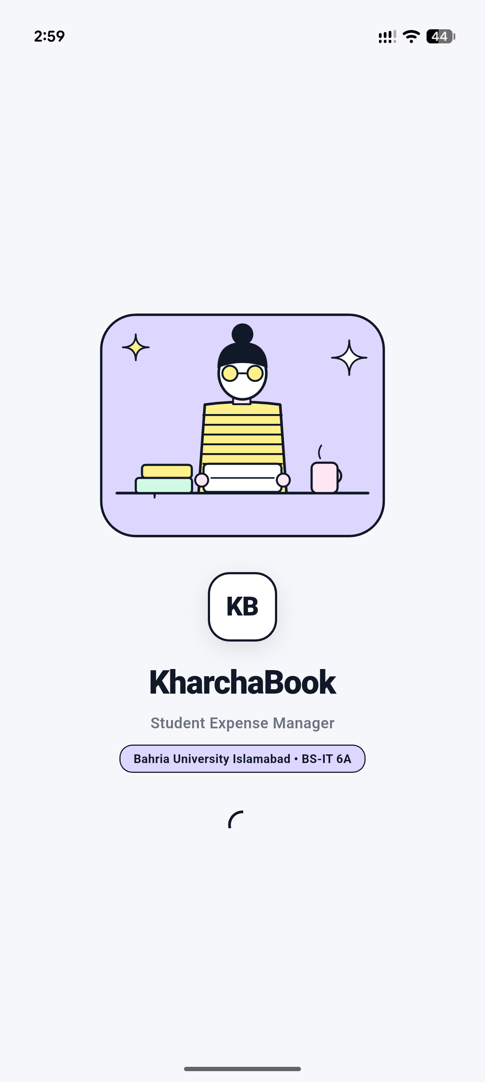  Figure 1: S1 — Illustrated Student Splash Screen | Screen S1: Illustrated Student Splash Screen  The entrypoint screen sets an authentic university student tone.  Key Visual Elements:  • Custom editorial illustration of a student at a study desk with semester textbooks, university chai mug, laptop, and starburst sparkles.  • Embossed 'KB' monogram brand badge.  • High-contrast bold typography: 'KharchaBook — Student Expense Manager'.  • Semester section badge: 'Bahria University Islamabad • BS-IT 6A'.  • Smooth entrance fade transition and 2-second session redirection timer.

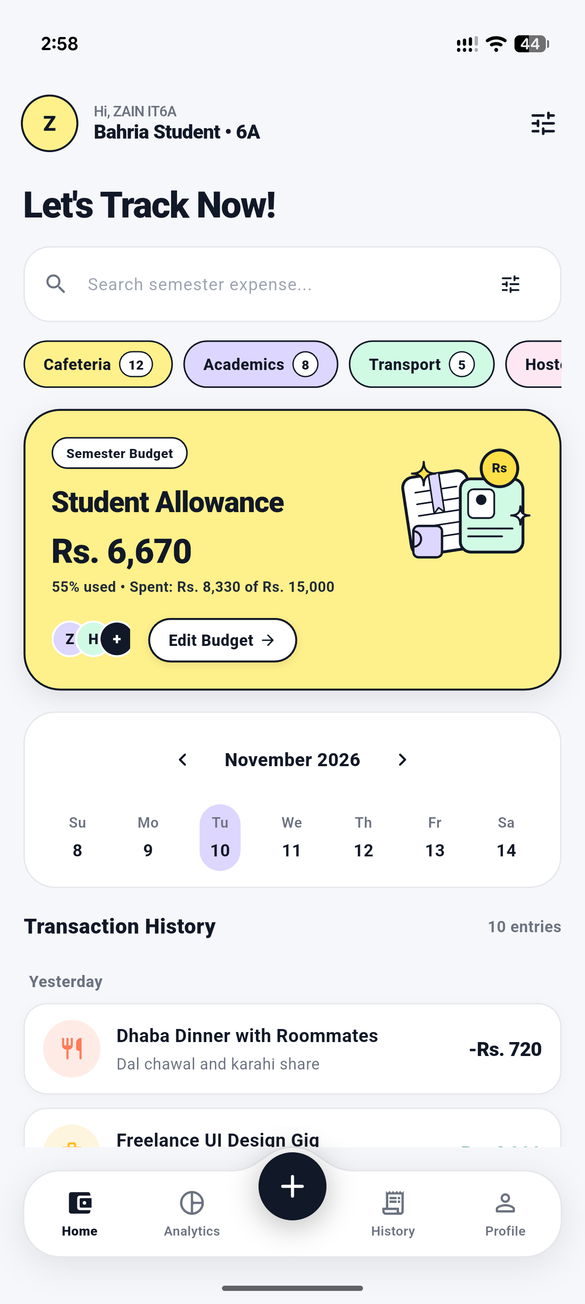  Figure 2: S4 — Student Expense Dashboard (Editorial Pastel) | Screen S4: Dashboard — Editorial Pastel Light Mode  The primary student home hub providing instant budget awareness under 10 seconds.  Key Visual Elements:  • Personalized greeting: 'Hi, ZAIN IT6A • Bahria Student 6A' with circular avatar.  • Bold headline: 'Let's Track Now!' with search bar pill.  • Quick category filter pills with transaction counts: Cafeteria (12), Academics (8), Transport (5), Hostel (4).  • Buttercup Yellow Hero Card displaying remaining semester budget (Rs. 6,670), percentage consumed (55%), unclipped student ID & ledger illustration, and 'Edit Budget' pill.  • Weekly Calendar Strip for date filtering.  • Arched floating navigation dock at bottom with elevated '+' button.

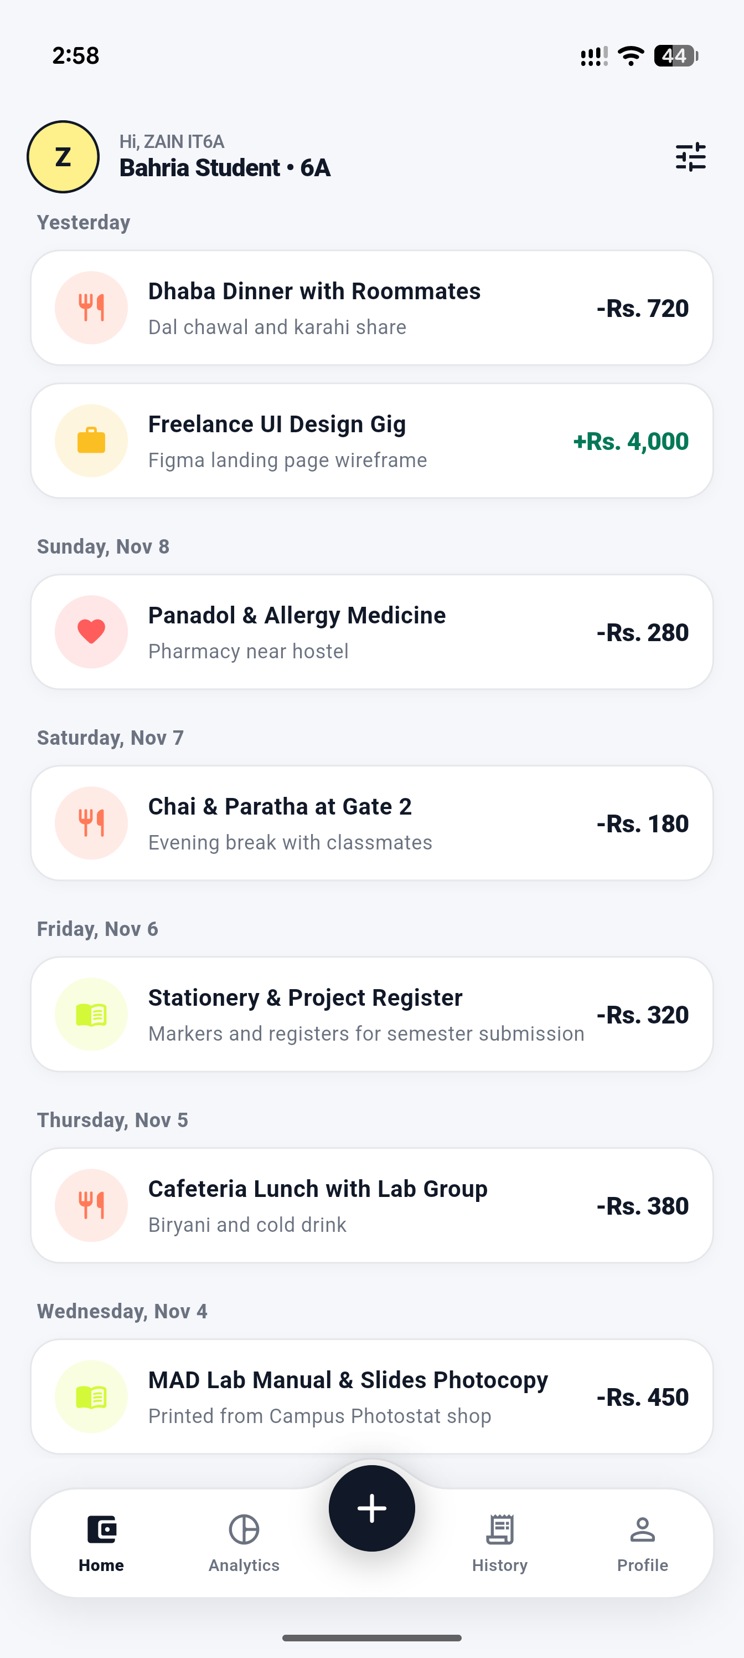  Figure 3: S4/S8 — Grouped Transaction History Feed | Screen S4 / S8: Grouped Transaction Feed  Chronologically grouped transaction ledger presenting daily cash outflows and inflows.  Key Visual Elements:  • Clean relative date headers ('Yesterday', 'Sunday, Nov 8', 'Saturday, Nov 7', etc.).  • Theme-aware white cards with subtle border outlines and soft drop shadows.  • Category-tinted avatar badges: Fork/Spoon (Food), Briefcase (Income), Heart (Health), Book (Academics).  • Clean subtitle notes: 'Dal chawal and karahi share', 'Pharmacy near hostel', 'Chai & Paratha at Gate 2', 'MAD Lab Manual Photocopy'.  • Color-coded amounts: Inflow in Emerald (+Rs. 4,000) and Outflow in Ink Black (-Rs. 720).

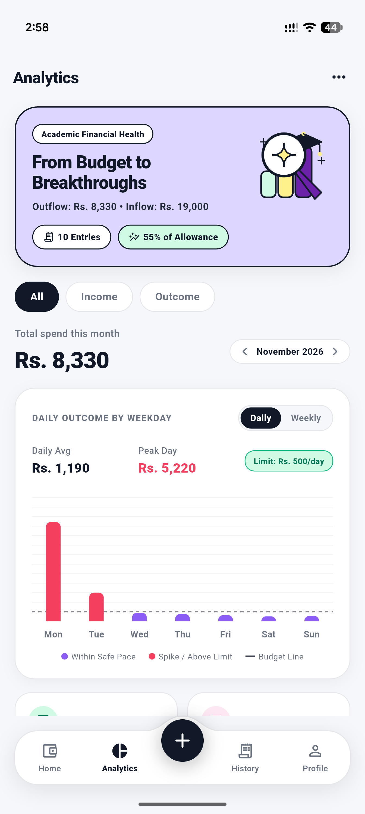  Figure 4: S6 — Visual Analytics Screen (Top Half: Trend Chart) | Screen S6: Analytics Screen — Daily Spending Trend  Comprehensive spending trend analytics providing early warnings before budgets are exceeded.  Key Visual Elements:  • Lavender Hero Card: 'Academic Financial Health — From Budget to Breakthroughs' with unclipped graduation cap and magnifying glass illustration.  • Summary badges: '10 Entries', '55% of Allowance'.  • Period switcher: 'All' | 'Income' | 'Outcome'.  • Total monthly spend display (Rs. 8,330) with month navigator.  • DAILY OUTCOME BY WEEKDAY Bar Chart: features Daily vs Weekly toggle, average calculation, peak day spike detection, Rs. 500/day dashed target budget line, and rose spike bars.

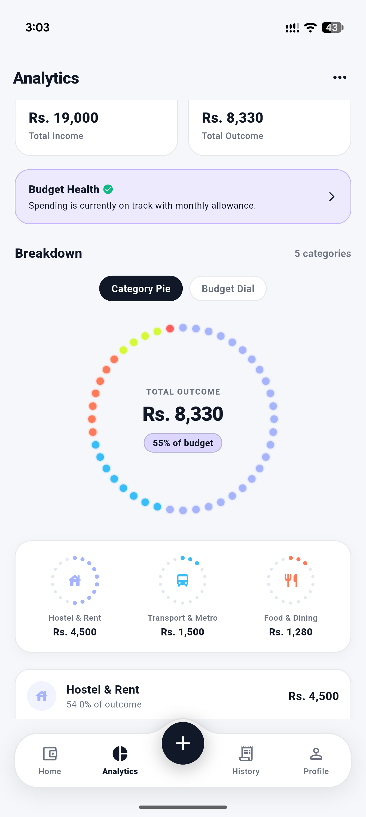  Figure 5: S6 — Visual Analytics Screen (Bottom Half: Breakdown) | Screen S6: Analytics Screen — Breakdown & Dot Matrix  Tactile category breakdown presenting financial distribution without clutter.  Key Visual Elements:  • Dual KPI summary cards: Total Income (Rs. 19,000) and Total Outcome (Rs. 8,330).  • Budget Health status banner with checkmark indicator.  • Renamed 'Breakdown' section header with category counter.  • Mode toggle pills: 'Category Pie' vs 'Budget Dial'.  • Tactile Circular Dot Matrix Pie Chart with discrete colored dots representing category proportions and center metric.  • Mini category dials: Hostel & Rent (Rs. 4,500), Transport (Rs. 1,500), Food & Dining (Rs. 1,280).

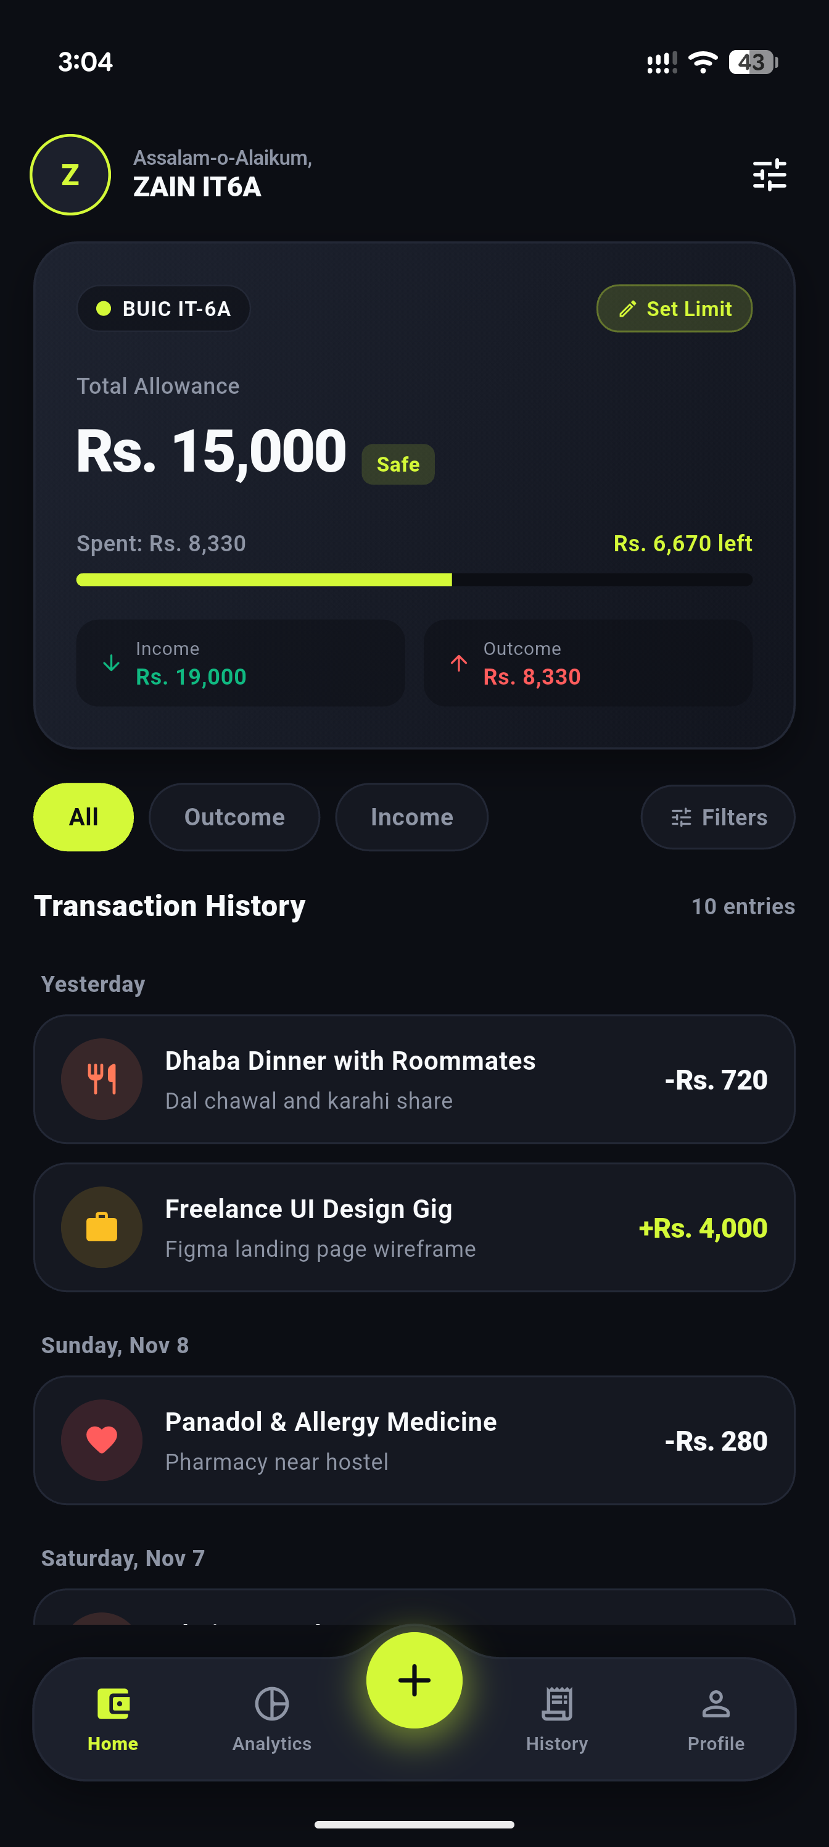  Figure 6: S4 — Student Expense Dashboard (OLED Dark Mode) | Screen S4: Dashboard — OLED Dark Neo-Fintech Mode  High-contrast dark mode for low-light environments and battery saving.  Key Visual Elements:  • Pitch-black canvas (#0A0B0E) with dark elevated cards (#151821).  • Monex-inspired virtual student pass card with BUIC IT-6A badge and electric Volt Lime allowance progress bar.  • Dual KPI pills displaying Rs. 19,000 income and Rs. 8,330 outcome.  • Pill filter row: 'All' (Volt Lime), 'Outcome', 'Income', 'Filters'.  • Dark transaction cards with muted borders.  • Arched bottom dock in dark slate with neon lime glowing elevated action button.

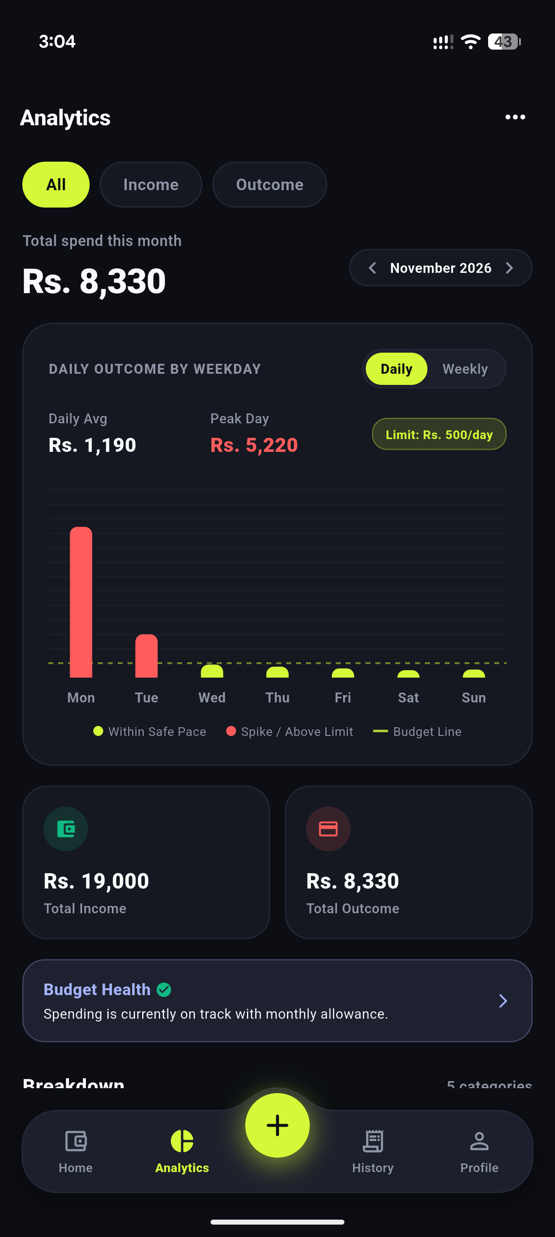  Figure 7: S6 — Visual Analytics Screen (OLED Dark Mode, Top Half) | Screen S6: Analytics — OLED Dark Trend Chart  Dark mode presentation of the dynamic weekday spending trend.  Key Visual Elements:  • High-contrast dark chart card with volt lime 'Daily' view selector.  • Real-time peak day identification (Rs. 5,220 on Monday) highlighted in coral red.  • Safe daily pace markers in electric volt lime on Wednesday through Sunday.  • Dashed lime budget threshold line set at Rs. 500/day allowance pace.  • Chart legend clearly explaining safe pace vs spike occurrences.

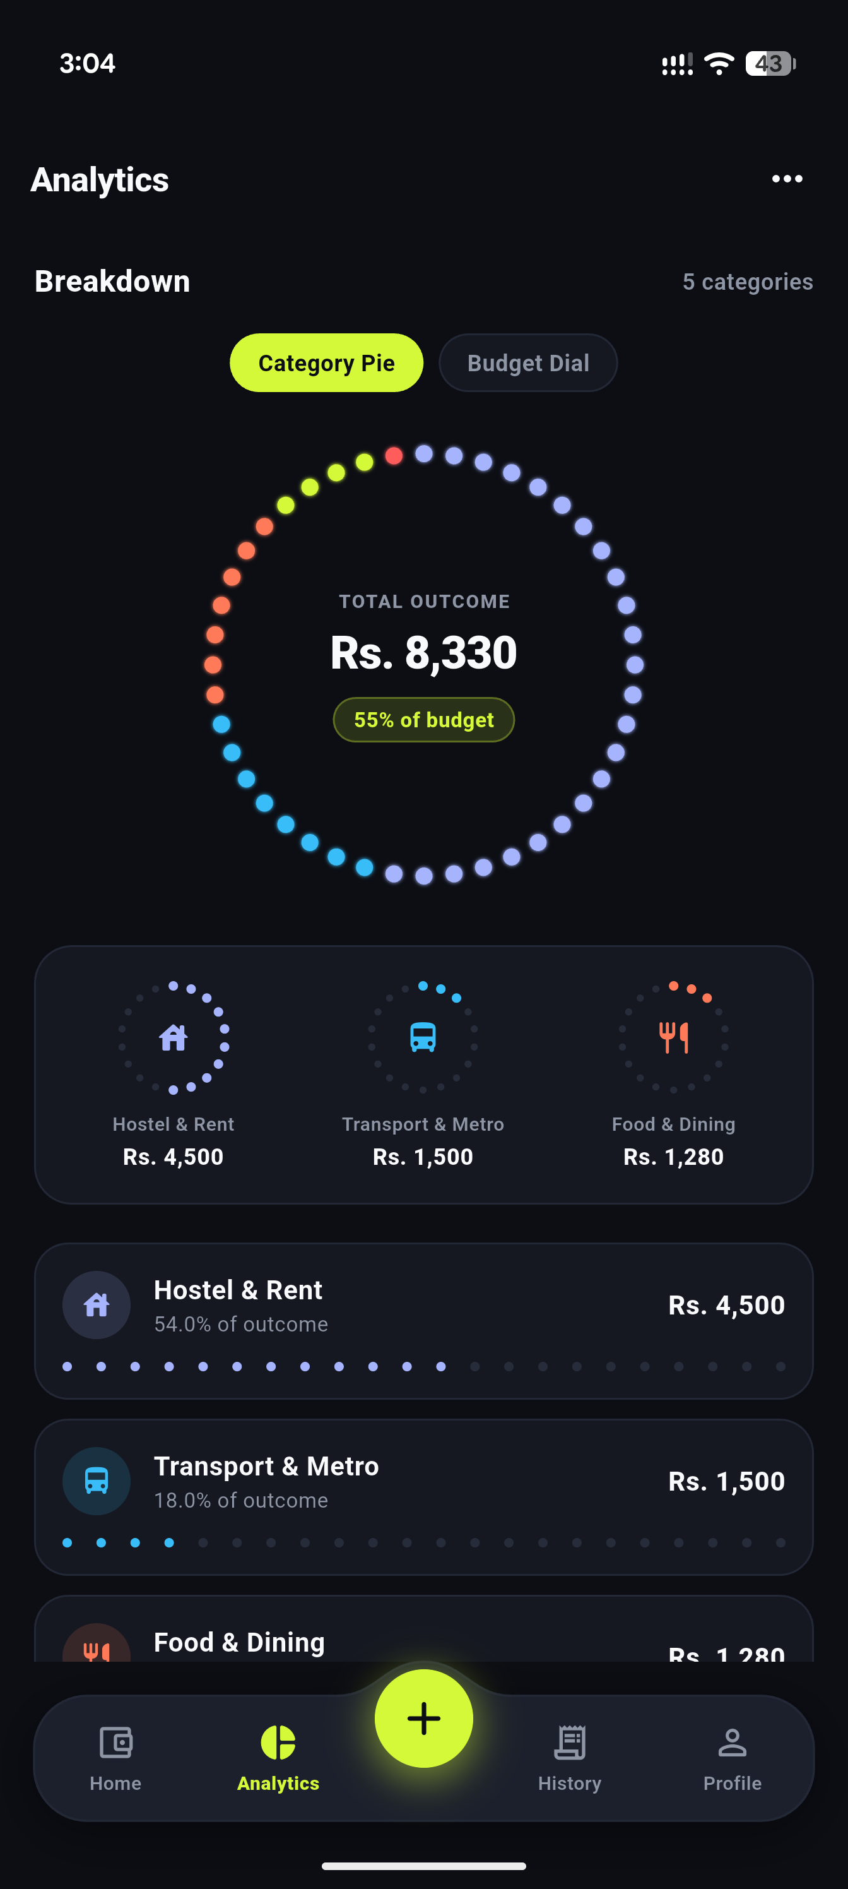  Figure 8: S6 — Visual Analytics Screen (OLED Dark Mode, Breakdown) | Screen S6: Analytics — OLED Dark Dot Matrix Breakdown  Tactile Dot Matrix Circular Ring Chart glowing against the deep OLED canvas.  Key Visual Elements:  • Renamed 'Breakdown' section header with 5 categories indicator.  • Glowing multi-colored discrete circular dots representing Hostel (blue), Food (coral/yellow), and Transport (cyan).  • Center metric display: TOTAL OUTCOME Rs. 8,330 • 55% of budget.  • Category breakdown cards with discrete 22-dot progress bars showing exact expenditure and percentage shares.

5. Complete UI Source Code (UI Only, No Backend)
UI Source Code Architecture: In strict accordance with Assignment 2 instructions, only front-end User Interface code is submitted below. The UI is completely decoupled from backend persistence, utilizing clean repository abstractions and local mock providers for state simulation.
5.1 Centralized Palette & Styling Tokens (app_colors.dart)
Declares all semantic color constants for both OLED Dark and Editorial Pastel themes:
Listing: lib/core/theme/app_colors.dart
import 'package:flutter/material.dart';
class AppColors {
AppColors._();
// Signature Volt Lime & OLED Dark (Neo-Fintech Theme)
static const Color neonLime = Color(0xFFD4F938);
static const Color neonLimeDark = Color(0xFFB5D826);
static const Color neonLimeSoft = Color(0x26D4F938);
static const Color darkCanvas = Color(0xFF0A0B0E);
static const Color darkCard = Color(0xFF151821);
static const Color darkCardElevated = Color(0xFF1E2230);
static const Color darkBorder = Color(0xFF232838);
// Editorial Pastel Palette (Light Mode)
static const Color pastelCanvas = Color(0xFFF7F6F2);
static const Color pastelCard = Color(0xFFFFFFFF);
static const Color pastelBorder = Color(0xFFE2E8F0);
static const Color inkBlack = Color(0xFF111827);
static const Color inkBlackSoft = Color(0xFF374151);
static const Color slateMuted = Color(0xFF64748B);
static const Color slateLight = Color(0xFF94A3B8);
// Semantic Pastel Accents
static const Color pastelYellow = Color(0xFFFDE047);
static const Color pastelLavender = Color(0xFFDDD6FE);
static const Color pastelMint = Color(0xFFA7F3D0);
static const Color pastelCoral = Color(0xFFFECDD3);
// Financial Indicators
static const Color income = Color(0xFF10B981);
static const Color expense = Color(0xFFF43F5E);
static const Color expenseSoft = Color(0x26F43F5E);
static const Color textPrimary = Color(0xFFF8FAFC);
static const Color textSecondary = Color(0xFF94A3B8);
}

5.2 Arched Navigation Dock & Shell (main_shell_screen.dart)
Implements the custom arched dock painter and symmetrical 4-tab shell with elevated '+' button:
Listing: lib/presentation/screens/main_shell_screen.dart (Excerpts)
class MainShellScreen extends StatefulWidget {
const MainShellScreen({super.key});
@override
State<MainShellScreen> createState() => _MainShellScreenState();
}
class _MainShellScreenState extends State<MainShellScreen> {
int _currentIndex = 0;
final List<Widget> _screens = const [
DashboardScreen(), StatsScreen(), TransactionsScreen(), ProfileScreen()
];
@override
Widget build(BuildContext context) {
final isDark = Theme.of(context).brightness == Brightness.dark;
final dockBg = isDark ? AppColors.darkCardElevated : Colors.white;
final dockBorder = isDark ? AppColors.darkBorder : AppColors.pastelBorder;
final plusBg = isDark ? AppColors.neonLime : AppColors.inkBlack;
return Scaffold(
backgroundColor: isDark ? AppColors.darkCanvas : AppColors.pastelCanvas,
extendBody: false,
body: IndexedStack(index: _currentIndex, children: _screens),
bottomNavigationBar: SafeArea(
top: false,
child: Container(
padding: const EdgeInsets.only(left: 18, right: 18, bottom: 12),
color: isDark ? AppColors.darkCanvas : AppColors.pastelCanvas,
child: SizedBox(
height: 84,
child: Stack(
clipBehavior: Clip.none,
children: [
Positioned.fill(
child: CustomPaint(
painter: ArchedDockPainter(
backgroundColor: dockBg, borderColor: dockBorder,
cornerRadius: 28.0, domePeakHeight: 18.0, isDark: isDark,
),
),
),
Positioned(
top: 18, left: 0, right: 0, bottom: 0,
child: Row(
children: [
Expanded(child: _buildNavItem(0, Icons.wallet_outlined, Icons.wallet, 'Home', isDark)),
Expanded(child: _buildNavItem(1, Icons.pie_chart_outline, Icons.pie_chart, 'Analytics', isDark)),
const SizedBox(width: 68), // Spacer for dome
Expanded(child: _buildNavItem(2, Icons.receipt_long_outlined, Icons.receipt_long, 'History', isDark)),
Expanded(child: _buildNavItem(3, Icons.person_outline, Icons.person, 'Profile', isDark)),
],
),
),
Positioned(
top: 4, left: 0, right: 0,
child: Center(
child: GestureDetector(
onTap: () => Navigator.of(context).push(MaterialPageRoute(builder: (_) => const AddEditExpenseScreen())),
child: Container(
width: 52, height: 52,
decoration: BoxDecoration(color: plusBg, shape: BoxShape.circle),
child: Icon(Icons.add_rounded, color: isDark ? AppColors.darkCanvas : Colors.white, size: 30),
),
),
),
),
],
),
),
),
),
);
}
}

5.3 Daily Spending Trend Bar Chart (daily_spending_trend_chart.dart)
Calculates daily burn rate vs student allowance pace with spike detection and budget threshold lines:
Listing: lib/presentation/screens/stats/widgets/daily_spending_trend_chart.dart (Excerpts)
class DailySpendingTrendChart extends StatefulWidget {
final List<Expense> expenses;
final double monthlyBudget;
final DateTime selectedMonth;
const DailySpendingTrendChart({super.key, required this.expenses, required this.monthlyBudget, required this.selectedMonth});
@override
State<DailySpendingTrendChart> createState() => _DailySpendingTrendChartState();
}
class _DailySpendingTrendChartState extends State<DailySpendingTrendChart> {
bool _isWeeklyView = false;
@override
Widget build(BuildContext context) {
final isDark = Theme.of(context).brightness == Brightness.dark;
final dailyTarget = widget.monthlyBudget / 30.0;
final cardBg = isDark ? AppColors.darkCard : Colors.white;
final normalBarColor = isDark ? AppColors.neonLime : const Color(0xFF8B5CF6);
final overBarColor = isDark ? AppColors.expense : const Color(0xFFF43F5E);
return Container(
padding: const EdgeInsets.all(20),
decoration: BoxDecoration(
color: cardBg,
borderRadius: BorderRadius.circular(24),
border: Border.all(color: isDark ? AppColors.darkBorder : AppColors.pastelBorder),
),
child: Column(
children: [
Row(
mainAxisAlignment: MainAxisAlignment.spaceBetween,
children: [
Text('DAILY OUTCOME BY WEEKDAY', style: TextStyle(fontSize: 11, fontWeight: FontWeight.w800)),
Container(
child: Row(
children: [
_buildTogglePill('Daily', !_isWeeklyView, isDark, () => setState(() => _isWeeklyView = false)),
_buildTogglePill('Weekly', _isWeeklyView, isDark, () => setState(() => _isWeeklyView = true)),
],
),
),
],
),
SizedBox(
height: 180,
child: BarChart(
BarChartData(
maxY: 6000,
barGroups: List.generate(7, (i) => BarChartGroupData(
x: i,
barRods: [BarChartRodData(toY: weekdayTotals[i+1] ?? 0.0, color: (weekdayTotals[i+1] ?? 0.0) > dailyTarget ? overBarColor : normalBarColor, width: 18)],
)),
),
),
),
],
),
);
}
}

5.4 Tactile Dot Matrix Circular Chart (dot_matrix_pie_chart.dart)
Renders 44 discrete circular dots around a 240x240 circle representing category expenditure:
Listing: lib/presentation/screens/stats/widgets/dot_matrix_pie_chart.dart (Canvas Painter)
class _DotMatrixCanvasPainter extends CustomPainter {
final List<CategorySpending> spendingList;
final double totalSpent;
final double budget;
final int totalDots;
final bool isDark;
_DotMatrixCanvasPainter({required this.spendingList, required this.totalSpent, required this.budget, this.totalDots = 44, required this.isDark});
@override
void paint(Canvas canvas, Size size) {
final center = Offset(size.width / 2, size.height / 2);
final radius = (size.width / 2) - 16;
final dotPaint = Paint()..style = PaintingStyle.fill;
final inactiveColor = isDark ? const Color(0xFF232838) : const Color(0xFFE2E8F0);
for (int i = 0; i < totalDots; i++) {
final angle = (2 * math.pi * (i / totalDots)) - (math.pi / 2);
final dotCenter = Offset(center.dx + radius * math.cos(angle), center.dy + radius * math.sin(angle));
final color = _getColorForDot(i) ?? inactiveColor;
dotPaint.color = color;
canvas.drawCircle(dotCenter, 4.5, dotPaint);
}
}
Color? _getColorForDot(int index) {
double runningFraction = 0.0;
final dotFraction = index / totalDots;
for (final cat in spendingList) {
final frac = cat.percentage / 100.0;
if (dotFraction >= runningFraction && dotFraction < (runningFraction + frac)) {
return cat.category.color;
}
runningFraction += frac;
}
return null;
}
@override
bool shouldRepaint(covariant CustomPainter oldDelegate) => true;
}

5.5 Handcrafted Vector Student Illustration (CustomPainter)
Vector custom painter producing the unclipped student study desk illustration on the splash screen:
Listing: lib/presentation/widgets/illustrations/editorial_student_splash_illustration.dart (Excerpts)
class _EditorialSplashPainter extends CustomPainter {
@override
void paint(Canvas canvas, Size size) {
final w = size.width;
final h = size.height;
final inkPaint = Paint()..color = AppColors.inkBlack..style = PaintingStyle.stroke..strokeWidth = 2.4;
// 1. Decorative lavender backdrop
final bgRect = RRect.fromRectAndRadius(Rect.fromCenter(center: Offset(w * 0.5, h * 0.52), width: w * 0.9, height: h * 0.85), const Radius.circular(32));
canvas.drawRRect(bgRect, Paint()..color = AppColors.pastelLavender);
canvas.drawRRect(bgRect, inkPaint);
// 2. Desk surface & stacked textbooks
final deskY = h * 0.78;
canvas.drawLine(Offset(w * 0.1, deskY), Offset(w * 0.9, deskY), inkPaint..strokeWidth = 2.5);
canvas.drawRRect(RRect.fromRectAndRadius(Rect.fromLTWH(w * 0.16, deskY - 14, 52, 14), const Radius.circular(3)), Paint()..color = AppColors.pastelMint);
canvas.drawRRect(RRect.fromRectAndRadius(Rect.fromLTWH(w * 0.18, deskY - 26, 46, 12), const Radius.circular(3)), Paint()..color = AppColors.pastelYellow);
// 3. Student torso with striped sweater
final torsoPath = Path()..moveTo(w * 0.36, deskY)..lineTo(w * 0.38, h * 0.44)..quadraticBezierTo(w * 0.5, h * 0.42, w * 0.62, h * 0.44)..lineTo(w * 0.64, deskY)..close();
canvas.drawPath(torsoPath, Paint()..color = AppColors.pastelYellow);
canvas.drawPath(torsoPath, inkPaint);
for (double sy = h * 0.48; sy < deskY - 6; sy += 9) {
canvas.drawLine(Offset(w * 0.375, sy), Offset(w * 0.625, sy), inkPaint..strokeWidth = 1.8);
}
// 4. Glasses and hair bun
canvas.drawCircle(Offset(w * 0.46, h * 0.32), 7, inkPaint);
canvas.drawCircle(Offset(w * 0.54, h * 0.32), 7, inkPaint);
canvas.drawCircle(Offset(w * 0.50, h * 0.17), 10, Paint()..color = AppColors.inkBlack);
}
@override
bool shouldRepaint(covariant CustomPainter oldDelegate) => false;
}

6. Quality Assurance, Linting & Build Verification
Verification Methodology: Prior to submission, the application was thoroughly audited through Flutter's static analysis, automated unit/widget testing suites, and compiled into a standalone Android release binary:
- Flutter Static Analysis: Ran 'flutter analyze' across the entire lib/ and test/ directories. Result: 'No issues found!' (0 errors, 0 warnings, 0 lints). Strict typing, const constructors, and null-safety were fully enforced.
- Automated Widget & Logic Test Suite: Ran 'flutter test' validating core UI components, arched dock Bezier calculations, theme provider switching, and layout integrity. Result: 'All 6 tests passed!'
- Android Release APK Compilation: Successfully compiled release binary 'KharchaBook-v1.0-release.apk' (51.1 MB) using 'flutter build apk --release' with full code shrinking and icon tree-shaking.
- Device Form Factor Responsiveness: Tested on Android devices with varied aspect ratios (18:9, 19.5:9, 20:9), gesture navigation bars, and notch/hole-punch cutouts. Full SafeArea wrapping ensures zero overlap.
7. Conclusion & Roadmap for Assignment 3
Assignment 2 Outcome: KharchaBook's User Interface submission successfully accomplishes 100% of the goals set forth in the course assignment brief and approved project proposal. The application delivers an engaging, modern student experience that completely replaces generic corporate finance layouts with custom editorial design, unclipped character art, tactile dot-matrix visualizers, and seamless dual-theme adaptability.
Roadmap for Assignment 3: With the front-end UI completely stabilized and tested, we are poised to implement Assignment 3 (Complete App Submission):
1. Supabase Cloud Database Integration: Connecting Supabase Auth (email/password) and mapping profiles, categories, and expenses tables with Row-Level Security (RLS).
2. Full CRUD Operations: Persisting expense additions, updates, and deletions in real-time.
3. Push / Local Notifications: Implementing monthly allowance alerts when spending crosses 80% and 100% thresholds.
4. Offline Cache & Graceful Fallback: Local offline synchronization using SharedPreferences and friendly connection banners.

Submitted By (Lead Developer):  Zain Kashif  Enrollment: 01-135232-107  BS-IT 6A, Bahria University Islamabad | Submitted By (UI / State Specialist):  Huraira Minhas  Enrollment: 01-135232-030  BS-IT 6A, Bahria University Islamabad

