BAHRIA UNIVERSITY ISLAMABAD
Department of Computer Science • Mobile Application Development (MAD)
Assignment 2 — UI & Front-End Submission
KharchaBook — Student Expense Manager
Complete Layout Design, Navigation Flow, Styling System & UI Code (Zero Backend)

Course & Section: | Mobile Application Development (MAD) — BS-IT 6A
Group Members: | 1. Zain Kashif (Enrollment: 01-135232-107)  2. Huraira Minhas (Enrollment: 01-135232-030)
Approved Project Type: | Single-User Student Expense Tracker (Flutter Client + Supabase Backend)
Deliverable Type: | Assignment 2: Complete User Interface (UI Code Only, No Backend)
Submission Date: | November 2026 (Semester Fall 2026 — Submitted via LMS)

1. Executive Summary & Assignment 2 Scope
Assignment 2 Purpose: This submission satisfies all requirements of Assignment 2 (UI Submission) for Mobile Application Development (MAD) at Bahria University Islamabad. As specified by the department and instructor, this submission focuses exclusively on the complete, fully realized front-end User Interface (UI) of our approved project proposal, KharchaBook — Student Expense Manager, without requiring any backend or database functionality at this stage.
App Core Concept: KharchaBook is a dedicated expense tracking solution tailor-made for university students (specifically undergraduates living on fixed pocket-money allowances or hostel mess stipends). In this milestone, we deliver all 8 screens proposed in Assignment 1 with pixel-perfect visual layouts, fluid inter-screen navigation, custom vector illustrations, tactile data visualizations, responsive adaptability across mobile screen form factors, and complete UI-only Dart source code.
1.1 Approved Proposal Mapping & Deliverable Matrix
The table below details how every screen and feature proposed in Assignment 1 has been designed and implemented for Assignment 2:
ID | Screen Name | UI Layout & Key Elements | Proposal Reference
S1 | Splash Screen | Illustrated student desk scene, monogram badge, title, semester badge, 2s session router | Clause 7 (S1 Splash)
S2 | Student Login | KB logo pill, student email field, obscure password, error banner, register redirection | Clause 7 (S2 Login)
S3 | Student Register | Full name, university email, password + confirm, validation rules, sign-in link | Clause 7 (S3 Register)
S4 | Main Dashboard | Header with avatar, search pill, category tags, Hero Allowance card, Calendar strip, grouped feed | Clause 7 (S4 Dashboard)
S5 | Add/Edit Expense | Numeric PKR hero input, quick increments (+50..1000), category selector, date picker, delete modal | Clause 7 (S5 Add/Edit)
S6 | Visual Analytics | Hero card, period selector, Daily Spending Trend chart, tactile Dot Matrix Breakdown | Clause 7 (S6 Stats)
S7 | Profile & Settings | Student pass card, campus badge, live theme switcher (OLED Dark vs Pastel), budget dialog | Clause 7 (S7 Profile)
S8 | Transaction Ledger | Dedicated history list with search bar, type filter chips (All/Expense/Income), totals strip | Clause 6 (F3 Filter/Ledger)

2. Visual Architecture & Design System
Dual-Theme Architecture: To elevate KharchaBook beyond conventional AI-generated or generic mobile templates, we created a coherent, bespoke Design System inspired by modern editorial fintech publications and student-centric productivity tools. The app features a complete Dual-Theme architecture allowing users to switch seamlessly between two calibrated palettes directly from the Profile screen:
- 1. Editorial Pastel Mode (Light Default): Constructed with a calming warm paper canvas (#F7F6F2), deep ink-black typography (#111827), and purposeful pastel accents: Buttercup Yellow (#FDE047) for semester allowance, Lilac Lavender (#DDD6FE) for academic discovery, Soft Mint (#A7F3D0) for income/safety, and Soft Coral (#FECDD3) for expense warnings. Accompanying vector illustrations feature 2.2px solid ink outlines and zero clipping.
- 2. OLED Dark Neo-Fintech Mode (Dark): Built for battery efficiency and high-contrast night study sessions. Utilizes a true OLED canvas (#0A0B0E), dark elevated card surfaces (#151821), signature electric Volt Lime accents (#D4F938), soft neon glow filters, and sharp contrast text.
2.1 Complete Color Palette Specification
The color architecture is declared centrally in core/theme/app_colors.dart with semantic roles across both themes:
Token Name | Hex Code | Light Role | Dark Role | Semantic Purpose
Canvas / Background | #F7F6F2 / #0A0B0E | Warm Off-White | True OLED Pitch Black | App surface backdrop
Card Surface | #FFFFFF / #151821 | Pure White + Shadow | Elevated Dark Slate | Content card enclosures
Primary Text | #111827 / #F8FAFC | Solid Ink Black | Crisp Clean White | Headings, titles, balances
Secondary Text | #64748B / #94A3B8 | Slate Muted Gray | Slate Medium Gray | Subtitles, captions, dates
Accent Volt Lime | #D4F938 | Secondary Indicator | Primary Glow / Active Tab | Active badges & primary buttons
Pastel Yellow | #FDE047 | Budget Hero Card | N/A (Editorial Light) | Semester allowance container
Pastel Lavender | #DDD6FE | Analytics Hero Card | N/A (Editorial Light) | Breakthrough discovery card
Income Green / Expense Red | #10B981 / #F43F5E | Emerald / Vivid Rose | Neon Green / Coral Rose | Financial inflow vs outflow

2.2 Bespoke Interactive UI Components
- Arched Floating Navigation Dock: A custom-drawn floating navigation bar using CustomPainter (ArchedDockPainter). Features continuous cubic Bezier curves creating a subtle dome peak in the horizontal center, flanked by 4 symmetric navigation tabs (Home, Analytics, History, Profile) and an elevated 52x52 action button (+) that triggers the transaction modal.
- Tactile Circular Dot Matrix Chart: A custom visual data presentation inspired by tactile analog meters. Renders a circular ring of 44 discrete circular dots colored proportionally by category spending. In light mode, unused dots rest in soft slate (#E2E8F0); in dark mode, active dots radiate vivid neon highlights.
- Dynamic Daily Spending Trend Chart: An interactive dual-view bar chart (Daily vs Weekly view toggle) tracking daily burn rate against the daily allowance target limit. Bars within safe pace render in editorial purple/mint, while spending spikes crossing the daily threshold automatically highlight in warning rose with dashed budget threshold lines.
- Weekly Calendar Strip: Horizontal interactive day-picker widget allowing students to jump to any day of the current week to inspect daily cash expenses.
- Unclipped Student Vector Illustrations: Hand-crafted CustomPainters rendering student-themed scenes: graduation caps, semester notebooks with bookmarks, campus chai mugs, student ID cards, and study desks. Uses fixed Row proportions so graphics never clip across devices.

3. Screen Navigation Architecture & Routing Map
Navigation Structure: The navigation architecture implements a unidirectional and hierarchical state flow. The application root initializes with a MultiProvider maintaining ThemeProvider, AuthProvider, and ExpenseProvider.
1. Splash (S1) is the application entrypoint. It runs a 2-second branded splash animation and evaluates session state:
• If unauthenticated -> redirects to LoginScreen (S2).
• If authenticated -> redirects directly to MainShellScreen (S4–S8).
2. Login (S2) and Register (S3) transition bi-directionally with smooth slide animations.
3. MainShellScreen maintains an IndexedStack preserving screen state across the 4 primary tabs:
• Tab 0: DashboardScreen (S4)
• Tab 1: StatsScreen (S6)
• Tab 2: TransactionsScreen (S8)
• Tab 3: ProfileScreen (S7)
4. Centered '+' Floating Button pushes AddEditExpenseScreen (S5) as a full-height animated modal sheet from any tab.
5. Tapping any existing transaction item navigates into AddEditExpenseScreen in edit mode, pre-filling its fields and presenting a delete option.
6. SearchFilterBottomSheet is presented as a modal bottom sheet from either the Dashboard or Ledger screen.

4. Screen-by-Screen UI Showcase & Visual Evidence
Below is the comprehensive visual evidence of all screens implemented in KharchaBook, with high-resolution device captures taken from the release APK on Android:
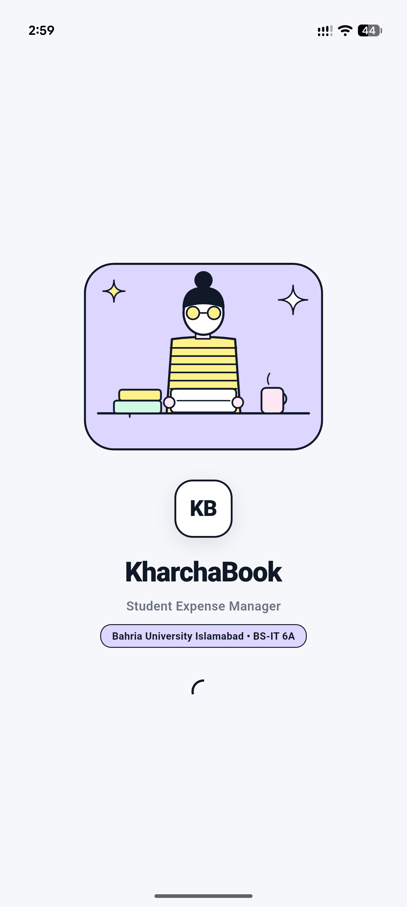  Figure 1: S1 — Illustrated Student Splash Screen | Screen S1: Illustrated Student Splash Screen  The entrypoint screen sets an authentic university student tone.  Key Visual Elements:  • Custom editorial illustration of a student at a study desk with semester textbooks, university chai mug, laptop, and starburst sparkles.  • Embossed 'KB' monogram brand badge.  • High-contrast bold typography: 'KharchaBook — Student Expense Manager'.  • Semester section badge: 'Bahria University Islamabad • BS-IT 6A'.  • Smooth entrance fade transition and 2-second session redirection timer.

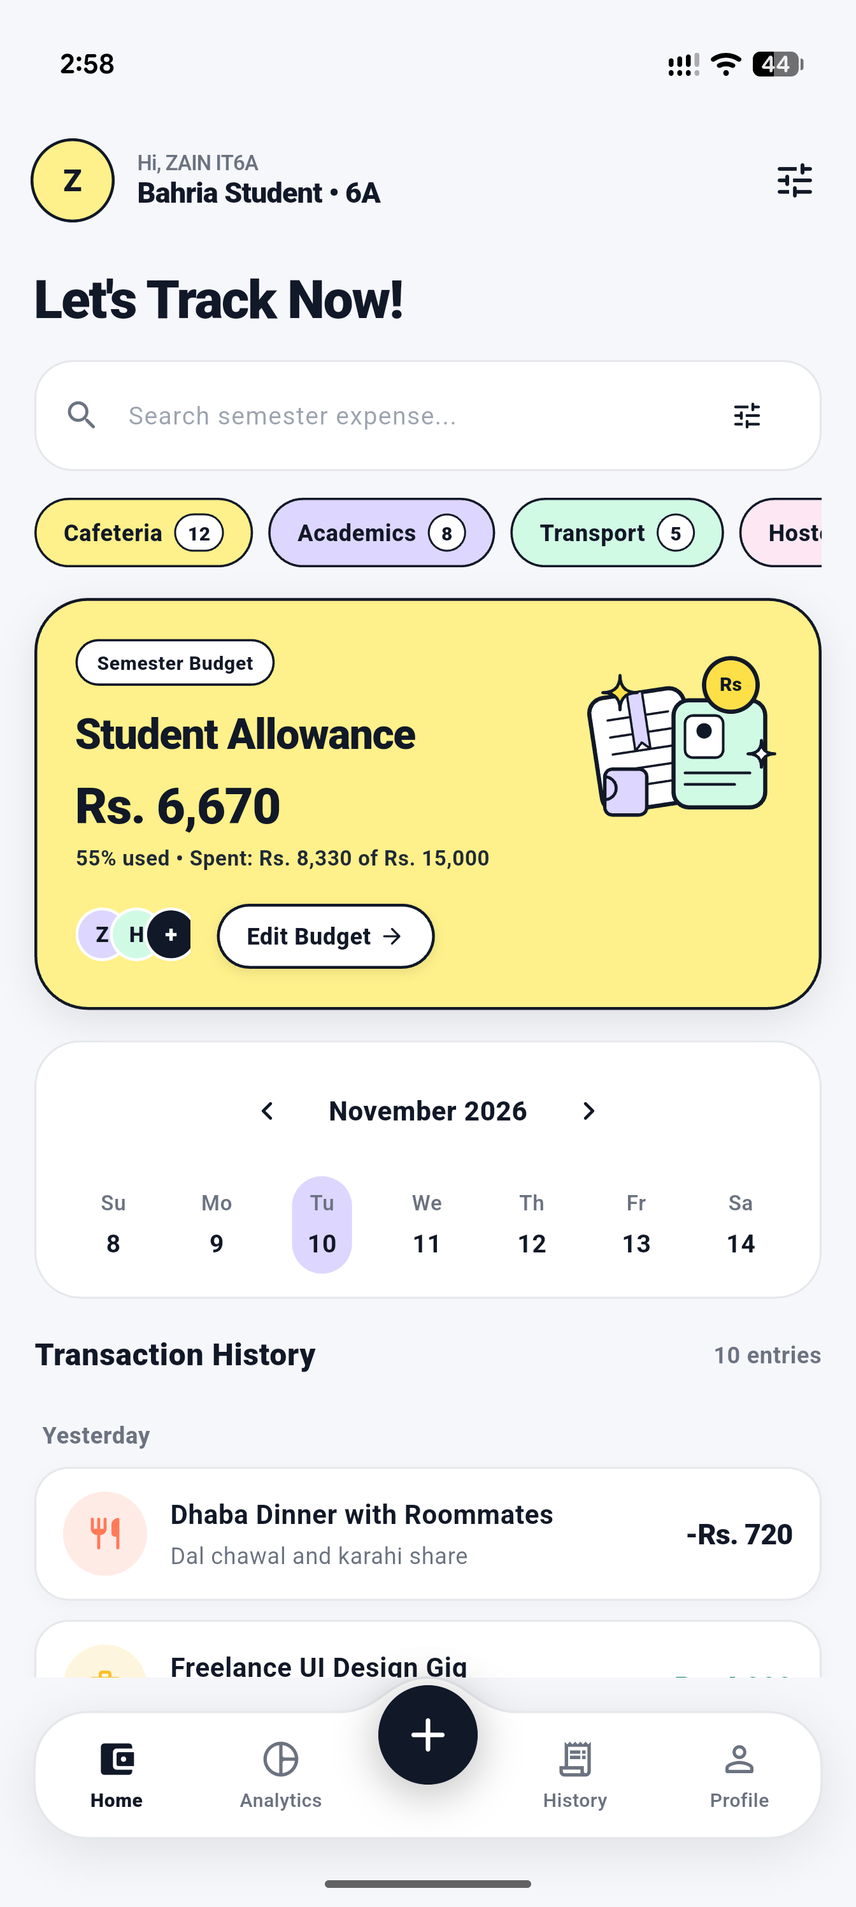  Figure 2: S4 — Student Expense Dashboard (Editorial Pastel) | Screen S4: Dashboard — Editorial Pastel Light Mode  The primary student home hub providing instant budget awareness under 10 seconds.  Key Visual Elements:  • Personalized greeting: 'Hi, ZAIN IT6A • Bahria Student 6A' with circular avatar.  • Bold headline: 'Let's Track Now!' with search bar pill.  • Quick category filter pills with transaction counts: Cafeteria (12), Academics (8), Transport (5), Hostel (4).  • Buttercup Yellow Hero Card displaying remaining semester budget (Rs. 6,670), percentage consumed (55%), unclipped student ID & ledger illustration, and 'Edit Budget' pill.  • Weekly Calendar Strip for date filtering.  • Arched floating navigation dock at bottom with elevated '+' button.

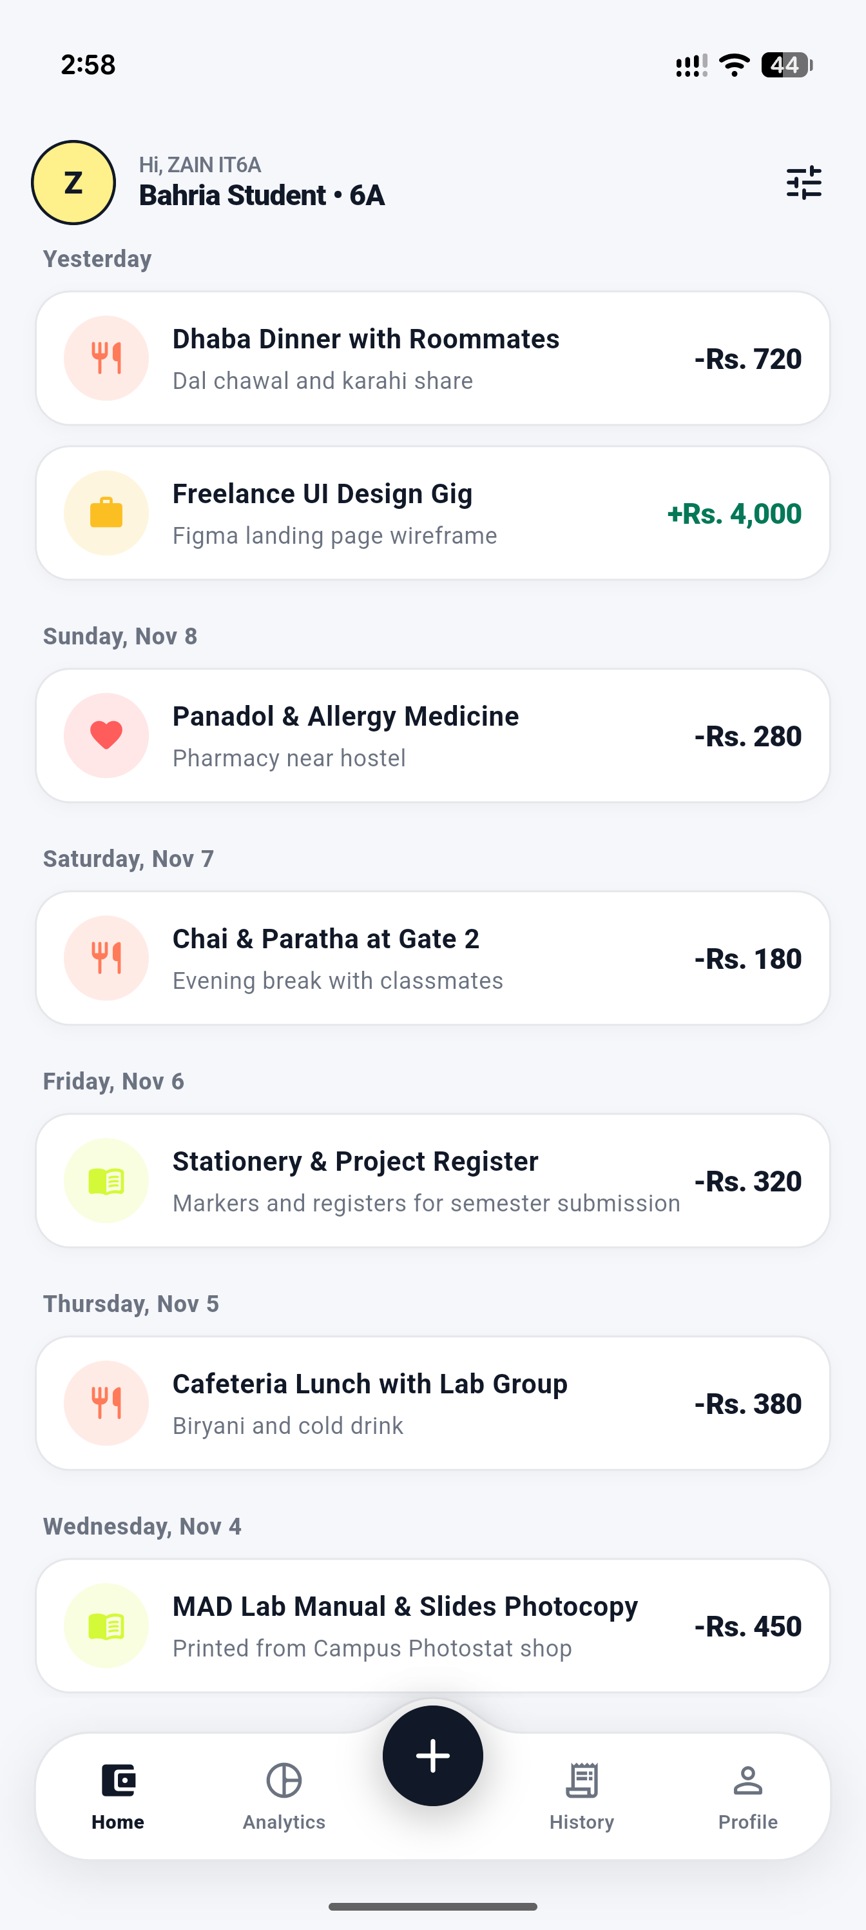  Figure 3: S4/S8 — Grouped Transaction History Feed | Screen S4 / S8: Grouped Transaction Feed  Chronologically grouped transaction ledger presenting daily cash outflows and inflows.  Key Visual Elements:  • Clean relative date headers ('Yesterday', 'Sunday, Nov 8', 'Saturday, Nov 7', etc.).  • Theme-aware white cards with subtle border outlines and soft drop shadows.  • Category-tinted avatar badges: Fork/Spoon (Food), Briefcase (Income), Heart (Health), Book (Academics).  • Clean subtitle notes: 'Dal chawal and karahi share', 'Pharmacy near hostel', 'Chai & Paratha at Gate 2', 'MAD Lab Manual Photocopy'.  • Color-coded amounts: Inflow in Emerald (+Rs. 4,000) and Outflow in Ink Black (-Rs. 720).

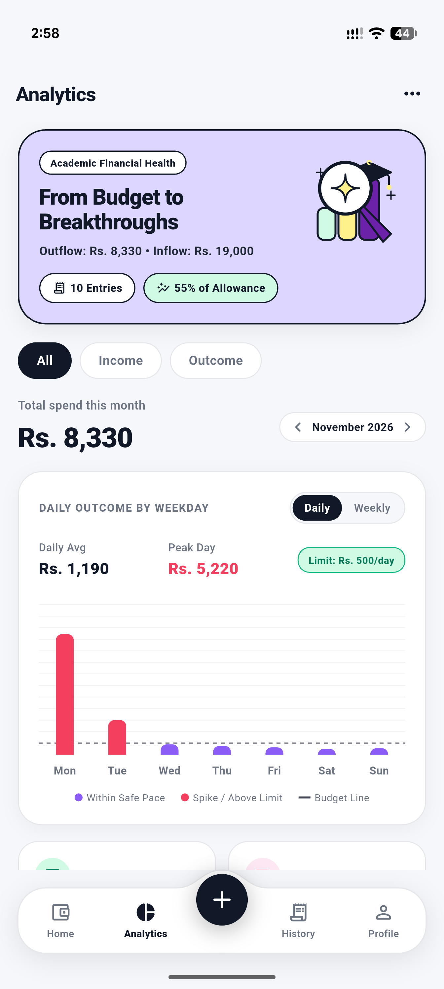  Figure 4: S6 — Visual Analytics Screen (Top Half: Trend Chart) | Screen S6: Analytics Screen — Daily Spending Trend  Comprehensive spending trend analytics providing early warnings before budgets are exceeded.  Key Visual Elements:  • Lavender Hero Card: 'Academic Financial Health — From Budget to Breakthroughs' with unclipped graduation cap and magnifying glass illustration.  • Summary badges: '10 Entries', '55% of Allowance'.  • Period switcher: 'All' | 'Income' | 'Outcome'.  • Total monthly spend display (Rs. 8,330) with month navigator.  • DAILY OUTCOME BY WEEKDAY Bar Chart: features Daily vs Weekly toggle, average calculation, peak day spike detection, Rs. 500/day dashed target budget line, and rose spike bars.

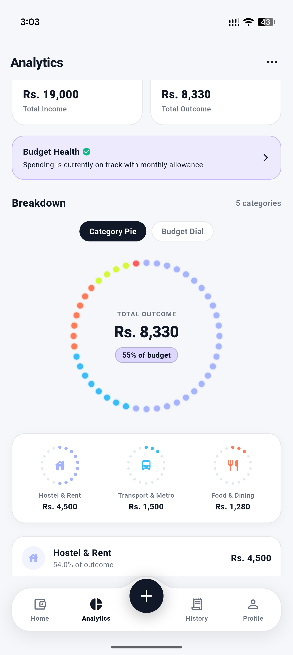  Figure 5: S6 — Visual Analytics Screen (Bottom Half: Breakdown) | Screen S6: Analytics Screen — Breakdown & Dot Matrix  Tactile category breakdown presenting financial distribution without clutter.  Key Visual Elements:  • Dual KPI summary cards: Total Income (Rs. 19,000) and Total Outcome (Rs. 8,330).  • Budget Health status banner with checkmark indicator.  • Renamed 'Breakdown' section header with category counter.  • Mode toggle pills: 'Category Pie' vs 'Budget Dial'.  • Tactile Circular Dot Matrix Pie Chart with discrete colored dots representing category proportions and center metric.  • Mini category dials: Hostel & Rent (Rs. 4,500), Transport (Rs. 1,500), Food & Dining (Rs. 1,280).

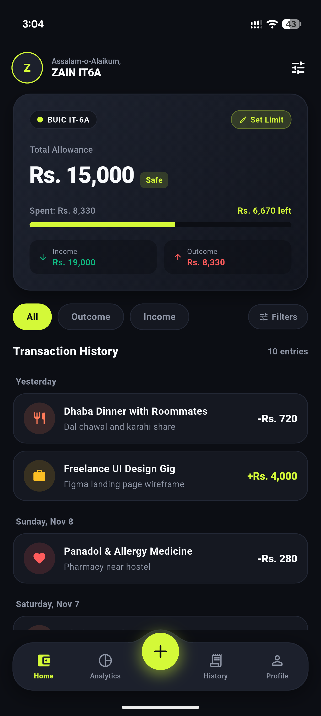  Figure 6: S4 — Student Expense Dashboard (OLED Dark Mode) | Screen S4: Dashboard — OLED Dark Neo-Fintech Mode  High-contrast dark mode for low-light environments and battery saving.  Key Visual Elements:  • Pitch-black canvas (#0A0B0E) with dark elevated cards (#151821).  • Monex-inspired virtual student pass card with BUIC IT-6A badge and electric Volt Lime allowance progress bar.  • Dual KPI pills displaying Rs. 19,000 income and Rs. 8,330 outcome.  • Pill filter row: 'All' (Volt Lime), 'Outcome', 'Income', 'Filters'.  • Dark transaction cards with muted borders.  • Arched bottom dock in dark slate with neon lime glowing elevated action button.

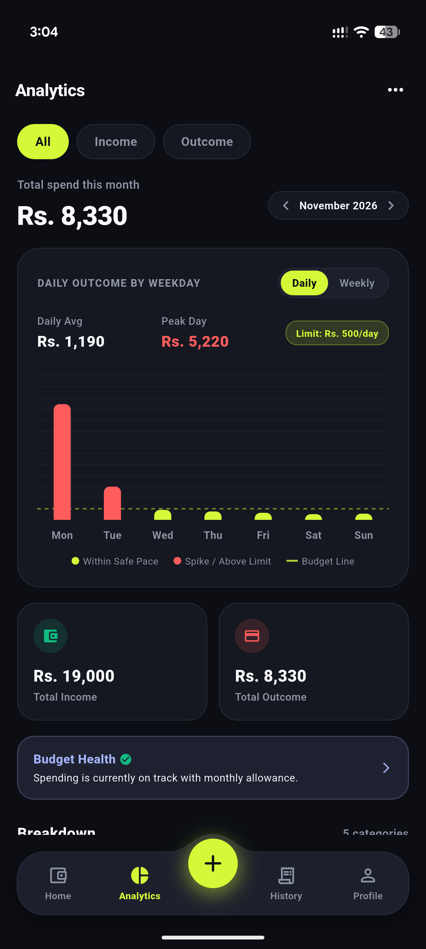  Figure 7: S6 — Visual Analytics Screen (OLED Dark Mode, Top Half) | Screen S6: Analytics — OLED Dark Trend Chart  Dark mode presentation of the dynamic weekday spending trend.  Key Visual Elements:  • High-contrast dark chart card with volt lime 'Daily' view selector.  • Real-time peak day identification (Rs. 5,220 on Monday) highlighted in coral red.  • Safe daily pace markers in electric volt lime on Wednesday through Sunday.  • Dashed lime budget threshold line set at Rs. 500/day allowance pace.  • Chart legend clearly explaining safe pace vs spike occurrences.

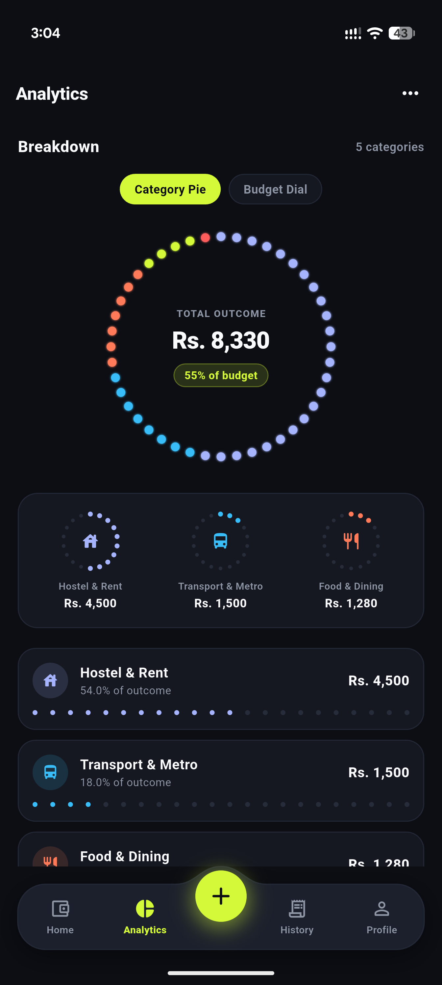  Figure 8: S6 — Visual Analytics Screen (OLED Dark Mode, Breakdown) | Screen S6: Analytics — OLED Dark Dot Matrix Breakdown  Tactile Dot Matrix Circular Ring Chart glowing against the deep OLED canvas.  Key Visual Elements:  • Renamed 'Breakdown' section header with 5 categories indicator.  • Glowing multi-colored discrete circular dots representing Hostel (blue), Food (coral/yellow), and Transport (cyan).  • Center metric display: TOTAL OUTCOME Rs. 8,330 • 55% of budget.  • Category breakdown cards with discrete 22-dot progress bars showing exact expenditure and percentage shares.

5. Complete UI Source Code (UI Only, No Backend)
UI Source Code Architecture: In strict accordance with Assignment 2 instructions, only front-end User Interface code is submitted below. The UI is completely decoupled from backend persistence, utilizing clean repository abstractions and local mock providers for state simulation.
5.1 Centralized Palette & Styling Tokens (app_colors.dart)
Declares all semantic color constants for both OLED Dark and Editorial Pastel themes:
Listing: lib/core/theme/app_colors.dart
import 'package:flutter/material.dart';
class AppColors {
AppColors._();
// Signature Volt Lime & OLED Dark (Neo-Fintech Theme)
static const Color neonLime = Color(0xFFD4F938);
static const Color neonLimeDark = Color(0xFFB5D826);
static const Color neonLimeSoft = Color(0x26D4F938);
static const Color darkCanvas = Color(0xFF0A0B0E);
static const Color darkCard = Color(0xFF151821);
static const Color darkCardElevated = Color(0xFF1E2230);
static const Color darkBorder = Color(0xFF232838);
// Editorial Pastel Palette (Light Mode)
static const Color pastelCanvas = Color(0xFFF7F6F2);
static const Color pastelCard = Color(0xFFFFFFFF);
static const Color pastelBorder = Color(0xFFE2E8F0);
static const Color inkBlack = Color(0xFF111827);
static const Color inkBlackSoft = Color(0xFF374151);
static const Color slateMuted = Color(0xFF64748B);
static const Color slateLight = Color(0xFF94A3B8);
// Semantic Pastel Accents
static const Color pastelYellow = Color(0xFFFDE047);
static const Color pastelLavender = Color(0xFFDDD6FE);
static const Color pastelMint = Color(0xFFA7F3D0);
static const Color pastelCoral = Color(0xFFFECDD3);
// Financial Indicators
static const Color income = Color(0xFF10B981);
static const Color expense = Color(0xFFF43F5E);
static const Color expenseSoft = Color(0x26F43F5E);
static const Color textPrimary = Color(0xFFF8FAFC);
static const Color textSecondary = Color(0xFF94A3B8);
}

5.2 Arched Navigation Dock & Shell (main_shell_screen.dart)
Implements the custom arched dock painter and symmetrical 4-tab shell with elevated '+' button:
Listing: lib/presentation/screens/main_shell_screen.dart (Excerpts)
class MainShellScreen extends StatefulWidget {
const MainShellScreen({super.key});
@override
State<MainShellScreen> createState() => _MainShellScreenState();
}
class _MainShellScreenState extends State<MainShellScreen> {
int _currentIndex = 0;
final List<Widget> _screens = const [
DashboardScreen(), StatsScreen(), TransactionsScreen(), ProfileScreen()
];
@override
Widget build(BuildContext context) {
final isDark = Theme.of(context).brightness == Brightness.dark;
final dockBg = isDark ? AppColors.darkCardElevated : Colors.white;
final dockBorder = isDark ? AppColors.darkBorder : AppColors.pastelBorder;
final plusBg = isDark ? AppColors.neonLime : AppColors.inkBlack;
return Scaffold(
backgroundColor: isDark ? AppColors.darkCanvas : AppColors.pastelCanvas,
extendBody: false,
body: IndexedStack(index: _currentIndex, children: _screens),
bottomNavigationBar: SafeArea(
top: false,
child: Container(
padding: const EdgeInsets.only(left: 18, right: 18, bottom: 12),
color: isDark ? AppColors.darkCanvas : AppColors.pastelCanvas,
child: SizedBox(
height: 84,
child: Stack(
clipBehavior: Clip.none,
children: [
Positioned.fill(
child: CustomPaint(
painter: ArchedDockPainter(
backgroundColor: dockBg, borderColor: dockBorder,
cornerRadius: 28.0, domePeakHeight: 18.0, isDark: isDark,
),
),
),
Positioned(
top: 18, left: 0, right: 0, bottom: 0,
child: Row(
children: [
Expanded(child: _buildNavItem(0, Icons.wallet_outlined, Icons.wallet, 'Home', isDark)),
Expanded(child: _buildNavItem(1, Icons.pie_chart_outline, Icons.pie_chart, 'Analytics', isDark)),
const SizedBox(width: 68), // Spacer for dome
Expanded(child: _buildNavItem(2, Icons.receipt_long_outlined, Icons.receipt_long, 'History', isDark)),
Expanded(child: _buildNavItem(3, Icons.person_outline, Icons.person, 'Profile', isDark)),
],
),
),
Positioned(
top: 4, left: 0, right: 0,
child: Center(
child: GestureDetector(
onTap: () => Navigator.of(context).push(MaterialPageRoute(builder: (_) => const AddEditExpenseScreen())),
child: Container(
width: 52, height: 52,
decoration: BoxDecoration(color: plusBg, shape: BoxShape.circle),
child: Icon(Icons.add_rounded, color: isDark ? AppColors.darkCanvas : Colors.white, size: 30),
),
),
),
),
],
),
),
),
),
);
}
}

5.3 Daily Spending Trend Bar Chart (daily_spending_trend_chart.dart)
Calculates daily burn rate vs student allowance pace with spike detection and budget threshold lines:
Listing: lib/presentation/screens/stats/widgets/daily_spending_trend_chart.dart (Excerpts)
class DailySpendingTrendChart extends StatefulWidget {
final List<Expense> expenses;
final double monthlyBudget;
final DateTime selectedMonth;
const DailySpendingTrendChart({super.key, required this.expenses, required this.monthlyBudget, required this.selectedMonth});
@override
State<DailySpendingTrendChart> createState() => _DailySpendingTrendChartState();
}
class _DailySpendingTrendChartState extends State<DailySpendingTrendChart> {
bool _isWeeklyView = false;
@override
Widget build(BuildContext context) {
final isDark = Theme.of(context).brightness == Brightness.dark;
final dailyTarget = widget.monthlyBudget / 30.0;
final cardBg = isDark ? AppColors.darkCard : Colors.white;
final normalBarColor = isDark ? AppColors.neonLime : const Color(0xFF8B5CF6);
final overBarColor = isDark ? AppColors.expense : const Color(0xFFF43F5E);
return Container(
padding: const EdgeInsets.all(20),
decoration: BoxDecoration(
color: cardBg,
borderRadius: BorderRadius.circular(24),
border: Border.all(color: isDark ? AppColors.darkBorder : AppColors.pastelBorder),
),
child: Column(
children: [
Row(
mainAxisAlignment: MainAxisAlignment.spaceBetween,
children: [
Text('DAILY OUTCOME BY WEEKDAY', style: TextStyle(fontSize: 11, fontWeight: FontWeight.w800)),
Container(
child: Row(
children: [
_buildTogglePill('Daily', !_isWeeklyView, isDark, () => setState(() => _isWeeklyView = false)),
_buildTogglePill('Weekly', _isWeeklyView, isDark, () => setState(() => _isWeeklyView = true)),
],
),
),
],
),
SizedBox(
height: 180,
child: BarChart(
BarChartData(
maxY: 6000,
barGroups: List.generate(7, (i) => BarChartGroupData(
x: i,
barRods: [BarChartRodData(toY: weekdayTotals[i+1] ?? 0.0, color: (weekdayTotals[i+1] ?? 0.0) > dailyTarget ? overBarColor : normalBarColor, width: 18)],
)),
),
),
),
],
),
);
}
}

5.4 Tactile Dot Matrix Circular Chart (dot_matrix_pie_chart.dart)
Renders 44 discrete circular dots around a 240x240 circle representing category expenditure:
Listing: lib/presentation/screens/stats/widgets/dot_matrix_pie_chart.dart (Canvas Painter)
class _DotMatrixCanvasPainter extends CustomPainter {
final List<CategorySpending> spendingList;
final double totalSpent;
final double budget;
final int totalDots;
final bool isDark;
_DotMatrixCanvasPainter({required this.spendingList, required this.totalSpent, required this.budget, this.totalDots = 44, required this.isDark});
@override
void paint(Canvas canvas, Size size) {
final center = Offset(size.width / 2, size.height / 2);
final radius = (size.width / 2) - 16;
final dotPaint = Paint()..style = PaintingStyle.fill;
final inactiveColor = isDark ? const Color(0xFF232838) : const Color(0xFFE2E8F0);
for (int i = 0; i < totalDots; i++) {
final angle = (2 * math.pi * (i / totalDots)) - (math.pi / 2);
final dotCenter = Offset(center.dx + radius * math.cos(angle), center.dy + radius * math.sin(angle));
final color = _getColorForDot(i) ?? inactiveColor;
dotPaint.color = color;
canvas.drawCircle(dotCenter, 4.5, dotPaint);
}
}
Color? _getColorForDot(int index) {
double runningFraction = 0.0;
final dotFraction = index / totalDots;
for (final cat in spendingList) {
final frac = cat.percentage / 100.0;
if (dotFraction >= runningFraction && dotFraction < (runningFraction + frac)) {
return cat.category.color;
}
runningFraction += frac;
}
return null;
}
@override
bool shouldRepaint(covariant CustomPainter oldDelegate) => true;
}

5.5 Handcrafted Vector Student Illustration (CustomPainter)
Vector custom painter producing the unclipped student study desk illustration on the splash screen:
Listing: lib/presentation/widgets/illustrations/editorial_student_splash_illustration.dart (Excerpts)
class _EditorialSplashPainter extends CustomPainter {
@override
void paint(Canvas canvas, Size size) {
final w = size.width;
final h = size.height;
final inkPaint = Paint()..color = AppColors.inkBlack..style = PaintingStyle.stroke..strokeWidth = 2.4;
// 1. Decorative lavender backdrop
final bgRect = RRect.fromRectAndRadius(Rect.fromCenter(center: Offset(w * 0.5, h * 0.52), width: w * 0.9, height: h * 0.85), const Radius.circular(32));
canvas.drawRRect(bgRect, Paint()..color = AppColors.pastelLavender);
canvas.drawRRect(bgRect, inkPaint);
// 2. Desk surface & stacked textbooks
final deskY = h * 0.78;
canvas.drawLine(Offset(w * 0.1, deskY), Offset(w * 0.9, deskY), inkPaint..strokeWidth = 2.5);
canvas.drawRRect(RRect.fromRectAndRadius(Rect.fromLTWH(w * 0.16, deskY - 14, 52, 14), const Radius.circular(3)), Paint()..color = AppColors.pastelMint);
canvas.drawRRect(RRect.fromRectAndRadius(Rect.fromLTWH(w * 0.18, deskY - 26, 46, 12), const Radius.circular(3)), Paint()..color = AppColors.pastelYellow);
// 3. Student torso with striped sweater
final torsoPath = Path()..moveTo(w * 0.36, deskY)..lineTo(w * 0.38, h * 0.44)..quadraticBezierTo(w * 0.5, h * 0.42, w * 0.62, h * 0.44)..lineTo(w * 0.64, deskY)..close();
canvas.drawPath(torsoPath, Paint()..color = AppColors.pastelYellow);
canvas.drawPath(torsoPath, inkPaint);
for (double sy = h * 0.48; sy < deskY - 6; sy += 9) {
canvas.drawLine(Offset(w * 0.375, sy), Offset(w * 0.625, sy), inkPaint..strokeWidth = 1.8);
}
// 4. Glasses and hair bun
canvas.drawCircle(Offset(w * 0.46, h * 0.32), 7, inkPaint);
canvas.drawCircle(Offset(w * 0.54, h * 0.32), 7, inkPaint);
canvas.drawCircle(Offset(w * 0.50, h * 0.17), 10, Paint()..color = AppColors.inkBlack);
}
@override
bool shouldRepaint(covariant CustomPainter oldDelegate) => false;
}

Submitted By  Zain Kashif  Enrollment: 01-135232-107  BS-IT 6A, Bahria University Islamabad | Submitted By  Huraira Minhas  Enrollment: 01-135232-030  BS-IT 6A, Bahria University Islamabad

