1. Please import as existing Maven project

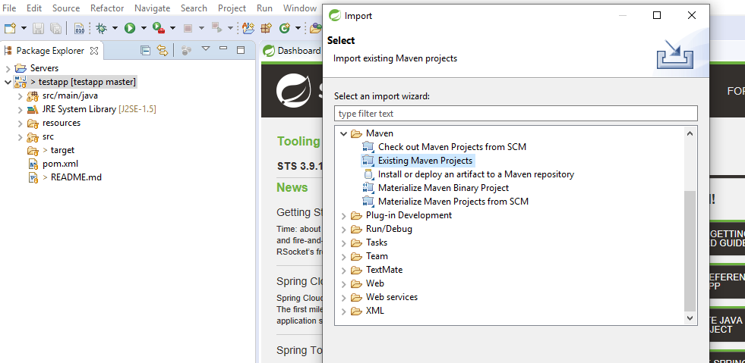

1. Please right click on the project and click on export 🡪 Runnable JAR file

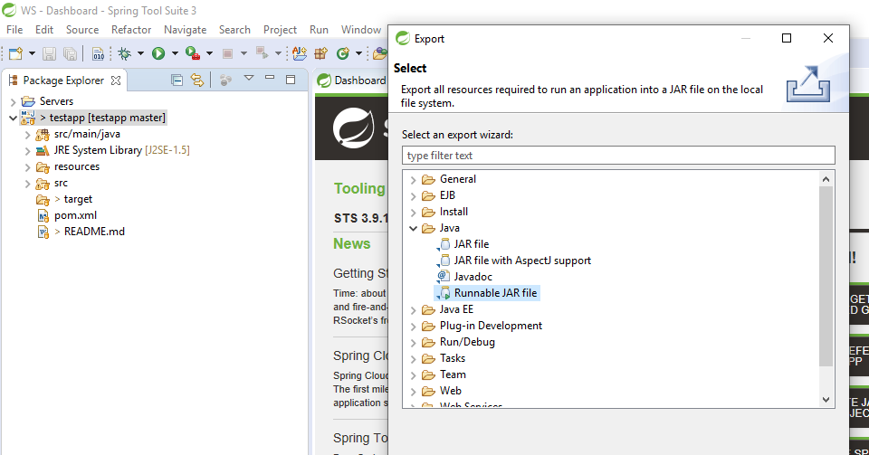

1. Next, please select the destination and write file name.

