# Problem:

Design 4x4 memory game that

* Has 8 images 16 buttons. Each image is used in two buttons
* Objective is to find the matching images.
* Can be played multiply times
* Each time the images arrangement differs
* Keep track of time
* Keep track of top scores
* Use sound for matching and non-matching

# Solution:

When opening the game all buttons will be unclickable only start button will be available, after clicking start the buttons will show their images for 2 seconds for the player then the images will disappear and the buttons will be clickable. The player needs to click on buttons to see their images and try to match them with the same image on other buttons

If the matching is correct both images will stay visible otherwise both will return invisible

After matching all images there will be text under the Timer says “Winner!!” and if the play got a new high Score (less time than any of the top 3) then the system will save the new top 3 scores.

After that the reset button will be available for the player to start a new game with new random images.

# Screen shots of the system:

before Starting the game

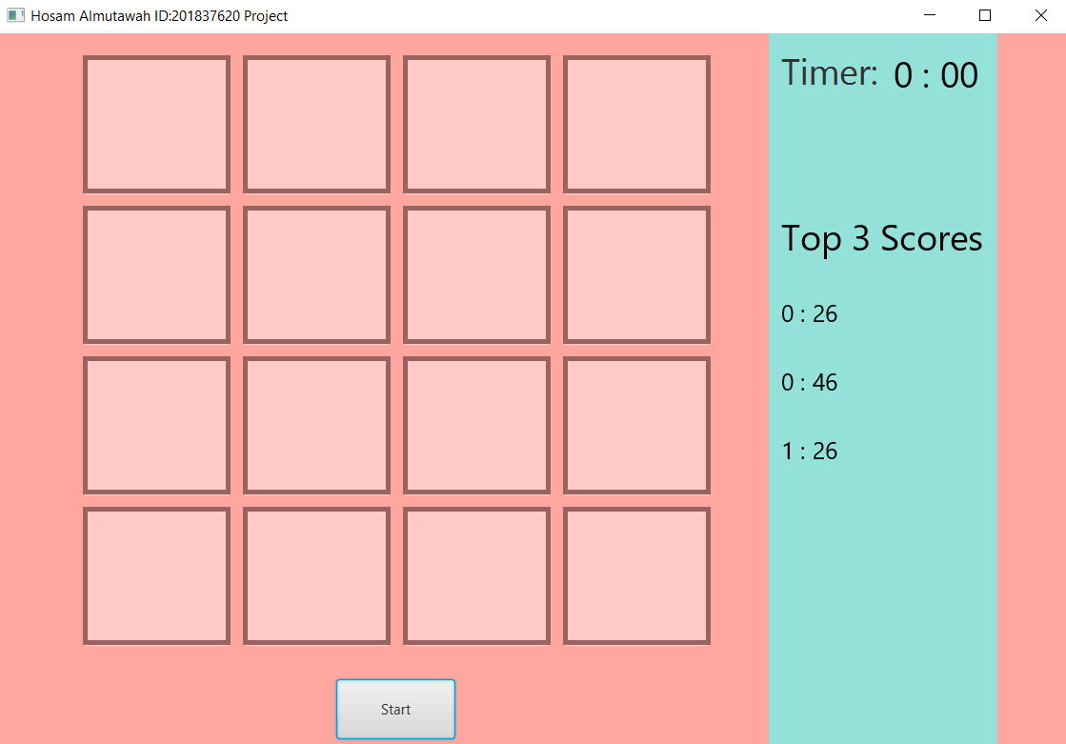

While playing

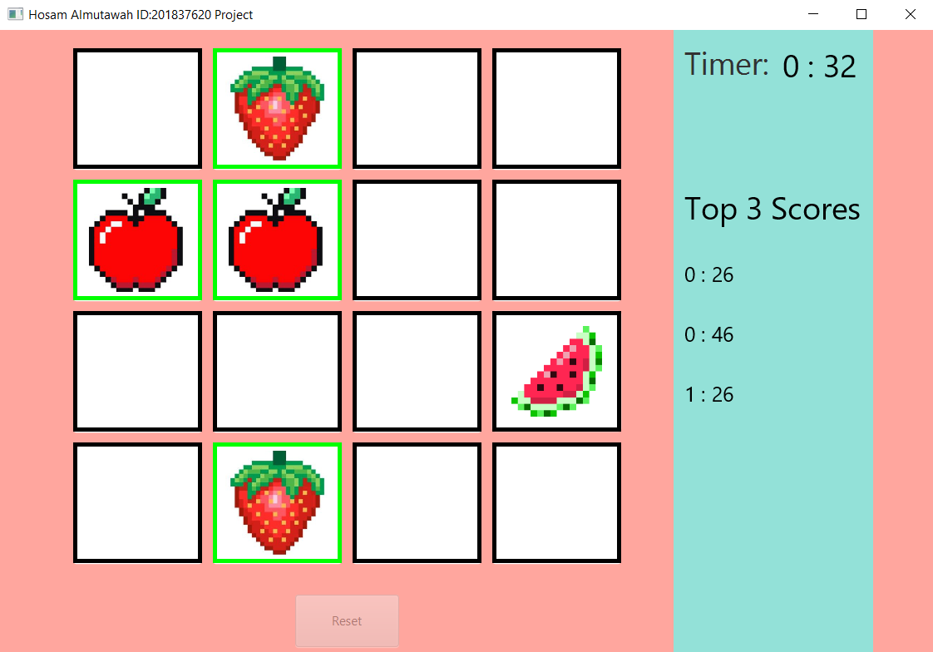

End of game (after matching all images)

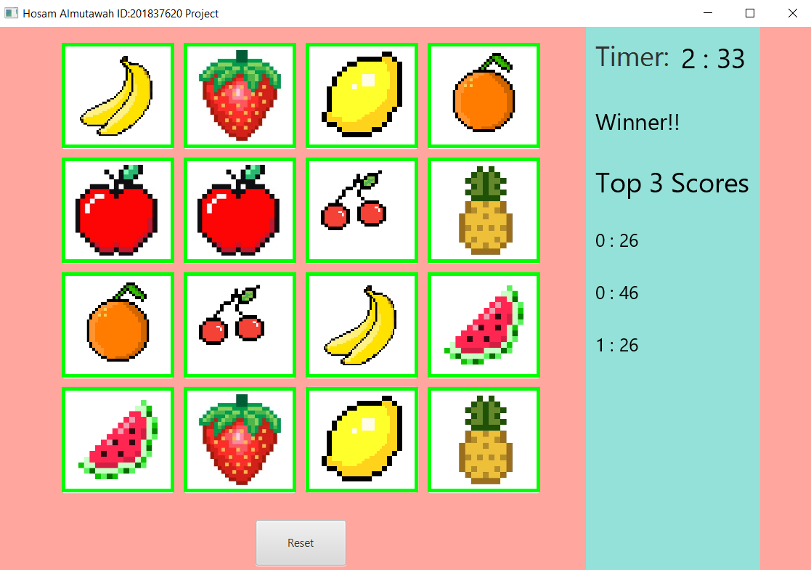

# Work distribution:

100% Hosam Almutawah