**In the Mix: Experimental Electrochemistry**

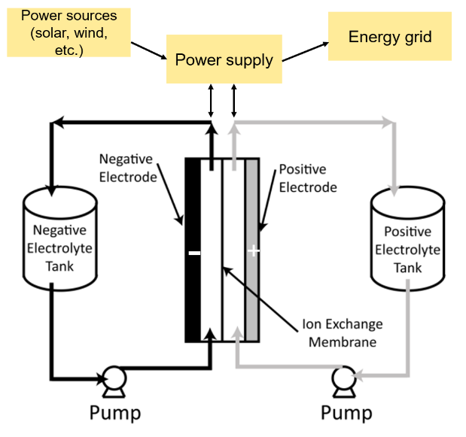

**Figure 1:** A diagram of a redox flow battery (adapted from *C. Ponce De Leon et al.*)

**Background:** Renewable energy options such as solar and wind have emerged as an affordable alternative to traditional fossil fuel energy sources, which emit carbon into the atmosphere. Because solar and wind are intermittent in nature, the development of effective and safe energy storage technologies is vital to maximize their energy output. Redox flow batteries (RFBs) are a grid scale energy storage technology that shows great promise for this. RFBs store energy in the form of electroactive species contained in liquid electrolytes, converting chemical energy to electrical energy through redox processes **(Figure 1).**

The design and optimization of a RFB is complex, as multiple factors including the electroactive species, electrolyte, separating membrane, and electrode material can all be modified. Because of this, analytical characterization is required to understand the fundamental electrochemical and physical properties of promising systems.

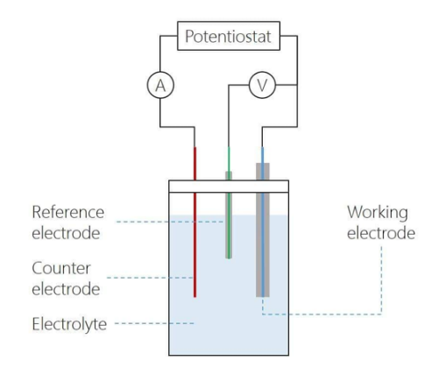

**Figure 2:** Diagram of a three electrode setup for cyclic voltammetry (CV).

Cyclic voltammetry (CV) is an analytical technique that measures current (A) as a function of an applied potential (V). In a typical setup, three electrodes are used- a working electrode, counter electrode, and reference electrode **(Figure 2).** The potential is applied at the working electrode and current is measured. Meanwhile, the counter electrode swings to extreme potentials to compensate the current being passed at the working electrode and the reference electrode provides a constant potential to reference for the working electrode.

CV provides a wealth of useful information on the thermodynamics and kinetics for the electron transfers an electroactive species can undergo **(Figure 3)**. As the potential is changed, species diffuse to the electrode surface and current is passed as electrons flow between the electrode and electroactive species. The upward and downward facing peaks in **Figure 3** are called redox features, and they correspond to the oxidation or reduction of species at the working electrode. Quantitative analysis of CV data enables the calculation of various electrochemical parameters such as the formal potential (E1/2), heterogeneous electron transfer rate (k0), and diffusion coefficient (D). Each of these parameters is relevant to the performance and optimization of a RFB- in terms of the cell voltage of the battery as well as the kinetics of the electron transfers.

Within this laboratory experience, we will use CV to characterize three electroactive quinone derivatives with different redox potentials. The aim is to become familiar with CV as an analytical technique and connect the chemical structure of each molecule to its measured redox potential (and computationally calculated redox potentials). Ultimately, this approach of characterizing molecules, connecting electrochemical behavior to chemical structure, and then further refining structural design is used to develop better batteries for energy storage applications.

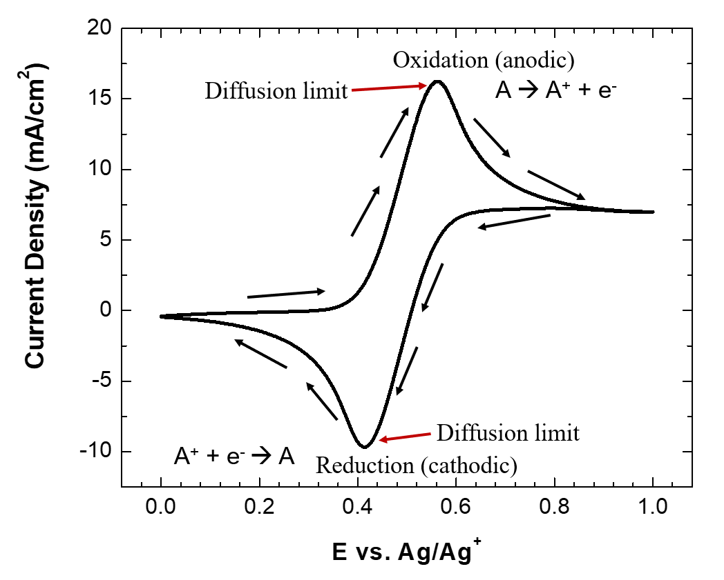

**Figure 3:** A cyclic voltammogram (CV) with key elements labeled.

______________________________________________________________________________**

**Figure 4:** The three benzoquinones we will be studying electrochemically.

**Figure 5:** An example of the electron transfer benzoquinone can undergo.

**Experimental:**

We will be studying the electrochemistry of the three quinones shown above (**Figure 4** **and 5)** using CV. Due to limited time, some stock solutions and reagents have been prepared beforehand and will be made available for you.

* 1 mM and 5 mM benzoquinone both in 0.1M TBABF4 electrolyte
* 1 mM and 5 mM naphthalenedione both in 0.1M TBABF4 electrolyte
* 1 mM and 5 mM tetramethyl benzoquinone both in 0.1M TBABF4 electrolyte

For convenience, we will be using gold screen-printed electrodes that have the working, counter, and reference electrode all contained together on one chip. Further information/pictures will be shown in the procedure section.

**Procedure:**

1. Acquire 10 mL volumetric flasks of of 1 mM and 5 mM benzoquinone, naphthalenedione, and tetramethylbenzoquinone, all in 0.1M TBABF4.
2. Set up your electrochemistry cell: pour 10 mL of 1 mM benzoquinone into the scintillation vial and put the Au screen-printed electrode into the supplied grip and into the vial. Hook the USB cable into the top of the screen-printed electrode grip and connect the other end into the connector board on the benchtop. From the potentiostat, connect the green wire to the WE pin, the red wire to the CE pin, and the white wire to the RE pin. (**Figure X)**
3. Setting CV parameters: Open the CHI software on the computer, and click on the parameters icon right below control in the top left of the screen (checklist icon). [Insert parameters that we want them to use here]
4. Obtaining a CV: When all parameters are set, click the run arrow to the right of the parameters icon. A CV will be obtained- when it is finished, name it as the concentration and scan rate that was used (eg. 1 mM benzoquinone 50 mV scan rate) and save it to the Echem Data folder as both a .bin and a .csv file.

[Insert an action/action procedure here once I’ve had the chance to run it with Jack and Elise]

[Include pictures of the SPE by itself with WE, CE, and RE labeled for students]

[Include picture of the entire setup (leads, connector board, etc.) for reference]

**Data Analysis:**

**Figure X:** Some relevant units and equations for your reference.

From the CV data, we will calculate the formal potential (E1/2) and the diffusion coefficient (D). The formal potential corresponds to the energy required to reduce each molecule (V = J/C), while the diffusion coefficient corresponds to how quickly species diffuse to the electrode to undergo electron transfer (cm2/sec).

We have created an Excel spreadsheet with equations already entered to assist you with each of these calculations.

**Formal potential (E1/2):**

The formal potential (E1/2) is the halfway potential between the potentials corresponding to the oxidation and reduction peak currents in the CV. *Enter your experimental potentials into the Excel spreadsheet to calculate the average between these potentials and determine the E1/2 value for each quinone at 1 mM and 5 mM.*

**Figure X:** An energy diagram as potential is changed at the electrode.

**Diffusion Coefficient (D):**

The diffusion coefficient (D) can be calculated from CVs at varying scan rates (as were collected in the procedure). As the potential is changed at different rates, the amount of current passed at the oxidation and reduction peak current changes. This phenomenon can be rationalized by looking at the units of current (A = C/s). When applying faster scan rates, there is less time to pass the same amount of coulombs (C) at the electrode. Because of this, larger peak currents are observed (as there is a smaller time value in the denominator). The Randles–Ševčík equation linearly connects the peak current (ip) in A to the square root of the scan rate (v1/2) in V/s.

[1] $i_{p}=2.69x{10}^{5}n^{\frac{3}{2}}AD^{1/2}Cv^{1/2}$

Additional parameters include the number of electrons transferred in the redox event (n), the electrode surface area in cm2 (A), and the concentration of the electroactive species in mol/cm3. By plotting the left side of the equation against the right side of the equation, D can be determined with other values known.

*****Enter your peak currents for each applied scan rate into the Excel spreadsheet to calculate D for each quinone at 1 mM and 5 mM.*

**Some things to think about:**

* What trend do you see in the E1/2 values for the redox feature for each quinone? Looking at the chemical structure of each molecule, what do you think contributes to this trend? How does this compare to computational work you have done with each quinone?
* How do diffusion coefficients change between concentration and between each molecule?
* If we were building a RFB and we wanted to use one of these quinones as the anolyte species (the species being oxidized during battery discharge), which molecule would be the best option? *Hint: Think about E1/2 values and how easy it is to oxidize/reduce each molecule.*